# 

# Introduction to Computer Science and Programming 1

# CSCI120

### Chapter5: Iterations

Assignment 5

**Note:** This document has been designed and developed as part of an initiative for creating an OER (Open Education Resource) package for the course CSCI 120 at Columbia College.

Please contact [Alireza.davoodi@gmail.com](mailto:Alireza.davoodi@gmail.com) for any comment, modification, and questions.

**Terms of use:** Please feel free to customize this document as needed

Last Modified: July 2022

# Requirements

* For each of the problem below write a Python program.
* When defining variable names, use proper and meaningful names for the variables.
* Follow Python’s convention for naming your variables (camel case)
* Remember Python is sensitive about indentation. Use proper indentation.
* Add comments to your code.
* Refer to lecture notes 2,3 and 4 if you need any help.
* Write all the python programs in one single file. Separate your answers for each question as following: Example:

##Problem 1

print(“Problem1--------------------------------------------”)

Python code for problem 1

##Problem 2

print(“Problem2--------------------------------------------”)

Python code for problem 2

If it is a group assignment, please add the information here

|  |  |  |
| --- | --- | --- |
| **# of Students in the Group:** |  | |
|  |  |  |
| **Student 1** | *First name, last name* | *Student-ID* |
| **Student 2** | *First name, last name* | *Student-ID* |
| **Student 3** | *First name, last name* | *Student-ID* |
| **Student 4** | *First name, last name* | *Student-ID* |

# Problem1

* Write a python program which prints all the numbers between 1 and 100 that are divisible by 3.

# Problem2

* Write a python program which asks the user to enter a positive number called “num1”. The program then prints all numbers between 0 and num.

# Problem3

* Write a python program which asks the user to enter a positive number that is greater than 30 called, “num2” and then does the following:
  + 1) Print all numbers between 1 and “num2” that are divisible by 2 and 3.
  + 2) Print all numbers between 1 and “num2” that are either divisible by 6 or 7.
  + 3) Print all numbers between 1 and “num3” that is not divisible by 5.

# Problem4

* Write a python program which keeps asking the user to enter a positive or a negative number until the user enters 0. Once the user enters 0, the program calculates the sum and average of all the numbers the user had entered and prints the sum and average and terminates.

# Problem5

* Write a python program which prints the following multiplication table. (You do not need to draw the vertical and horizontal lines).

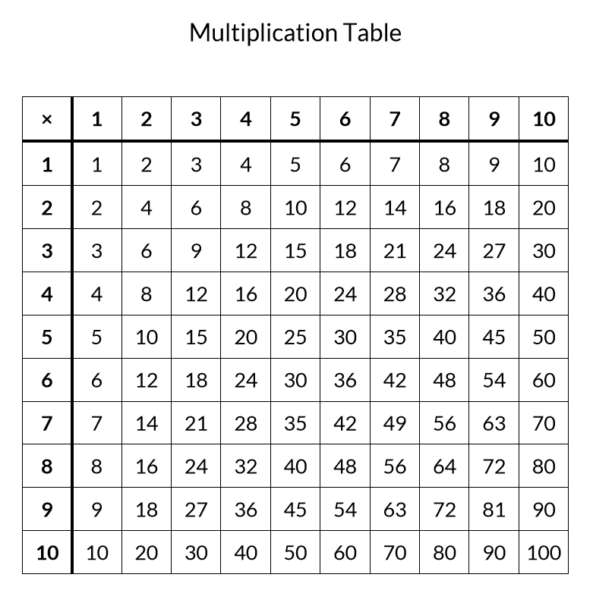

# Problem6

* Write a Python program which reads a number from input (like 123). You make the assumption that the user does not enter a decimal number (like 123.4). The number entered by the user should not be divisible by 10 and if the user enters a number that is divisible by 10 (like 560), it is considered invalid and the application should keep asking until the user enters a valid input. Once the user enters a valid input, the program calculates the reverse of the number (for instance for 153, the reverse is 351) and prints the result.

# Problem7

* Write a Python program which keeps asking the user to enter a name. The program checks the entered name. If the entered name contains any digit, then the program terminates, if the entered name has no digits and only contains alphabets, then converts the name to uppercase and prints it and asks for the next name from the user and repeats.

**Good Luck ☺**