FedCARE: Class-Aware Recalibration for Federated Medical Image Classification under Label Skew and Acquisition Shift
Alireza Fathi, Reza Boostani, Rahil Hosseini, and Mazin Abed Mohammed

Abstract—Federated learning (FL) lets hospitals and medical Internet-of-Things devices train a shared classifier without exchanging images, but skewed label distributions bias the global classifier against minority classes, and site-specific acquisition conditions shift image appearance. Existing remedies regularize local training or re-calibrate the classifier afterwards, yet still average the classifier with sample-size weights. We show that this dilutes the update of each class by the share of data held by the clients that observed it. We propose FedCARE, which pairs a Bayes-consistent prior-corrected local loss with class-aware aggregation of the classifier rows; it adds only label counts to the upload and has no tuned hyper-parameter. We also introduce LR-Cal, a classifier calibration that transmits rank-r principal-component summaries of class-conditional features instead of full covariances. On BloodMNIST with severe label skew and simulated site shift and on the long-tailed DermaMNIST (ten clients, eight baselines, three seeds that re-draw the partitions), FedCARE attains the highest mean macro-F1 on BloodMNIST (0.443 ± 0.247 vs. 0.433 for the best baseline, SCAFFOLD), and a macro-F1 of 0.319 ± 0.029 on DermaMNIST, 11.1 points above the best training-time baseline (FedLC) but 1.9 points below FedAvg+LR-Cal. It wins 37 of 42 paired comparisons with the seven training-time baselines (Wilcoxon p ≤ 0.05 against 3), while post-hoc calibration of FedAvg remains competitive on DermaMNIST. LR-Cal matches full-covariance calibration with 6.6× less upload, and aligning features with PCA class subspaces did not add accuracy. The compact network, 28×28 images and simulated shift call for validation on real multi-centre data before deployment.
Index Terms—Federated learning, label skew, class imbalance, classifier calibration, acquisition shift, principal component analysis, medical image classification, Internet of Medical Things.
I. Introduction
Clinical images are generated at many hospitals, laboratories and, increasingly, at point-of-care devices of the Internet of Medical Things (IoMT). Federated learning (FL) trains a shared model on these distributed collections without moving patient data: every round, clients improve the current global model on their own data and a server aggregates the resulting parameters [1], [2]. FL is therefore regarded as a practical route to multi-institutional medical AI [3]–[6] and to learning on resource-constrained IoT nodes [7].
Two kinds of heterogeneity make medical FL difficult. First, label skew: disease prevalence and referral patterns differ across sites, so each client sees a different, often extremely unbalanced, label distribution, and globally the classes are long-tailed. Second, acquisition shift: staining protocols, scanners, illumination and optics change the appearance of the same class from site to site. Under label skew, local training pushes the classifier towards the locally frequent classes and suppresses the classes a client never observes; after averaging, the global classifier is biased and minority classes are recognized poorly or not at all [8]–[10]. In our earlier experiments with subspace-weighted aggregation, several tissue classes kept F1 scores close to zero for exactly this reason, which motivated the present, classifier-centric design.
Existing remedies act at different points of the pipeline. Drift-correcting optimizers such as FedProx [11], SCAFFOLD [12], FedNova [13] and MOON [14] constrain or correct the local updates of the whole network but do not target the classifier bias that label skew induces. Label-skew methods modify the local softmax, either by restricting the logits of locally absent classes (FedRS [8]) or by calibrating logits with local class counts (FedLC [9]); they still aggregate the classifier with sample-size weights. Post-hoc calibration (CCVR [10]) re-trains the classifier on virtual features drawn from class-conditional Gaussians, but each client must upload a full d×d covariance matrix per class. Prototype- and subspace-based methods [15], [16] align feature distributions across clients but rely on statistics that drift while the representation is still being learned.
Research gap. The classifier is the component that label skew damages most directly, yet the aggregation rule for its rows has received little attention: with sample-size weights, the update of the row of class c is averaged together with clients that never observed c. We show that this dilutes the informative update of every class by the fraction of data held by the clients that observed it, a factor that is small exactly for the clinically important minority classes. Correcting the local objective and the aggregation rule jointly, without extra models, control variates or covariance uploads, has not been studied systematically, and published comparisons in this area are frequently based on a single partition and seed.
This paper makes the following contributions:
1) We propose FedCARE (Federated Class-Aware REcalibration), which combines a prior-corrected (balanced-softmax) local objective with class-aware aggregation of the classifier rows. We show analytically that the two parts are complementary: prior correction makes the rows of locally absent classes inert during local training, and class-aware weights then remove the dilution of the informative rows (Proposition 1). FedCARE adds only C label counts per client to the upload and has no tuned hyper-parameter.
2) We introduce LR-Cal, a low-rank variant of classifier calibration in which clients upload rank-r principal-component summaries of their class-conditional features instead of full covariances; the server merges them exactly with the law of total covariance. With d = 64 and r = 4, LR-Cal reduces the per-class upload from 2145 to 326 values (6.6× smaller) while matching CCVR.
3) We evaluate against eight baselines (FedAvg, FedProx, SCAFFOLD, FedNova, MOON, FedRS, FedLC and FedAvg+CCVR) on two public medical benchmarks with naturally long-tailed classes and with simulated per-site acquisition shift, using three seeds that re-draw the data subsample, the client partition, the site parameters and the initialization; we report means and standard deviations, paired Wilcoxon signed-rank tests, macro-F1, balanced accuracy, macro-AUC, worst-class recall, full per-class precision/recall/F1 and confusion matrices.
4) We report the outcome of the subspace-guided direction transparently: aligning features with PCA class subspaces did not add accuracy on top of FedCARE, and we analyse why. All code, configurations, raw results and unit tests are released.
The remainder of the paper is organized as follows. Section II reviews related work, Section III formalizes the problem, Section IV presents FedCARE and LR-Cal, Section V describes the experimental protocol, Section VI reports and analyses the results, Section VII discusses limitations and Section VIII concludes.
II. Related Work
A. Federated Optimization under Heterogeneity
FedAvg [1] averages locally trained models with sample-size weights. When client distributions differ, local optima diverge (client drift) and convergence slows [11], [12], [17]. FedProx adds a proximal term to the local objective [11]; SCAFFOLD corrects local gradients with control variates [12]; FedNova normalizes local updates to remove the objective inconsistency caused by unequal numbers of local steps [13]; MOON regularizes local representations towards the global model with a contrastive loss [14]. Large benchmark studies found that none of these methods dominates under label skew [18]. These methods treat all parameters alike, whereas FedCARE changes only the classifier's loss and aggregation.
B. Label Skew and Classifier Bias
Long-tail learning showed that a softmax classifier trained on imbalanced labels absorbs the label prior and that adding the log-prior to the logits during training (logit adjustment, balanced softmax) yields a classifier that is consistent for the balanced error [19], [20]. In FL, FedRS scales down the logits of classes a client does not hold [8], FedLC subtracts a count-dependent calibration term [9], FedBABU freezes the classifier during federated training [21], and CCVR [10] and CReFF [22] re-train the classifier on the server with virtual or federated features. FedCARE uses the Bayes-consistent log-prior correction locally, but its distinctive element is the aggregation rule for the classifier rows, which these methods leave unchanged; LR-Cal reduces the communication of CCVR-style calibration.
C. Feature Shift, Prototypes and PCA in FL
FedBN keeps batch-normalization layers local to absorb feature shift [23], at the price of client-specific models; FedDG exchanges amplitude spectra for domain generalization [24]. Prototype methods share class means and pull local features towards them [15], [16], which is related to center-loss regularization [25]. Principal component analysis has been federated directly [26], and probabilistic PCA [27] provides the low-rank-plus-isotropic covariance model that LR-Cal transmits. Our ablation tests whether aligning features with PCA class subspaces adds value on top of classifier recalibration.
D. Federated Learning for Medical Imaging and IoMT
Medical FL has been demonstrated across institutions [3], [4] and surveyed for medical image analysis [6] and for IoT systems [7]. Realistic cross-silo benchmarks such as FLamby [28] and distribution-shift benchmarks such as WILDS [29] highlight that conclusions drawn from a single synthetic split are fragile, which motivates the multi-seed protocol and the tempered claims of this study. Table I summarizes how the compared methods differ.
TABLE I
Where Each Method Acts and What It Adds to the Upload
Method | Local objective | Aggregation | Post-hoc | Extra upload / client
FedAvg [1] | CE | sample-weighted | — | none
FedProx [11] | CE + proximal | sample-weighted | — | none
SCAFFOLD [12] | corrected gradients | sample-weighted | — | control variate (= model size)
FedNova [13] | CE | normalized updates | — | number of local steps
MOON [14] | CE + contrastive | sample-weighted | — | none
FedRS [8] | restricted softmax | sample-weighted | — | none
FedLC [9] | calibrated logits | sample-weighted | — | none
CCVR [10] | CE | sample-weighted | classifier re-fit | C(d+d(d+1)/2+1), once
FedCARE (ours) | log-prior corrected | class-aware rows | optional LR-Cal | C label counts
LR-Cal (ours) | — | — | classifier re-fit | C(rd+d+r+2), once

III. Problem Formulation
Consider K clients. Client k holds n_{k} labelled images {(x_{i}, y_{i})} with y ∈ {1, …, C}; n_{k,c} denotes its number of images of class c, N_{c} = Σ_{k} n_{k,c} and N = Σ_{k} n_{k}. The local label distribution is π_{k,c} = n_{k,c}/n_{k}. Label skew means π_{k} differs across clients and from the global distribution; acquisition shift means that the class-conditional distribution p_{k}(x|y) differs across clients. The model is f = g ∘ φ, a feature extractor φ: x ↦ h ∈ ℝ^{d} followed by a linear classifier g(h) = Wh + b with rows w_{c}. Because clinically rare classes matter as much as frequent ones, we evaluate the global model with class-balanced metrics: balanced accuracy (mean per-class recall), macro-F1, macro-AUC (one-vs-rest) and the worst per-class recall.
IV. Proposed Method
A. Overview
Fig. 1 summarizes FedCARE. In each round the server broadcasts the global model θ^{t} = (φ^{t}, W^{t}, b^{t}). Each client trains with a prior-corrected objective (Section IV-B) and uploads its parameters together with its C label counts. The server averages the feature extractor with sample-size weights and the classifier rows with class-count weights (Section IV-C). LR-Cal (Section IV-E) is an optional post-hoc step, and subspace alignment (Section IV-F) is the ablation studied in Section VI.

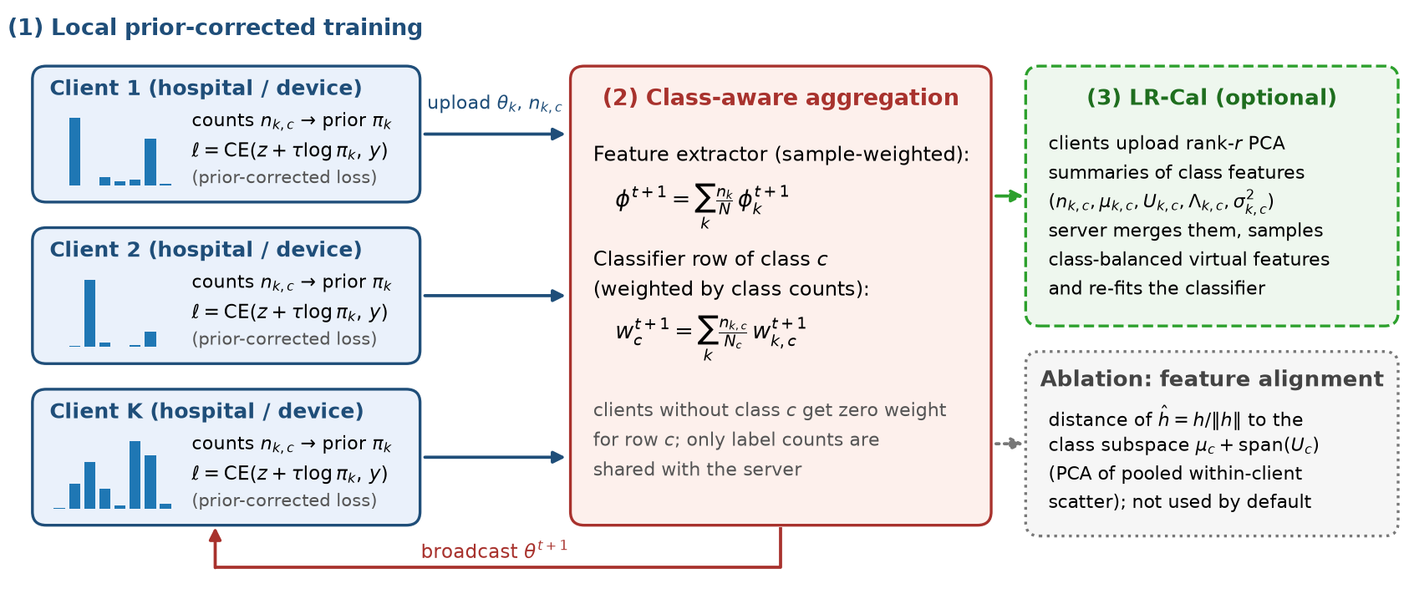
Fig. 1. Overview of FedCARE. (1) Clients train with the prior-corrected loss, which keeps the rows of locally absent classes inert. (2) The server averages the feature extractor with sample-size weights and every classifier row only over the clients that observed the corresponding class, weighted by their class counts. (3) Optional low-rank (PCA) classifier calibration (LR-Cal). The dotted box is the subspace-alignment variant evaluated as an ablation.

B. Prior-Corrected Local Objective
Client k minimizes the balanced-softmax cross-entropy [19], [20]
ℓ_{k}(x, y) = −log [ exp(z_{y} + τ log π̃_{k,y}) / Σ_{c} exp(z_{c} + τ log π̃_{k,c}) ], (1)
where z = Wh + b are the logits, τ = 1 and π̃_{k,c} = (n_{k,c} + 1)/(n_{k} + C) is the add-one-smoothed local prior. If the logits model log p(x|y) up to a constant, the corrected softmax equals the local posterior p_{k}(y|x), so the minimizer learns prior-free logits that transfer to any label distribution [19]. Two consequences matter for FL. For a class absent from client k, π̃_{k,c} ≈ 1/n_{k} lowers its logit by ≈ log n_{k}, its softmax probability is ≈ 0 and the gradient with respect to w_{c}, p_{c}(x)·h, nearly vanishes: the client neither learns nor suppresses that class. For classes that are present but rare, the correction removes the local majority bias. With τ = 1 the correction is Bayes-consistent, so FedCARE has no hyper-parameter to tune.
C. Class-Aware Aggregation of the Classifier
The feature extractor is averaged as in FedAvg, φ^{t+1} = Σ_{k} (n_{k}/N) φ_{k}^{t+1}. Each classifier row is averaged only over the clients that observed the class:
w_{c}^{t+1} = Σ_{k} (n_{k,c}/N_{c}) w_{k,c}^{t+1}, b_{c}^{t+1} = Σ_{k} (n_{k,c}/N_{c}) b_{k,c}^{t+1}. (2)
If no participating client holds class c in a round, the row falls back to sample-size weights. Proposition 1 (row dilution). Let Δ_{k,c} = w_{k,c}^{t+1} − w_{c}^{t} and let 𝒮_{c} be the clients with n_{k,c} > 0. If Δ_{k,c} = 0 for k ∉ 𝒮_{c} (the inert rows produced by the prior correction, up to weight decay), the FedAvg update of row c is Δ_{c}^{avg} = ρ_{c} Δ̄_{c}, where ρ_{c} = Σ_{k∈𝒮_{c}} n_{k}/N ≤ 1 and Δ̄_{c} is a convex combination of the informative updates Δ_{k,c}, k ∈ 𝒮_{c}. The class-aware update (2) is Δ_{c}^{CA} = Σ_{k∈𝒮_{c}} (n_{k,c}/N_{c}) Δ_{k,c}, i.e., it is not scaled by ρ_{c} and weights every client by its amount of class-c evidence. Proof: substitute Δ_{k,c} = 0 for k ∉ 𝒮_{c} into Σ_{k} (n_{k}/N) Δ_{k,c} and factor out ρ_{c}. ∎
FedAvg therefore applies a smaller effective server step to the row of every class held by few clients. Without the prior correction the rows of absent classes are not inert but are actively pushed away from the local features, which is the classical source of classifier bias [8]; with the correction alone, the informative updates are still diluted by ρ_{c}. The two components therefore address different failure modes, which the ablation in Section VI confirms. Class-aware aggregation needs only Σ_{k} n_{k,c} w_{k,c} and Σ_{k} n_{k,c}, both sums over clients, so it is compatible with secure aggregation [30].
D. Algorithm and Cost
Algorithm 1 lists one FedCARE round. Compared with FedAvg, local computation is unchanged (one vector addition to the logits), the upload grows by C integers, and the server performs a weighted average per classifier row, which is negligible. No extra model copies (MOON), control variates (SCAFFOLD) or covariance matrices (CCVR) are needed, which suits clients with limited memory and bandwidth such as IoMT gateways.
Algorithm 1 FedCARE (one communication round t)
Input: global model θ^{t} = (φ^{t}, W^{t}, b^{t}); clients k = 1, …, K
1: server broadcasts θ^{t} to all participating clients
2: for each client k in parallel do
3: π̃_{k,c} ← (n_{k,c} + 1)/(n_{k} + C) for c = 1, …, C
4: θ_{k} ← θ^{t}; run E local epochs of SGD on loss (1)
5: upload θ_{k}, n_{k} and the label counts n_{k,c}
6: end for
7: φ^{t+1} ← Σ_{k} (n_{k}/N) φ_{k} ⊳ incl. BN statistics
8: for c = 1, …, C do w_{c}^{t+1}, b_{c}^{t+1} ← Eq. (2)
9: return θ^{t+1}; optionally LR-Cal after the last round

E. LR-Cal: Classifier Calibration from Low-Rank Feature Statistics
CCVR [10] re-fits the classifier on virtual features sampled from class-conditional Gaussians whose means and covariances are aggregated from clients. LR-Cal keeps this procedure but replaces the covariance upload by a probabilistic-PCA summary [27]. After training, client k computes the features of at most 64 images per class with the final global model and, for each class it holds, uploads the count n_{k,c}, the mean μ_{k,c} and the top-r eigenpairs (U_{k,c}, Λ_{k,c}) of the class covariance S_{k,c} together with the mean residual eigenvalue σ²_{k,c}. The server reconstructs
Ŝ_{k,c} = U_{k,c} Λ_{k,c} U_{k,c}⊤ + σ²_{k,c} (I − U_{k,c} U_{k,c}⊤), (3)
and merges the summaries with the law of total covariance,
Σ_{c} = Σ_{k} (n_{k,c}/N_{c}) [ Ŝ_{k,c} + (μ_{k,c} − μ_{c})(μ_{k,c} − μ_{c})⊤ ], (4)
where μ_{c} = Σ_{k} (n_{k,c}/N_{c}) μ_{k,c}. The merge is exact when r = d (verified by the unit tests of the released code); for r < d it preserves the trace and the leading spectrum of every client covariance. The server then samples 128 virtual features per class from 𝒩(μ_{c}, Σ_{c}) and fine-tunes the classifier for 100 SGD steps with a class-balanced cross-entropy. The per-class upload is rd + d + r + 2 values (326 for d = 64, r = 4) instead of d(d+1)/2 + d + 1 (2145).
F. Ablation: Alignment with PCA Class Subspaces
Subspace-based aggregation was the starting point of this work, so we also test whether aligning features across sites helps on top of FedCARE. Clients summarize ℓ₂-normalized features ĥ = h/‖h‖ with the received global model; the server merges them and keeps, per class, the mean μ_{c} and the top-r eigenvectors U_{c} of the pooled within-client scatter, which deliberately excludes the between-site spread of the class means. Clients then add β·R to (1), with
R(h, y) = ‖(I − U_{y}U_{y}⊤)(ĥ − μ_{y})‖² + γ‖U_{y}U_{y}⊤(ĥ − μ_{y})‖², (5)
which penalizes site-specific deviations outside the shared class subspace fully and deviations along it by γ = 0.1 (β = 0.5, r = 4; r = 0 reduces to prototype alignment). A first version that scaled the penalty by the estimated class variances (a probabilistic-PCA Mahalanobis distance) diverged, because the variances of early-round features are tiny and change quickly; the bounded form (5), which never exceeds 4 for γ ≤ 1, trains stably.
V. Experimental Setup
A. Datasets
We use the official 28×28 releases and splits of two MedMNIST v2 datasets [31]; every file is verified against its published MD5 checksum before use. BloodMNIST contains 17,092 microscopy images of eight peripheral-blood cell types acquired at the Hospital Clinic of Barcelona [32]. DermaMNIST contains 10,015 dermatoscopic images of seven pigmented-lesion classes from the multi-source HAM10000 collection [33], [34]; it is naturally long-tailed, with melanocytic nevi forming 67% of the training images and dermatofibroma 1.1%.
B. Federated Settings
Each setting has K = 10 clients with full participation. From the official training split we draw a class-stratified subsample of 4,000 images and partition it with the Dirichlet label-skew protocol [18], [35]: for every class, client proportions are drawn from Dir(α), and partitions are re-drawn until every client holds at least ten images. Blood-shift uses α = 0.1 (severe skew) and adds a static, per-site acquisition shift: each client's images are transformed once by a site-specific stain-intensity jitter in optical-density space (per-channel scale in [0.65, 1.35] and offset in [−0.4, 0.4]; the same model as the HED jitter of Tellez et al. [36] without restricting it to H&E stain vectors [37]), brightness and contrast changes of up to ±10% and ±15%, Gaussian blur (σ ≤ 0.9 px) and sensor noise (σ ≤ 0.03). Derma uses α = 0.3 on top of the natural long tail. Fig. 2 shows the resulting client label distributions for seed 0, and Fig. 3 shows how the same blood cells look at five simulated sites. Validation uses the official validation split (1,000 images for BloodMNIST, all 1,003 for DermaMNIST), and all final results are computed on the complete official test splits (3,421 and 2,005 images), which are not shifted and therefore act as a reference site.
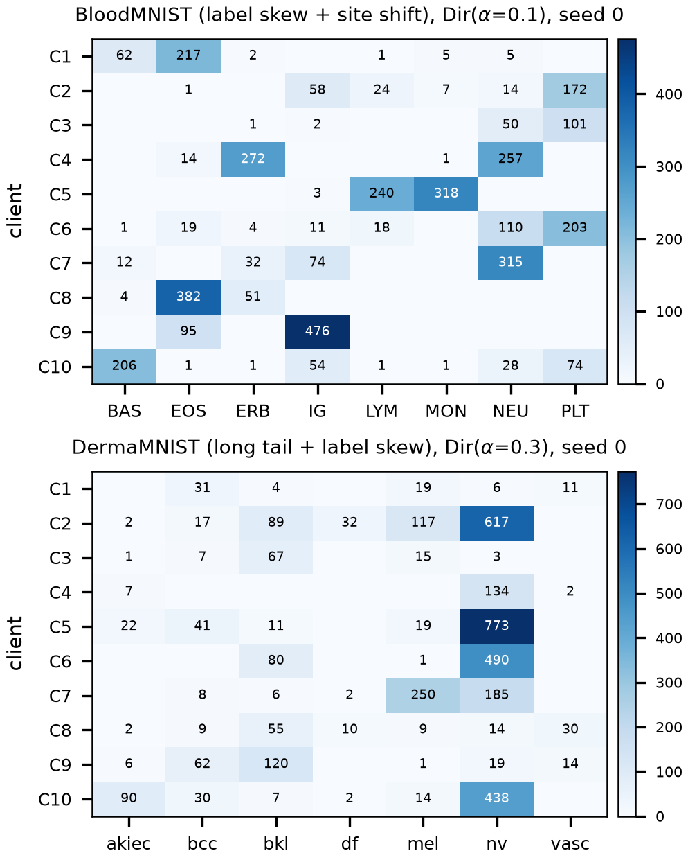
Fig. 2. Client-by-class sample counts for seed 0 (cells without a number are empty). In BloodMNIST (α = 0.1) most clients hold two to four of the eight cell types; in DermaMNIST (α = 0.3) the natural dominance of nevi (nv) is compounded by label skew, and several clients hold no dermatofibroma (df) or vascular lesion (vasc) images.
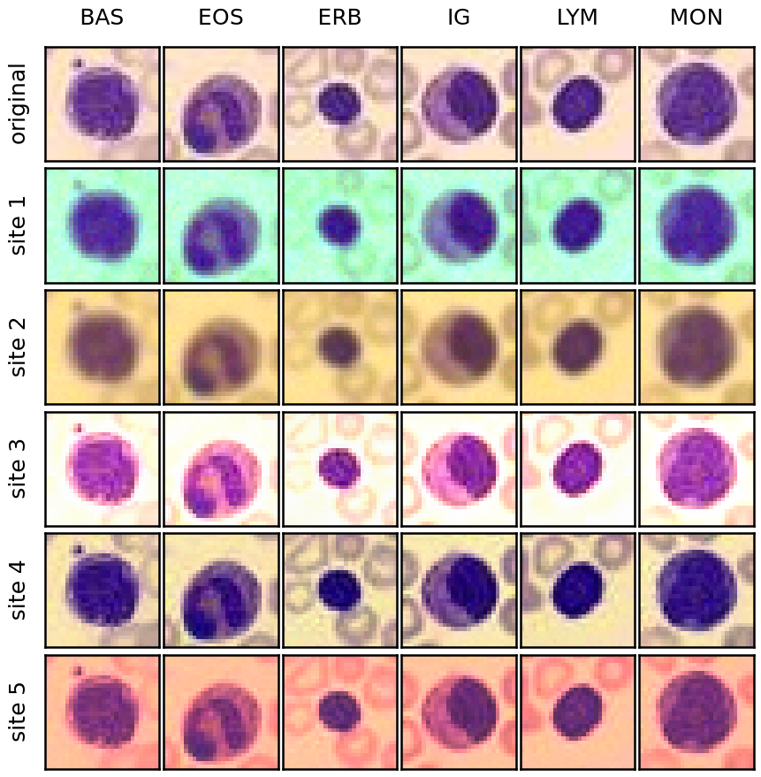
Fig. 3. Simulated acquisition shift in the Blood-shift setting: the same six test cells (top row) rendered with the stain-intensity, exposure, blur and noise parameters of sites 1–5 (seed 0). Each client's training images are transformed once with its own site parameters; the test set is left unshifted.
C. Model and Training Protocol
All methods share the same compact CNN (three 3×3 convolution blocks with batch normalization and ReLU, 16/32/64 channels, global average pooling to a d = 64 feature vector and a linear classifier; 24,440 parameters including normalization statistics), the same initialization for a given seed and the same local optimizer (SGD, learning rate 0.05, momentum 0.9, weight decay 0.0005, batch size 32, 1 local epoch per round, 25 rounds). Flips and 90° rotations are used as augmentation. The small model reflects the memory budget of edge clients and keeps the 66 federated runs of this study tractable on a single CPU core; Table II lists the configuration.
TABLE II
Experimental Configuration
Item | Value
Clients / participation | 10 / all clients every round
Partition | Dirichlet α = 0.1 (Blood-shift), α = 0.3 (Derma)
Training images (per seed) | 4,000 (class-stratified subsample)
Rounds × local epochs | 25 × 1
Optimizer | SGD, lr 0.05, momentum 0.9, wd 0.0005, batch 32
Model | compact CNN, 24,440 parameters, d = 64
Seeds | 0, 1, 2 (re-draw subsample, partition, site shift, init.)
Evaluation | final round, full official test split
Hardware | 1 CPU core (Intel Xeon), PyTorch 2

D. Baselines and Hyper-Parameters
We compare with FedAvg [1], FedProx (μ = 0.01) [11], SCAFFOLD [12], FedNova [13], MOON (μ = 1, temperature 0.5, applied to the penultimate features) [14], FedRS (α = 0.5) [8], FedLC (τ = 1) [9] and post-hoc CCVR [10] applied to the final FedAvg model; hyper-parameters are the defaults recommended by the original papers. Because all methods use momentum SGD, the SCAFFOLD control variates and the FedNova normalizer both use the effective number of local steps of heavy-ball SGD, [τ − ρ(1 − ρ^{τ})/(1 − ρ)]/(1 − ρ) [13]; with the plain-SGD rule SCAFFOLD diverged in our pilot runs. FedCARE uses τ = 1 and has no tuned parameter; LR-Cal uses r = 4, the same virtual-sample budget and the same optimizer as CCVR.
E. Metrics and Statistical Protocol
We report accuracy, balanced accuracy, macro-F1, macro-AUC (one-vs-rest), worst-class recall and per-class precision, recall and F1 of the final global model on the full test split; no checkpoint is selected on test data. Every configuration is run with seeds 0, 1 and 2, and each seed re-draws the training subsample, the Dirichlet partition, the site parameters and the initialization, giving three independent federations per setting. We report mean ± standard deviation and compare FedCARE with every baseline using the two-sided exact Wilcoxon signed-rank test [38], [39] and a paired t-test over the six (setting, seed) pairs; with six pairs the smallest attainable Wilcoxon p-value is 0.031. Design decisions made during development (for example, removing subspace alignment from the default configuration) used only the validation split of seed 0 of Blood-shift.
F. Implementation and Reproducibility
The framework is implemented in PyTorch and released with configuration files for every run, the raw per-run result files, scripts that regenerate all tables and figures, and a unit-test suite (exact statistic merging, aggregation rules, partitioning and an end-to-end run of every method) at https://github.com/alirezafathi84/FedCARE. A full run of one method takes 30 to 50 s on one CPU core.
VI. Results and Analysis
A. Overall Comparison
Table III reports all metrics. On BloodMNIST, FedCARE obtains the highest mean macro-F1 (0.443 ± 0.247), 15.1 points above FedAvg (0.291) and 0.9 points above the strongest baseline, SCAFFOLD (0.433). Its balanced accuracy is 0.498 versus 0.383 for FedAvg, and its worst-class recall is 0.119 versus 0.000. On DermaMNIST, FedCARE ranks 3 in mean macro-F1 (0.319 ± 0.029), 15.5 points above FedAvg (0.164) and 1.9 points below the strongest baseline, FedAvg+LR-Cal (0.338). Its balanced accuracy is 0.399 versus 0.173 for FedAvg, and its worst-class recall is 0.023 versus 0.000.
The two groups of baselines behave differently. Relative to FedAvg, the drift-correcting methods (FedProx, SCAFFOLD, FedNova, MOON) change macro-F1 by +0.9 points on average and the label-skew methods FedRS and FedLC by +6.4 points, which indicates that classifier bias rather than optimization drift is the main failure mode in these settings. On Blood-shift the standard deviations are large for every method, FedCARE included: the macro-F1 of FedCARE on the three federations is 0.650, 0.507, 0.170, and seed 2 is the hardest federation for 8 of the 10 methods, so under α = 0.1 combined with site shift the particular partition matters as much as the method. The paired analysis in Section VI-B accounts for this by comparing methods on the same federation. Post-hoc calibration changes the macro-F1 of FedAvg from 0.291 to 0.316 on BloodMNIST and from 0.164 to 0.338 on DermaMNIST (CCVR); FedCARE exceeds it on BloodMNIST by 12.6 points without an extra calibration round, whereas on DermaMNIST it is 1.9 points better than FedCARE. Plain accuracy is less informative under class imbalance (BloodMNIST: 0.507 vs. 0.487 for SCAFFOLD; DermaMNIST: 0.548 vs. 0.693 for FedLC): a classifier that favors the majority class attains high accuracy on DermaMNIST while missing the rare lesion types (FedAvg assigns 96.2% of all DermaMNIST test images to nevi), which is why we focus on class-balanced metrics.

TABLE III
Test Performance of the Final Global Model (Mean ± S.D. over Three Seeds)
 | Blood-shift (α = 0.1, simulated site shift) |  |  |  |  | Derma (α = 0.3, natural long tail)
Method | Acc. | Bal. acc. | Macro-F1 | Macro-AUC | Worst rec. | Acc. | Bal. acc. | Macro-F1 | Macro-AUC | Worst rec.
FedAvg | 0.421±0.041 | 0.383±0.026 | 0.291±0.013 | 0.841±0.023 | 0.000±0.000 | 0.684±0.007 | 0.173±0.015 | 0.164±0.024 | 0.849±0.009 | 0.000±0.000
FedProx | 0.451±0.164 | 0.395±0.140 | 0.321±0.164 | 0.901±0.026 | 0.000±0.000 | 0.685±0.004 | 0.172±0.016 | 0.164±0.027 | 0.848±0.008 | 0.000±0.000
SCAFFOLD | 0.487±0.246 | 0.503±0.199 | 0.433±0.237 | 0.915±0.063 | 0.010±0.009 | 0.642±0.025 | 0.171±0.031 | 0.144±0.022 | 0.756±0.028 | 0.000±0.000
FedNova | 0.373±0.125 | 0.347±0.089 | 0.241±0.104 | 0.895±0.029 | 0.000±0.000 | 0.670±0.003 | 0.174±0.055 | 0.147±0.057 | 0.807±0.028 | 0.000±0.000
MOON | 0.418±0.112 | 0.350±0.090 | 0.289±0.091 | 0.878±0.044 | 0.000±0.000 | 0.682±0.007 | 0.170±0.016 | 0.157±0.024 | 0.843±0.013 | 0.000±0.000
FedRS | 0.476±0.161 | 0.462±0.141 | 0.395±0.195 | 0.913±0.031 | 0.041±0.037 | 0.687±0.002 | 0.181±0.011 | 0.178±0.021 | 0.850±0.008 | 0.000±0.000
FedLC | 0.463±0.224 | 0.439±0.232 | 0.387±0.257 | 0.888±0.094 | 0.036±0.061 | 0.693±0.006 | 0.206±0.036 | 0.209±0.047 | 0.848±0.010 | 0.000±0.000
FedAvg+CCVR | 0.389±0.128 | 0.397±0.078 | 0.316±0.089 | 0.859±0.057 | 0.003±0.005 | 0.519±0.003 | 0.431±0.022 | 0.338±0.012 | 0.823±0.007 | 0.173±0.043
FedAvg+LR-Cal | 0.392±0.126 | 0.397±0.072 | 0.318±0.084 | 0.859±0.056 | 0.003±0.005 | 0.518±0.010 | 0.435±0.020 | 0.338±0.012 | 0.825±0.005 | 0.188±0.025
FedCARE (ours) | 0.507±0.228 | 0.498±0.210 | 0.443±0.247 | 0.901±0.055 | 0.119±0.109 | 0.548±0.071 | 0.399±0.001 | 0.319±0.029 | 0.822±0.019 | 0.023±0.040
Bold: best mean in each column. FedAvg+CCVR and FedAvg+LR-Cal re-calibrate the classifier of the final FedAvg model with full-covariance and rank-4 class statistics, respectively. All metrics are computed on the complete official test splits.

B. Statistical Significance
Table IV pairs FedCARE with each baseline on the same federation (setting and seed), giving six paired observations per comparison. FedCARE wins all six pairs against 3 of the 9 baseline configurations and the two-sided Wilcoxon test rejects equality at the 0.05 level for 3 of them (0.031 is the smallest attainable p-value with six pairs). The smallest average advantage is 5.3 macro-F1 points, against FedAvg+LR-Cal. With only six pairs the tests have limited power, so the effect sizes and standard deviations in Table III should be read together with the p-values.
TABLE IV
Paired Comparison of FedCARE with Each Baseline
Baseline | Δ Macro-F1 | Wins | p_{W} | p_{t} | Δ Bal. acc. | p_{W}
FedAvg | +0.153 | 5/6 | 0.094 | 0.067 | +0.171 | 0.063
FedProx | +0.138 | 6/6 | 0.031 | 0.027 | +0.165 | 0.031
SCAFFOLD | +0.092 | 5/6 | 0.094 | 0.087 | +0.112 | 0.219
FedNova | +0.187 | 6/6 | 0.031 | 0.009 | +0.188 | 0.063
MOON | +0.158 | 5/6 | 0.063 | 0.039 | +0.189 | 0.063
FedRS | +0.094 | 4/6 | 0.156 | 0.038 | +0.128 | 0.156
FedLC | +0.083 | 6/6 | 0.031 | 0.019 | +0.126 | 0.031
FedAvg+CCVR | +0.054 | 3/6 | 0.844 | 0.360 | +0.035 | 1.000
FedAvg+LR-Cal | +0.053 | 3/6 | 0.844 | 0.375 | +0.033 | 1.000
Δ: mean difference (FedCARE − baseline) over six (setting, seed) pairs; p_{W}: two-sided exact Wilcoxon signed-rank test; p_{t}: paired t-test.
C. Convergence Behaviour
Fig. 4 plots the test macro-F1 of the global model every five rounds (mean over seeds with ±1 s.d. bands; intermediate points use a fixed 2,000-image test subsample, the final point the full test split). The x-axis is the communication round and the y-axis the macro-F1. The FedCARE curve is the highest at 4 of 5 evaluation points on Blood-shift and 5 of 5 on Derma. The mean absolute change of the macro-F1 between consecutive evaluations, a measure of round-to-round instability, is 0.063 for FedAvg and 0.082 for FedCARE on Blood-shift and 0.012 and 0.015 on Derma; under severe skew every FedAvg aggregation re-mixes classifier rows that were pushed in conflicting directions by different clients. Already at round 5, FedCARE is 12.8 and 17.2 points above FedAvg on the two settings, which indicates that the classifier, rather than the feature extractor, limits early progress.

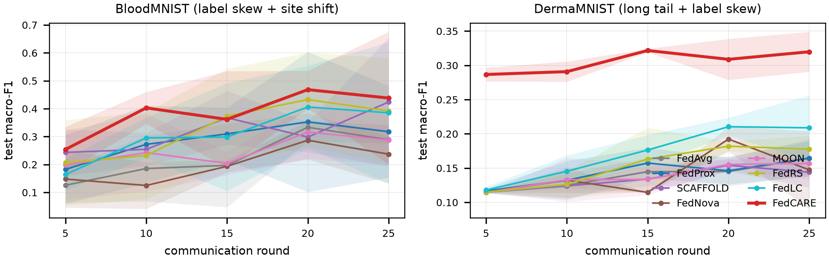
Fig. 4. Test macro-F1 of the global model versus communication round (mean ± 1 s.d. over three seeds). Left: Blood-shift (α = 0.1 with simulated site shift). Right: Derma (α = 0.3, naturally long-tailed). Intermediate points use a fixed 2,000-image test subsample; the last point uses the full test split.

D. Minority Classes and Per-Class Behaviour
Fig. 5 shows the per-class F1 of FedAvg, the two label-skew baselines and FedCARE, averaged over seeds; the complete precision, recall and F1 values of every class are listed in Appendix A. With FedAvg, 1 BloodMNIST and 5 DermaMNIST classes have a mean F1 below 0.1; with FedCARE the numbers are 0 and 2. The weakest FedAvg class on BloodMNIST, MON, improves from 0.000 to 0.415. On DermaMNIST the three rarest classes change as follows: df 0.000 → 0.080, vasc 0.000 → 0.024, akiec 0.074 → 0.308. Fig. 6 shows the row-normalized confusion matrices summed over the three seeds. The mean of the diagonal (the balanced accuracy) rises from 0.383 to 0.498 on BloodMNIST and from 0.173 to 0.399 on DermaMNIST. The largest remaining confusion of FedCARE on BloodMNIST is LYM predicted as BAS (47.1% of the LYM images); The largest remaining confusion of FedCARE on DermaMNIST is vasc predicted as bcc (29.9% of the vasc images).
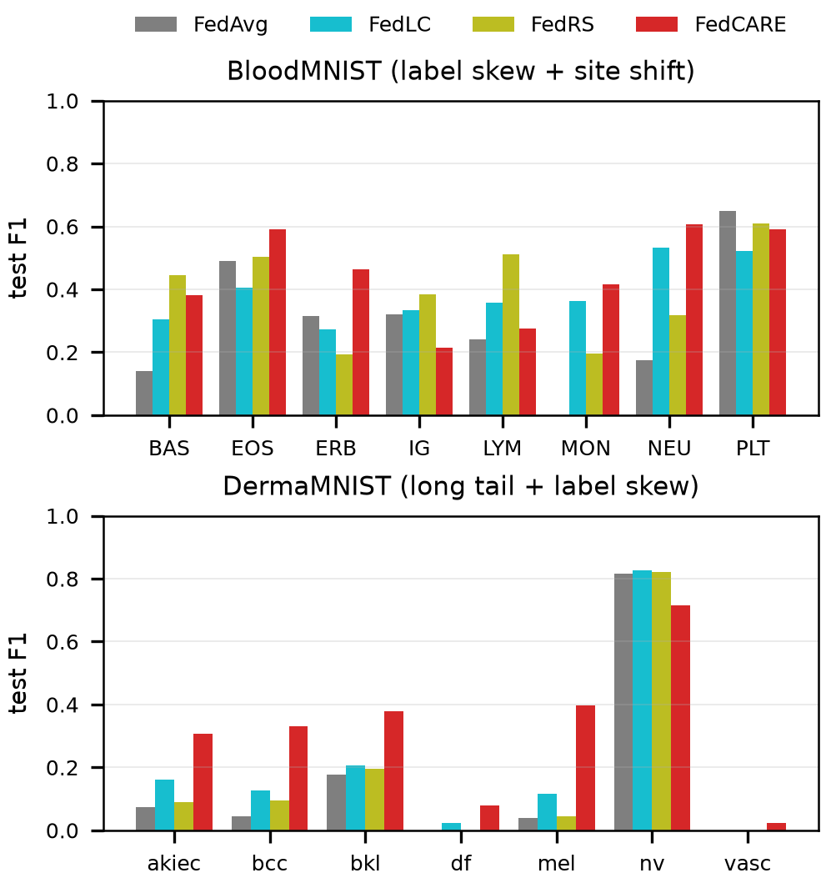
Fig. 5. Per-class test F1 (mean over three seeds) of FedAvg, FedLC, FedRS and FedCARE. Top: BloodMNIST cell types. Bottom: DermaMNIST lesion types; df, vasc and akiec are the rarest classes.

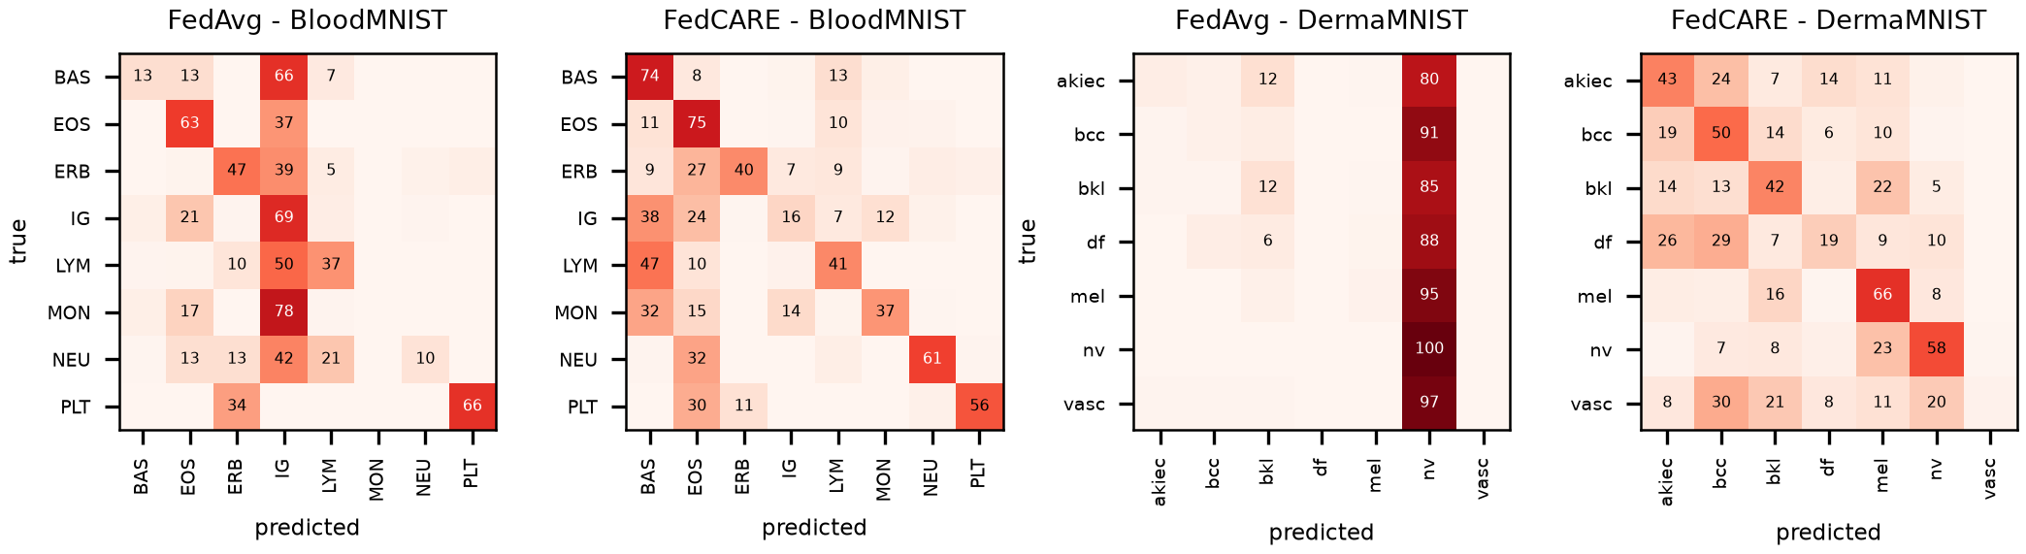
Fig. 6. Row-normalized confusion matrices (in %, summed over three seeds; values below 5% omitted) of FedAvg and FedCARE on BloodMNIST (left pair) and DermaMNIST (right pair). Rows are true classes and columns predicted classes.

E. Ablation Study
Table V and Fig. 7 isolate the components. Removing class-aware aggregation (prior correction only) lowers macro-F1 by 1.7 and 0.2 points on Blood-shift and Derma, and removing the prior correction (class-aware aggregation only) by 22.8 and 11.6 points. Both components therefore contribute in both settings, but the prior correction accounts for most of the gain; the class-aware rule adds a smaller improvement, consistent with Proposition 1 in direction but modest in size here, because once the prior correction has made absent-class rows inert, dilution only slows the rows of classes held by few clients rather than biasing them. Adding PCA subspace alignment changes macro-F1 by -5.9 and -1.3 points, and prototype alignment (rank 0) by -2.7 and -0.7 points. Post-hoc LR-Cal on top of FedCARE changes macro-F1 by -10.7 and 1.9 points. It helps on DermaMNIST but not on BloodMNIST: when the global label distribution is itself long-tailed, re-fitting the classifier on class-balanced virtual features adds a correction that local prior correction alone does not provide, whereas for a classifier that is already balanced the Gaussian approximation of the features costs accuracy.
TABLE V
Ablation of FedCARE (Test Macro-F1 and Worst-Class Recall)
 | Macro-F1 |  | Worst-class recall
Variant | Blood | Derma | Blood | Derma
FedCARE (full) | 0.443±0.247 | 0.319±0.029 | 0.119±0.109 | 0.023±0.040
w/o class-aware head | 0.426±0.208 | 0.317±0.036 | 0.135±0.184 | 0.000±0.000
w/o prior correction | 0.215±0.212 | 0.204±0.032 | 0.000±0.000 | 0.000±0.000
+ subspace alignment | 0.384±0.171 | 0.307±0.017 | 0.032±0.041 | 0.023±0.040
+ prototype alignment | 0.415±0.205 | 0.313±0.003 | 0.021±0.033 | 0.069±0.119
FedCARE + LR-Cal | 0.336±0.131 | 0.339±0.010 | 0.003±0.006 | 0.228±0.029
w/o class-aware head: prior-corrected loss with sample-weighted aggregation; w/o prior correction: class-aware aggregation with plain cross-entropy; + alignment: subspace (rank 4) or prototype (rank 0) penalty (5) with β = 0.5.
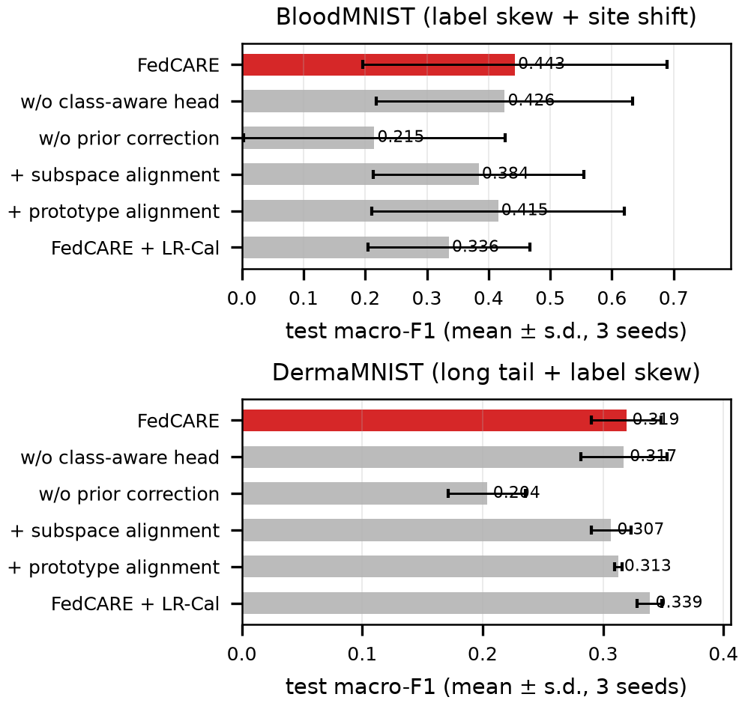
Fig. 7. Ablation of FedCARE: test macro-F1 (mean ± s.d. over three seeds). The full method is shown in red.
F. Low-Rank Calibration and Communication Cost
Table VI compares calibration and communication. Every method uploads the 24,440 model values per client and round. LR-Cal and CCVR give practically the same classifier for FedAvg (macro-F1 0.318 vs. 0.316 and 0.338 vs. 0.338), while the one-time statistics upload per client drops from about 10,082/10,940 to 1,532/1,663 values (Blood-shift/Derma, 6.6× fewer). The gain of LR-Cal grows quadratically with the feature dimension: for a ResNet-18 with d = 512 the per-class upload would fall from 131,841 to 2,566 values. FedCARE itself needs only C label counts per round (8 or 7 integers), whereas SCAFFOLD doubles the upload with its control variates. Mean wall-clock training time on one CPU core was 1.004× that of FedAvg for FedCARE and 1.631× for MOON, which runs two additional forward passes per batch.
TABLE VI
Calibration Quality and Upload Cost per Client
Method | Blood F1 | Derma F1 | Stats. (once) | Extra / round
FedAvg | 0.291±0.013 | 0.164±0.024 | — | 0
FedAvg + CCVR | 0.316±0.089 | 0.338±0.012 | 10,082 | 0
FedAvg + LR-Cal | 0.318±0.084 | 0.338±0.012 | 1,532 | 0
SCAFFOLD | 0.433±0.237 | 0.144±0.022 | — | 24,440
FedCARE | 0.443±0.247 | 0.319±0.029 | — | C = 8
Values are counts of transmitted numbers per client (statistics column: Blood-shift, average number of classes per client × per-class summary size; 2145 values per class for CCVR, 326 for LR-Cal with r = 4). Model upload: 24,440 values per round for every method.
VII. Discussion and Limitations
Why class-aware aggregation helps. Proposition 1 quantifies the dilution of FedAvg. For the seed-0 partitions, the share of training data held by the clients that observe a class, ρ_{c}, averages 0.549 and is as low as 0.290 on Blood-shift (0.732 and 0.141 on Derma, where the natural long tail places the rare classes on few clients). Under FedAvg the informative update of such a class is therefore shrunk to 29.0% of its size in every round, which is consistent with the slow and oscillating learning of minority classes in Figs. 4 and 5. Because the correction acts on the classifier rows only, it is complementary to drift-correcting optimizers and could be combined with them.
Why subspace alignment did not help. Aligning features with PCA class subspaces was the natural continuation of subspace-guided aggregation, but it did not improve on FedCARE. Three observations explain this. First, the targets are estimated from a representation that is still changing quickly, so pulling features towards last round's class subspace partly fights the learning of the representation; the variance-normalized form of the penalty even diverged for this reason. Second, in these settings the dominant error is classifier bias, which FedCARE already removes, as the small gains of the drift- and representation-oriented baselines also indicate. Third, the simulated site shift changes colour, contrast and sharpness, to which the batch-normalized CNN is partly invariant. Feature alignment may still matter for stronger, real scanner shifts, which we leave to future work.
When post-hoc calibration is preferable. On DermaMNIST, re-fitting the FedAvg classifier on class-balanced virtual features (CCVR or LR-Cal) reached a macro-F1 of 0.338 and a worst-class recall of 0.188, compared with 0.319 and 0.023 for FedCARE. FedCARE corrects each client's classifier for the local label prior and then aggregates class-wise, but the global label distribution of DermaMNIST is itself long-tailed (nevi form two thirds of the data), and the class-aware rows inherit this imbalance through the shared features. Post-hoc calibration targets exactly this global imbalance at the cost of an extra statistics round, so the two approaches are complementary: FedCARE removes the client-level bias during training, and LR-Cal can remove a remaining global imbalance cheaply. Indeed, applying LR-Cal to the final FedCARE model on DermaMNIST gives a macro-F1 of 0.339 and a worst-class recall of 0.228, the best values of all configurations on this dataset; on Blood-shift, where the global label distribution is nearly balanced, the same calibration lowers the macro-F1 of FedCARE (0.336 vs. 0.443), so it should be applied only when the global distribution is known to be long-tailed.
Limitations. The conclusions are bounded by the experimental scale. (i) A compact CNN on 28×28 images, 4,000 training images per federation and 25 rounds were used so that 66 federated runs fit on a single CPU core; larger backbones, higher resolutions and longer training may change the size of the gaps. (ii) BloodMNIST and DermaMNIST provide real class imbalance, but the acquisition shift of Blood-shift is simulated, and the official test splits are unshifted, so the experiments do not measure generalization to unseen hospitals. Validation on naturally multi-centre data, such as the external-centre test set of PathMNIST, Fed-ISIC2019 of FLamby [28] or Camelyon17-WILDS [29], is necessary before any clinical or IoMT deployment claim; the released configuration files include the PathMNIST and multi-domain settings for this purpose. (iii) Three seeds per setting give six paired observations, enough to detect consistent differences but not small ones, and the Blood-shift results vary strongly across partitions; more seeds and partitions would narrow the confidence intervals. (iv) All clients participated in every round; partial participation, client dropout and asynchronous IoMT clients were not studied. (v) FedCARE shares per-client label counts, which reveal the local label distribution; secure aggregation [30] of the sums required by (2) or differentially private counts [40] can mitigate this, and model updates themselves remain exposed to gradient-inversion attacks [41].
VIII. Conclusion
We identified a simple but consequential weakness of federated averaging under label skew, namely that the classifier row of every class is diluted by the share of data held by clients that never observed it, and proposed FedCARE, which combines a prior-corrected local loss with class-aware aggregation of the classifier. FedCARE requires no tuning and only label counts as extra communication. It obtained the highest mean macro-F1 among the training-time methods in both settings and won 37 of 42 paired comparisons with them, with clear gains in balanced accuracy over FedAvg. Results under the most severe skew varied strongly across partitions, and on the naturally long-tailed DermaMNIST post-hoc calibration of FedAvg was at least as accurate, which suggests combining both. LR-Cal reduces the upload of feature-statistics calibration by a factor of 6.6 without loss of accuracy, and aligning features with PCA class subspaces did not add accuracy. Future work will evaluate FedCARE on real multi-centre data, with partial participation and larger backbones, and will combine it with privacy-preserving aggregation of the label counts.

Appendix A
Per-Class Precision, Recall and F1
Tables VII and VIII list the per-class precision (P), recall (R) and F1 on the full test splits, averaged over the three seeds, for FedAvg, the strongest label-skew baseline FedLC, post-hoc CCVR and FedCARE; the last rows give the macro averages. The raw per-run values, including the confusion matrices of every run, are part of the released result files.
TABLE VII
Per-Class Results on BloodMNIST (Blood-shift Setting, Mean of Three Seeds)
 |  | FedAvg |  |  | FedLC |  |  | FedAvg+CCVR |  |  | FedCARE
Class | n | P | R | F1 | P | R | F1 | P | R | F1 | P | R | F1
BAS | 244 | 0.150 | 0.133 | 0.141 | 0.273 | 0.494 | 0.305 | 0.243 | 0.320 | 0.249 | 0.257 | 0.740 | 0.382
EOS | 624 | 0.422 | 0.629 | 0.490 | 0.501 | 0.657 | 0.405 | 0.549 | 0.339 | 0.394 | 0.632 | 0.747 | 0.592
ERB | 311 | 0.235 | 0.475 | 0.314 | 0.443 | 0.203 | 0.274 | 0.545 | 0.569 | 0.534 | 0.636 | 0.400 | 0.465
IG | 579 | 0.286 | 0.687 | 0.322 | 0.351 | 0.318 | 0.333 | 0.536 | 0.257 | 0.267 | 0.501 | 0.158 | 0.215
LYM | 243 | 0.281 | 0.374 | 0.242 | 0.453 | 0.369 | 0.359 | 0.107 | 0.652 | 0.183 | 0.506 | 0.406 | 0.274
MON | 284 | 0.000 | 0.000 | 0.000 | 0.506 | 0.353 | 0.364 | 0.123 | 0.008 | 0.015 | 0.508 | 0.366 | 0.415
NEU | 666 | 0.557 | 0.104 | 0.174 | 0.739 | 0.454 | 0.533 | 0.597 | 0.363 | 0.261 | 0.809 | 0.613 | 0.608
PLT | 470 | 0.640 | 0.658 | 0.649 | 0.443 | 0.667 | 0.522 | 0.594 | 0.664 | 0.627 | 0.646 | 0.557 | 0.592
Macro avg. | 3421 | 0.321 | 0.383 | 0.291 | 0.464 | 0.439 | 0.387 | 0.412 | 0.397 | 0.316 | 0.562 | 0.498 | 0.443

TABLE VIII
Per-Class Results on DermaMNIST (Derma Setting, Mean of Three Seeds)
 |  | FedAvg |  |  | FedLC |  |  | FedAvg+CCVR |  |  | FedCARE
Class | n | P | R | F1 | P | R | F1 | P | R | F1 | P | R | F1
akiec | 66 | 0.339 | 0.045 | 0.074 | 0.199 | 0.146 | 0.160 | 0.249 | 0.530 | 0.337 | 0.263 | 0.429 | 0.308
bcc | 103 | 0.107 | 0.029 | 0.046 | 0.277 | 0.087 | 0.126 | 0.277 | 0.479 | 0.347 | 0.249 | 0.498 | 0.330
bkl | 220 | 0.551 | 0.117 | 0.176 | 0.611 | 0.136 | 0.205 | 0.390 | 0.489 | 0.434 | 0.361 | 0.415 | 0.379
df | 23 | 0.000 | 0.000 | 0.000 | 0.056 | 0.015 | 0.023 | 0.060 | 0.174 | 0.089 | 0.061 | 0.188 | 0.080
mel | 223 | 0.355 | 0.021 | 0.038 | 0.418 | 0.070 | 0.117 | 0.325 | 0.573 | 0.414 | 0.288 | 0.664 | 0.398
nv | 1341 | 0.692 | 0.996 | 0.817 | 0.712 | 0.988 | 0.828 | 0.970 | 0.530 | 0.685 | 0.954 | 0.578 | 0.716
vasc | 29 | 0.000 | 0.000 | 0.000 | 0.000 | 0.000 | 0.000 | 0.033 | 0.241 | 0.058 | 0.026 | 0.023 | 0.024
Macro avg. | 2005 | 0.292 | 0.173 | 0.164 | 0.325 | 0.206 | 0.209 | 0.329 | 0.431 | 0.338 | 0.315 | 0.399 | 0.319

Acknowledgment
The authors used an AI assistant (Claude, Anthropic) for code development, experiment orchestration and language editing; all methods, results and statements were checked by the authors, who take full responsibility for the content.
References
[1] H. B. McMahan, E. Moore, D. Ramage, S. Hampson, and B. A. y Arcas, “Communication-efficient learning of deep networks from decentralized data,” in Proc. Int. Conf. Artif. Intell. Statist. (AISTATS), 2017, pp. 1273–1282.
[2] P. Kairouz et al., “Advances and open problems in federated learning,” Found. Trends Mach. Learn., vol. 14, no. 1–2, pp. 1–210, 2021.
[3] N. Rieke et al., “The future of digital health with federated learning,” npj Digit. Med., vol. 3, Art. no. 119, 2020.
[4] M. J. Sheller et al., “Federated learning in medicine: Facilitating multi-institutional collaborations without sharing patient data,” Sci. Rep., vol. 10, Art. no. 12598, 2020.
[5] G. A. Kaissis, M. R. Makowski, D. Rückert, and R. F. Braren, “Secure, privacy-preserving and federated machine learning in medical imaging,” Nat. Mach. Intell., vol. 2, no. 6, pp. 305–311, 2020.
[6] H. Guan, P.-T. Yap, A. Bozoki, and M. Liu, “Federated learning for medical image analysis: A survey,” Pattern Recognit., vol. 151, Art. no. 110424, 2024.
[7] D. C. Nguyen, M. Ding, P. N. Pathirana, A. Seneviratne, J. Li, and H. V. Poor, “Federated learning for Internet of Things: A comprehensive survey,” IEEE Commun. Surveys Tuts., vol. 23, no. 3, pp. 1622–1658, 2021.
[8] X.-C. Li and D.-C. Zhan, “FedRS: Federated learning with restricted softmax for label distribution non-IID data,” in Proc. ACM SIGKDD Conf. Knowl. Discov. Data Min., 2021, pp. 995–1005.
[9] J. Zhang, Z. Li, B. Li, J. Xu, S. Wu, S. Ding, and C. Wu, “Federated learning with label distribution skew via logits calibration,” in Proc. Int. Conf. Mach. Learn. (ICML), 2022.
[10] M. Luo, F. Chen, D. Hu, Y. Zhang, J. Liang, and J. Feng, “No fear of heterogeneity: Classifier calibration for federated learning with non-IID data,” in Proc. Adv. Neural Inf. Process. Syst. (NeurIPS), 2021.
[11] T. Li, A. K. Sahu, M. Zaheer, M. Sanjabi, A. Talwalkar, and V. Smith, “Federated optimization in heterogeneous networks,” in Proc. Mach. Learn. Syst. (MLSys), 2020.
[12] S. P. Karimireddy, S. Kale, M. Mohri, S. J. Reddi, S. U. Stich, and A. T. Suresh, “SCAFFOLD: Stochastic controlled averaging for federated learning,” in Proc. Int. Conf. Mach. Learn. (ICML), 2020.
[13] J. Wang, Q. Liu, H. Liang, G. Joshi, and H. V. Poor, “Tackling the objective inconsistency problem in heterogeneous federated optimization,” in Proc. Adv. Neural Inf. Process. Syst. (NeurIPS), 2020.
[14] Q. Li, B. He, and D. Song, “Model-contrastive federated learning,” in Proc. IEEE/CVF Conf. Comput. Vis. Pattern Recognit. (CVPR), 2021, pp. 10713–10722.
[15] Y. Tan, G. Long, L. Liu, T. Zhou, Q. Lu, J. Jiang, and C. Zhang, “FedProto: Federated prototype learning across heterogeneous clients,” in Proc. AAAI Conf. Artif. Intell., 2022.
[16] W. Huang, M. Ye, Z. Shi, H. Li, and B. Du, “Rethinking federated learning with domain shift: A prototype view,” in Proc. IEEE/CVF Conf. Comput. Vis. Pattern Recognit. (CVPR), 2023.
[17] K. Hsieh, A. Phanishayee, O. Mutlu, and P. B. Gibbons, “The non-IID data quagmire of decentralized machine learning,” in Proc. Int. Conf. Mach. Learn. (ICML), 2020.
[18] Q. Li, Y. Diao, Q. Chen, and B. He, “Federated learning on non-IID data silos: An experimental study,” in Proc. IEEE Int. Conf. Data Eng. (ICDE), 2022.
[19] A. K. Menon, S. Jayasumana, A. S. Rawat, H. Jain, A. Veit, and S. Kumar, “Long-tail learning via logit adjustment,” in Proc. Int. Conf. Learn. Represent. (ICLR), 2021.
[20] J. Ren, C. Yu, S. Sheng, X. Ma, H. Zhao, S. Yi, and H. Li, “Balanced meta-softmax for long-tailed visual recognition,” in Proc. Adv. Neural Inf. Process. Syst. (NeurIPS), 2020.
[21] J. Oh, S. Kim, and S.-Y. Yun, “FedBABU: Toward enhanced representation for federated image classification,” in Proc. Int. Conf. Learn. Represent. (ICLR), 2022.
[22] X. Shang, Y. Lu, G. Huang, and H. Wang, “Federated learning on heterogeneous and long-tailed data via classifier re-training with federated features,” in Proc. Int. Joint Conf. Artif. Intell. (IJCAI), 2022.
[23] X. Li, M. Jiang, X. Zhang, M. Kamp, and Q. Dou, “FedBN: Federated learning on non-IID features via local batch normalization,” in Proc. Int. Conf. Learn. Represent. (ICLR), 2021.
[24] Q. Liu, C. Chen, J. Qin, Q. Dou, and P.-A. Heng, “FedDG: Federated domain generalization on medical image segmentation via episodic learning in continuous frequency space,” in Proc. IEEE/CVF Conf. Comput. Vis. Pattern Recognit. (CVPR), 2021, pp. 1013–1023.
[25] Y. Wen, K. Zhang, Z. Li, and Y. Qiao, “A discriminative feature learning approach for deep face recognition,” in Proc. Eur. Conf. Comput. Vis. (ECCV), 2016, pp. 499–515.
[26] A. Grammenos, R. Mendoza-Smith, J. Crowcroft, and C. Mascolo, “Federated principal component analysis,” in Proc. Adv. Neural Inf. Process. Syst. (NeurIPS), 2020.
[27] M. E. Tipping and C. M. Bishop, “Probabilistic principal component analysis,” J. Roy. Statist. Soc. B, vol. 61, no. 3, pp. 611–622, 1999.
[28] J. Ogier du Terrail et al., “FLamby: Datasets and benchmarks for cross-silo federated learning in realistic healthcare settings,” in Proc. Adv. Neural Inf. Process. Syst. (NeurIPS) Datasets Benchmarks Track, 2022.
[29] P. W. Koh et al., “WILDS: A benchmark of in-the-wild distribution shifts,” in Proc. Int. Conf. Mach. Learn. (ICML), 2021.
[30] K. Bonawitz et al., “Practical secure aggregation for privacy-preserving machine learning,” in Proc. ACM SIGSAC Conf. Comput. Commun. Secur. (CCS), 2017, pp. 1175–1191.
[31] J. Yang, R. Shi, D. Wei, Z. Liu, L. Zhao, B. Ke, H. Pfister, and B. Ni, “MedMNIST v2—A large-scale lightweight benchmark for 2D and 3D biomedical image classification,” Sci. Data, vol. 10, Art. no. 41, 2023.
[32] A. Acevedo, A. Merino, S. Alférez, Á. Molina, L. Boldú, and J. Rodellar, “A dataset of microscopic peripheral blood cell images for development of automatic recognition systems,” Data Brief, vol. 30, Art. no. 105474, 2020.
[33] P. Tschandl, C. Rosendahl, and H. Kittler, “The HAM10000 dataset, a large collection of multi-source dermatoscopic images of common pigmented skin lesions,” Sci. Data, vol. 5, Art. no. 180161, 2018.
[34] N. Codella et al., “Skin lesion analysis toward melanoma detection 2018: A challenge hosted by the International Skin Imaging Collaboration (ISIC),” 2019, arXiv:1902.03368.
[35] T.-M. H. Hsu, H. Qi, and M. Brown, “Measuring the effects of non-identical data distribution for federated visual classification,” 2019, arXiv:1909.06335.
[36] D. Tellez, G. Litjens, P. Bándi, W. Bulten, J.-M. Bokhorst, F. Ciompi, and J. van der Laak, “Quantifying the effects of data augmentation and stain color normalization in convolutional neural networks for computational pathology,” Med. Image Anal., vol. 58, Art. no. 101544, 2019.
[37] A. C. Ruifrok and D. A. Johnston, “Quantification of histochemical staining by color deconvolution,” Anal. Quant. Cytol. Histol., vol. 23, no. 4, pp. 291–299, 2001.
[38] F. Wilcoxon, “Individual comparisons by ranking methods,” Biometrics Bull., vol. 1, no. 6, pp. 80–83, 1945.
[39] J. Demšar, “Statistical comparisons of classifiers over multiple data sets,” J. Mach. Learn. Res., vol. 7, pp. 1–30, 2006.
[40] M. Abadi, A. Chu, I. Goodfellow, H. B. McMahan, I. Mironov, K. Talwar, and L. Zhang, “Deep learning with differential privacy,” in Proc. ACM SIGSAC Conf. Comput. Commun. Secur. (CCS), 2016, pp. 308–318.
[41] L. Zhu, Z. Liu, and S. Han, “Deep leakage from gradients,” in Proc. Adv. Neural Inf. Process. Syst. (NeurIPS), 2019.

Alireza Fathi — Dept. Computer Engineering, NT.C., Islamic Azad University, Tehran, Iran; alirezafathi84@gmail.com Reza Boostani — CSE&IT Dept., ECE School, Shiraz University, Shiraz, Iran; rboostani87@gmail.com Rahil Hosseini — Dept. Computer Engineering, Islamic Azad University, ShQ.C., Tehran, Iran; rahilhosseini@gmail.com Mazin Abed Mohammed — Dept. Computer Science, University of Anbar, Ramadi, Iraq; mazinalshujeary@uoanbar.edu.iq

