SQL Assessment Test 2

- How can you retrieve all the information from the cd.facilities table?

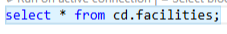
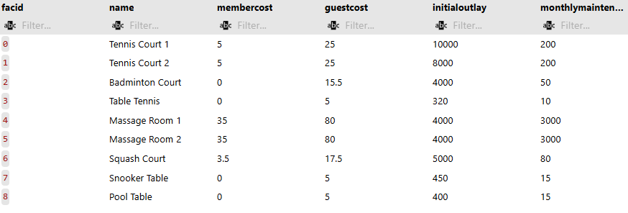

- You want to print out a list of all of the facilities and their cost to members. How would you retrieve a list of only facility names and costs?

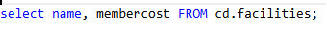
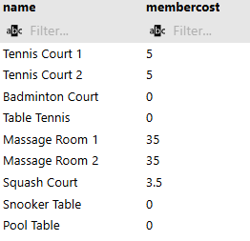
- How can you produce a list of facilities that charge a fee to members?

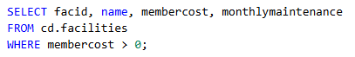

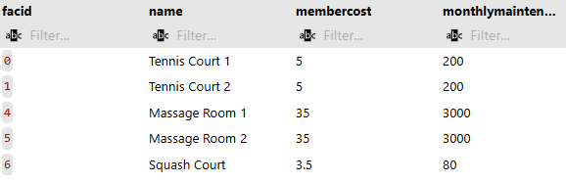

- How can you produce a list of facilities that charge a fee to members, and that fee is less than 1/50th of the monthly maintenance cost? Return the facid, facility name, member cost, and monthly maintenance of the facilities in question.
  - Result is just two rows:

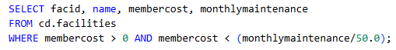
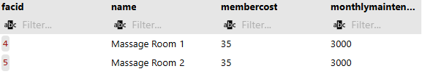

- How can you produce a list of all facilities with the word 'Tennis' in their name?

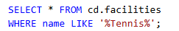

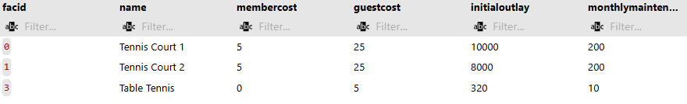

- How can you retrieve the details of facilities with ID 1 and 5? Try to do it without using the OR operator.

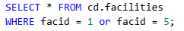

Or



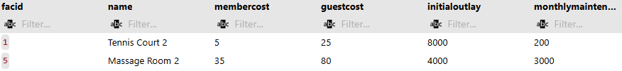

- How can you produce a list of members who joined after the start of September 2012? Return the memid, surname, firstname, and joindate of the members in question.

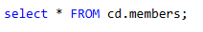
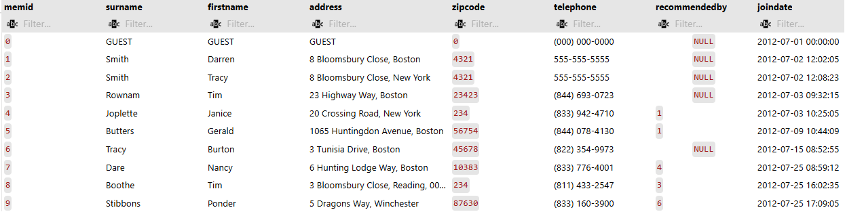
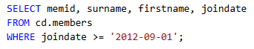

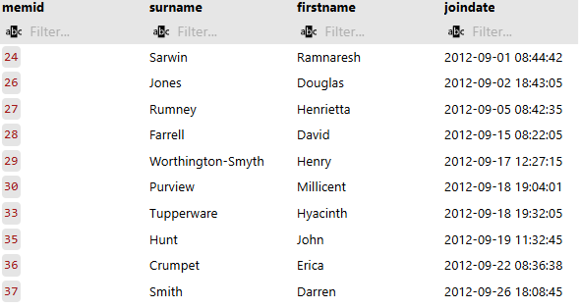

- How can you produce an ordered list of the first 10 in the members table? The list must not contain duplicates.

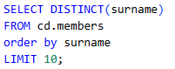

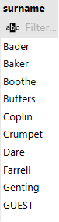

- You'd like to get the signup date of your last member. How can you retrieve this information?

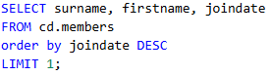

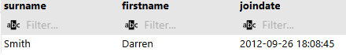
- Produce a count of the number of facilities that have a cost to guests of 10 or more.

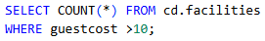

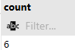

- Produce a list of the total number of slots booked per facility in the month of September 2012. Produce an output table consisting of facility id and slots, sorted by the number of slots.

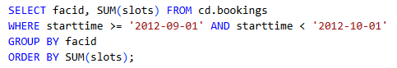
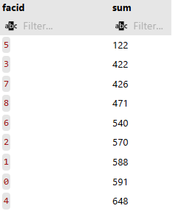

[
You can't use:
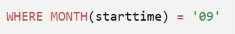
because PostgreSQL does not have a MONTH() function. That function exists in databases like MySQL, but not in PostgreSQL.
In PostgreSQL, you should use:
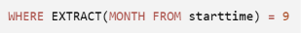
However, this alone is not enough, because it returns every September, regardless of the year.
Since the question asks for September 2012, you also need to filter by the year:
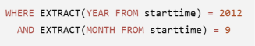
The most common and efficient solution is to use a date range:
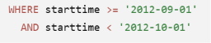
This approach is generally preferred because it is faster, more readable, and allows PostgreSQL to make better use of indexes on the starttime column.
]

- Produce a list of facilities with more than 1000 slots booked. Produce an output table consisting of facility id and total slots, sorted by facility id.


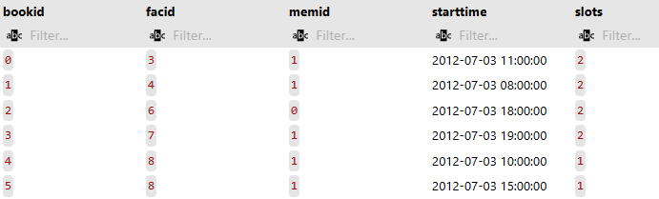

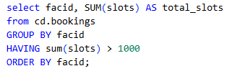

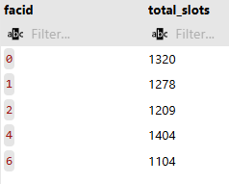

- How can you produce a list of the start times for bookings for tennis courts, for the date '2012-09-21'? Return a list of start time and facility name pairings, ordered by the time.

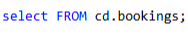
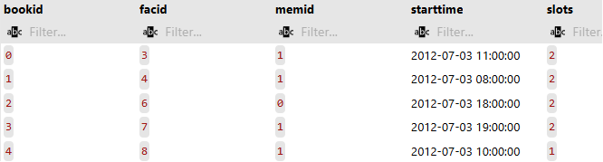


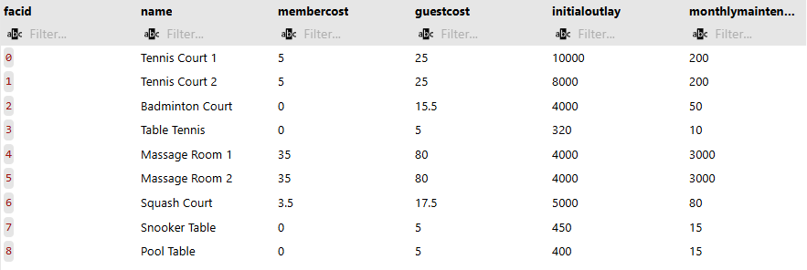

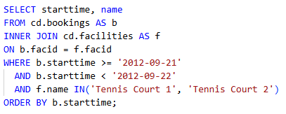

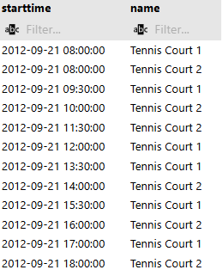

- How can you produce a list of the start times for bookings by members named 'David Farrell'?



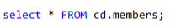
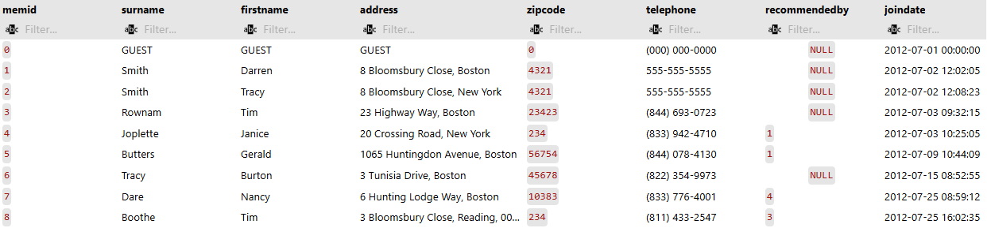

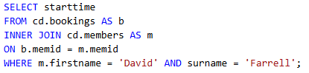

Expected result is 34 rows of timestamps
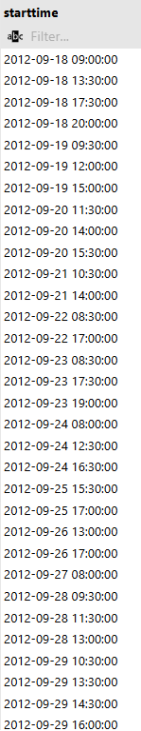

My answer:
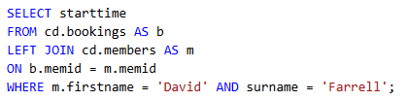
Yes, your query is correct, but LEFT JOIN is unnecessary for this question.

Why does it work?
A LEFT JOIN returns:
- all rows from bookings,
- plus matching rows from members.
However, your WHERE clause says:
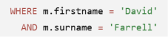
If a booking has no matching member, then m.firstname and m.surname are NULL. Those rows are removed by the WHERE clause.
So, in effect, your LEFT JOIN behaves exactly like an INNER JOIN.

Why is the tutor's INNER JOIN correct?
The tutor probably wrote:
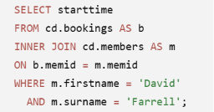

This is the preferred solution because:
It expresses the intention more clearly: only bookings with a matching member are needed.
It avoids bringing in unmatched rows that will be discarded anyway.
It is the standard SQL style for this type of query.
Rule of thumb
Use INNER JOIN when you only want rows that have matching records in both tables.
Use LEFT JOIN when you also want to keep rows from the left table even if there is no match in the right table.

So, your answer returns the same result, but INNER JOIN is the better and more appropriate choice for this question.

