DEKAE: Dynamic Edge-driven Topology for Episodic Few-Shot Learning
Paper identity: A topology-learning framework with explicit structural regularization and supervised relational recovery for episodic few-shot learning.Extension of FSAKE with Supervised Relational Recovery — introducing vector-valued edge features, dynamic graph topology, and a Latent Mediator Transformer into the few-shot episodic learning pipeline.

High-Level Overview

What Problem Is Being Solved?
Few-shot learning (FSL) asks: given only a handful of labeled examples per class, can a model recognize new classes? The standard episodic protocol draws N-way K-shot episodes — N classes, K labeled support examples each, and a query set to classify.
Most FSL methods either:
- Compute fixed similarity metrics between query and support prototypes (PrototypicalNetworks), or
- Use a GNN to pass messages over the support+query graph — but these GNNs use static adjacency (HGNN) or scalar per-edge weights (FSAKE).
DEKAE's key claim: Using vector-valued edge features and supervised topology recovery enables richer relational reasoning that scalar-weight GNNs cannot represent.

Architecture Overview
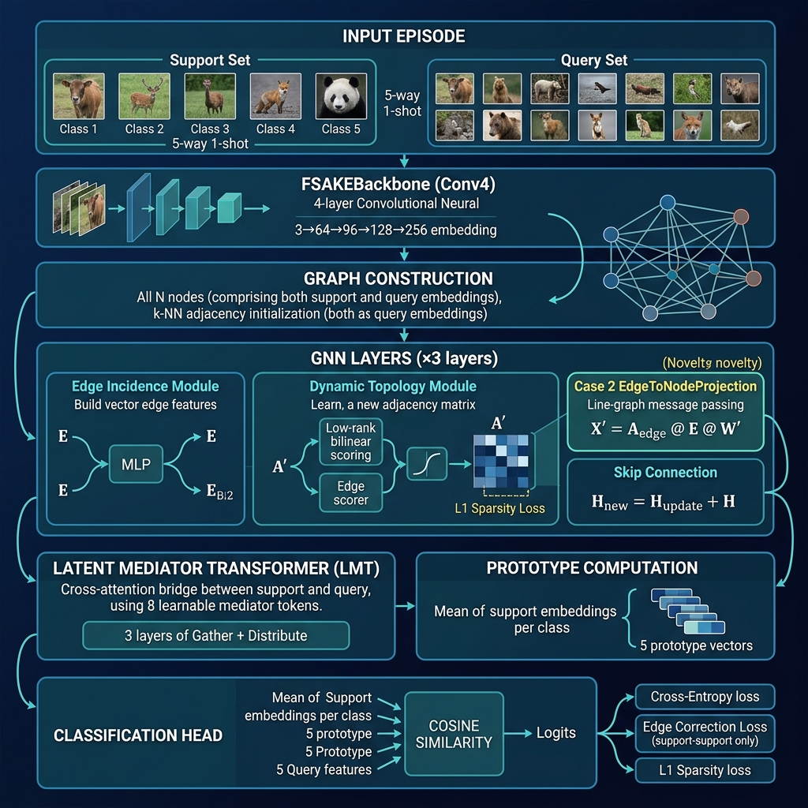
Input Episode │ ├── Support Set: N_way × K_shot images (5 labeled, 5-way 1-shot) └── Query Set: N_way × N_query images (15 unlabeled) │ ▼ ┌─────────────────────────────────────┐ │ FSAKEBackbone (Conv4) │ ← shared backbone, identical to FSAKE │ 3→64→96→128→256→128-dim │ for fair comparison │ 4 conv blocks + BN + LeakyReLU │ │ Output: (N_s + N_q, 128) │ └─────────────────────────────────────┘ │ ▼ Initial Graph: k-NN adjacency on all nodes │ ┌─────────────────────────────────────┐ ── Repeated ×3 GNN layers ── │ GNN Layer │ │ ┌──────────────────────────────┐ │ │ │ EdgeIncidenceModule │ │ E = MLP([h_i ‖ h_j]) → (|E|, 128) │ │ edge features: E ∈ R^{|E|×d}│ │ vector per edge, not scalar │ └──────────────────────────────┘ │ │ ┌──────────────────────────────┐ │ │ │ DynamicTopologyModule │ │ A'_ij = sigmoid(bilinear(h_i,h_j) + │ │ new adjacency: A' (learned) │ │ edge_scorer(E_ij)) │ │ + L1 sparsity loss │ │ row-normalised, spectral-normed weights │ └──────────────────────────────┘ │ │ ┌──────────────────────────────┐ │ │ │ EdgeToNodeProjection (Case2) │ │ X' = A_edge @ E @ W' │ │ THE NOVEL CONTRIBUTION │ │ nodes update from EDGE VECTORS │ │ line-graph message passing │ │ (impossible with scalar attention) │ └──────────────────────────────┘ │ │ + Skip connection: H ← H_new + H │ └─────────────────────────────────────┘ │ ▼ ┌─────────────────────────────────────┐ │ Latent Mediator Transformer (LMT) │ 8 learnable mediator tokens M ∈ R^{8×128} │ Phase A (Gather): M ← CrossAttn(Q=M, KV=[Q‖S]) │ │ Phase B (Distrib): Q ← CrossAttn(Q=Q, KV=M) │ │ S ← CrossAttn(Q=S, KV=M) │ │ × 3 layers — O(m(N_q+N_s)d) complexity │ └─────────────────────────────────────┘ │ ▼ ┌──────────────────────────────────────┐ │ Prototype Computation │ mean of support embeddings per class │ Cosine Similarity → Logits │ cosine(H_query, prototypes) └──────────────────────────────────────┘ │ ▼ Total Loss = CrossEntropy(logits, q_labels) + λ_edge × EdgeCorrectionLoss (support-support pairs ONLY) + L1 sparsity on A'

Key Novelties vs. FSAKE Baseline
Component | HGNN (A1) | FSAKE (A2) | DEKAE
Graph construction | Static k-NN | Dynamic scalar adjacency | Dynamic vector-valued edges
Edge representation | None | Scalar  A^(l)_ij ∈ R | Vector e_ij ∈ R^d
Node update | A @ H | softmax(MLP(|h_i−h_j|)) @ H | A_edge @ E @ W'  (line-graph MP)
Supervised topology | None | None | Edge correction loss  (S-S only)
Cross-set alignment | None | None | Latent Mediator Transformer

The Structural Novelty: Case 2 EdgeToNodeProjection
Standard attention updates nodes from neighboring node features:
X'_i = Σ_j α_ij · h_j ← scalar α, node source
DEKAE's Case 2 updates nodes from edge feature vectors:
X'_i = Σ_{e=(i,j)} w_i,e · (E_e @ W') ← vector E_e, edge source
This is structurally equivalent to one step of line-graph message passing and is the mechanism that enables edge-level supervision — impossible when edges are scalars.

Training Procedure

Episodic Protocol
- 5-way 1-shot on CIFAR-FS (64 train / 16 val / 20 test classes)
- Augmented training: RandomResizedCrop + RandomHorizontalFlip + ColorJitter
- 300 episodes per epoch, 200 epochs

Loss Function
L_total = L_CE(logits, q_labels) + λ_edge · L_edge_correction ← contrastive on support-support edges + L1_sparsity ← on learned A'
Edge correction loss (Section 9):
L_edge = Σ_{i,j ∈ Support} [y_i == y_j] · (1 - cos(h_i, h_j)) ← pull same-class together + [y_i != y_j] · max(0, cos(h_i, h_j) - margin) ← push different apart
⚠️ Only support-support pairs are used. Query supervision is strictly forbidden to prevent label leakage.

Warm-up + Curriculum Schedule
Phase | Epochs | Topology
Warm-up | 1–5 | Static k-NN adjacency
Edge-loss ramp | 6–25 | λ_edge linearly ramps 0 → 0.05
Full DEKAE | 26–200 | Dynamic A' + full edge loss

Optimizer
- Adam, lr=1e-3, weight_decay=1e-6 (matching FSAKE exactly)
- StepLR: gamma=0.5 every ~33 epochs (mirrors FSAKE's 10k-iteration halve policy)
- Gradient clip: 5.0

Ablation Groups
Group | What changes | Ablations
A | Graph construction | A0 (ProtoNet), A1 (HGNN static), A2 (FSAKE dynamic scalar), A3 (Case1 edge-gating),  A5+ (DEKAE)
B | Prototype strategy | B1 (max-pool), B2 (nearest-centroid), B3 (mean)
C | Edge projection type | C1 (none), C2 (linear), C3 (MLP default)
D | Seed stability & topology init | Multiple seed runs, topology sensitivity
E | Sparsity mode | E1 (L1), E2 (Laplacian), E3 (top-k hard mask)
H | LMT ablations | H1 (no LMT), H2 (fixed mediators), H3 (zero init), H4 (gather only)

Project Structure (Notebook Sections)
Section | Description
0 | Google Drive mount & persistent paths
1 | Environment setup & GPU check
2 | Data pipeline (CIFAR-FS / miniImageNet download + archive)
3 | EpisodicSampler  & synthetic episode generator
4 | FSAKEBackbone  (Conv4, 128-dim output, ~317K params)
5 | Static k-NN graph module (  A1_HGNN  baseline)
6 | EdgeIncidenceModule  — vector edge features
7 | DynamicTopologyModule  — adaptive A' with sparsity
8 | EdgeAwareKnowledgeFilter  (Case 1) &  EdgeToNodeProjection  (Case 2)
9 | edge_correction_loss  — supervised topology recovery
10 | Sparsity regularization utilities & graph health metrics
11 | DEKAEModel  full assembly +  LatentMediatorTransformer
12 | Training loop, health monitor, checkpointing
12b | ▶ Execute training  (CIFAR-FS, 5-way 1-shot)
13 | Evaluation utilities + statistical testing
13b | ▶ Real test-set evaluation
14 | Synthetic topology recovery experiment
15b | ▶ Ablation sweeps (Groups A & E)
15c | Edge feature comparison (Group C)
15d | Seed stability & topology init (Group D)
16 | W&B metrics logging
17 | Visualization suite

Execution Order
1. Run cells 0–3 → setup, data, loaders 2. Run cells 4–12 → architecture definitions 3. ▶ Run cell 12b → training (~60–90 min on T4 GPU) 4. ▶ Run cell 13b → test-set evaluation 5. ▶ Run cell 14 → synthetic topology recovery 6. ▶ Run cell 15b → ablation sweeps (Groups A & E)

Dependencies
torch >= 2.0 torch-geometric learn2learn (episodic dataset loading) torchvision wandb (optional, for metrics logging) scipy, scikit-learn matplotlib, seaborn, networkx tqdm

Hardware
Designed to run on Google Colab T4 GPU (15.6 GB VRAM).
Total model parameters: ~1.58M (backbone: ~317K, GNN modules: ~850K, LMT: ~1M, shared with GNN layers).
Checkpoints and results are saved persistently to Google Drive under MyDrive/DEKAE_Project/.

Compared Baselines
Method | Graph | Edge type | Supervised topology
ProtoNet (A0) | None | — | —
HGNN (A1) | Static k-NN | Scalar weight | None
FSAKE (A2) | Dynamic per-layer | Scalar  softmax(MLP(|h_i−h_j|)) | None
DEKAE | Dynamic per-layer | Vector e_ij ∈ R^d | Contrastive edge loss

The primary dataset is CIFAR-FS (100 classes, 600 images each, split 64/16/20).
miniImageNet is supported as an additional benchmark (required for direct FSAKE paper comparison).

