An Accuracy and Calibration Benchmark of scGPT Pipelines and Matched Classical Models for Cell Type Annotation
Alireza Khosravi¹˒²˒³, Arshia Khosravi³, Kamil Łangowski¹, Michał Sieczczyński¹˒⁵,
Krzysztof Pastuszak¹˒²˒⁴, Anna Supernat¹˒²˒*, Anna J. Żaczek¹˒²
¹Laboratory of Translational Oncology, Medical University of Gdańsk, Gdańsk, Poland
²Centre of Biostatistics and Bioinformatics Analysis, Medical University of Gdańsk, Gdańsk, Poland
³Scientific Circle of Artificial Intelligence in Medicine, Medical University of Gdańsk, Gdańsk, Poland
⁴Department of Algorithms and System Modeling, Gdańsk University of Technology, Gdańsk, Poland
⁵Department of Software Engineering, Gdańsk University of Technology, Gdańsk, Poland
*Correspondence: Anna Supernat, abednarz@gumed.edu.pl

Abstract

Foundation-model embeddings are used for single-cell annotation, but their value depends on biological holdout, comparator design and downstream learning. We compared frozen scGPT 0.2.5 embeddings with matched expression; both were paired with independently tuned Logistic Regression, Random Forest and XGBoost. Training-fitted SVD-512 was evaluated with Logistic Regression across all atlases and with all classifiers only in TNBC and brain. Five donor-held-out folds yielded 965,427 analysed cells from 312 donors. Matched expression achieved higher pooled Macro F1 in six TNBC/PBMC comparisons; scGPT was higher in three brain comparisons. Donor-cluster bootstraps supported the six expression advantages and the brain Random Forest scGPT advantage, while the other brain intervals crossed zero. Where available, SVD-512 remained close to expression, arguing against compression alone as the explanation. Under strict PBMC label scarcity, expression reached Macro F1 0.818–0.930 versus 0.779–0.881 for scGPT. Held-out-donor temperature scaling reduced mean expected calibration error from 0.0072 to 0.0057 but not in every pipeline. Class analyses identified lymphocyte-boundary errors in TNBC and PBMC and rare-class errors in brain. Performance was atlas- and classifier-dependent for this frozen-scGPT pipeline; official fine-tuning, newer checkpoints and cross-cohort transfer were not tested.
Keywords: single-cell RNA sequencing; scGPT; cell-type annotation; calibration; donor-held-out validation; classical machine learning; foundation models

Introduction
Single-cell RNA sequencing (scRNA-seq) has made it possible to resolve heterogeneous tissues at cellular scale and to construct reference atlases spanning organs, developmental stages and disease states [1–6]. Interpreting these data still depends on cell-type annotation: the assignment of biologically meaningful identities to measured expression profiles. Manual annotation based on canonical markers remains valuable, but it is laborious, sensitive to expert judgement and difficult to scale. Automated methods therefore occupy a central place in atlas construction and reference mapping [7–12].
The available annotation strategies span a wide range of statistical complexity. Logistic regression, support-vector machines, nearest-neighbour projection, tree ensembles and reference-mapping systems can perform strongly when labelled cells from an appropriate reference population are available [7–9,13]. Latent-variable models such as scVI and scANVI additionally provide probabilistic representations and batch-aware integration [14,15]. These methods establish demanding baselines: a more complex representation is useful for supervised annotation only if it preserves task-relevant biological signal, transfers across the intended biological partition and improves an endpoint that matters in practice.
Single-cell foundation models seek to learn reusable representations from very large transcriptomic corpora. scBERT, Geneformer, scGPT, scFoundation and Universal Cell Embeddings differ in tokenization, architecture and pretraining objective, but share the premise that large-scale pretraining can encode regularities that are useful across downstream tasks [16–20]. scGPT is a generative transformer pretrained on more than 33 million cells and has been applied to cell-type annotation, integration, perturbation response and multi-omic analysis [18]. Its released whole-human checkpoint and public embedding interface make it a reproducible case study for asking whether a fixed pretrained cell representation improves supervised annotation.
The answer depends on the evaluation regime. Frozen embeddings followed by a supervised classifier are neither zero-shot annotation nor end-to-end fine-tuning. They test whether a fixed representation makes target labels accessible to a downstream learner. Strong performance in this regime may be valuable, but it does not establish transfer to unlabelled cell types, external atlases or biological conditions absent from the target training data. Conversely, weak frozen-embedding performance does not rule out benefits from official fine-tuning, other checkpoints or other foundation models. Recent independent evaluations have similarly emphasized that foundation-model conclusions depend on task definition, pretraining exposure, comparator choice and adaptation protocol [21,22].
Biological partitioning is especially important in single-cell benchmarks. A random cell split allows cells from the same donor, sample or processing batch to appear in both training and testing. Such a split measures interpolation among cells from an atlas, but can yield optimistic estimates of deployment to unseen biological units. Grouped validation instead keeps all cells from a donor together, preserving the hierarchy of the data and making the test question explicit [23,24]. It does not by itself create external-atlas validation—cohort-specific acquisition, curation and label definitions remain shared—but it removes direct donor overlap and provides multiple biological test partitions.
Comparator construction also changes the scientific question. scGPT returns a 512-dimensional, unit-normalized cell embedding, whereas a direct expression baseline can contain more than one thousand sparse, log-normalized gene values on a different numerical scale. Applying the same regularization setting to both representations need not be neutral. Hyperparameters should therefore be selected separately inside the training data for every representation–classifier pair. A dimensionality-matched expression control is also informative: if direct expression outperforms a 512-dimensional embedding, a 512-component expression projection can help distinguish a scGPT-specific effect from the generic information loss associated with compression.
Annotation systems are often used through their confidence scores as well as their discrete predictions. Accuracy and Macro F1 assess discrimination, whereas calibration asks whether predictive probabilities agree with observed frequencies [25–27]. These properties are distinct. Expected calibration error (ECE) summarizes a reliability diagram but depends on binning; the multiclass Brier score and negative log-likelihood are proper scoring rules that jointly reflect probability quality and discrimination [28–30]. Moreover, probabilities in a frozen-embedding pipeline are generated by the downstream classifier. Calibration findings must consequently be attached to complete representation–classifier pipelines, not attributed to the encoder alone. Post-hoc temperature scaling provides a simple test of how much probability error can be corrected without changing the predicted class [25].
We conducted an accuracy and calibration benchmark of official frozen scGPT embeddings, matched normalized expression and a 512-component expression projection. Frozen scGPT and matched expression were each paired with Logistic Regression, Random Forest and XGBoost, with hyperparameters selected independently inside the training donors. The primary evaluation used five donor-held-out folds in three human atlases spanning breast cancer, peripheral blood and brain. SVD-512 was evaluated as a dimensionality control with Logistic Regression in all three atlases and with all three classifiers in the TNBC and brain atlases. We further examined class-specific errors, labelled-cell scarcity with labelled-only feature selection, held-out-donor temperature scaling in two fully audited atlases and a separately reported pig-pancreas stress test using the human checkpoint. This design addresses a specific question: under supervised annotation of broad portal labels, how do fixed scGPT 0.2.5 embeddings compare with equally trained classical representations when the evaluated cells come from donors not used to fit the classifier?

Methods

Study design and estimands
The core benchmark compared two representations under three supervised classifiers. The representations were (i) frozen 512-dimensional cell embeddings returned by the official scGPT interface and (ii) normalized expression of exactly the genes supplied to scGPT. Each was paired with Logistic Regression, Random Forest and XGBoost. A 512-component truncated singular-value decomposition (SVD) of the matched expression matrix provided a secondary dimensionality control. SVD-512 was paired with Logistic Regression in all three atlases and with all three classifiers in TNBC and brain. Hyperparameters were selected separately for every evaluated representation–classifier pair using only cells from the outer training donors.
The primary estimand was annotation performance on cells from donors excluded from model fitting but drawn from the same curated atlas. It was evaluated with five-fold stratified group cross-validation in three human datasets. The comparison was prespecified at matched classifier: matched expression versus scGPT embeddings with Logistic Regression, with Random Forest and with XGBoost. SVD-512 comparisons were secondary controls for dimensional compression. No classifier was selected from outer-test performance for primary inference. A porcine dataset analysed with the released human checkpoint was treated separately as a cross-species stress test and was not included in the human benchmark summary.

Public single-cell datasets
Four processed, public H5AD objects were downloaded from CZ CELL×GENE Discover [31]. The primary human benchmark comprised TNBC breast cancer (427,823 cells; 101 unique donor identifiers), Indonesia peripheral blood mononuclear cells (PBMC; 462,034 cells; 199 unique donor identifiers) [32], and a human brain atlas (75,583 cells; 12 unique donor identifiers) [33]. Together these objects contained 965,440 cells before shared-input quality control. Pig pancreas (22,056 cells) originated from a cross-species islet study [34]; it contained one value of donor_id and two values of sample, could not support donor-held-out evaluation and was therefore analysed only as a stress test.
The direct download UUIDs, matrix dimensions, label counts and metadata audit are supplied with the code. The curated portal field cell_type defined the target. Labels represented by five or fewer cells were excluded before splitting; no retained class was subsequently removed. The human datasets contained 7–13 retained labels. These are portal-level cell categories rather than a harmonized fine-state ontology, and their biological granularity differs among datasets.
The grouping variable for every human dataset was donor_id. It was complete in all three objects. The metadata audit found 101, 199 and 12 unique donor IDs in TNBC, Indonesia PBMC and brain, respectively. The Indonesia object contained 199 unique sample_id values in one-to-one correspondence with the 199 donor IDs and 27 processing batches; the biological donor was used as the grouping unit.
Table 1. Datasets and biological partitions used in the benchmark. Cell counts precede shared-input quality control. Pig pancreas is not part of the primary human donor-held-out analysis.
Dataset | Cells | Classes | Donors | Analysis role
TNBC breast cancer | 427,823 | 7 | 101 | Five-fold donor-held-out human benchmark
Indonesia PBMC | 462,034 | 13 | 199 | Five-fold donor-held-out benchmark and scarcity analysis
Brain atlas | 75,583 | 10 | 12 | Five-fold donor-held-out human benchmark
Pig pancreas | 22,056 | 4 | 1 | Random-cell cross-species stress test
Pig pancreas contained two sample values but only one donor identifier. The whole-human checkpoint was applied without orthology mapping.

Outer donor-held-out partitions

For each human dataset, all cells belonging to one donor were assigned to the same fold. We used StratifiedGroupKFold with five folds, shuffling and deterministic dataset-specific seeds. Because rare classes can be concentrated in a small number of donors, the implementation searched a prespecified sequence of up to 100 seeds and retained the first assignment for which every class occurred in both training and test cells of every fold. The chosen seed is recorded for each dataset. Assertions verified that training and test donor sets were disjoint, that all retained classes were present on both sides of each split, and that the five outer-test index sets formed a non-overlapping out-of-fold partition after shared-input quality control. The training sets overlap across folds, as is intrinsic to cross-validation; the five folds are not described as independent training samples.

Training-only feature selection and shared gene input

All feature operations were repeated inside each outer fold. Raw integer counts were materialized from adata.raw for the outer-training cells only. Genes with fewer than three total counts in that training partition were removed, after which the top 1,200 highly variable genes (HVGs) were ranked with the Seurat v3 variance-stabilizing method implemented by Scanpy [35,36]. This step did not access the outer-test cells.
Gene identifiers were compared with the released scGPT vocabulary by exact symbol, followed by uppercase-symbol matching when exact matching failed. Genes still absent from the vocabulary were removed, and duplicate mapped symbols retained only the highest-ranked training HVG. The resulting list was the sole input gene set for all three representations in that fold. Thus, direct expression did not receive genes unavailable to scGPT. Cells with zero counts across every shared input gene were excluded symmetrically before representation construction; exclusions and their original indices were recorded.

Frozen scGPT cell embeddings
The benchmark used scGPT 0.2.5 from source commit cebd6fa and the released whole-human checkpoint [18]. The checkpoint files were pinned by SHA-256 digest: args.json, c18e075e018140cb8b2d9029387b9de26607a5ce6a8ccabd6ead70cd76b95d60; vocab.json, acca93d114ca62c3f0f50debbd23e8c87f0714f4737764454f6b2b13f2e8580f; and best_model.pt, 6cb5d451ab5c4b33eb673adbe4fddc61d2389df1b89b7651a9fe2e557572b922.
Cell embeddings were extracted with the public scgpt.tasks.embed_data function, using raw counts, the matched feature_name symbols, max_length=1200, a batch size of 256, the released value-binning behaviour, fast-transformer execution and CUDA. The model weights were frozen. The function returned one 512-dimensional vector per cell. Every output was required to be finite, have the expected shape and have unit Euclidean norm within a tolerance of 10^-5. A downstream classifier was then trained with the target-atlas labels; accordingly, this is a frozen-representation supervised evaluation, not zero-shot annotation and not official end-to-end fine-tuning.

Matched expression and the SVD-512 control
For matched expression, counts of the same training-selected, vocabulary-matched genes were library-size normalized to 10,000 counts per cell and transformed with log(1+x) using Scanpy. The transformation was applied identically to outer-training and outer-test cells after the gene list had been fixed. Sparse zeros were retained as measured expression zeros.
The dimensionality control used randomized TruncatedSVD on the matched-expression matrix. Exactly 512 components were fitted to at most 100,000 outer-training cells, selected with class-stratified subsampling when necessary. The algorithm used five power iterations and a recorded fold-specific seed. Outer-test cells did not contribute to the decomposition. Truncated SVD was used rather than centred principal-component analysis because the expression matrix was sparse; the explained-variance ratio is supplied for every fold. This control asks whether reducing matched expression from approximately 1,100 variables to the same nominal dimension as scGPT accounts for the observed representation difference. It is not a generative or batch-corrected baseline and should not be interpreted as scVI.

Inner partitions and representation-specific hyperparameter selection
Outer-training donors were divided into disjoint inner partitions for hyperparameter fitting, validation and probability calibration. We created up to five stratified group folds, selected one class-complete group fold for validation, one different class-complete group fold for calibration and used the remaining folds for candidate fitting. Assertions excluded donor overlap among these partitions. For computational tractability, the hyperparameter fitting and validation partitions were separately capped at 50,000 cells using class-stratified subsampling. The calibration partition was not used in hyperparameter selection.

The primary selection criterion was validation Macro F1. Candidate grids were fixed before outer-test evaluation and searched independently for every evaluated representation–classifier combination:
Logistic Regression: C ∈ {10⁻³,10⁻²,10⁻¹,1,10,100,1000}, with either the native representation scale or featurewise standardization. Sparse expression was scaled without centring. Models used the L2-penalized lbfgs solver with at most 5,000 iterations.
Random Forest: 300 trees, max_features ∈ {√p,0.25p} and min_samples_leaf ∈ {1,5}, with bootstrap sampling and the Gini criterion [37].
XGBoost: histogram tree building with (max_depth,learning_rate,n_estimators) equal to (3,0.10,300), (6,0.10,300), (6,0.05,500) or (9,0.05,400) [38]. Expression matrices were materialized for XGBoost so that an absent sparse entry was treated as a measured zero rather than as a missing value.
Ties were resolved by candidate order. Once parameters had been selected, the corresponding classifier was refitted on all outer-training cells and evaluated once on the outer-test donors. The deterministic search code, candidate grids, selected parameters retained by completed jobs and timings are supplied. Primary comparisons keep the classifier fixed, eliminating outer-test selection of a preferred head.

Discrimination and probability metrics
Macro F1 was the primary discrimination metric because it weights each portal cell category equally. For K classes,
Macro F1 = (1/K) Σₖ [2 × precisionₖ × recallₖ / (precisionₖ + recallₖ)].
Accuracy and balanced accuracy were secondary measures. We reported outer-fold values and pooled out-of-fold values. Pooled values concatenate every donor's prediction exactly once and therefore need not equal the unweighted mean of the five fold values.
Calibration and probability quality were described with five complementary statistics. Top-label equal-width ECE used ten bins over [0,1]:
ECE = Σᵇ (|Bᵇ|/n) × |accuracy(Bᵇ) − confidence(Bᵇ)|, for ten confidence bins.
We additionally calculated ten-bin adaptive ECE, ten-bin classwise ECE, the multiclass Brier score and multiclass negative log-likelihood (NLL) [26,28,29]. Because ECE depends on binning and all five metrics can be influenced by discrimination, no single statistic was treated as a complete description of uncertainty. Reliability data retain the number of observations, mean confidence and empirical accuracy in every bin.

Group-cluster bootstrap comparisons

For each dataset and pipeline, out-of-fold predictions were converted to one confusion matrix per donor. We drew 5,000 bootstrap replicates by sampling the observed donors with replacement and summing all cells belonging to every selected donor. The same donor multiplicities were used for both members of a paired comparison. Macro F1 was calculated from the resampled confusion matrices, and the 2.5th and 97.5th percentiles of the paired difference formed a 95% interval. The primary contrast was matched expression minus scGPT embeddings for each fixed classifier; matched expression versus SVD-512 and SVD-512 versus scGPT were secondary.
This cluster bootstrap respects the donor as the sampling unit, but it does not refit HVG selection, SVD, hyperparameter tuning or classifiers inside each bootstrap replicate. Its intervals are therefore conditional on the completed five-fold set of fitted pipelines. They quantify sensitivity to the empirical donor composition, not the full uncertainty of rebuilding the entire analysis in a new cohort.

Held-out-donor temperature scaling

Scalar temperature scaling was evaluated for Logistic Regression and XGBoost in all three representations in the TNBC and brain atlases [25]. Hyperparameters were chosen on the inner fitting and validation groups. A calibration-evaluation model was then fitted on the union of those two groups, leaving the disjoint inner calibration donors untouched. For Logistic Regression, the decision function supplied logits. For XGBoost, the logarithm of clipped class probabilities was used as a logit vector, which preserves the original softmax probabilities. A positive scalar T minimized calibration-donor NLL:
T̂ = arg minₜ₎₀ [−Σᵢ log softmax(zᵢ/T)ᵧᵢ].
The fitted temperature was applied once to the outer-test logits. Positive scalar scaling cannot change the class with the maximum logit; code assertions verified identical predicted classes before and after scaling. These calibration rows arise from classifiers trained without the calibration donors and are therefore not numerically identical to the final discrimination models refitted on all outer-training donors.

Strict labelled-cell scarcity sensitivity
The Indonesia PBMC cohort supported a controlled label-scarcity sensitivity because it combined 13 labels with 199 unique donor IDs. The same five outer donor folds were used. Within each outer-training partition, we sampled exactly 10, 50, 100, 250 or 500 labelled cells per class with two deterministic sampling seeds. Crucially, gene filtering, Seurat v3 HVG ranking and vocabulary matching were recomputed from these labelled cells alone. Unlabelled outer-training cells were not used for feature selection, embedding extraction, classifier fitting or parameter selection.
The labelled and outer-test cells were represented by frozen scGPT embeddings and matched normalized expression. Logistic Regression parameters were selected independently for each representation by three-fold stratified cross-validation within the labelled subset using the same C and scaling grid, then refitted to all labelled cells. Evaluation remained on donors excluded by the outer fold. Results were first averaged across the two label-sampling seeds within fold and then summarized across five outer folds. This experiment concerns supervised few-label adaptation to known broad classes; it does not test zero-shot annotation, unseen label categories or discovery of rare states.

Biological error analysis
Out-of-fold predictions were aggregated into per-class precision, recall, F1 and support for every complete human representation–classifier pipeline. Complete confusion matrices were retained as counts and row-normalized proportions. The main text emphasizes the weakest classes and largest off-diagonal confusions in TNBC, PBMC and brain rather than relying only on pooled scores. Errors were interpreted against the supplied portal annotations, which were treated as reference labels but not as an error-free biological gold standard.

Pig-pancreas cross-species stress test

Pig pancreas was excluded from the primary human summary because its metadata contained one donor identifier and because the available checkpoint was trained for human data. We retained an explicitly secondary stress test to document the behaviour of the released pipeline under direct application. Porcine feature symbols were matched to the human vocabulary by exact name and uppercase fallback; no orthology map, one-to-one orthologue filtering or species-specific checkpoint was used. The analysis used one stratified random 80/20 cell split (seed 42), training-only HVG selection, the same three representations and independent inner hyperparameter tuning. It therefore measures within-object interpolation after an intentionally uncurated human-to-pig mapping, not a competitive assessment of cross-species annotation.

Software, reproducibility and computational audit
Analyses ran under Python 3.11.10 with scGPT 0.2.5, PyTorch 2.5.1 and CUDA 12.4, AnnData 0.12.3, Scanpy 1.11.5, NumPy 1.26.4, pandas 2.3.3, SciPy 1.13.1, scikit-learn 1.9.0 [39] and XGBoost 3.2.0 on NVIDIA H100 80-GB GPUs. Seeds were fixed at every splitting, subsampling, decomposition and fitting stage. Each prediction archive records the dataset, fold, original test indices, donor IDs, class order, true labels and full probability matrix. Final aggregation was performed locally from already completed prediction files and admitted a pipeline only when all five aligned outer folds were present. Executable code, environment records, checkpoint digests, grouping audit, selected genes, available tuning traces, fold outputs and final tables are included in the submission package and public repository.

Results

A donor-held-out benchmark across three human atlases

The primary analysis comprised 965,440 cells from three human atlases and 312 donor identifiers before shared-input quality control (Figure 1; Table 1). Five outer folds were completed per dataset. The aligned out-of-fold set contained 965,427 cells: 427,813 from TNBC, 462,034 from Indonesia PBMC and 75,580 from brain. Thirteen outer-test cells had zero counts across the fold-specific shared input genes and were excluded symmetrically before representation construction. No donor occurred in both training and test cells within a fold, every retained portal class was represented on both sides of every split, and the five test sets contained each retained cell once. Fold-specific vocabulary matching retained 1,167–1,172 genes in TNBC, 1,132–1,141 in PBMC and 930–953 in brain (Table 2).
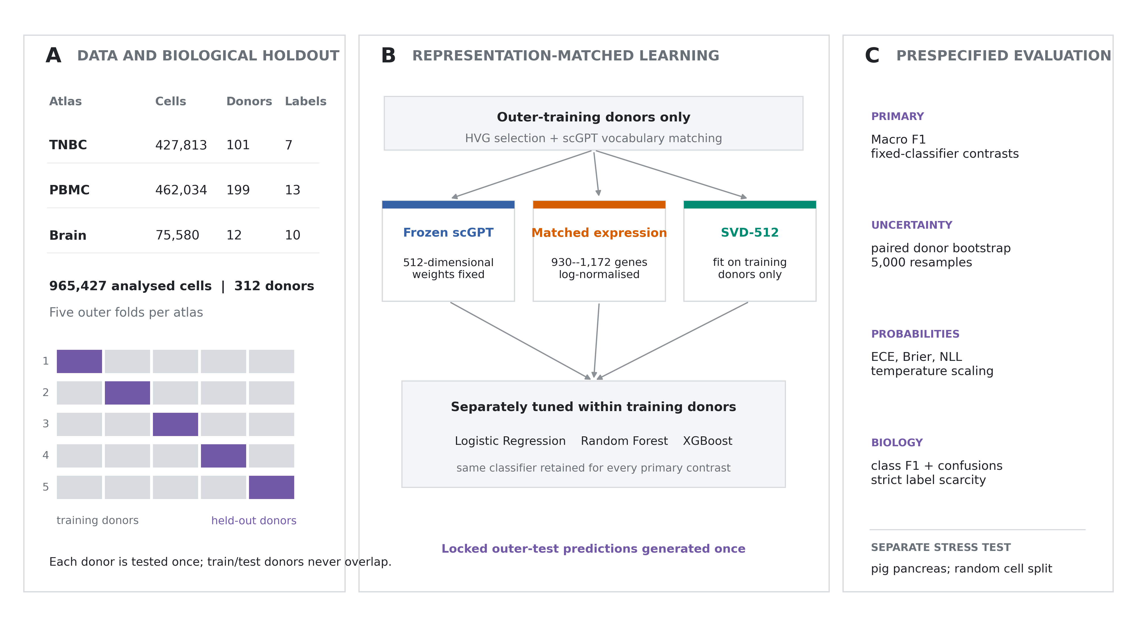
Figure 1. Study design. Three human atlases were evaluated with donor-held-out outer folds. Highly variable gene selection, vocabulary matching, SVD fitting, representation-specific hyperparameter selection and classifier fitting were restricted to outer-training donors. The primary contrasts compared frozen scGPT embeddings with matched expression at the same downstream classifier. Pig pancreas was excluded from the human summary and retained as a separate stress test.
Table 2. Completed out-of-fold design audit.
Dataset | Donor IDs | Classes | OOF cells | Matched HVGs
TNBC | 101 | 7 | 427,813 | 1,167–1,172
PBMC | 199 | 13 | 462,034 | 1,132–1,141
Brain | 12 | 10 | 75,580 | 930–953

Representation effects depend on atlas and classifier

Matched expression had higher pooled out-of-fold Macro F1 than scGPT embeddings in six of the nine prespecified classifier-matched comparisons (Figure 2; Table 3). All six occurred in TNBC and PBMC. In TNBC, matched-expression Macro F1 was 0.990, 0.985 and 0.990 with Logistic Regression, Random Forest and XGBoost, compared with 0.983, 0.968 and 0.978 for scGPT embeddings. In PBMC, the corresponding values were 0.959, 0.933 and 0.957 for matched expression and 0.949, 0.915 and 0.935 for scGPT embeddings.
The ordering reversed in brain. scGPT embeddings achieved Macro F1 values of 0.940, 0.908 and 0.930 with Logistic Regression, Random Forest and XGBoost, whereas matched expression achieved 0.911, 0.870 and 0.925. The pooled brain accuracies were nevertheless 0.983–0.987, illustrating the sensitivity of Macro F1 to rare classes in this imbalanced atlas. No classifier was selected from these results: every value is one member of a prespecified fixed-classifier comparison. Complete accuracy, balanced accuracy, probability metrics and outer-fold results are reported in Supplementary Tables S3 and S4.
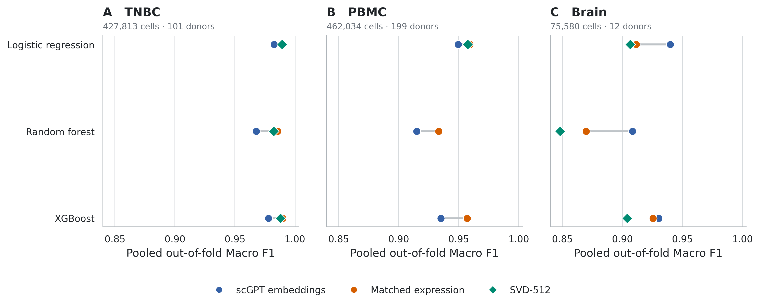
Figure 2. Donor-held-out annotation performance. Pooled out-of-fold Macro F1 for frozen scGPT embeddings, matched normalized expression and available SVD-512 controls. Frozen scGPT and matched expression were evaluated with all three classifiers in all three atlases. SVD-512 was evaluated with Logistic Regression in all three atlases and with all classifiers in TNBC and brain. A missing point denotes that a complete five-fold pipeline was not available and was not included.
Table 3. Primary classifier-matched donor-held-out performance. Values are pooled out-of-fold Macro F1; every retained cell contributes exactly once.
Dataset | Classifier | scGPT embeddings | Matched expression | SVD-512
TNBC | Logistic Regression | 0.983 | 0.990 | 0.989
TNBC | Random Forest | 0.968 | 0.985 | 0.982
TNBC | XGBoost | 0.978 | 0.990 | 0.988
PBMC | Logistic Regression | 0.949 | 0.959 | 0.958
PBMC | Random Forest | 0.915 | 0.933 | Unavailable
PBMC | XGBoost | 0.935 | 0.957 | Unavailable
Brain | Logistic Regression | 0.940 | 0.911 | 0.906
Brain | Random Forest | 0.908 | 0.870 | 0.848
Brain | XGBoost | 0.930 | 0.925 | 0.904
PBMC SVD-512 Random Forest and XGBoost were unavailable as complete five-fold pipelines and were not imputed.

SVD-512 preserves most expression performance
The same-dimensional expression control remained close to matched expression. With Logistic Regression, SVD-512 reached Macro F1 values of 0.989 in TNBC, 0.958 in PBMC and 0.906 in brain, compared with 0.990, 0.959 and 0.911 for the uncompressed matched-expression input. The corresponding expression-minus-SVD differences were 0.0005, 0.0016 and 0.0049. Donor-bootstrap intervals excluded zero for TNBC and PBMC but included zero for brain. Across the seven classifier–atlas comparisons for which both matched expression and SVD-512 had five complete folds, matched expression was higher in all seven; six conditional intervals excluded zero.
SVD-512 also preserved the atlas-specific ordering relative to scGPT. It exceeded scGPT with Logistic Regression in TNBC and PBMC, whereas scGPT exceeded SVD-512 in brain. Fold-specific SVD explained-variance ratios were 0.954–0.956 in TNBC, 0.958–0.959 in PBMC and 0.934–0.942 in brain (Supplementary Table S5); all SVD contrasts are reported in Supplementary Table S6. These results do not support dimensionality alone as an explanation for the TNBC and PBMC differences, although they also show that a simple linear compression retained most of the matched-expression signal.

Donor-level intervals distinguish stable and uncertain orderings

The paired donor-cluster bootstrap sampled all cells from a donor together and retained the pairing between representations (Figure 3; Table 4). In TNBC, the matched-expression advantages were 0.0071, 0.0177 and 0.0118 for Logistic Regression, Random Forest and XGBoost; the conditional 95% intervals were [0.0060, 0.0084], [0.0145, 0.0217] and [0.0099, 0.0141]. In PBMC, the differences were 0.0097 [0.0085, 0.0109], 0.0183 [0.0162, 0.0205] and 0.0217 [0.0199, 0.0236].
In brain, matched expression minus scGPT was -0.0285 [-0.0720, 0.0039] for Logistic Regression, -0.0387 [-0.0662, -0.0143] for Random Forest and -0.0048 [-0.0241, 0.0138] for XGBoost. Thus, the observed scGPT advantage was donor-bootstrap-secure for Random Forest but not for the other two classifiers. These intervals condition on the fitted out-of-fold pipelines; they do not incorporate rebuilding feature selection, decomposition, tuning and model fitting.
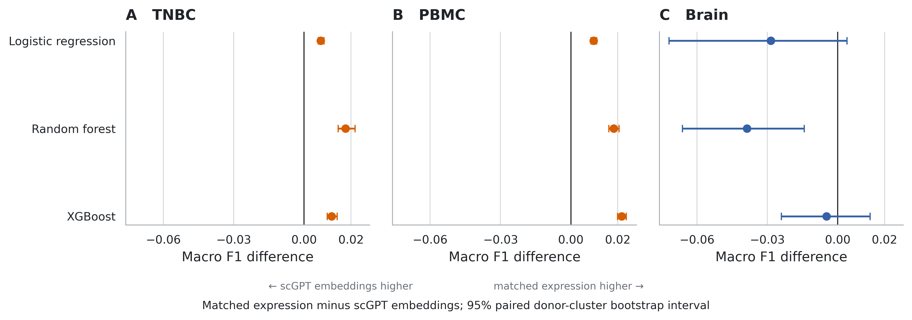
Figure 3. Paired donor-cluster bootstrap contrasts. Macro F1 difference between matched expression and frozen scGPT embeddings at a fixed classifier. Points are observed out-of-fold differences and bars are percentile intervals from 5,000 paired donor resamples. The resampling unit is the donor; fitted models are held fixed.
Table 4. Paired donor-cluster bootstrap contrasts for matched expression versus frozen scGPT embeddings. Intervals are conditional on the fitted out-of-fold pipelines.
Dataset | Classifier | Expression | scGPT | Difference | 95% interval
TNBC | Logistic Regression | 0.990 | 0.983 | 0.007 | [0.006, 0.008]
TNBC | Random Forest | 0.985 | 0.968 | 0.018 | [0.014, 0.022]
TNBC | XGBoost | 0.990 | 0.978 | 0.012 | [0.010, 0.014]
PBMC | Logistic Regression | 0.959 | 0.949 | 0.010 | [0.009, 0.011]
PBMC | Random Forest | 0.933 | 0.915 | 0.018 | [0.016, 0.020]
PBMC | XGBoost | 0.957 | 0.935 | 0.022 | [0.020, 0.024]
Brain | Logistic Regression | 0.911 | 0.940 | -0.028 | [-0.072, 0.004]
Brain | Random Forest | 0.870 | 0.908 | -0.039 | [-0.066, -0.014]
Brain | XGBoost | 0.925 | 0.930 | -0.005 | [-0.024, 0.014]

Calibration is a property of the complete pipeline

Uncalibrated probability quality differed more strongly by classifier than by representation. Random Forest had the largest pooled equal-width ECE in TNBC and PBMC (0.037–0.059), whereas Logistic Regression and XGBoost were generally below 0.01. This pattern was visible for both scGPT embeddings and matched expression, arguing against assigning calibration behaviour to the encoder alone.
Held-out-donor temperature scaling was evaluated for Logistic Regression and XGBoost in TNBC and brain across all three representations (Figure 4; Table 5). Across the 60 outer-fold pipeline evaluations, mean equal-width ECE decreased from 0.0072 to 0.0057 and improved in 41 evaluations. Mean multiclass Brier score decreased from 0.02605 to 0.02591 and improved in 42 evaluations; mean NLL decreased from 0.0698 to 0.0610 and improved in 39. The remaining evaluations were unchanged or worsened, particularly where the unscaled predictions were already close to calibrated. Scalar temperature scaling preserved every predicted class, so discrimination was unchanged by construction. The Macro F1 values in the calibration supplement differ from the primary table because the calibration-evaluation classifiers deliberately exclude the inner calibration donors rather than being refitted on all outer-training donors.
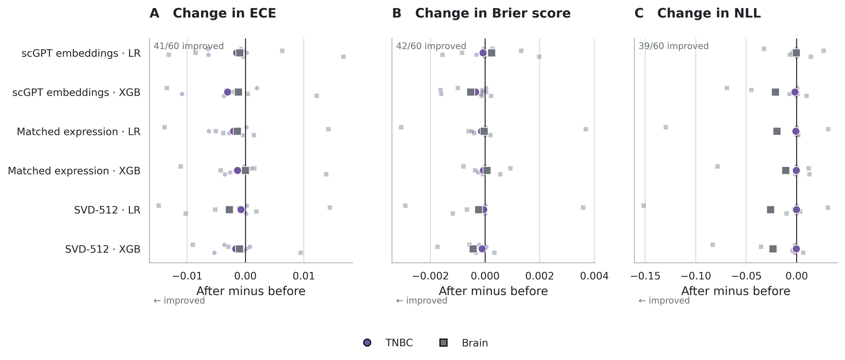
Figure 4. Held-out-donor temperature scaling. Fold-level changes after scalar temperature scaling for equal-width expected calibration error (ECE), multiclass Brier score and negative log-likelihood (NLL). Small points are individual outer folds; large points are dataset means. Negative differences indicate improvement. Circles denote TNBC and squares denote brain. LR, Logistic Regression; XGB, XGBoost.
Table 5. Held-out-donor temperature scaling, averaged over TNBC and brain (ten outer folds). Lower values are better.
Representation | Classifier | ECE before | ECE after | Brier before | Brier after | NLL before | NLL after
scGPT embeddings | Logistic Regression | 0.0073 | 0.0060 | 0.0293 | 0.0294 | 0.0713 | 0.0708
scGPT embeddings | XGBoost | 0.0083 | 0.0062 | 0.0337 | 0.0333 | 0.0873 | 0.0758
Matched expression | Logistic Regression | 0.0069 | 0.0051 | 0.0231 | 0.0230 | 0.0630 | 0.0528
Matched expression | XGBoost | 0.0069 | 0.0062 | 0.0221 | 0.0221 | 0.0602 | 0.0545
SVD-512 | Logistic Regression | 0.0066 | 0.0048 | 0.0239 | 0.0238 | 0.0673 | 0.0542
SVD-512 | XGBoost | 0.0070 | 0.0056 | 0.0242 | 0.0239 | 0.0696 | 0.0576

Matched expression retains an advantage under strict label scarcity
The Indonesia-PBMC sensitivity recomputed gene selection and vocabulary matching from the labelled subset alone. With 10 labelled cells per class, matched expression reached a mean donor-held-out Macro F1 of 0.818 (SD 0.025), compared with 0.779 (SD 0.032) for scGPT embeddings. At 50, 100, 250 and 500 labels per class, the corresponding values were 0.886 versus 0.841, 0.904 versus 0.855, 0.922 versus 0.872 and 0.930 versus 0.881 (Figure 5; Table 6). The fold-mean matched-expression difference ranged from 0.040 at 10 labels per class to approximately 0.051 at 250 labels per class and was positive in every outer fold at every budget. This discrimination advantage did not imply uniformly better uncalibrated ECE: at 100–500 labels per class, the scGPT-embedding Logistic Regression pipelines had lower mean top-label ECE.
Table 6. Strict Indonesia-PBMC label scarcity. Feature selection and tuning used only the labelled cells. Macro F1 is mean ± SD across five donor-held-out folds after averaging the two sampling seeds within fold.
Labels per class | scGPT embeddings | Matched expression | Mean matched HVGs
10 | 0.779 ± 0.032 | 0.818 ± 0.025 | 1,169
50 | 0.841 ± 0.013 | 0.886 ± 0.019 | 1,160
100 | 0.855 ± 0.009 | 0.904 ± 0.013 | 1,156
250 | 0.872 ± 0.006 | 0.922 ± 0.006 | 1,154
500 | 0.881 ± 0.008 | 0.930 ± 0.008 | 1,149

Class-level errors reveal distinct biological regimes
The TNBC XGBoost pipelines performed strongly across all seven portal categories, but most remaining errors involved lymphocyte boundaries. scGPT embeddings assigned 9.9% of B-lineage lymphocytes to the T-cell class, compared with 3.7% for matched expression; the corresponding B-lineage F1 values were 0.916 and 0.967. Myeloid-to-T-cell confusion was 3.3% with scGPT and 1.5% with matched expression. These differences account for much of the aggregate TNBC advantage while showing that the broad stromal and endothelial categories were already near saturation.
PBMC contained more closely related immune categories. With XGBoost, scGPT embeddings confused 19.7% of naive CD8 T cells with CD4 T cells, whereas matched expression reduced this to 7.0%. Reciprocal CD8–natural-killer confusion remained prominent in both representations. The lowest scGPT class F1 was 0.830 for naive CD8 T cells, compared with 0.913 for matched expression. These errors are biologically plausible at broad portal boundaries but also show that a pooled accuracy can conceal systematic redistribution among related lymphocyte states.
Brain showed the opposite representation ordering and the strongest class imbalance. The rare central-nervous-system macrophage, perivascular-cell and pericyte categories each contained only 104–113 cells. Their XGBoost F1 values ranged from 0.775 to 0.911 with scGPT embeddings and from 0.777 to 0.853 with matched expression. Central-nervous-system macrophages were frequently assigned to microglia, while perivascular cells, pericytes and oligodendrocyte precursor cells were frequently assigned to oligodendrocytes. These rare-class errors explain why pooled accuracy exceeded 0.98 even when Macro F1 was substantially lower. Full class metrics and row-normalized confusion matrices are provided in Supplementary Figures S3–S4 and Tables S10–S11.
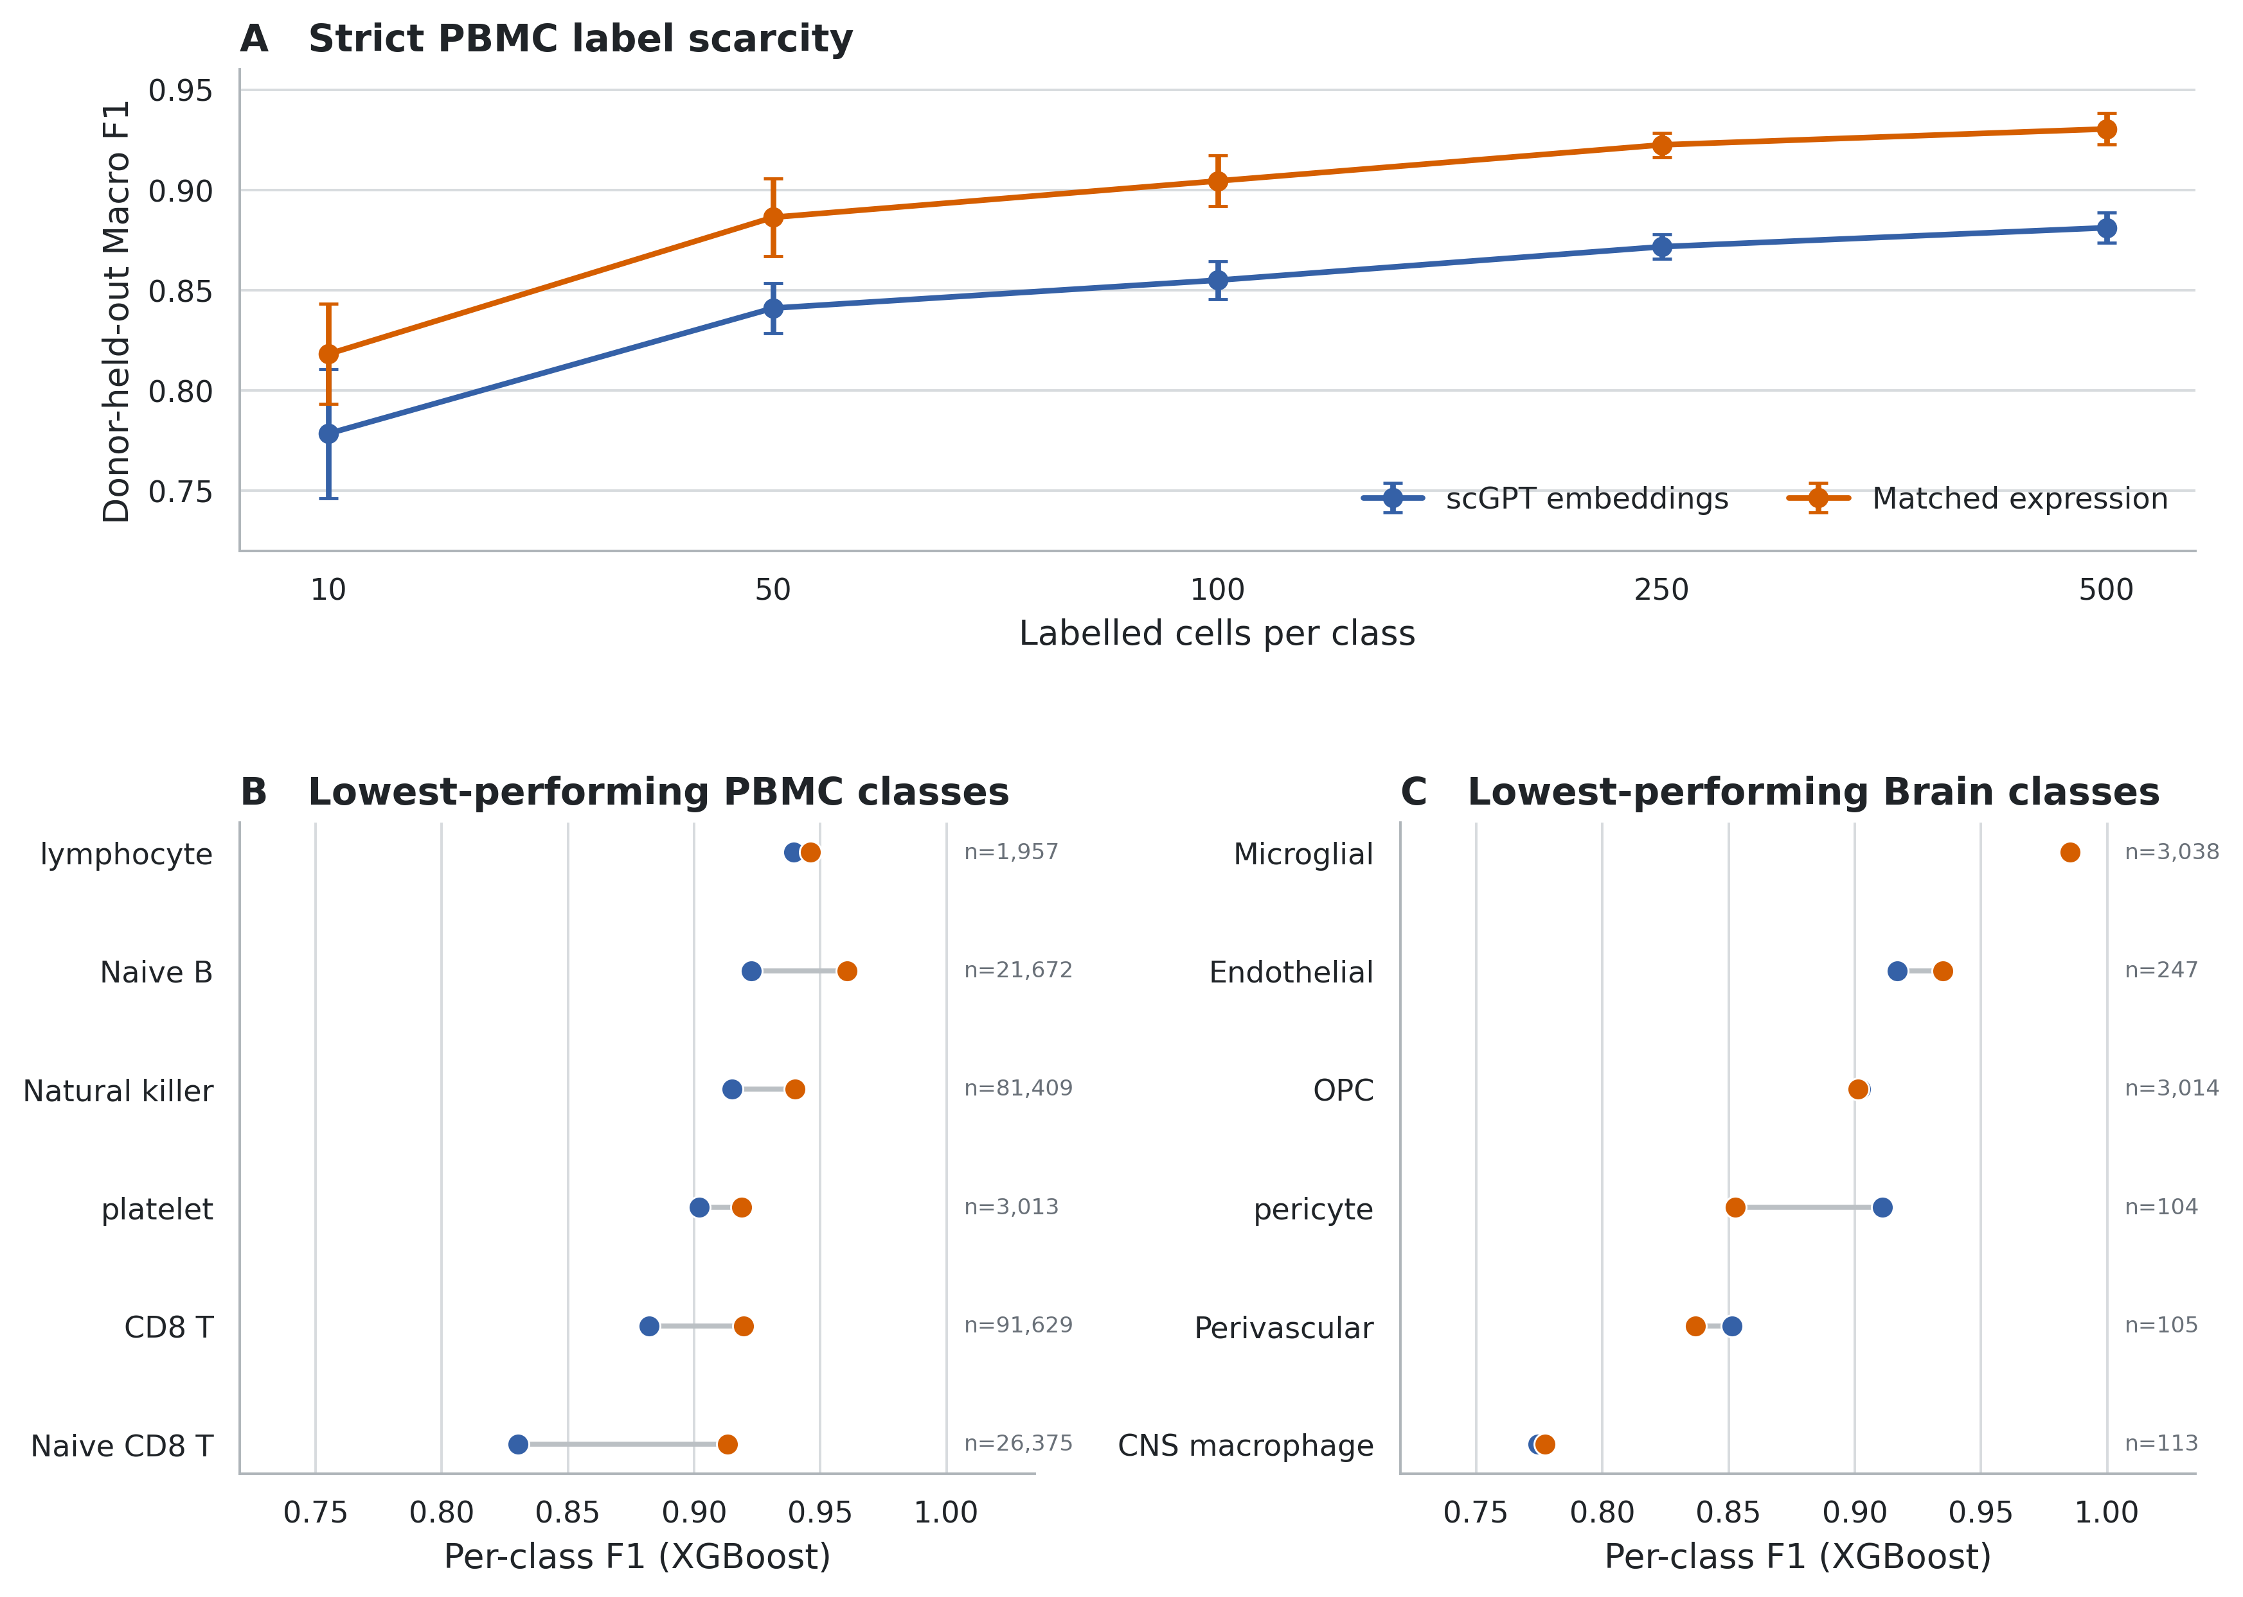
Figure 5. Strict scarcity and class-level performance. (A) Indonesia-PBMC Macro F1 when feature selection and model selection use only the indicated labelled cells. Points are means across five outer donor folds after averaging two sampling seeds within fold; bars are fold SD. (B–C) XGBoost F1 for the six lowest-performing portal classes by mean representation-level F1 in PBMC and brain.

Pig pancreas remains a cross-species stress test

The porcine object contained one donor ID, so donor-held-out evaluation was impossible. Under the separate random-cell stress test, matched expression produced Macro F1 values of 0.988, 0.989 and 0.992 with Logistic Regression, Random Forest and XGBoost, respectively. Frozen human-scGPT embeddings produced 0.966, 0.613 and 0.888, while SVD-512 produced 0.987, 0.938 and 0.967. These high values partly reflect interpolation among randomly separated cells from the same object. Because the whole-human checkpoint was applied through direct/uppercase symbol matching without an orthology map, these results are not included in the primary evidence and do not evaluate a principled cross-species scGPT workflow.

Discussion

This benchmark addresses a deliberately narrow practical question: when cell labels are predicted from a fixed frozen-scGPT representation, how does the complete pipeline compare with supervised models trained on the same selected expression variables? The answer was atlas-dependent. Matched expression outperformed scGPT embeddings with every prespecified classifier in TNBC and PBMC, whereas scGPT embeddings were higher with all three classifiers in brain. Donor-cluster intervals supported all six TNBC and PBMC expression advantages, supported the scGPT advantage for brain Random Forest, and did not separate the brain Logistic Regression or XGBoost pipelines. The resulting conclusion is not that either representation is universally superior. It is that frozen scGPT utility depends on tissue, label structure and downstream learner, and that strong matched-expression models remain necessary controls.

The donor-held-out design changes the meaning of the benchmark. Randomly separating cells within an atlas estimates interpolation when donor, sample and batch signatures can occur on both sides of the split. Grouping every donor's cells together instead asks whether a labelled training cohort supports annotation of an unseen donor processed within the same curated resource. The evaluated test sets therefore exclude direct donor overlap, but they do not constitute external-atlas validation. Acquisition protocols, annotation conventions, ancestry composition and study-specific curation remain shared within each resource. The appropriate interpretation is within-atlas unseen-donor performance, not broad biological generalization.

Fairness between representations requires more than supplying the same classifier name. The official scGPT embeddings are unit-normalized and 512-dimensional, while matched expression is sparse, differently scaled and approximately twice as wide. A fixed Logistic Regression penalty can act differently in these spaces. Independent searches over regularization and scaling remove that avoidable asymmetry. The same principle applies to tree learners, whose feature-sampling and depth choices interact with representation geometry. Keeping the classifier fixed for each primary contrast also prevents a favourable head from being chosen after observing outer-test performance.
The SVD-512 control clarifies the role of compression. A training-fitted 512-component expression projection retained most of the uncompressed expression performance, with Logistic Regression differences of only 0.0005–0.0049 across the three atlases. SVD-512 preserved the matched-expression advantage over scGPT in TNBC and PBMC and the scGPT advantage in brain. Thus, the results are not consistent with a simple explanation in which reducing approximately 1,100 selected genes to 512 coordinates necessarily causes the observed losses. At the same time, SVD is not a substitute for scVI, does not model counts generatively and does not remove batch effects. Generative latent-variable baselines remain an important extension.
The brain result is an informative counterexample to a one-directional narrative. Rare macrophage, vascular and precursor classes contributed strongly to Macro F1 despite accounting for a small fraction of cells. scGPT may preserve features useful for separating some rare brain populations, or its pretraining distribution may be more favourable for this tissue. The present design cannot distinguish those mechanisms. Only 12 brain donors were available, and the conditional intervals were correspondingly wider than in TNBC and PBMC. The Random Forest interval nevertheless favoured scGPT, while Logistic Regression and XGBoost remained uncertain at the donor-resampling level. Reporting all three fixed heads prevents one of these outcomes from being elevated post hoc.

The strict scarcity experiment did not reveal a reversal in favour of frozen scGPT embeddings. Matched expression had higher Macro F1 at every tested label budget and in every outer fold even when the gene list was learned only from labelled cells. At the smallest budget, both representations exceeded 0.77 mean Macro F1 across 13 PBMC categories, showing that the supervised heads extracted useful signal from very limited labels. Calibration told a different story: scGPT embeddings sometimes gave lower uncalibrated ECE at larger budgets despite lower discrimination. This divergence reinforces that accuracy, calibration and representation utility are separate properties.

Calibration must be attributed to the complete prediction pipeline. Frozen scGPT supplies a vector, not the class probability used here; the supervised head and its regularization shape confidence. Random Forest was substantially less calibrated than Logistic Regression and XGBoost in TNBC and PBMC for both representations. Temperature scaling improved mean ECE, Brier score and NLL in the TNBC and brain sensitivity analysis, but improvement was not universal at the individual fold level. A scalar temperature cannot repair class confusion or missing biological information, and improved ECE does not guarantee simultaneous improvement in every proper score. Reliability-bin counts, Brier score and NLL should therefore accompany ECE, preferably under external cohort shift.
Class-level results similarly limit any single-number account. In TNBC, the main difference was not a general failure of one representation but a concentration of errors at B-lineage, T-cell and myeloid boundaries. In PBMC, naive and conventional CD8 T cells overlapped with CD4 T and natural-killer categories, with larger errors from scGPT embeddings. Brain errors clustered among biologically related or rare populations, including central-nervous-system macrophages versus microglia and vascular-associated cells versus oligodendrocytes. Portal categories provide reproducible targets, but they are not an error-free biological ground truth. Differences may reflect transcriptional continuity, donor-specific abundance, annotation granularity or label harmonization as well as representation quality.

The pig analysis illustrates why dataset count should not be confused with independent evidence. One donor value cannot support donor-held-out inference, and direct uppercase symbol matching is not a defensible orthology workflow. The high random-split scores show only that the pipelines can interpolate broad categories within this object. A dedicated cross-species evaluation would require an explicit orthologue map, species-aware preprocessing, multiple animals and animal-held-out validation.
The uncertainty analysis improves the biological unit of inference but remains conditional. Donor-cluster resampling preserves within-donor dependence and pairs the representation contrast. It does not refit HVG selection, SVD or models. Repeating the complete nested workflow inside each bootstrap replicate would quantify additional training and selection variability but would be substantially more computationally demanding. The reported intervals therefore show sensitivity to the observed donor composition after fitting. Independent cohorts remain the strongest test of reproducibility.

Several limitations define the evidence boundary. The human benchmark contains three atlases and does not cover the full diversity of tissues, technologies or disease contexts; in particular, a completed donor-held-out TME or human-pancreas analysis is not part of the evidence. SVD-512 Random Forest and XGBoost were not available as complete five-fold pipelines for PBMC and were omitted rather than imputed. Temperature scaling was restricted to TNBC and brain. Only scGPT 0.2.5, one released whole-human checkpoint and one frozen embedding interface were studied. Official end-to-end fine-tuning, newer checkpoints, scVI-like baselines and other foundation models were not tested. Public checkpoint pretraining may overlap source studies, and available metadata do not support a complete cell-level overlap audit. The target labels are broad and differ in granularity among atlases. Finally, the benchmark concerns supervised annotation of known categories rather than novel-state discovery, perturbation response, regulatory inference or multimodal transfer.
Within those boundaries, the study provides a reproducible evaluation template. Foundation-model embeddings should be compared with strong matched inputs, tuned on training groups, assessed under biological holdout and evaluated as complete representation–classifier pipelines. Compression controls and class-level errors are needed to interpret performance differences, while calibration should be reported with multiple probability metrics and a clearly identified calibration cohort. These practices remain useful whether a pretrained representation wins, ties or loses.

Conclusions

Pretrained representations are often assumed to provide a more powerful starting point for cell annotation than conventional expression features. This study shows why that assumption must be tested rather than accepted. Carefully matched expression models were more accurate in the TNBC and PBMC atlases, whereas frozen scGPT representations were more useful in brain. The practical lesson is that the best representation depends on the tissue, the label structure and the intended use; it cannot be chosen from the reputation or scale of the underlying model alone.
For researchers applying single-cell foundation models, frozen scGPT embeddings should therefore be treated as one candidate representation, not as a default replacement for transparent expression baselines. Biological donor holdout, fair model tuning, confidence quality and class-specific errors all matter when deciding whether a pretrained representation adds value. The broader contribution of this benchmark is a practical framework for making that decision. It identifies settings in which frozen scGPT helps, settings in which simpler models remain stronger, and the evidence needed before claiming an advantage. Whether official fine-tuning, newer models or transfer across independent cohorts changes this balance remains an important question for future work.

References
1. Macosko, E. Z., Basu, A., Satija, R. et al. Highly parallel genome-wide expression profiling of individual cells using nanoliter droplets. Cell 161:1202–1214 (2015). https://doi.org/10.1016/j.cell.2015.05.002.
2. Zheng, G. X. Y., Terry, J. M., Belgrader, P. et al. Massively parallel digital transcriptional profiling of single cells. Nature Communications 8:14049 (2017). https://doi.org/10.1038/ncomms14049.
3. Tanay, A., Regev, A. Scaling single-cell genomics from phenomenology to mechanism. Nature 541:331–338 (2017). https://doi.org/10.1038/nature21350.
4. Regev, A., Teichmann, S. A., Lander, E. S. et al. The Human Cell Atlas. eLife 6:e27041 (2017). https://doi.org/10.7554/eLife.27041.
5. Consortium, T. T. S. The Tabula Sapiens: a multiple-organ single-cell transcriptomic atlas of humans. Science 376:eabl4896 (2022). https://doi.org/10.1126/science.abl4896.
6. Luecken, M. D., Theis, F. J. Current best practices in single-cell RNA-seq analysis: a tutorial. Molecular Systems Biology 15:e8746 (2019). https://doi.org/10.15252/msb.20188746.
7. Aran, D., Looney, A. P., Liu, L. et al. Reference-based analysis of lung single-cell sequencing reveals a transitional profibrotic macrophage. Nature Immunology 20:163–172 (2019). https://doi.org/10.1038/s41590-018-0276-y.
8. Kiselev, V. Y., Yiu, A., Hemberg, M. scmap: projection of single-cell RNA-seq data across data sets. Nature Methods 15:359–362 (2018). https://doi.org/10.1038/nmeth.4644.
9. Alquicira-Hernández, J., Sathe, A., Ji, H. P. et al. scPred: accurate supervised method for cell-type classification from single-cell RNA-seq data. Genome Biology 20:264 (2019). https://doi.org/10.1186/s13059-019-1862-5.
10. Hao, Y., Hao, S., Andersen-Nissen, E. et al. Integrated analysis of multimodal single-cell data. Cell 184:3573–3587 (2021). https://doi.org/10.1016/j.cell.2021.04.048.
11. Abdelaal, T., Michielsen, L., Cats, D. et al. A comparison of automatic cell identification methods for single-cell RNA sequencing data. Genome Biology 20:194 (2019). https://doi.org/10.1186/s13059-019-1795-z.
12. Pasquini, G., Rojo Arias, J. E., Schäfer, P., Busskamp, V. Automated methods for cell type annotation on scRNA-seq data. Computational and Structural Biotechnology Journal 19:961–969 (2021). https://doi.org/10.1016/j.csbj.2021.01.015.
13. Domínguez Conde, C., Xu, C., Jarvis, L. B. et al. Cross-tissue immune cell analysis reveals tissue-specific features in humans. Science 376:eabl5197 (2022). https://doi.org/10.1126/science.abl5197.
14. Lopez, R., Regier, J., Cole, M. B. et al. Deep generative modeling for single-cell transcriptomics. Nature Methods 15:1053–1058 (2018). https://doi.org/10.1038/s41592-018-0229-2.
15. Luecken, M. D., Büttner, M., Chaichoompu, K. et al. Benchmarking atlas-level data integration in single-cell genomics. Nature Methods 19:41–50 (2022). https://doi.org/10.1038/s41592-021-01336-8.
16. Yang, F., Wang, W., Wang, F. et al. scBERT as a large-scale pretrained deep language model for cell type annotation of single-cell RNA-seq data. Nature Machine Intelligence 4:852–866 (2022). https://doi.org/10.1038/s42256-022-00534-z.
17. Theodoris, C. V., Xiao, L., Chopra, A. et al. Transfer learning enables predictions in network biology. Nature 618:616–624 (2023). https://doi.org/10.1038/s41586-023-06139-9.
18. Cui, H., Wang, C., Maan, H. et al. scGPT: toward building a foundation model for single-cell multi-omics using generative AI. Nature Methods 21:1470–1480 (2024). https://doi.org/10.1038/s41592-024-02201-0.
19. Hao, M., Gong, J., Zeng, X. et al. Large-scale foundation model on single-cell transcriptomics. Nature Methods 21:1481–1491 (2024). https://doi.org/10.1038/s41592-024-02305-7.
20. Rosen, Y., Roohani, Y., Agrawal, A. et al. Universal cell embeddings: a foundation model for cell biology. bioRxiv (2023). https://doi.org/10.1101/2023.11.28.568918.
21. Boiarsky, R., Singh, N. M., Buendia, A. et al. Deeper evaluation of a single-cell foundation model. Nature Machine Intelligence 6:1443–1446 (2024). https://doi.org/10.1038/s42256-024-00949-w.
22. Kędzierska, K. Z., Crawford, L., Amini, A. P., Lu, A. X. Zero-shot evaluation reveals limitations of single-cell foundation models. Genome Biology 26:101 (2025). https://doi.org/10.1186/s13059-025-03574-x.
23. Roberts, D. R., Bahn, V., Ciuti, S. et al. Cross-validation strategies for data with temporal, spatial, hierarchical, or phylogenetic structure. Ecography 40:913–929 (2017). https://doi.org/10.1111/ecog.02881.
24. Squair, J. W., Gautier, M., Kathe, C. et al. Confronting false discoveries in single-cell differential expression. Nature Communications 12:5692 (2021). https://doi.org/10.1038/s41467-021-25960-2.
25. Guo, C., Pleiss, G., Sun, Y., Weinberger, K. Q. On calibration of modern neural networks. Proceedings of the 34th International Conference on Machine Learning 70:1321–1330 (2017).
26. Vaicenavicius, J., Widmann, D., Andersson, C., Lindsten, F., Roll, J., Schön, T. B. Evaluating model calibration in classification. Proceedings of the Twenty-Second International Conference on Artificial Intelligence and Statistics 89:3459–3467 (2019).
27. Silva Filho, T., Song, H., Perelló-Nieto, M. et al. Classifier calibration: a survey on how to assess and improve predicted class probabilities. Machine Learning 112:3211–3260 (2023). https://doi.org/10.1007/s10994-023-06336-7.
28. Brier, G. W. Verification of forecasts expressed in terms of probability. Monthly Weather Review 78:1–3 (1950).
29. Gneiting, T., Raftery, A. E. Strictly proper scoring rules prediction and estimation. Journal of the American Statistical Association 102:359–378 (2007). https://doi.org/10.1198/016214506000001437.
30. Nixon, J., Dusenberry, M. W., Zhang, L. et al. Measuring calibration in deep learning. Proceedings of the CVPR Workshops (2019).
31. Program, C. S. B., Abdulla, S., Aevermann, B. et al. CZ CELL×GENE Discover: a single-cell data platform for scalable exploration analysis and modeling of aggregated data. bioRxiv (2023). https://doi.org/10.1101/2023.10.30.563174.
32. Fachrul, M., Sukonthamarn, P., Kusuma, P. et al. Ancestral and environmental diversity shape the immune landscape in Indonesia. bioRxiv (2026). https://doi.org/10.64898/2026.02.15.704933.
33. Takeuchi, E. et al. Single-nucleus multiome shows motor neuron glutamate overactivation in amyotrophic lateral sclerosis. Brain (2025). https://doi.org/10.1093/brain/awaf426.
34. Tritschler, S., Thomas, M., Böttcher, A. et al. A transcriptional cross species map of pancreatic islet cells. Molecular Metabolism 66:101595 (2022). https://doi.org/10.1016/j.molmet.2022.101595.
35. Stuart, T., Butler, A., Hoffman, P. et al. Comprehensive integration of single-cell data. Cell 177:1888–1902 (2019). https://doi.org/10.1016/j.cell.2019.05.031.
36. Wolf, F. A., Angerer, P., Theis, F. J. SCANPY: large-scale single-cell gene expression data analysis. Genome Biology 19:15 (2018). https://doi.org/10.1186/s13059-017-1382-0.
37. Breiman, L. Random forests. Machine Learning 45:5–32 (2001). https://doi.org/10.1023/A:1010933404324.
38. Chen, T., Guestrin, C. XGBoost: a scalable tree boosting system. Proceedings of the 22nd ACM SIGKDD International Conference on Knowledge Discovery and Data Mining:785–794 (2016). https://doi.org/10.1145/2939672.2939785.
39. Pedregosa, F., Varoquaux, G., Gramfort, A. et al. Scikit-learn: machine learning in Python. Journal of Machine Learning Research 12:2825–2830 (2011).

Declarations
Ethics approval and consent to participate. Not applicable. This study used only publicly available, fully de-identified single-cell RNA-sequencing datasets distributed through the Chan Zuckerberg CELL×GENE Discover portal under the original data generators’ ethics approvals. No new participants were recruited and no new specimens were collected.
Consent for publication. Not applicable.
Availability of data and materials. The four datasets reported in this study are publicly available through the CZ CELL×GENE Discover portal. For each dataset, the collection page, interactive Explorer page and direct H5AD download are provided below.
TNBC breast cancer. Collection: https://cellxgene.cziscience.com/collections/ceef2841-5333-46ac-92ef-ccbe0c20fe55; Explorer: https://cellxgene.cziscience.com/e/6f9de485-58cd-4342-bfc4-b3d3dd223aa8.cxg/; Direct H5AD: https://datasets.cellxgene.cziscience.com/af8c4fce-4c63-4671-b339-91a383cf36f6.h5ad
Indonesia PBMC. Collection: https://cellxgene.cziscience.com/collections/d1e0e64d-6d2a-4a3e-b7f4-43ed909a9d9c; Explorer: https://cellxgene.cziscience.com/e/ca7d95ac-53aa-4a94-8c76-300c608ce6a0.cxg/; Direct H5AD: https://datasets.cellxgene.cziscience.com/665714af-4be5-49a3-913b-5ab5ac25620d.h5ad
Brain atlas. Collection: https://cellxgene.cziscience.com/collections/0986e4cd-7a58-405d-9b91-4b199bb4124e; Explorer: https://cellxgene.cziscience.com/e/e2a00644-0a48-4815-ae87-d562045114f5.cxg/; Direct H5AD: https://datasets.cellxgene.cziscience.com/0ab54d91-066c-4223-a9ea-6a3b0d1adef4.h5ad
Pig pancreas. Collection: https://cellxgene.cziscience.com/collections/0a77d4c0-d5d0-40f0-aa1a-5e1429bcbd7e; Explorer: https://cellxgene.cziscience.com/e/db4a9ed2-e994-40c1-b7ec-4091fdf7b6c1.cxg/; Direct H5AD: https://datasets.cellxgene.cziscience.com/55cfae87-6348-44df-a4ed-c132569dea54.h5ad
The released whole-human scGPT checkpoint and source are available from https://github.com/bowang-lab/scGPT. Analysis code and aggregate outputs are available under the MIT licence at https://github.com/alirezakhosravii/scGPTvsClassical.
Competing interests. The authors declare that they have no competing interests.
Funding. This research was supported by the OPUS grant of the National Science Centre, Poland (grant number 2020/37/B/NZ7/02069) and by the National Recovery Plan grant of the Medical Research Agency, Poland (grant number KPOD.07.07-IW.07-0007/24). Cloud GPU computational costs were personally funded by A.K. The funding bodies played no role in study design; data collection, analysis or interpretation; manuscript preparation; or the decision to submit the work.
Authors’ contributions. A.K. conceptualised the study, designed the methodology, implemented the software, performed the formal analysis and investigation, curated the data, produced the visualisations, drafted the manuscript, and contributed to review and editing. Ar.K. contributed to software implementation, formal analysis, and manuscript review and editing. K.Ł. and M.S. contributed to manuscript review and editing. K.P. contributed to manuscript review and editing and to supervision. A.S. contributed to conceptualisation, manuscript review and editing, supervision, and project administration. A.J.Ż. contributed to manuscript review and editing, supervision, and funding acquisition. All authors read and approved the final manuscript.
Acknowledgements. The authors thank the staff of the Centre of Biostatistics and Bioinformatics Analysis, Medical University of Gdańsk, and in particular Małgorzata Madej for her support. The authors thank the Chan Zuckerberg Initiative for open access to the CELL×GENE Discover portal and the curated single-cell datasets used in this study, and acknowledge the scGPT development team at the Wang Lab, University of Toronto, for releasing the model weights and Python package. Computational resources were provided by RunPod cloud GPU services.

