TosGUI: TinyOS Graphical Simulation Project Summary

Mark E. Miyashita
May 2, 2002
Kent State University

1. Project introduction

The goal of this project was to create a simple but effective graphical user interface (GUI) for TinyOS simulation that would depict network topology formed by running the simulation. In addition, this project began in fall semester, must adapt, not only to the new distribution of TinyOS 6.0 which modified underlying assumptions such as the socket port number and the method used to simulate motes on the PC, but also to extend the functionality of the original source code to include support such as simulations using physical motes. This project is an attempt to enable one to see the network topology when one is running the simulation on a PC or on physical motes connected through a serial port. The standard distribution of TinyOS provides message outputs generated by simulated motes in the network by means of a standard output to the screen. Other tools included as part of TinyOS distribution lack any GUI tools that enable one to understand topology through either a simulation on a PC or a physical mote; it simply provides simple tools to capture the network packet injected into the network. Thus, it is difficult to understand the network topology generated by the simulation. Therefore, the goal for this project was to create a simple front end GUI, implemented in Java, to display graphically the network topology. In addition, the project must include enough examples of the use of Java Swing components so that others can make future modifications easily.
This project summary will discuss implementation details, how to use this simulation, and suggested enhancements that can be made to this project’s source files.

2. How to run tosGUI

All Java source project files are compiled under the Java 2 platform version 1.3.0, using Swing components for the graphical user interface. For IBM distribution Java 2 platform running under Linux, you must also have separately downloaded Java communication API from IBM (this does not apply to SUN distribution) in order to compile the source code. This Java communication API will allow a programmer to code the serial port IO in the Linux platform by means of importing “javax.comm.*” class file. In order to compile the source programs, one must execute command "javac tosGUI.java". This will create all necessary class files needed to run tosGUI front end. To execute tosGUI just compiled, one must execute command "java tosGUI" which will prepare and display the GUI as shown in figure 1. Also, a help facility is provided to override any default settings (explained next in detail) at the start up by starting tosGUI by command “java tosGUI –h”. This will produce the output shown below.

Java tosGUI [-<optionflag>]
-h : Display this message
-comm : Set Serial port name
-port : Set server socket name
-debug : Display debug message

This startup option may be redundant because these settings can be altered after starting up the tosGUI. However, it provides a means to demonstrate this use for students who may alter the source file in the future.

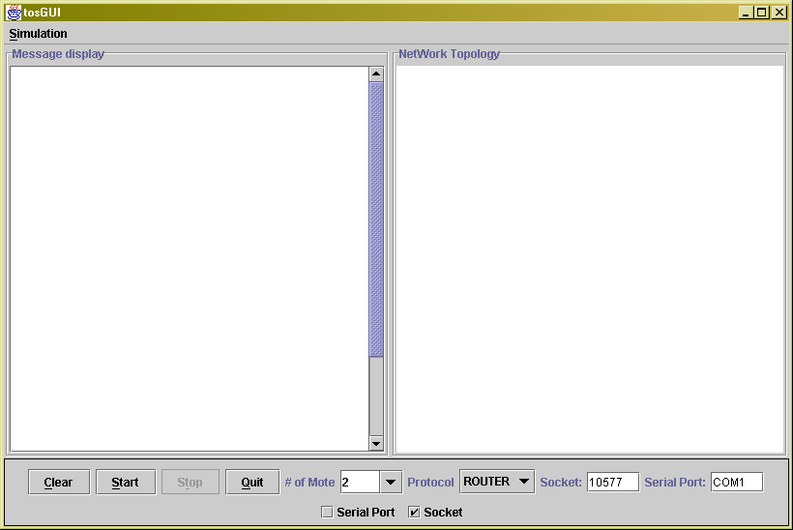

Figure 1

As a default, tosGUI selects two motes to be simulated as indicated in the Combo Box labeled “# of mote”. This Combo Box is editable, and a user can pick as many motes to be simulated as possible, in addition to the default selection listed under the drop down list. Also as a default, a second combo box labeled “Protocol” will select the router application to be simulated. This Combo Box is left un-editable so that this tool can limit the use of supported TinyOS applications based on what has been implemented in the tool. In other words, “router” is one of the applications that enables tosGUI to understand packet format and render the topology. Furthermore, when the user of this tool simulates unsupported applications (contradicting protocol selection), it will simply display all packets traveling through the socket or the serial port but will not render the topology formed. This behavior is normal because TinyOS’s message size is standardized to 36 bytes. The other default settings for tosGUI (as depicted in figure 1) are socket number and serial port name. These two fields can be edited so that the user can not only change the socket and/or the serial port name to which the simulation must listen for the network traffic, but which also anticipates that the future release of TinyOS may change these settings.
Also note that the bottom panel controls the simulation in the tosGUI program. The "start" button will begin the simulation based on the selection the user made for the number of motes, protocol, and either the user socket (PC simulation) or the serial port (physical mote). The "stop" button will stop the simulation, while the "clear" button will clear the mote message display panel on the left side of the frame (labeled “message display”). Finally, the "quit" button allows one to exit the application.
In addition to the "quit" button, the application also handles a standard window event (window minimize, window maximize, and window close) by allowing the user to click on one of the three buttons at the top right corner. Also, the menu item labeled "Simulation" contains the submenu "exit" which allows an additional means of terminating the application, and “print” which will print the network topology at the time of execution. These menu items were designed such that a future project could incorporate additional functionality into the application through menu items by simple inspection of the source code.
The picture below (figure 2) depicts what happens after the user starts the simulation by first selecting five motes to be simulated and then clicking on the "start" button.

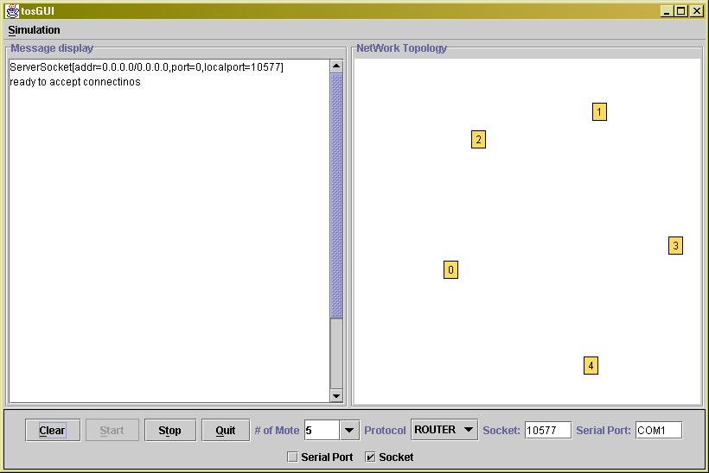

Figure 2

After initializing the simulation, the message display panel to the left shows the opening of sockets, ready to accept messages. On the other hand, the network topology panel to the left shows a graphical representation of five motes on the network. Each node is represented by a rectangle with a mote number. The drawing of the initial topology is randomly placed on the panel, which a user can adjust by dragging a single mote to the location the user prefers to be displayed; or the user can single click on the panel, which will move the closest mote on the panel to the location of the mouse click.
Once a user has started tosGUI, the user must then start, in a separate window, the TOSSIM by previously compiling TOS under the binpc directory or downloaded code to the physical mote. Upon completion of starting all motes using the TOSSIM or switching on all physical motes, the tosGUI will show that the message was passed among the motes and that the network topology has been formed. The picture below (figure 3) shows what the user will see in tosGUI.

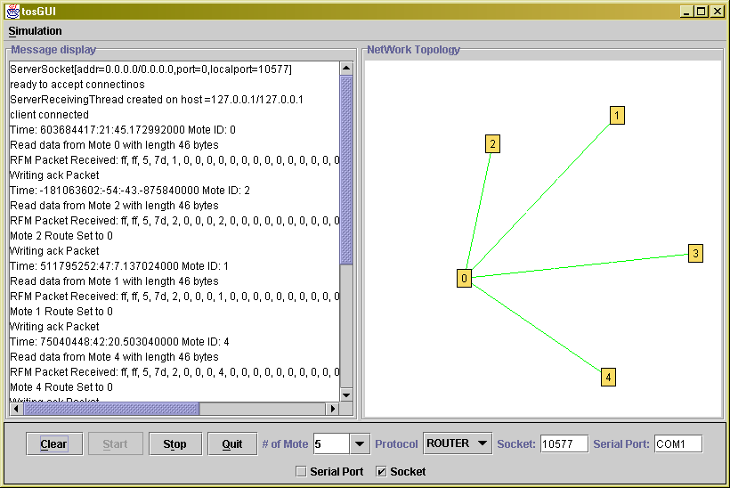

Figure 3

The green line linking the nodes indicates that the route is set between the two nodes. If the route is not set between the two nodes, then there will be no line linking the nodes between them. Thus, once the simulations are started in a separate window using the TOSSIM or physical mote, the diagram will show the link changing among nodes simulated as routing information propagates.
One of the additional features added in this project is printing capability. In order to print the network topology formed during the simulation, select the “simulation” menu bar and then select the submenu titled “Print”. Alternatively, user can use “CTR+S” to open the “Simulation” menu bar and then use “CTR+P” to select the “print” submenu. Depending on the platform upon which the user is running the tosGUI, the actual print dialog may appear different. However, on the Windows platform, the picture in figure 4 depicts an example of how such a print dialog appears on the screen after print action is initiated.

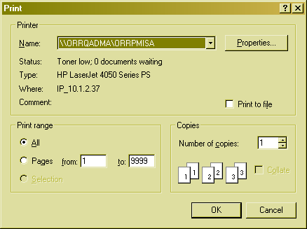

Figure 4

After the printer selection is made and, if necessary, other printer properties have been selected, the next step is simply to click on the “OK” button and the printing process will begin. When printing completes, the dialog shown in figure 5 will appear on the screen to indicate successful completion.

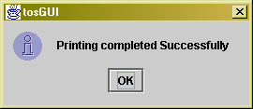

Figure 5

In addition to the printing functionality, there are some other enhancements made to overall GUI functionality; namely, the progress bar displayed during the initialization of tosGUI after the user selects the “start” button. This feature was added because of the length of time that occurs internally before tosGUI becomes available for simulation (such as attempt to simulate over 500 motes). For a simple simulation, the progress bar will appear but will disappear shortly after starting the simulation. Figure 6 shows an example of the progress bar in action.
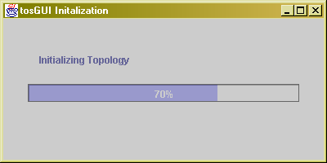

Figure 6

The final notable enhancement made to the GUI in this project invokes the use of dialog to display error messages. For example, if a user selects an invalid serial port name, dialog will notify the user of such an error. Similarly, if the user selects a socket in which a socket cannot be opened, dialog will appear and notify the user of such error. In both instances, the application will reset status internally and wait for the user’s next action. Figure 7 and 8 show examples of the use of the dialog feature just discussed.

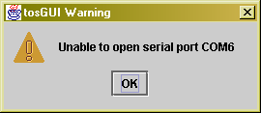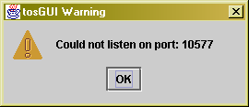

Figure 7 Figure 8

3. Implementation details

In this section, some implementation details are described so that others who may wish to pursue future projects can understand this implementation without reading the source code in detail. The source code is made up of ButtonPannel.java, DisplayPannel.java, GraphicsPannel.java, MoteConnection.java, SocketManager.java, and tosGUI.java. This section will describe each Java source file and its key concept which comprises GUI implementation.

tosGUI.java

This file contains the source code for creating a top frame that puts all other panels, namely, display panels, graphics panels, and button panels on to this top-level frame. In addition, it handles menu items and standard windows’ events such as minimizing, maximizing, and closing events. This is the file that implements the main method and starts its own thread. In a future project, others may wish to add additional functionality by implementing additional menu items. Below is a portion of the actual code implemented in this file.

public class tosGUI extends JFrame implements ActionListener {
private ButtonPanel buttons; /* Control panel with buttons */
private static DisplayPanel display; /* Text area with Mote message output */
private GraphicsPanel topology; /* Panel with Network topology */

public tosGUI() { /* Constructor */

super("tosGUI"); /* Set Header for the frame */
JMenuBar menuBar;
JMenu menu;
JMenuItem menuItem;

<some code omitted here>

/* Create the Menu bar */

menuBar = new JMenuBar();
setJMenuBar(menuBar);
menu = new JMenu("Simulation");
menu.setMnemonic(KeyEvent.VK_S);
menuBar.add(menu);
menuItem = new JMenuItem("Exit", KeyEvent.VK_E);
menuItem.addActionListener(this);
menu.add(menuItem);

<some code omitted here>

} /* End of constructor */

/* Handle Menu item action "exit" */
public void actionPerformed(ActionEvent e) {

if (e.getActionCommand().equals("Exit")) System.exit(0);
}

As shown in the code example above, it is easy to add additional menu items and associated shortcuts to the source code. In addition, the code example below shows how to enhance the application run time options by adding additional standard output messages to indicate such options. In short, this method is used to display command line arguments that could be used with this application. Any additional command line arguments can be added here for display. Note that if you add option, you must implement them in the right place. First, one must pass them into the tosGUI constructor; next, one must implement them in the appropriate source section.

public static void usage() {

System.out.println("java tosGUI [-<optionflag>]");
System.out.println("\t -h : Displays this message");
System.out.println("\t -comm [serial port name|host:port]");
System.out.println("\t -port [server port]");
System.out.println("\t -debug = display debug messages");

}
ButtonPanel.java

The main goal of this file is to implement a panel that controls the entire application. This panel is used to display buttons and drop down boxes under a central location where simulation is controlled. For instance, the user can start, stop, clear, and select the number of motes to be simulated. The default number of motes to be simulated is two. The Combo Box is editable so that the user can specify any number of motes not listed under the selection. The section of code set forth below shows how to implement the button and the Combo Box to the panel. The constructor argument takes two panels as its argument, such that the pointer to these panels can be set from the main frame from the tosGUI.java file.

public ButtonPanel(DisplayPanel dpanel, GraphicsPanel gpanel) {

super();
/* Initialize internal structure */
this.dpanel = dpanel;
this.gpanel = gpanel;
this.sckManager = null;

<some code omitted here>

/* Set up Label for Combo Box */

mote_nor = new JLabel("Number of Mote");
moteSelection = new JComboBox(example);
moteSelection.setEditable(true);
moteSelection.setAlignmentX(Component.LEFT_ALIGNMENT);
moteSelection.addActionListener(new comboListener());

/* Create buttons */

clearButton = new JButton("Clear");
startButton = new JButton("Start");
stopButton = new JButton("Stop");
quitButton = new JButton("Quit");

/* Set properties for quit button */

quitButton.setVerticalTextPosition(AbstractButton.CENTER);
quitButton.setHorizontalTextPosition(AbstractButton.LEFT);
quitButton.setMnemonic('q');
quitButton.setActionCommand("Quit");
quitButton.addActionListener(new QuitListener());
quitButton.setToolTipText("Click this button to Quit Simulation.");

<Some code omitted here>
}

As shown above, each button is implemented with ToolTip to aid the functionality of the button by using the method "setToolTipText". Also, the Combo Box is initialized with a pre-loaded array called "example" so that the user has a small selection without editing the Combo Box. In addition, this Combo Box is set to “editable” by using the method "setEditable(true)", which allows one the flexibility of changing the number of motes to be simulated at run time.
The next important implementation detail is how simulation is started by clicking on the "start" button". After the user clicks on the "start" button, a button event will fire and will prepare for the start of the simulation. The sequence of steps thereafter is as follows: first, a new instance of SocketManager is started, which is a modified version of ListenServer but with pointers to two panels and to a number of motes, and protocol (TinyOS application) selection, to be simulated as an argument to the SocketManager; second, the button event will enable the "stop" button so that the simulation can be stopped; third, the button event will disable the "start" button to prevent the user from initializing an already-started simulation; and finally, each display panel and each graphics panel thread will be started in order to accept actions performed during the simulation through the SocketManager. Below is the section of code that handles the "start" button.

public void actionPerformed(ActionEvent e) { /* Start Simulation */

if ( sckManager == null ) {

UpdateGlobals();
sckManager = new SocketManager(dpanel,gpanel,
Integer.valueOf(CurrentSelection).intValue(),
Current_sim_selection);
stopButton.setEnabled(true); /* Enable stop button */
startButton.setEnabled(false); /* Disable start button */
dpanel.start(); /* Start Display Panel thread */
gpanel.surf.start(); /* Start Graphics Panel thread */
sckManager.start(); /* Start SinkManager */

}

}

In addition to the explanation of actions performed after pressing the “start” button, one can see from the above code that the method call “UpdateGlobals()” must be clarified. The purpose of this method is to read user selections made through GUI and set corresponding internal settings. As one can see from the code below, it will make the selection of either serial port or socket based on the user checking the box in the panel and reading both text fields for serial port name and socket name. This method is always called prior to starting the simulation so that these settings propagate through other running threads.

public void UpdateGlobals ( )
{
// set application/communications defaults
tosGUI.sourceSerial = cbSerialData.isSelected();
tosGUI.sourceSocket = cbSocketData.isSelected();
tosGUI.commPort = fieldSerialPort.getText();
tosGUI.serverPort = Integer.parseInt ( fieldServerPort.getText() );
}

Finally, the code below describes “stop” button implementation. When a user clicks on the “stop” button, this action will first call the SocketManager to initiate the shutdown process and to close all threads running in the background that hold either an open socket or a serial port. The shutdown process will not only terminate the running thread, but will also release resources such as the open socket or the serial port. This process is critical because a user may not be able to restart the simulation due to an unreleased resource unless the user closes the application. The second step involves clearing the connection list built during the simulation. This accomplishes the task of erasing the topology built during the simulation and allows a clean start for the next round of simulation. The remaining step involve stopping the graphics panel thread and the display panel thread so that no other pending action will continue to be processed by these threads. After these steps, this action will enable the “start” button and disable the “stop” button so that the user can continue with the next round of simulation.

public void actionPerformed(ActionEvent e) { /* Stop Simulation */

if ( sckManager != null ) {

sckManager.Shutdown(); /* Shoutdown all running threads */
sckManager.clear_connection_list();/* Reset connection list */
sckManager = null;
gpanel.surf.stop(); /* Stop all threads */
dpanel.stop(); /* Stop display panel */
stopButton.setEnabled(false); /* Disable stop button */
startButton.setEnabled(true); /* Enable start button */

}

}

DisplayPanel.java

This panel is used to display the text area that contains an output message generated and received from the mote. The display panel is generic enough to be used with any other program. In this implementation, the SocketManager and MoteConnection will call the method defined in this file for the display of messages received through the socket or the serial port. These methods are synchronized so that the message displayed will not be interrupted with other message display requests. In short, this file implements the right hand panel titled "Message Display" which is a non-editable scroll panel running as a separate thread. There are three main methods used in this file that get called. All three methods are overloaded and accomplish the same task. The method “displayMsg” may simply display a string passed as an argument or it may display an entire packet received, represented in the array as an argument. Below are lists of these three methods used to display a string of messages to this panel.

/* Method used to write the simple Mote message on the text area */

protected synchronized void displayMsg(String msg) {

textarea.append(msg); /* Display message on the panel */
}

/* Method used to write the whole Mote message on the text area */

protected synchronized void displayMsg(int msg[], int len) {

/* print message - must be synchronized so that message will be clean */

textarea.append("Received: ");

for(int i=0; i<len; i++){
textarea.append(Integer.toHexString(msg[i]) + ", ");
}

textarea.append(newline); /* Start new line before exit */

}

protected synchronized void displayMsg(byte msg[], int len) {

textarea.append("RFM Packet Received: ");

for (int i = 0; i < len; i++) {
textarea.append(Integer.toString((int)(msg[i] & 0xff),16) + ", ");
}

textarea.append(newline); /* Start new line before exit */

}

In short, this file handles the display of text messages on the panel in order to mimic the behavior of the output displayed on a standard output when running non-GUI TOSSIM simulation on a PC.

GraphicsPanel.java

This file implements the method used to display network topology formed by motes communicating among themselves. The initial topology is generated randomly on the panel based on how many motes are going to be simulated. Because of the random fashion in which the graphic panel draws the initial topology, this file also implements mouse events that can be used to modify the layout of the topology displayed during the simulation. A user can drag a node anywhere on the panel, and then single click on the panel to move the closest panel to the clicked location. Because of the custom paint implemented in this panel, all painting requests will first be initiated through a method called “paintComponent” which calls the method “drawTopology”.
The drawing of topology utilizes the simple out-of-box class “drawline” and “drawRectangle” to accomplish the drawing. The key feature of this panel is that of a mouse event that will alter the topology drawn on the panel at the run time. The main purpose of this file is to draw the topology and all associated events such as window minimized, window maximized, mouse click, and request from the MoteConnection directing the alteration of network topology during the simulation. Below is the section of code that accomplishes the dragging of the node and which jumps one of the closest nodes to the location where the mouse was released.

public void mousePressed(MouseEvent e) {
addMouseMotionListener(this);
if (status == true) { /* make sure the thread has started */
double bestdist = Double.MAX_VALUE;
int x = e.getX(); /* Find x-cord of mouse */
int y = e.getY(); /* Find y-cord of mouse */
for (int i = 0 ; i < nnodes ; i++) {
Node n = nodes[i]; /* Locate closest node to the mouse click */
double dist = (n.x - x) * (n.x - x) + (n.y - y) * (n.y - y);
if (dist < bestdist) {
pick = n;
bestdist = dist;
}
}
/* Relocate the closest node to new location to be painted */
pickfixed = pick.fixed;
pick.fixed = true;
pick.x = x;
pick.y = y;
repaint(); /* Calls paintComponent method */
}
e.consume();
}

public void mouseReleased(MouseEvent e) {
removeMouseMotionListener(this);
if (status == true) { /* make sure the thread has started */
if (pick != null) {
pick.x = e.getX();
pick.y = e.getY();
pick.fixed = pickfixed;
pick = null;
}
repaint(); /* Call paintComponent method */
}
e.consume();
}

public void mouseDragged(MouseEvent e) {
/* Drag the node in the direction of mouse */
if (status == true) { /* make sure the thread has started */
pick.x = e.getX();
pick.y = e.getY();
repaint(); /* Call paintComponent */
}
e.consume();
}

The data structure used to organize topology information is shown below. The class node holds information such as mote id, as well as x and y coordinates for panels where the node is located. In the class edge, it contains information regarding links between two nodes. The mote id links the starts and the ends (identified by mote id) so that a line can be drawn between nodes to depict the routes between them. Both classes are implemented with an array to allow each node in the network to have multiple edges between them. However, it will be better encapsulated (better organized) if two classes are combined. For future enhancement, one may consider combining these two classes so that the representation of a node in the network is better understood.

class Node {
double x; /* x-cord of mote */
double y; /* y-cord of mote */
boolean fixed; /* fixed location ? */
String lbl; /* Mote ID */
}

class Edge {
int from; /* Mote ID connecting from */
int to; /* Mote ID connecting to */
boolean Route; /* Mote ID where message is routed */
}

An example of using these classes in arrays to draw lines between two motes is described in the code segments below. This code segment performs the task of drawing the line between motes by iterating all edges between two nodes and verifying if the given edge or edges have a route set between them. This is a simple approach to accomplish the task of displaying topology. However, as one implements more sophisticated protocols requiring more elaborate representations, such as drawing multiple lines between two nodes with different colors, then this section of the code must be modified to accommodate such requirements.

for (int i = 0 ; i < nedges ; i++) {
/* For each edges out of total edges in the graph */ Edge e = edges[i];
int x1 = (int)nodes[e.from].x; /* x-cord of edge from one of the node */
int y1 = (int)nodes[e.from].y; /* y-cord of edge from one of the node */
int x2 = (int)nodes[e.to].x; /* x-cord of edge to one of the node */
int y2 = (int)nodes[e.to].y; /* y-cord of edge to one of the node */
/* Set color of link based on if route is set between two nodes or not */
offgraphics.setColor(e.Route ? arcColor1 : arcColor3);
offgraphics.drawLine(x1, y1, x2, y2); /* Draw line between two nodes */
}

MoteConnection.java

This file contains the core functionality of listening to the serial port or socket as the user selects such through the GUI front-end. It spawns thread for each connection from the SocketManager and interprets the packet message content for further processing. After the constructor for this class gets called, this class file will perform the tasks of initializing connections (either socket or serial port), reading packets delivered, and shutting down the thread if signaled. The code below describes the central portion of this running thread.

public void run()
{
//open inputstream
InitConnection ( );
dpanel.displayMsg("client connected" + newline);
//read packets from stream
ReadPackets ( );
//close connection
Shutdown ();
dpanel.displayMsg("client disconnected" + newline);
if (tosGUI.sourceSocket)
dpanel.displayMsg("MoteConnection: terminating host = " + strHstNm
+ newline);
else
dpanel.displayMsg("MoteConnection: Terminating serial port " +
tosGUI.commPort + newline);
}

In the InitConnection method, the procedure will try and obtain an input stream and an output stream for the socket in order to prepare for the packet delivery to the socket the user selected. It also includes a dialog box to handle situations where a connection cannot be opened and a thread must be terminated. On the other hand, if the user has chosen to perform serial port IO, this procedure will open the specified serial port as well as both input and output streams to prepare for packet delivery to the serial port. Similar to the socket, in the case where a serial port cannot be opened, the dialog will display a message indicating a failure to open the specified serial port and will thereafter terminate the thread.
Next, as for the ReadPacets method, the procedure will perform not only the reading of the packets delivered to the opened input/output stream, but will also strip the packet header where the simulation was based on a PC. In the PC simulation using TOSSIM, it appends 8 bytes of timestamp and 2 bytes of moteID in front of the standard 36 bytes message packet. The method RFMPacket shown below will strip these fields out of the delivered packet and return the 36 bytes to the caller of this procedure (ReadPackets method in this case).

public byte[] RFMPacket(byte[] data) throws IOException {
DataInputStream stream = new DataInputStream(new
ByteArrayInputStream(data));
byte[] packet = new byte[MSG_DATA_BYTES]; /* 36 bytes standard message */
setTime(stream.readLong()); /* Remove timestamp */
setID(stream.readShort()); /* Remove moteID */
stream.readFully(packet); /* Return 36 bytes to caller */
return packet;
}

As mentioned previously, this method is only used when performing a simulation on the PC using TOSSIM. When running simulations on physical motes, the ReadPackets method will simply read through 36 bytes of message without processing the message through RFMPacket method and will call the CreateTopology method, which is the core method used in this class to direct Graphics.java class file to draw a topology when formed. This same method is also called when running the simulation on a PC. The difference is that one needs the removal of the packet header, which is added by the TOSSIM and the serial port without altering the delivered packet.
In the method CreateTopology, as shown next, it performs the core function of directing GraphicsPannel.java to draw the topology based on the newly arrived packet. This section of code can be modified so that it can make to be more flexible because it supports only the router application and the AODV. Simply stated, depending on the application, the definition of each byte within the 36-byte message may vary by application. This procedure simply looks for the routing information and passes it to the GraphicsPannel.java for rendering of the topology. In future, as one may implement other protocols, one must confirm that the packet is interpreted correctly for an appropriate rendering of the topology.

public void CreateTopology(byte [] data) {

tosGUI.DEBUG("MoteConnection: CreateTopology called" + newline);

int Msg_type = 0;
int depth = 0;
int sender = 0;

if (Sim_protocol.compareTo("ROUTER") == 0) {

Msg_type = getByte(data, 2);
depth = getByte(data, 4);

if (Msg_type == 5 && depth > 1) {

int[] tree = new int[depth];

for (int j = 0; j < depth; j++) {
try {

tree[j] = getShort(data, 5 + j * 2);

} catch (Exception e ) {
e.printStackTrace();

}

}

for (int k = 0; k < depth - 1; k++) {

if (gpanel.surf.searchNode(Integer.toString(tree[k]))) {
if (gpanel.surf.CheckRoute(tree[k+1],tree[k])) {
dpanel.displayMsg("Mote " + tree[k+1] + " Route Already Set to "
+ tree[k] + newline);
} else {
dpanel.displayMsg("Mote " + tree[k+1] + " Route Set to " +
tree[k] + newline);
gpanel.surf.SetRoute(tree[k+1],tree[k]);
gpanel.surf.repaint();
}
}

}

}

<Rest of the code omitted>

4. Enhancements idea

Logical enhancements could be made to this project, such as adding additional information to the topology panel. One could easily add a hop count next to the link between nodes to aid one in locating the base mote in the graph. As currently implemented, it is difficult to locate the base station or the central location of the network topology, if one exists. In a large network, regardless of the presence of base stations, it is quite difficult to understand the direction of the multi-hop relationship. With the simple enhancement of adding a label next to the link between the codes depicting the hop count or the depth of the tree would greatly improve the readability of the topology.
Second, one may consider implementing sliding panels or internal frames often deployed by commercial applications. The goal of this approach is to resize and/or eliminate unnecessary information. One can close a display panel and utilize only a topology panel. One can also minimize the topology panel and resize the display panel to fit one’s preference during the simulation without effecting the execution of the tool. The use of an internal frame can lead to enhanced flexibility for the tool where additional functionality could be added with ease. For instance, some student may develop a GUI representation of signal strength. This functionality can, in turn, be incorporated through menu items initiating creation of a new frame inside the main frame without affecting already implemented functionality. In either approach, such a technique would enhance the overall tool by providing limited real estate (screen size) to be utilized to its fullest extent.
Third, in relation to limited screen size, there may be another approach one should consider to improve a topology panel displaying thousands of motes. Currently, using an out-of-box drawing method, the simulation of a thousand nodes is not possible due to the space required to draw a single node. It may be possible to extend the mouse event to drill down the topology by clicking on the node representing some number of subnodes within the nodes. In essence, one could create a hierarchy of nodes that allows the user to drill down on the node of interest. When the user selects the node, the hierarchy will expand the node and display the detailed topology formed inside this node. This approach may take some coding, but should greatly improve the usability of this tool.
Finally, one could consider enhancing the tool to implement or to simulate link breakage in the topology. Currently, if a node fails or if a node is purposely turned off, the link between this failed node and the other nodes will remain linked until the next round of refresh of windows. However, it may be better to describe the node failure by changing the color of the link to red, indicating formally that there was a functional link. One who pursues this project in the future must be cautious in his/her approach as one would not want this tool to work on only specific implementations. Instead, one should be rather generic in approach so that any future protocol implemented can reuse the same underlying workings of the code without a total rewrite.

