Name: Alireza Samadifardheris Batch code=LISUM14

Submission date: 27/10/2022 Submitted to Canvas, Github

This Application which is deployed on flask is a model trained over the passengers’ dataset of RMS Titanic and if they have survived or not. The aim is to have a web application based on the pickled-trained model to predict if a passenger could have survived or died. Final application would look like the following:

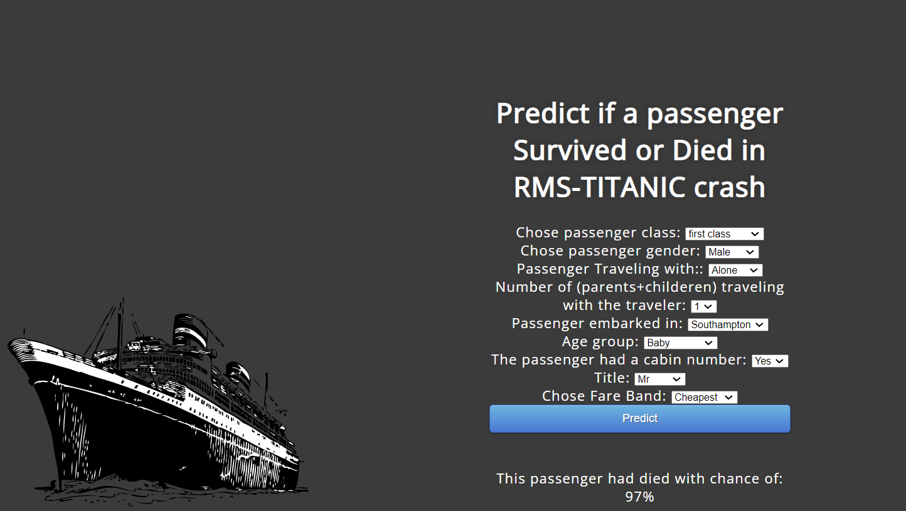

The dataset and the code for EDA, Data cleaning, and model training are available on Kaggle

<https://www.kaggle.com/code/nadintamer/titanic-survival-predictions-beginner/notebook>

skipping the preliminary steps of the notebook,In the final step, the notebook is evaluating different models and finally picks out the gradient-boosting classifier as the best model. And so did I. I saved the trained model as a pickle file to be loaded by the server.

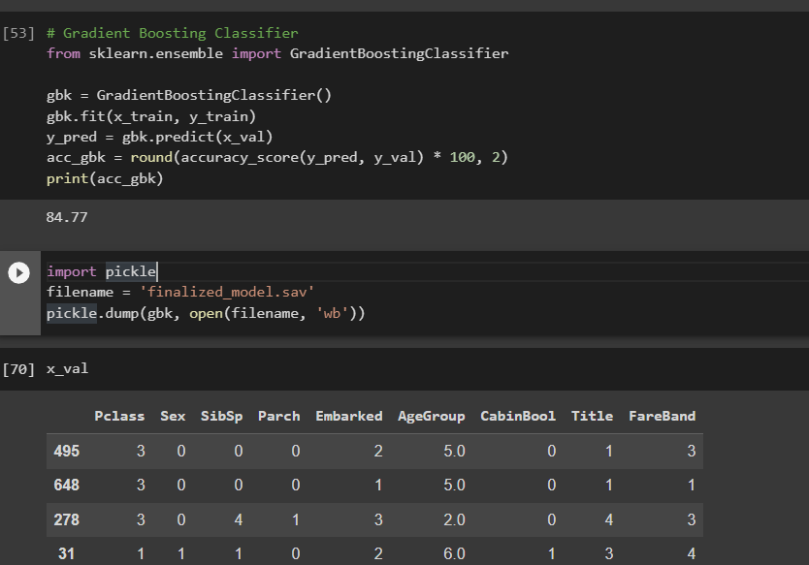

Based on the above snapshot of the notebook it is clear that for predicting, we need 9 features, which include:

Pclass (Passenger Class )

SibSp( passenger traveling alone, with a sibling, or with a spouse)

Parch(number of parents and children with the traveler

Embarked (Where did passenger embark from )

Cabinbool If the passenger had a cabin number

Sex, Age group, Title and Fare bond

**Note**: All these inputs are mapped to integers in the training code as well as descriptive texts to integers as model inputs for prediction in the web application.

After understanding our problem, data, training on different models and saving the best model,then there is deployment on the flask. Here is a snapshot of our server. After running the following code it will provide us with a link to our application

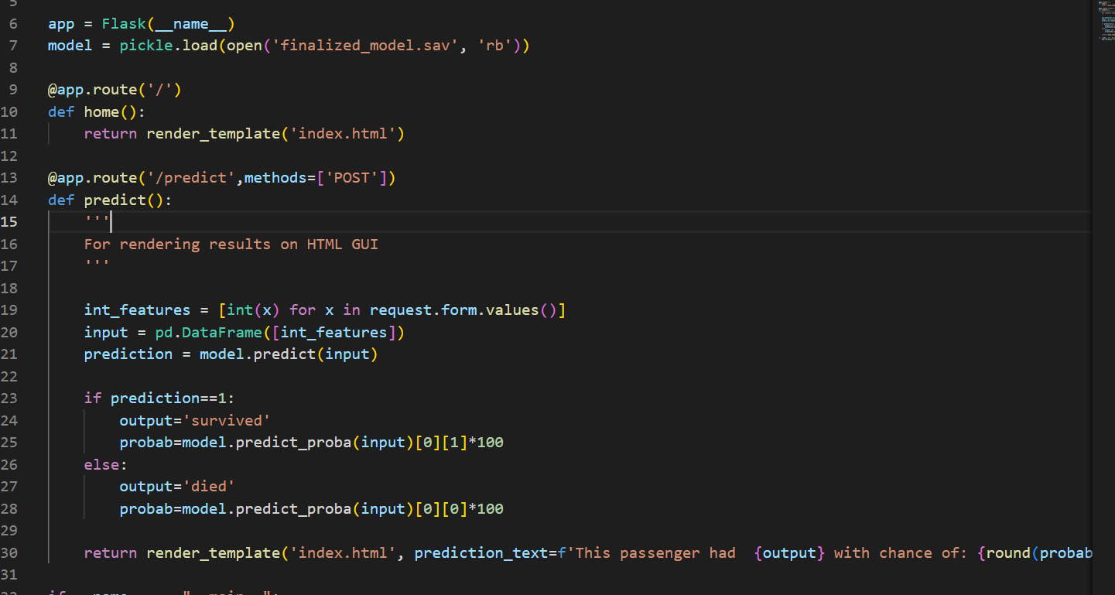

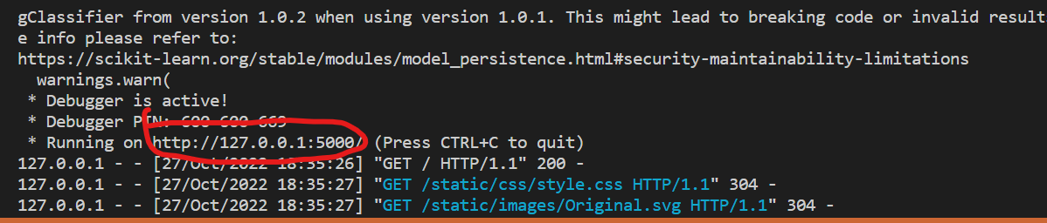

In the server, The predict function takes the int features from the HTML form as a list and feeds this list as input to our loaded model for prediction and returning the value (survived or died ) as well as chance of survival or death.

HTML:

The input format of the HTML form is select, where the user selects a descriptive value mapped to integers which are understandable values for our model as following snapshot:

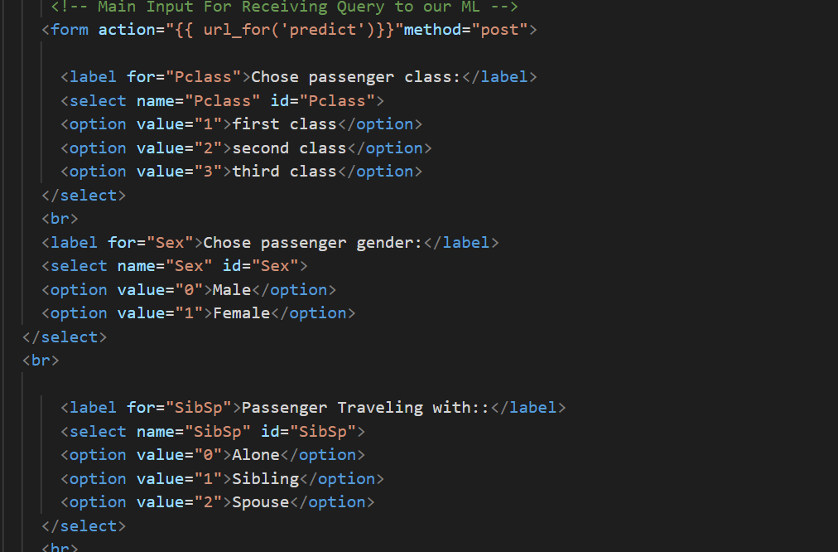

In the end, the web application look like the following :

