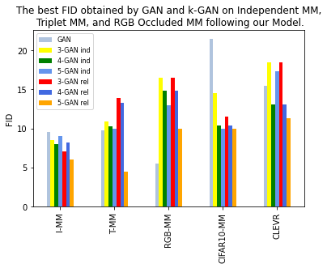

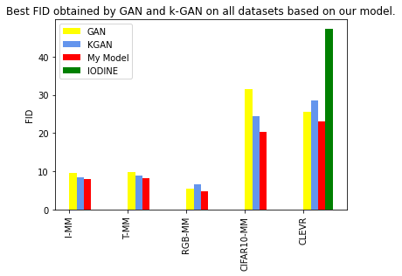

{
"D_lr": 0.0003,
"G_lr": 3e-05,
"batch_size": 64,
"beta1": 0.5,
"beta2": 0.9,
"data_source": "multimnist(I,T,RBG)",
"data_type": "image",
"depth": 3,
"device": "cuda:0",
"eval_device": "cuda:0",
"eval_every": int(1e4),
"eval_fid": true,
"fused_noise": true,
"grad_penalty": 10,
"loss_type": "wgan-gp",
"mirror_lr": 0,
"n_discriminators": 3,4,5,
"n_generators": 3,4,5,
"n_iter": int(5e5),
"ndf": 128,
"ngf": 128,
"noise_dim": 128,
"output_dir": null,
"print_every": int(1e5),
"restart": true,
"sampling": "all_alternated",
"seed": 5
}

—----------------

{
data_type = 'image'
data_source = 'cifar10(MM)'
n_generators = 3,4,5
n_discriminators = 3,4,5

depth = 1
ndf = 128
ngf = 128

loss_type = 'wgan-gp'
device = 'cuda:0'
n_iter = int(5e5)

noise_dim = 128 # For image data

batch_size = 64
D_lr = 3e-4
G_lr = 3e-5
mirror_lr = 0

beta1 = 0.5
beta2 = 0.9

grad_penalty = 10

sampling = 'all_alternated'
fused_noise = True

seed = 0

eval_fid = True
print_every = 10000
eval_every = 10000
eval_device = 'cuda:0'

restart = True

—-----------------------------------
{
data_type = 'image'
data_source = CLEVR'

n_generators = 5
n_discriminators = 5

depth = 3

ndf = 512
ngf = 512

loss_type = 'wgan'
device = 'cuda:0'
n_iter = 30000

noise_dim = 32

batch_size = 512
D_lr = 1e-3
G_lr = 1e-4
mirror_lr = 1e-1

beta1 = 0.
beta2 = 0.999

grad_penalty = 10

sampling = 'all_extra_alternated'
fused_noise = True

seed = 100
eval_every = 500

print_every = 500
eval_device = 'cuda:0'
eval_fid = True
restart = False
output_dir = None

}
—---------------------------------

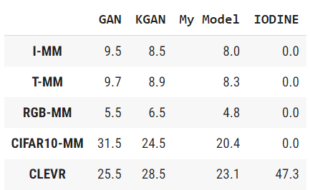

Result k-GAN On My Model:

