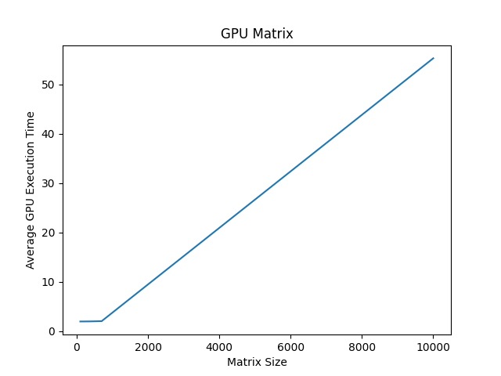

**Matrix Size: 100 || Average GPU Execution Time: 0.3868706226348877 seconds**

**Matrix Size: 200 || Average GPU Execution Time: 0.38753676414489746 seconds**

**Matrix Size: 400 || Average GPU Execution Time: 0.3906825542449951 seconds**

**Matrix Size: 700 || Average GPU Execution Time: 0.40021638870239257 seconds**

**Matrix Size: 10000 || Average GPU Execution Time: 11.053799867630005 seconds**

**The CPU usage is: 0.1**

**RAM memory % used: 14.8**

**RAM Used (GB): 0.953704448**

**The CPU usage is: 8.8**

**RAM memory % used: 45.4**

**RAM Used (GB): 3.441463296**

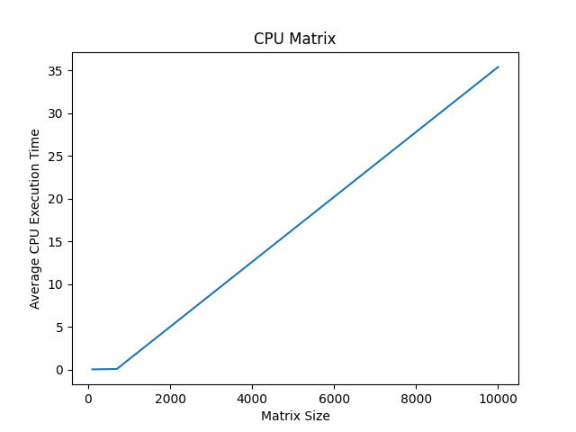

**Matrix Size: 100 || Average CPU Execution Time: 0.005206584930419922 seconds**

**Matrix Size: 200 || Average CPU Execution Time: 0.006499624252319336 seconds**

**Matrix Size: 400 || Average CPU Execution Time: 0.00947728157043457 seconds**

**Matrix Size: 700 || Average CPU Execution Time: 0.01448073387145996 seconds**

**Matrix Size: 10000 || Average CPU Execution Time: 7.0789430141448975 seconds**

**GPU RAM Free: 6959MB | Used: 1073MB | Util 13% | Total 8192MB**

**GPU RAM Free: 4131MB | Used: 3901MB | Util 48% | Total 8192MB**