Spatial Downscaling of SMAP Soil Moisture Using Machine Learning and Environmental Predictors
Final Report

Summary
This project tested whether machine learning can generate a finer, 1 km soil moisture product from NASA’s coarser Soil Moisture Active Passive (SMAP) satellite soil moisture data by using higher-resolution radar, vegetation, and terrain information. The workflow was implemented as a supervised regression problem: SMAP soil moisture served as the coarse reference target, while Sentinel-1 radar backscatter, MODIS NDVI, SRTM terrain variables, and month as a seasonal predictor were used as model inputs. The final tuned Random Forest model with month performed best on the SMAP-scale stratified test set, with RMSE = 0.0094 m³/m³, MAE = 0.0067 m³/m³, and R² = 0.9545. This model was then retrained on all 1,543 SMAP-scale samples and applied to 94,527 valid 1 km pixel-month rows to generate monthly downscaled soil moisture maps. External validation against one Fort Reno ISMN station showed a strong temporal correlation (0.9282) but also a negative bias, meaning the downscaled product underestimated the in-situ soil moisture values. The result should therefore be interpreted as a SMAP-consistent 1 km spatial disaggregation, not as a fully validated independent point-scale soil moisture retrieval. Figure 1 illustrates the overall downscaling concept used in this project: a coarse SMAP soil moisture value is used as the training target, while finer-resolution radar, vegetation, and terrain variables provide spatial detail that allows the model to redistribute soil moisture within the coarse footprint.

Figure 1. Conceptual illustration of spatial downscaling: a coarse SMAP soil moisture value is redistributed using high-resolution proxy information. The project used the GEE SMAP L3 Enhanced 9 km product rather than the classic 36 km SMAP product shown in the illustration.

1. Problem Statement
Many environmental and agricultural decisions require soil moisture information at local or field scale, but passive microwave satellite products such as SMAP are spatially coarse. This creates a practical gap: SMAP provides frequent, physically meaningful soil moisture estimates, but its native grid is too coarse for many local decisions such as irrigation planning, localized drought monitoring, field accessibility, and flood-risk interpretation.
The goal of this project is to test a machine-learning downscaling method that redistributes coarse SMAP soil moisture into a 1 km grid using finer-resolution proxy variables. The selected study area is a southwestern Oklahoma region near Little Washita/Fort Cobb, bounded approximately by longitude $-$99.0 to $-$97.7 and latitude 34.5 to 35.8. The analysis period is April through September 2024, which provides growing-season soil moisture variation while avoiding winter freeze/thaw complications.
The main challenge is that there are no direct ground-truth soil moisture measurements available for every 1 km pixel to use as training labels. Therefore, the model is trained at the SMAP scale, where the target is available, and then applied at 1 km resolution using the fine-resolution predictors. The potential benefit is a practical, SMAP-consistent spatial disaggregation workflow that provides more local spatial detail without requiring a new high-resolution soil moisture satellite.

2. Model Outcomes and Predictions
This is a supervised regression problem. The model predicts a continuous soil moisture value, expressed in volumetric soil moisture units (m³/m³), for each 1 km pixel and month in the study area. The training target is monthly SMAP soil moisture, while the model inputs are higher-resolution radar, vegetation, terrain, and seasonal variables.
The final output is a monthly 1 km gridded table and map of Random Forest downscaled soil moisture for April–September 2024. A secondary output is a model interpretation summary, including feature importance and residual diagnostics. The report also compares the downscaled product with the coarse SMAP reference and with the available ISMN station observations.

3. Data Acquisition
The project used multiple remote-sensing and ground-observation datasets. SMAP Level 3 Enhanced soil moisture was used as the coarse satellite reference target. Sentinel-1 Synthetic Aperture Radar (SAR) Ground Range Detected (GRD) imagery provided VV and VH radar backscatter and incidence angle as higher-resolution radar predictors. The Moderate Resolution Imaging Spectroradiometer (MODIS) Normalized Difference Vegetation Index (NDVI) product was used as a vegetation proxy, because vegetation affects both soil moisture patterns and radar response. The Shuttle Radar Topography Mission (SRTM) Digital Elevation Model (DEM) was used to derive terrain predictors, including elevation, slope, and aspect. Finally, the International Soil Moisture Network (ISMN) provided in-situ soil moisture observations for preliminary external validation.
The data were acquired primarily through Google Earth Engine, with in-situ validation data were downloaded separately from ISMN. The final prototype used the SMAP L3 Enhanced 9 km product available in Earth Engine. This keeps the same downscaling concept as the original 36 km project idea while making the workflow computationally manageable for the capstone project. Table 1 summarizes the main datasets used in the project, including the coarse SMAP soil moisture reference, the high-resolution predictor variables, and the independent ISMN validation source.

Data Source | Dataset/Source | Role in Project
SMAP Soil Moisture | NASA/SMAP/SPL3SMP_E/006 | Coarse soil moisture reference target
Sentinel-1 SAR | COPERNICUS/S1_GRD | VV, VH, VV$-$VH, and incidence angle predictors
MODIS NDVI | MODIS/061/MOD13Q1 | Vegetation proxy for canopy and surface conditions
SRTM Terrain | USGS/SRTMGL1_003 | Elevation, slope, and aspect-derived terrain predictors
ISMN Station Data | Fort Reno #1, SCAN Network | Independent preliminary validation source
Table 1. Main data sources used in the downscaling workflow.
The final cleaned SMAP-scale training table contained 1,543 valid pixel-month samples. Figure 2 shows the monthly distribution of SMAP soil moisture during the April–September 2024 study period. This visualization helps explain the seasonal pattern in the target variable, with May showing the wettest conditions and August–September showing the driest conditions. The 1 km prediction table contained 94,527 valid pixel-month rows. The available ISMN validation data came from one near-surface Fort Reno sensor at approximately 5.08 cm depth, resulting in six station-month validation points for April–September 2024.
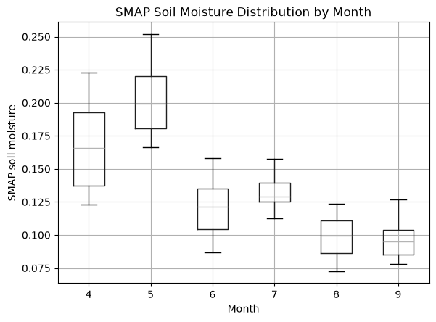
Figure 2. Monthly SMAP soil moisture distribution for the April–September 2024 study period. May was the wettest month, while August and September were the driest months.

4. Data Preprocessing and Preparation
The remote-sensing datasets were converted into monthly composites to align data sources with different revisit intervals. SMAP soil moisture was summarized using monthly mean values, because it served as the coarse reference target. Sentinel-1 VV/VH and MODIS NDVI were summarized using monthly median values to reduce the effect of radar speckle, outliers, and optical artifacts. Terrain variables from SRTM were static.
For model training, the fine-resolution predictors were aggregated to the 9 km SMAP scale. This step is important, because the model should learn the relationship between SMAP-scale soil moisture and SMAP-scale predictor summaries, rather than treating repeated 1 km pixels as independent high-resolution soil moisture labels. Aspect was encoded as sine and cosine variables to avoid the circular discontinuity of compass direction.
The exported table was cleaned by removing the geometry column, checking for duplicate rows, confirming that there were no missing values, and filtering physically unrealistic values. The final feature set included Sentinel-1 VV, VH, incidence angle, VV-VH difference, MODIS NDVI, elevation, slope, aspect sine/cosine, and month. The final evaluation split used a stratified random split by month so that each month would be represented in both the training and test sets.

5. Modeling
The project compared a simple mean baseline, Lasso Regression, and Random Forest Regression. Lasso was used as an interpretable linear benchmark, while Random Forest was used as the main nonlinear model because it can capture situations where the relationship between radar backscatter and soil moisture changes depending on vegetation, terrain, or season. Models were tested both with and without the month variable to evaluate whether month acted as useful seasonal information or as a risky shortcut.
Early diagnostics showed that a strict April–August to September temporal split caused weak generalization and compressed Random Forest predictions. Leave-one-month-out tests also showed that temporal transfer is difficult with only six months of one-year data. Figure 3 summarizes the leave-one-month-out diagnostic results for Random Forest models with and without month. This diagnostic shows that temporal generalization is more difficult than the final stratified random test split suggests, especially when an entire month is excluded from training. For the final capstone product, the stratified random split by month was used as the main in-distribution evaluation.
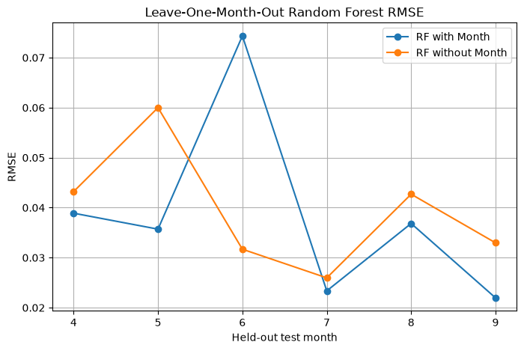
Figure 3. Leave-one-month-out RMSE comparison. The diagnostic shows that temporal generalization is harder than random-split evaluation and that month does not consistently improve performance when an entire month is held out.

6. Model Evaluation

6.1 SMAP-Scale Test Performance
The tuned Random Forest with month was the best-performing model under the final stratified random test split. This indicates strong in-distribution predictive skill within the April–September 2024 period. However, because month was a dominant feature, the result should be interpreted as interpolation within the observed seasonal range rather than proof of transferability to unusual future conditions. Table 2 compares the tuned regression models on the final stratified SMAP-scale test set. This comparison was used to select the tuned Random Forest with month as the final model for generating the 1 km downscaled soil moisture product. Figure 4 compares observed SMAP soil moisture with predictions from the tuned models. The tuned Random Forest with month shows the strongest agreement with the SMAP-scale test data, which supports its selection as the final in-distribution model.

Model | RMSE | MAE | R²
Tuned Random Forest with Month | 0.0094 | 0.0067 | 0.9545
Tuned Lasso with Month | 0.0231 | 0.0187 | 0.7232
Tuned Random Forest without Month | 0.0232 | 0.0182 | 0.7192
Tuned Lasso without Month | 0.0274 | 0.0224 | 0.6099
Mean Baseline | 0.0439 | 0.0362 | -0.0002
Table 2. Final model comparison on the stratified SMAP-scale test set.
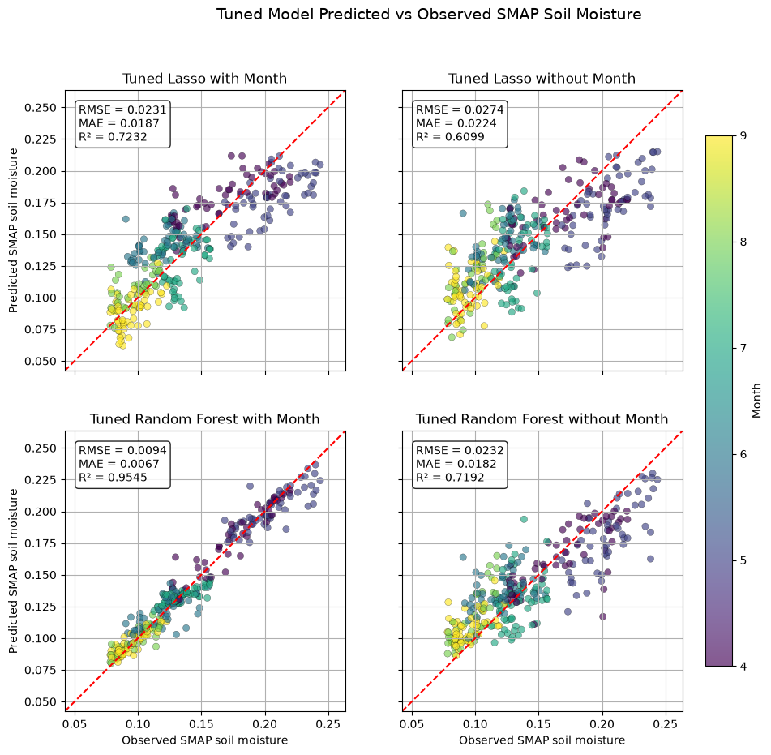
Figure 4. Tuned model predicted-versus-observed plots. The tuned Random Forest with month produced the strongest agreement on the SMAP-scale test set.
One important limitation of the stratified random split is that soil moisture values are spatially and temporally correlated. Nearby locations and neighboring months may have similar SMAP soil moisture and predictor values, so randomly splitting the data can place highly similar samples in both the training and test sets. This does not represent direct target leakage, but it can make the test performance appear stronger than performance under a fully independent spatial or temporal evaluation. For this reason, the reported SMAP-scale test results should be interpreted as in-distribution interpolation performance rather than proof of generalization to independent regions, years, or unusual weather conditions.

6.2 Model Interpretation and Residual Checks
Feature importance confirmed that month was the dominant predictor in the selected Random Forest model, followed by VV backscatter and elevation. This explains the strong in-distribution performance, but it also warrants caution when applying the model to future years with unusual rainfall patterns. Residual analysis against the SMAP-scale test target showed small monthly errors: mean residuals ranged from about $-$0.0019 to 0.0034 m³/m³, and monthly mean absolute errors ranged from 0.0040 to 0.0092 m³/m³. This indicates limited systematic bias relative to SMAP, not necessarily relative to ground sensors. Figure 5 shows two model-diagnostic outputs: the feature importance plot (top) and the spatial residual map (bottom). The feature importance plot shows that month was the dominant predictor, while the residual map checks whether the selected model’s SMAP-scale test errors were spatially clustered.
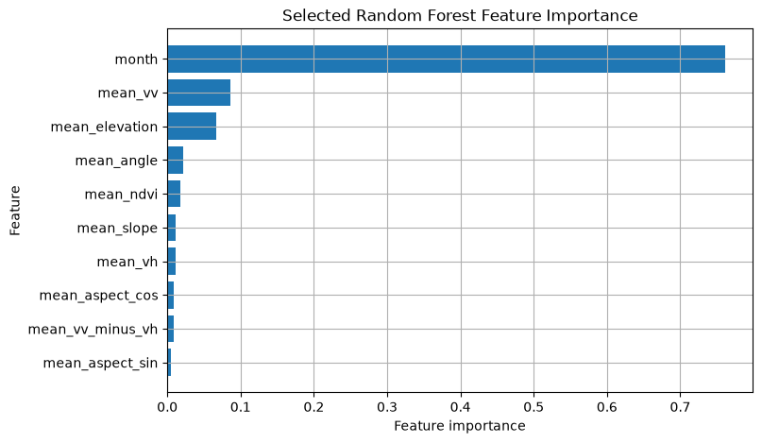
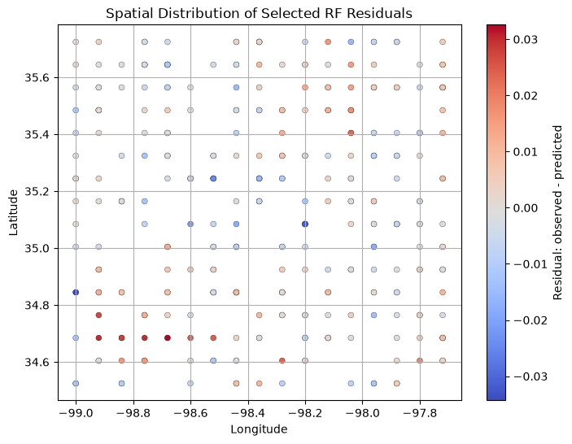
Figure 5. Selected Random Forest feature importance and spatial residual map. Most SMAP-scale residuals were small, although a localized southern/southwestern underprediction pattern appeared in the test residuals.

6.3 Downscaled 1 km Product
After model selection, the final Random Forest was retrained on all SMAP-scale samples using the fixed best hyper-parameters and then applied to the 1 km predictor table. The model generated predictions for all 94,527 valid 1 km rows. Monthly mean downscaled predictions followed the same broad seasonal pattern as SMAP, i.e., higher soil moisture in April–May, lower values in August–September, and intermediate values in June–July. Figure 6 shows the monthly 1 km downscaled soil moisture maps generated by the selected Random Forest model. These maps are the main spatial output of the project and show how the model redistributes the SMAP signal across the study area. Table 3 summarizes the monthly 1 km downscaled Random Forest predictions. The table shows that the downscaled product follows the same broad seasonal pattern as SMAP, with higher values in April–May and lower values in August–September.
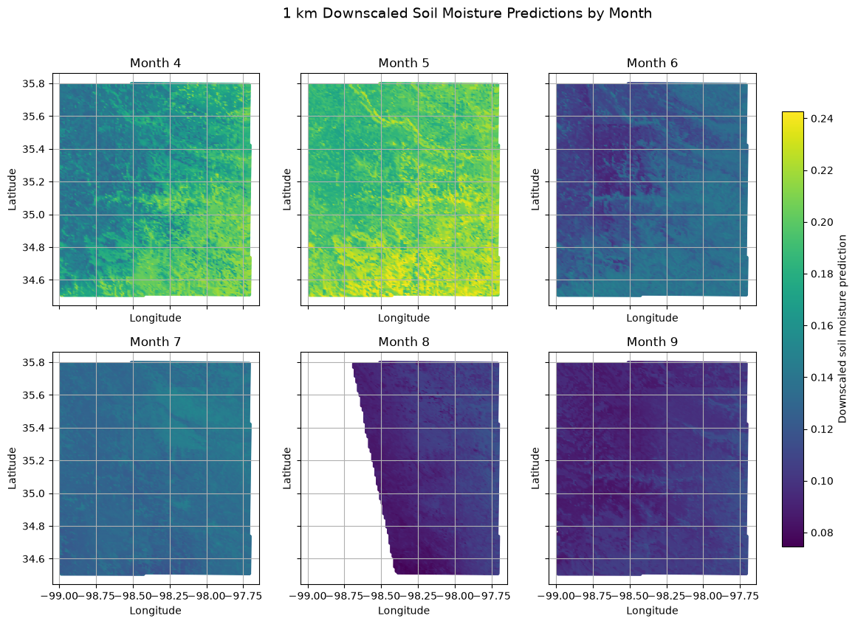
Figure 6. Monthly 1 km downscaled soil moisture maps generated by the selected Random Forest model.

Month | 1 km Rows | Mean Prediction | Minimum | Maximum
April | 16,725 | 0.1698 | 0.1265 | 0.2248
May | 16,725 | 0.2018 | 0.1696 | 0.2425
June | 16,725 | 0.1239 | 0.0890 | 0.1505
July | 16,725 | 0.1336 | 0.1156 | 0.1532
August | 10,904 | 0.0979 | 0.0747 | 0.1197
September | 16,723 | 0.0978 | 0.0809 | 0.1214
Table 3. Monthly summary of 1 km downscaled Random Forest predictions.

6.4 Preliminary ISMN Validation
The downscaled product was compared with monthly mean soil moisture from the Fort Reno #1 ISMN station. Each station-month observation was matched to the nearest 1 km prediction from the same month; the nearest pixel was approximately 0.37 km from the station. Table 4 summarizes the preliminary Fort Reno ISMN validation results. The table compares the RF 1 km downscaled predictions and the coarse SMAP reference against the available in-situ station observations. Figure 7 presents the preliminary ISMN validation plots. The scatter plot shows agreement between ISMN observations and RF predictions relative to the 1:1 line, while the monthly time-series plot compares ISMN, RF downscaled predictions, and the coarse SMAP reference through time.
The ISMN validation results are mixed. The RF downscaled predictions are strongly correlated with the monthly ISMN observations, which means they follow the temporal pattern. However, the RF predictions are systematically lower than the in-situ values, with a negative bias of $-$0.0416 m³/m³. In this one-station validation, the coarse SMAP reference has slightly lower RMSE and MAE than the RF downscaled product. Therefore, the downscaled product should be interpreted as adding 1 km spatial detail while remaining anchored to the SMAP signal, not as a proven improvement over SMAP at point scale. Moreover, while this validation is independent of the model training target, it is limited to one station and six monthly observations, so it should be treated as a preliminary external check rather than a robust regional validation.
Metric | RF 1 km Prediction vs ISMN | Coarse SMAP Reference vs ISMN
RMSE | 0.0504 | 0.0425
MAE | 0.0428 | 0.0389
Bias | $-$0.0416 | $-$0.0362
Correlation | 0.9282 | not calculated
Station-months | 6 | 6
Table 4. Preliminary Fort Reno ISMN validation summary.
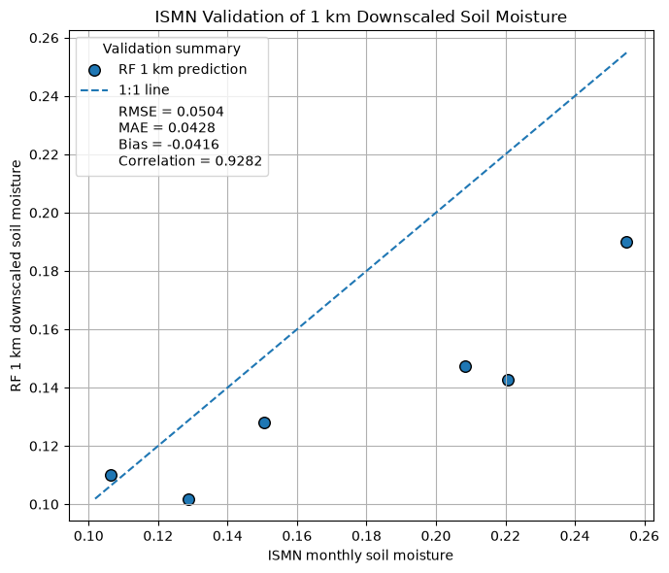
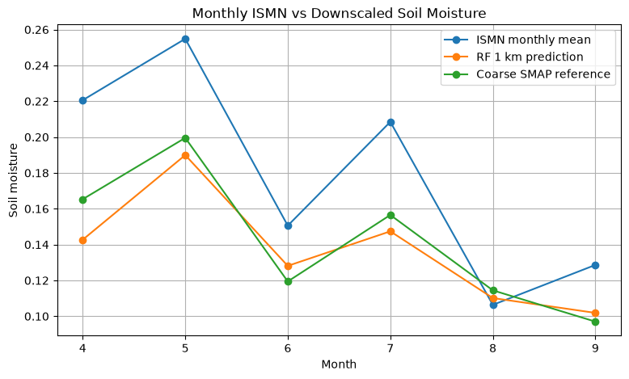
Figure 7. ISMN validation plots. The RF downscaled product captured the month-to-month pattern but underestimated Fort Reno in-situ soil moisture, especially during wetter months.

7. Conclusion and Next Steps
The project successfully built an end-to-end machine-learning workflow for SMAP soil moisture downscaling: multi-source data acquisition, monthly raster-stack construction, SMAP-scale model training, model diagnostics, 1 km prediction, mapping, and preliminary ISMN validation. The strongest final model was the tuned Random Forest with month, which performed very well on the stratified SMAP-scale test set and produced a complete 1 km monthly downscaled product for the Oklahoma ROI.
The most important limitation is that strong SMAP-scale performance did not fully translate into strong point-scale ISMN agreement. This is expected because the model was trained to reproduce SMAP-scale soil moisture. The validation also relied on only one station, so the results cannot prove regional accuracy. The project should therefore be evaluated primarily as a proof-of-concept for SMAP-consistent 1 km spatial disaggregation, rather than as a fully validated operational soil moisture retrieval method. In addition, the month feature improved 2024 in-distribution performance but may reduce transferability to future years with unusual rainfall conditions.
The recommended next steps for this work include:
- Extend the analysis to multiple years and more ISMN stations to strengthen validation.
- Add precipitation, temperature, and evapotranspiration variables so that the model can respond to unusual weather conditions rather than relying heavily on month.
- Compare RF with month, RF without month, and anomaly-based downscaling for future-year transferability.
- Validate not only absolute soil moisture values but also whether the 1 km spatial patterns are physically reasonable across different land-cover and terrain settings.
- Use spatially and temporally blocked validation strategies, such as holding out entire SMAP footprints, geographic subregions, months, or years, to better test generalization and reduce the effect of spatial-temporal autocorrelation between training and test samples.
Overall, the final product is best described as a SMAP-consistent 1 km spatial disaggregation of monthly soil moisture. It is promising for visualizing finer-scale spatial patterns within the coarse SMAP signal, but additional validation and climate/weather predictors are needed before the model can be treated as an operational high-resolution soil moisture retrieval.

8. Project Organization and Reproducibility Note
The accompanying Jupyter notebooks are organized with explanatory Markdown headings before code cells, plot titles and axis labels, code comments, and named intermediate outputs. The initial report notebook documents the project setup, data-source selection, ROI definition, GEE dataset preparation, and early workflow design, while the final report notebook provides the code-level evidence for data cleaning, model diagnosis, model tuning, visualizations, residual diagnostics, downscaling, and ISMN validation. This report is intended to stand alone for a non-technical reader, while the notebooks provide the technical details for readers who want to inspect the coding workflow. The file package includes this final report, the initial and final Jupyter notebooks, the required datasets, a README file, and the image outputs of the final notebook in clearly-named folders. The exported prediction and validation CSV files are not included due to their large size.

The smaller number of valid August prediction rows is due to masking and data availability differences in the exported 1 km predictor table.

