Math & Statistics Q&A Assistant
A PDF-grounded Retrieval-Augmented Generation (RAG) app
User Guide & Technical Reference
Components · how they work · configuration · worked example

Contents
Contents 2
1. What this tool is 3
What it does 3
Who it is for 3
2. Architecture at a glance 3
3. The processing pipeline, step by step 4
Phase A — Indexing (one-time, per upload) 4
3.1 Text extraction (PyMuPDF) 4
3.2 Chunking 4
3.3 Embedding (sentence-transformers) 5
3.4 The vector index 5
Phase B — Answering (every question) 5
3.5 Embed the question 5
3.6 Retrieve the most relevant chunks 5
3.7 The 'is it in the documents?' gate 5
3.8 Augmentation — building the prompt 5
3.9 Generation (Claude) 6
3.10 Rendering and export 6
4. Component reference 6
Key functions in rag.py 6
5. Configuration reference 6
6. Worked example 7
6.1 A question the documents can answer 7
6.2 A question the documents cannot answer 8
7. Tuning & troubleshooting 8
Calibrating the threshold 8
Common issues 8
8. Limitations & responsible use 8
Appendix — Further reading 9

1. What this tool is
This application answers mathematics and statistics questions using only the PDF documents you upload. It is built on the Retrieval-Augmented Generation (RAG) pattern: instead of relying on a language model's memory, the app first retrieves the most relevant passages from your files, then asks a language model to generate an answer strictly from those passages. The result is grounded in your source material and cites the page it came from.
In plain terms, it behaves like a patient teaching assistant who has read your course notes and will only answer from them — and who openly says so when the notes do not contain the answer.

What it does
- Accepts up to three PDF files (textbooks, lecture notes, papers) of substantial length.
- Answers questions in a fixed, study-friendly structure: intuition, technical details, and applications/further study — kept to about one page.
- Renders mathematics properly, both on screen and in an exported Word document.
- Detects when the answer is not in your documents and offers a one-click Google search instead of guessing.
- Let’s you download the full question-and-answer session as a Word file.

Who it is for
Instructors preparing study notes, students revising from a fixed set of materials, or anyone who wants answers anchored to a specific, trusted source rather than the open web.

2. Architecture at a glance
The system has two phases. The first, indexing, runs once when you upload and process your PDFs. The second, answering, runs every time you ask a question. The diagram below shows how the pieces connect and traces two example questions through the flow.
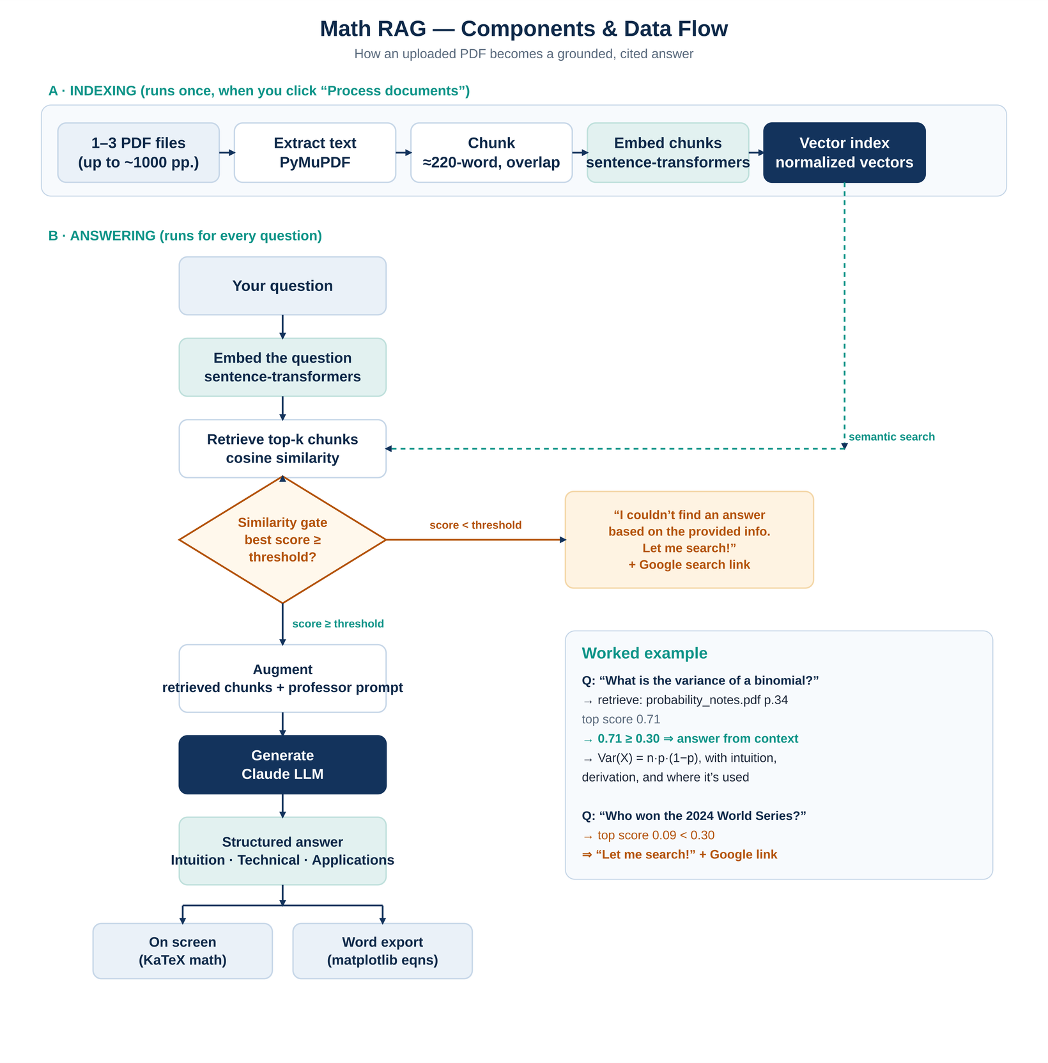
Figure 1. Components and data flow, with two worked examples (answered vs. not-found).

3. The processing pipeline, step by step

Phase A — Indexing (one-time, per upload)

3.1 Text extraction (PyMuPDF)
Each PDF is opened from memory and its text is pulled out page by page using PyMuPDF (the fitz library), which is fast even on thousand-page files. Page numbers are preserved so that later answers can cite an exact page. Light cleanup collapses stray whitespace. Scanned, image-only PDFs contain no extractable text and must be run through OCR first.

3.2 Chunking
A long page is too large to match precisely against a short question, so each page is split into overlapping chunks of roughly 220 words. Consecutive chunks share about 40 words so that a definition or formula split across a boundary is still captured whole. Every chunk remembers its source file and page.

3.3 Embedding (sentence-transformers)
Each chunk is converted into a numerical vector — an embedding — using a local sentence-transformers model (all-MiniLM-L6-v2). Embedding capture meaning: passages about the same idea land near each other in vector space, even when they use different words. This step runs on your machine and needs no API key. The vectors are length-normalized so that similarity is a simple, fast calculation later.

3.4 The vector index
All chunk vectors together form the index — the searchable representation of your documents. It is held in memory for the session, so re-asking questions is instant; only changing the uploaded files requires re-processing.

Phase B — Answering (every question)

3.5 Embed the question
Your question is embedded with the same model, producing a vector that can be compared directly against the chunk vectors.

3.6 Retrieve the most relevant chunks
The app computes the cosine similarity between the question vector and every chunk vector (a single, efficient matrix operation because the vectors are normalized) and keeps the top handful — the top-k chunks, best first. Each comes with a similarity score between roughly 0 and 1.

3.7 The 'is it in the documents?' gate
Two independent checks decide whether the documents can answer the question:
- A similarity threshold (cheap). If even the best-matching chunk scores below the threshold, nothing relevant was found and the app stops here — it shows the 'Let me search!' message and a Google link, without calling the language model.
- The model's own judgment (thorough). If chunks did pass the threshold, the model is instructed to return a special signal when the retrieved text does not actually contain the answer. If it does, the app falls back to the same 'not found' response.
This two-gate design is what keeps the assistant honest: it answers from your materials or admits it cannot, but it does not invent.

3.8 Augmentation — building the prompt
When the gate passes, the retrieved chunks are assembled into a labelled CONTEXT block (each tagged with its file and page) and combined with the question and a fixed system prompt. That system prompt is where the 'college math professor' persona lives: it sets the three-part structure, the one-page length limit, the rule to answer only from the context, and the math-formatting conventions. This assembled message is the 'augmentation' in Retrieval-Augmented Generation.

3.9 Generation (Claude)
The augmented prompt is sent to the language model (Anthropic's Claude). The model writes the answer from the supplied passages only, in the required structure, using dollar-sign LaTeX for equations. This is the single step that requires an API key — the local retrieval model can find relevant text but cannot compose, reason about, or explain it.

3.10 Rendering and export
The answer is shown on screen with live mathematics (rendered by KaTeX) and a short 'Sources' line. You can also export the whole session to Word: each equation is drawn as a small image (via matplotlib) and embedded, so the formulas survive in the document even though Word has no native LaTeX.

4. Component reference
The code is deliberately split into three files so each concern can be read and changed in isolation.
File | Layer | What it is responsible for
app.py | Interface | The Streamlit web app: file upload, the question box, rendering answers and math on screen, the Google fallback button, and the Word download. The only file that touches Streamlit or your API key.
rag.py | Engine | All retrieval and generation logic: PDF parsing, chunking, embedding, the vector search, the two-gate 'not found' check, and the call to Claude. Framework-free, so it can be tested on its own.
docx_export.py | Export | Turns a session's questions and answers (markdown + LaTeX) into a downloadable Word document, rendering each equation to an embedded image.

Key functions in rag.py
- extract_pages() — read text and page numbers from one PDF.
- chunk_pages() — split a page's text into overlapping, page-tagged chunks.
- load_embedder() / build_index() — load the local model and embed every chunk.
- retrieve() — rank chunks by cosine similarity to the question.
- answer_question() — assemble the prompt and call Claude; detect the 'no answer' signal.
- ask() — the conductor: retrieve, apply the threshold gate, generate, and return the result the screen renders.

5. Configuration reference
Every tunable value lives in the CONFIG block at the top of rag.py. The two you will adjust most often — top-k and the threshold — are also exposed as live sliders in the app's sidebar, so you can experiment without editing code and then bake the best values back into CONFIG as defaults.
Setting | Default | What it does and how to choose
EMBED_MODEL_NAME | MiniLM-L6 | The local retrieval model. The default is small and fast on CPU. For sharper matching on dense material, switch to a larger model (e.g. all-mpnet-base-v2) at the cost of speed.
CHUNK_WORDS | 220 | Words per chunk. Smaller chunks match more precisely but carry less surrounding context; larger chunks give context but blur relevance. 150–300 is a sensible range for textbook prose.
CHUNK_OVERLAP_WORDS | 40 | Words shared between neighbouring chunks. Prevents a formula or definition from being lost at a boundary. Keep it ~15–20% of the chunk size.
TOP_K | 6 | How many chunks are sent to the model. Higher improves recall but adds cost and can introduce noise. 4–8 works well.
MIN_SIMILARITY | 0.30 | The found / not-found threshold — the value most worth calibrating. Raise it to cut irrelevant answers; lower it if good questions are wrongly reported as not found. See §7 for a calibration recipe.
LLM_MODEL | Claude Sonnet | The answer generator. Use a balanced model by default; a stronger model for harder reasoning, a smaller one for speed and cost.
LLM_MAX_TOKENS | 900 | Upper bound on answer length (≈ one page). Pair it with the word limit stated in the system prompt.
NOT_FOUND_MESSAGE | — | The exact wording shown when nothing relevant is found.
SYSTEM_PROMPT | — | The persona, three-part structure, length limit, grounding rule, and math-formatting conventions. Edit here to change how every answer reads.

6. Worked example
To make the flow concrete, here are the two questions traced in Figure 1.

6.1 A question the documents can answer
Suppose probability_notes.pdf has been uploaded and processed, and you ask:
“What is the variance of a binomial distribution?”
- The question is embedded and compared against the index.
- Retrieval returns the closest chunk — from page 34 — with a similarity score of about 0.71.
- Because 0.71 exceeds the 0.30 threshold, the gate passes and the chunk is sent to the model.
- Claude answers from that passage, in the standard structure, for example:
Intuition. A binomial count is a sum of independent yes/no trials, so its spread grows with the number of trials and is largest when success is most uncertain (p near one-half).
Technical. For n trials with success probability p, the variance is n·p·(1−p); on screen this appears as a properly typeset equation.
Applications. Used for error bars on proportions, sample-size planning, and the normal approximation to the binomial.
A 'Sources: probability_notes.pdf p.34' line appears beneath the answer, and the exchange can be exported to Word with the equation intact.

6.2 A question the documents cannot answer
Now you ask an unrelated question: “Who won the 2024 World Series?”
- Retrieval still returns the nearest chunks, but the best score is only about 0.09.
- Because 0.09 is below the 0.30 threshold, the model is never called.
- The app displays: “I couldn't find an answer based on the provided info. Let me search!” together with a button that runs the same question as a Google search.

7. Tuning & troubleshooting

Calibrating the threshold
Treat the threshold empirically. Ask several questions you know are answered by your PDFs and a few you know are not, watch the top similarity score the app reports, and set the threshold in the gap between the two groups. Then raise it slightly if irrelevant answers slip through, or lower it if genuine questions are wrongly refused.

Common issues
Symptom | Likely cause and fix
'No extractable text found' | The PDF is scanned/image-only. Run it through OCR (e.g. ocrmypdf) before uploading.
Everything says 'not found' | Threshold too high, or the documents genuinely don't cover the topic. Lower MIN_SIMILARITY and confirm the right files were processed.
Irrelevant answers | Threshold too low. Raise MIN_SIMILARITY, or reduce TOP_K so fewer marginal chunks reach the model.
Slow first question | Indexing a very large PDF embeds thousands of chunks once; later questions are fast. A larger embedding model is also slower.
An equation shows as raw LaTeX in Word | matplotlib could not render that specific command. On-screen rendering (KaTeX) is more complete; see the limitation below.

8. Limitations & responsible use
- Source-bound by design. The assistant reports what your documents say; it is not a substitute for a textbook or instructor, and it does not browse the web itself (it links out).
- Math fidelity in Word. Equations in the Word export are images rendered by matplotlib, which covers common notation; a few exotic commands fall back to plain text. For publication-grade Word equations, a MathML-to-OMML conversion would be the next step.
- Retrieval is not perfect. A poorly phrased question or unusual notation can miss the right passage. Rephrasing, or raising top-k, often helps.
- Keep the API key private. Provide it as an environment variable or secret rather than embedding it in the code or an image.

Appendix — Further reading
- Streamlit documentation — the web framework.
- sentence-transformers — the local embedding models.
- PyMuPDF — PDF text extraction.
- Anthropic API documentation — the answer-generation model.
- FAISS — for scaling retrieval to very large corpora.

