Math & Statistics Q&A — Session Notes
Generated 2026-06-16

Q1. Explain the central limit theorem

Intuition
The Central Limit Theorem (CLT) addresses what happens to the sample mean of random variables that are not Normally distributed. It tells us that even when individual observations follow any distribution, their sample mean will behave approximately like a Normal random variable, as long as the observations are independent and identically distributed (i.i.d.). This approximation improves as the sample size 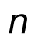 grows larger.

Technical details
Theorem (CLT): Let 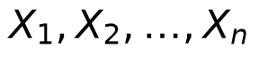 be i.i.d. random variables with mean 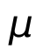 and variance 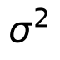. Then:
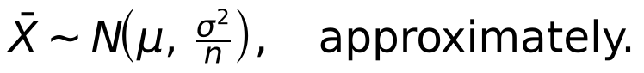
- The result holds for any underlying distribution, which distinguishes it from the exact normality result that requires the 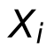 to already be Normally distributed.
- The approximation is only exact in the limit; for finite  it remains an approximation, but it becomes increasingly accurate as  increases.
- A standardised version also follows: if 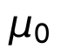 is a hypothesised mean, then 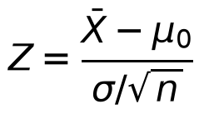 is approximately standard Normal.

Applications & further study
- Confidence intervals: When data do not come from a Normal population, the CLT can be used to construct approximate confidence intervals for the population mean using the Normal distribution.
- Hypothesis testing: The CLT enables hypothesis tests for large samples even when the population distribution is unknown, by using the approximately Normal test statistic .
- A worked example from the text shows that for a sample of 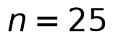 pregnancy durations (mean 266 days, SD 16 days), the CLT gives 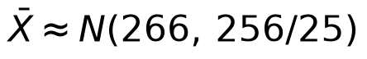, allowing probability calculations without knowing the exact distribution of individual durations.
Sources: A First Course in Statistical Inference.pdf p.34, 38, 58, 81, 136

