Math & Statistics Q&A — Session Notes
Generated 2026-06-16

Q1. Explain the Lagrange interpolation with an example

Intuition
Lagrange interpolation builds a function that passes exactly through a prescribed set of data points (called nodes) by constructing special "cardinal" basis functions. Each basis function 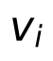 equals 1 at node 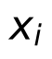 and 0 at every other node — this cardinal property guarantees the interpolant reproduces the given data values exactly.

Technical details
Given nodes 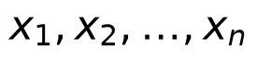 in , the classical Lagrange basis polynomials 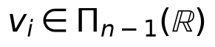 are defined by:
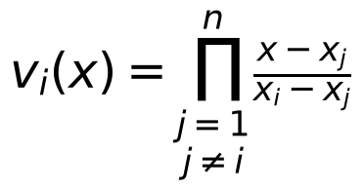
These satisfy 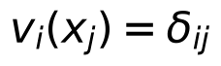. The interpolating polynomial to a function  is then:
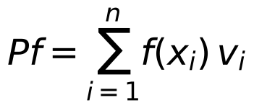
This paradigm generalizes broadly: replace  with any set  and introduce a function 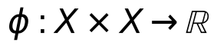 satisfying \phi(x,y) = 0 \iff x = y. Then define 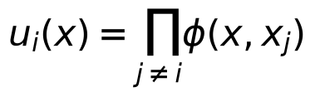 and 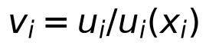, recovering the cardinal property. For example, if 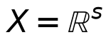 and 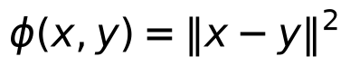, then each 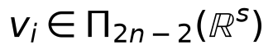.

Applications & further study
- Shepard's method is a notable variant: assuming 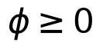, one sets 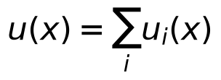 and 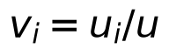, giving 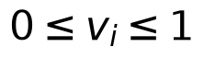 globally, though a drawback is that all derivatives of  vanish at the nodes.
- This general framework connects naturally to multivariate interpolation using hyperplane intersections (as in 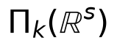) and to spline interpolation (Exercise 7 in the text treats piecewise linear bases as a Lagrangian system).
- Further study could explore Chapter 11 (interpolation by translates) and Chapters 12–16 on positive definite functions, which build on this same paradigm.
Sources: A course in approximation theory Cheney and Light.pdf p.14, 79, 80, 84, 86, 352

