Math & Statistics Q&A — Session Notes
Generated 2026-06-18

Q1. explain chi-squared goodness of fit and how it is related/different from chi-squared test

Intuition
The chi-square goodness-of-fit test asks: *how well does a hypothesised distribution match what we actually observed?* We classify outcomes into 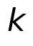 categories, compare observed counts 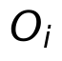 to expected counts 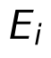 under the null hypothesis, and large discrepancies give evidence against that hypothesis. The smaller the resulting statistic, the more consistent the data are with the hypothesis.

Technical details
The goodness-of-fit statistic is
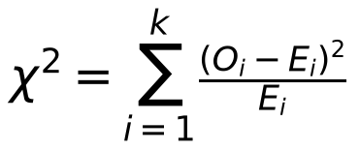
and it follows approximately a chi-square distribution with 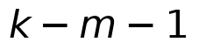 degrees of freedom, where 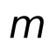 is the number of parameters estimated from the data. The approximation is reliable only when 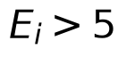 for every category; otherwise categories should be merged. The acceptance region at significance level 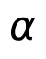 is A = \{\chi^2 : 0 \le \chi^2 \le \chi^2_{1-\alpha}(k-m-1)\}.
The chi-square distribution itself (used in both settings) arises separately: if 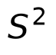 is the sample variance from a Normal population with variance 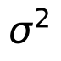, then 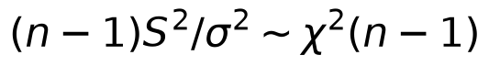. This distributional result underlies variance tests, whereas the goodness-of-fit test uses the *same family of distributions* but constructs the statistic from categorical counts. The contingency-table (independence) test is a related use: its statistic has the same form but degrees of freedom 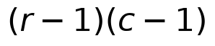 for an 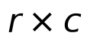 table, rather than .

Applications & further study
- The goodness-of-fit test applies whenever you want to check whether data follow a proposed model (e.g., testing whether a die is fair by rolling it 60 times and comparing face frequencies to the expected 10 each).
- The context mentions that the chi-square framework extends naturally to contingency tables (Section 5.3.2) for testing independence between two categorical variables, sharing the same statistic structure but a different degrees-of-freedom formula.
- A gap in the provided context is a full derivation of *why* the sum of squared standardised counts converges to a chi-square distribution; that would require additional asymptotic theory beyond what is excerpted here.
Sources: A First Course in Statistical Inference.pdf p.10, 36, 81, 89, 93

