Math & Statistics Q&A — Session Notes
Generated 2026-06-18

Q1. explain martingales

Intuition
A martingale is a stochastic process that stays the same on average. Informally, knowing the current value of the process tells you that the best prediction for the next value is exactly the current value — there is no systematic drift up or down. The classic motivating example is a fair coin-flip gamble: if you start with 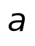 dollars and bet fairly, your expected fortune never changes.

Technical details
Formally, a process 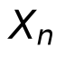 is a martingale if 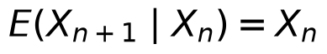 for all 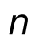. A fundamental consequence is:
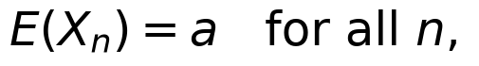
where 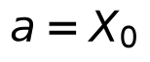 is the initial value (Theorem 11.4.1). For example, simple random walk with 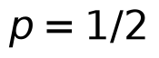 satisfies , making it a martingale. By contrast, with 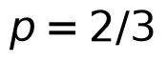, the conditional expectation equals 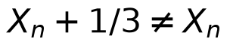, so it is not a martingale. A process need not use 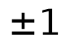 steps — Example 11.4.3 shows that starting at 5 and adding 3 (probability 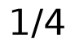) or subtracting 1 (probability 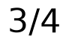) also yields , confirming it is a martingale.

Applications & further study
- Martingale theory makes otherwise difficult computations easy: in Example 11.4.6, finding 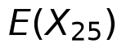 after 25 steps of adding 2 (prob. 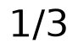) or subtracting 1 (prob. 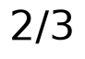), starting at 10, is immediate — since  is a martingale, 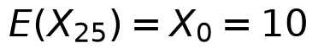.
- The Optional Stopping Theorem extends these ideas to random stopping times 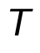, allowing martingale methods to solve the Gambler's Ruin problem (Examples 11.4.10–11.4.11) with far less effort than classical approaches.
- The context introduces stopping times and the use of transformed processes (e.g., 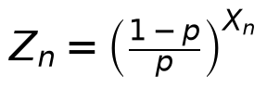) to handle the case 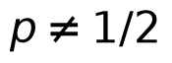, but full details of those results go beyond what is excerpted here.
Sources: Probability and Statistics The Science of Uncertainty.pdf p.664, 665, 666, 668

