Math & Statistics Q&A — Session Notes
Generated 2026-06-19

Q1. What is projection pursuit algorithm?

Intuition
Projection pursuit is a curve-fitting strategy that approximates a general function of many variables by a sum of simpler, univariate nonlinear functions, each applied to a linear combination of the original variables. Think of it as finding a small set of "interesting directions" in the data, much like finding principal components, but optimized for function approximation rather than variance alone.

Technical details
The core representation sought is:
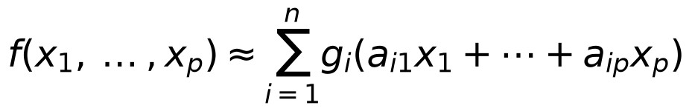
where the univariate functions 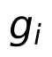 and the direction vectors 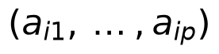 are chosen to minimize approximation error. The greedy version of the algorithm proceeds stage by stage: at each step it finds the direction 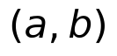 that minimizes , i.e., the direction giving the maximum reduction in residual variance. This is analogous to choosing principal components of a covariance matrix—the selected directions have a well-defined interpretation in terms of variance reduction.

Applications & further study
- The algorithm performs well in nonparametric regression with noisy data, high-dimensional density estimation, and multidimensional spline approximation.
- Key theoretical results (by Diaconis and Shahshahani) include necessary and sufficient conditions for exact equality in the representation, and results on non-uniqueness: if two representations share the same directions, their component functions differ only by polynomials of degree at most 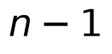.
- For deeper study, the context points to Friedman & Stuetzle (1981), Friedman & Tukey (1974), and Huber (1981) as foundational references; convergence of the greedy approximation in 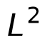 for normally distributed inputs was proved by Donoho and Johnstone independently.
Sources: ON NONLINEAR FUNCTIONS OF LINEAR COMBINATIONS DIACONIS SHAHSHAHANI.pdf p.1, 2, 4, 5, 16

