SOFTWARE QUALITY ENGINEERING – LAB 03
Black Box Testing: Equivalence Partitioning and Boundary Value Analysis
Student Name: Ali Riaz
Registration No: SE-241054
Section: BS-SE-5B
Course: Software Quality Engineering
Lab No: 03
1. Objective
The objective of this lab was to understand Black Box Testing techniques, especially Equivalence Partitioning (EP) and Boundary Value Analysis (BVA). These techniques were used to test a marks entry program that accepts marks between 0 and 100, inclusive.
2. Procedure
- Created a Java program named MarksEntryChecker.java.
- Compiled and executed the Java program.
- Identified valid and invalid input partitions using Equivalence Partitioning.
- Selected boundary values using Boundary Value Analysis.
- Prepared 3 EP test cases and 6 BVA test cases in Microsoft Excel.
- Entered the expected results before executing the test cases.
- Ran the program manually using the selected test values.
- Recorded the actual results and Pass/Fail status in the Excel sheet.
3. Screenshots
Screenshot 1: Equivalence Partitions and Boundary Values
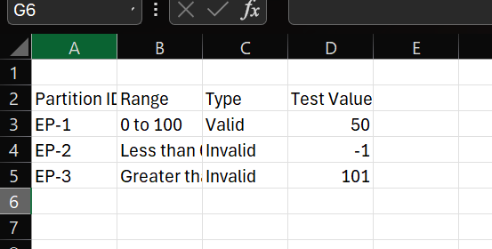
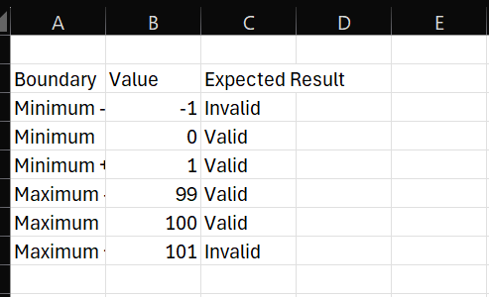
Screenshot 2: Test Cases with Actual Result and Status
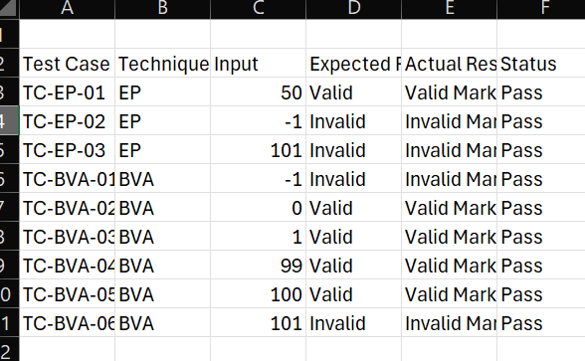
Screenshot 3: Failed Test Case Output
Not applicable because all test cases passed.
4. Observations
- Total test cases executed: 9
- EP test cases: 3
- BVA test cases: 6
- All 9 test cases passed.
- Marks from 0 to 100 were accepted as valid.
- Marks below 0 and above 100 were rejected as invalid.
- No defects were observed in the tested program.
5. Conclusion
In this lab, I learned how to apply Equivalence Partitioning and Boundary Value Analysis in Black Box Testing. I tested the marks entry program using valid, invalid, and boundary values. All 9 test cases passed, and the program produced the expected results for the tested inputs.
GitHub Repository Link: https://github.com/aliriaz199/SQE-Lab03-BlackBox-Testing?utm_source=chatgpt.com

