**AISS Infoscreen – Quickstart Guide**

<https://aiss-portal.cegeka.de/infoscreen-cb/>

**Add and Manage Locations (Briefung Rooms or other screen locations)**

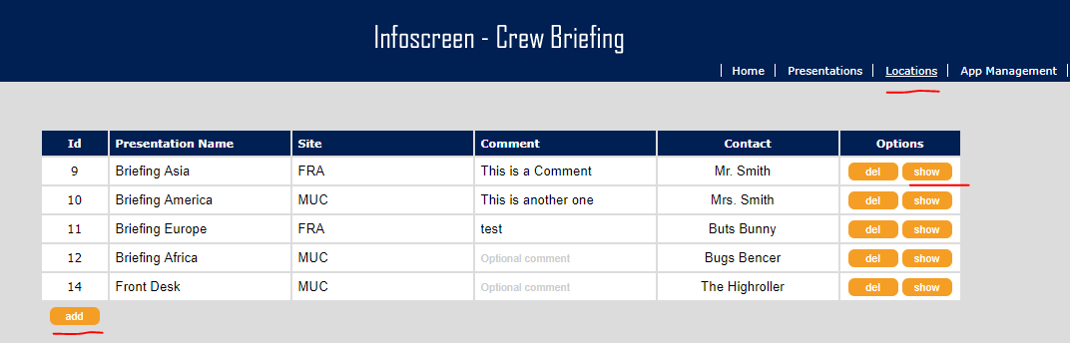

Via clicking on „show“ you’ll be forwarded to the available presentations for this location (show room)

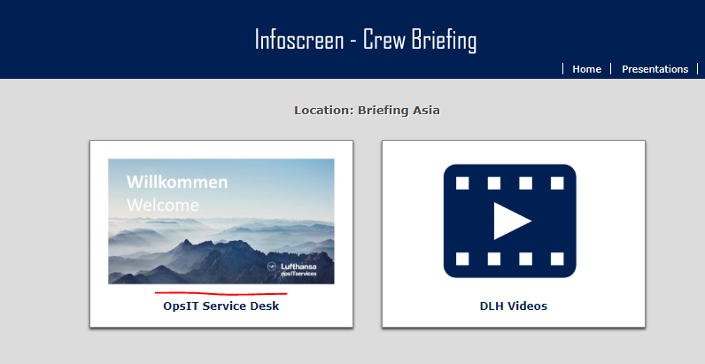

Via clicking on a thumb you’ll be forwarded to the online slide show.

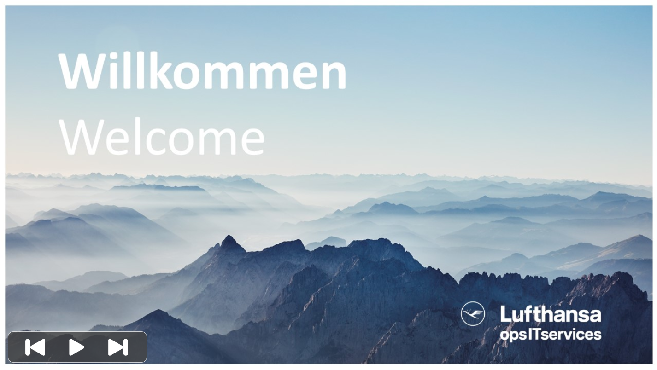

Media control bar will appear by clicking the slide.

**Add and Manage Presentations**

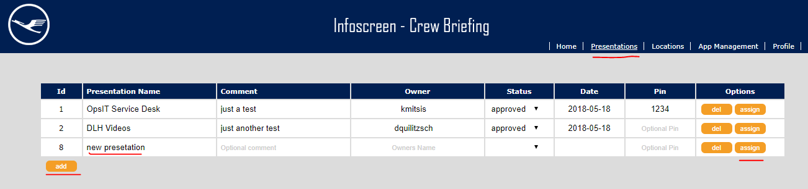

Only presentations with status approved or review are available in the show rooms.

Optional you can secure a presentation with a pin code.

Via „assign“ you can manage presentation content and assignment to locations.

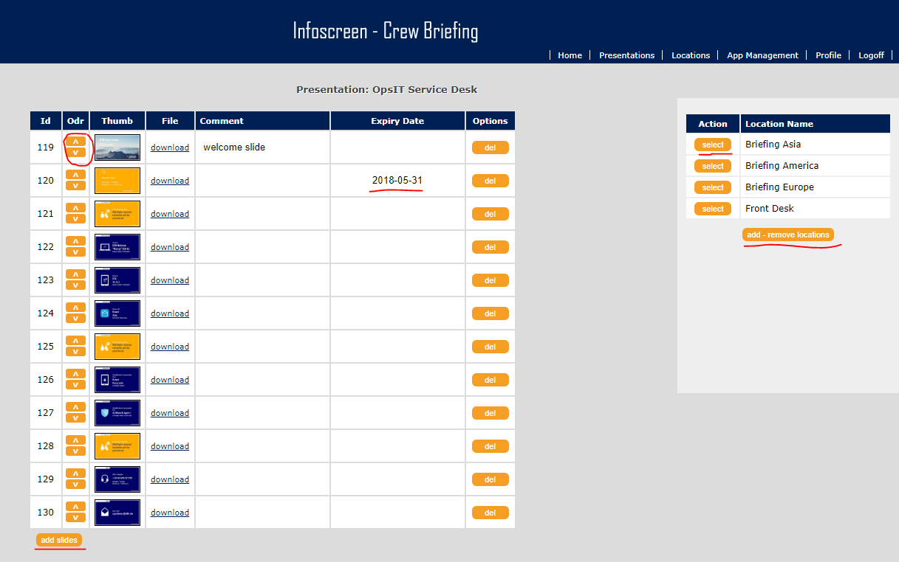

Here you can add media (images and **mp4** videos)

Sort media, define an optional Expiry Date and add comments.

On the right side You can define in which locations this presentation is available.

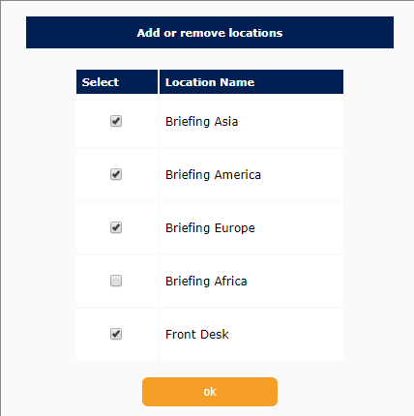

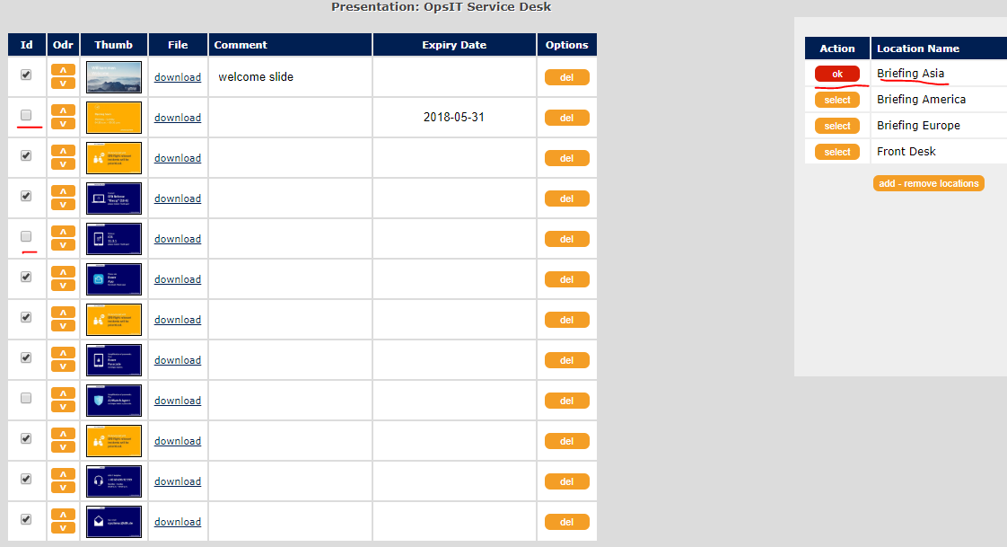

And you can define which slide or video is valid in which location.