**Business Requirements**: The requirement of this document is to create a university website which will be responsive and showing College related details. This will be a 4 page website with landing page included and other features as mentioned below.

**Site Map:**

Home -> Academic -> Faculty (One page each in Academic and Faculty)

|  |  |  |  |
| --- | --- | --- | --- |
| **Page** | **Home** | **Academics (One Page)** | **Faculty (One Page)** |
| **Features** | Mega Menu | Mega Menu | Mega Menu |
| Footer | Footer | Footer |
| SVG File with Bright colors | Contact Directory | Left Side Navigation |
| Counter with Tabs | Dynamic Dropdowns | Content creation (3 Paragraphs about College) |
| Image Gallery |  | Tables |

**Sample Feature screenshots:**

**Mega Menu:**

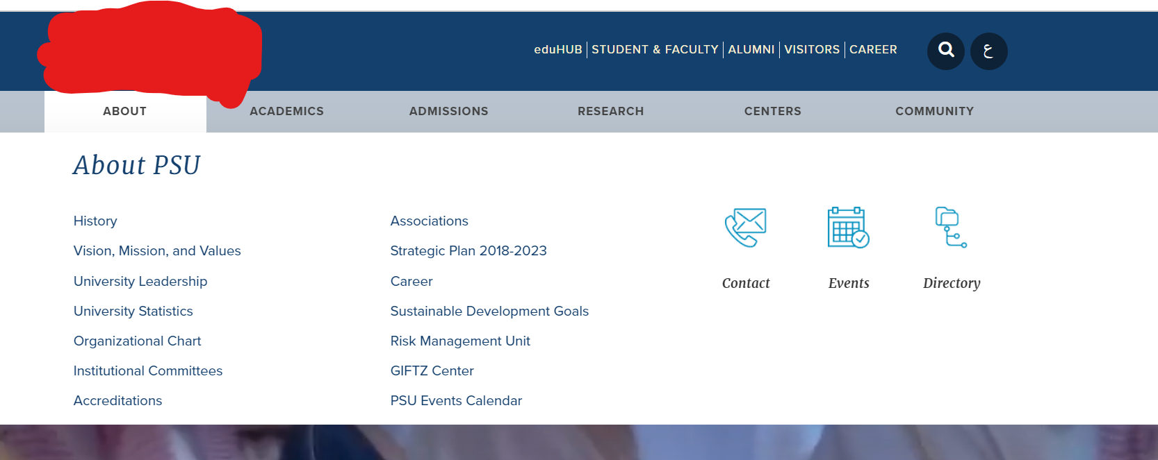

**SVG file:**

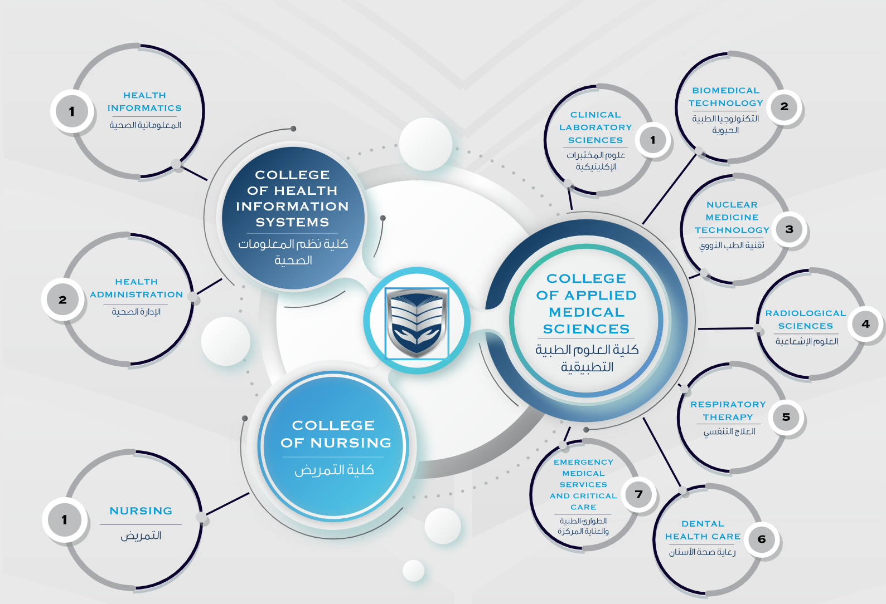

**Counter with Tabs:**

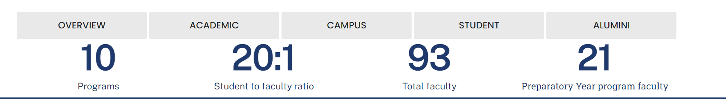

**Contact Directory:**

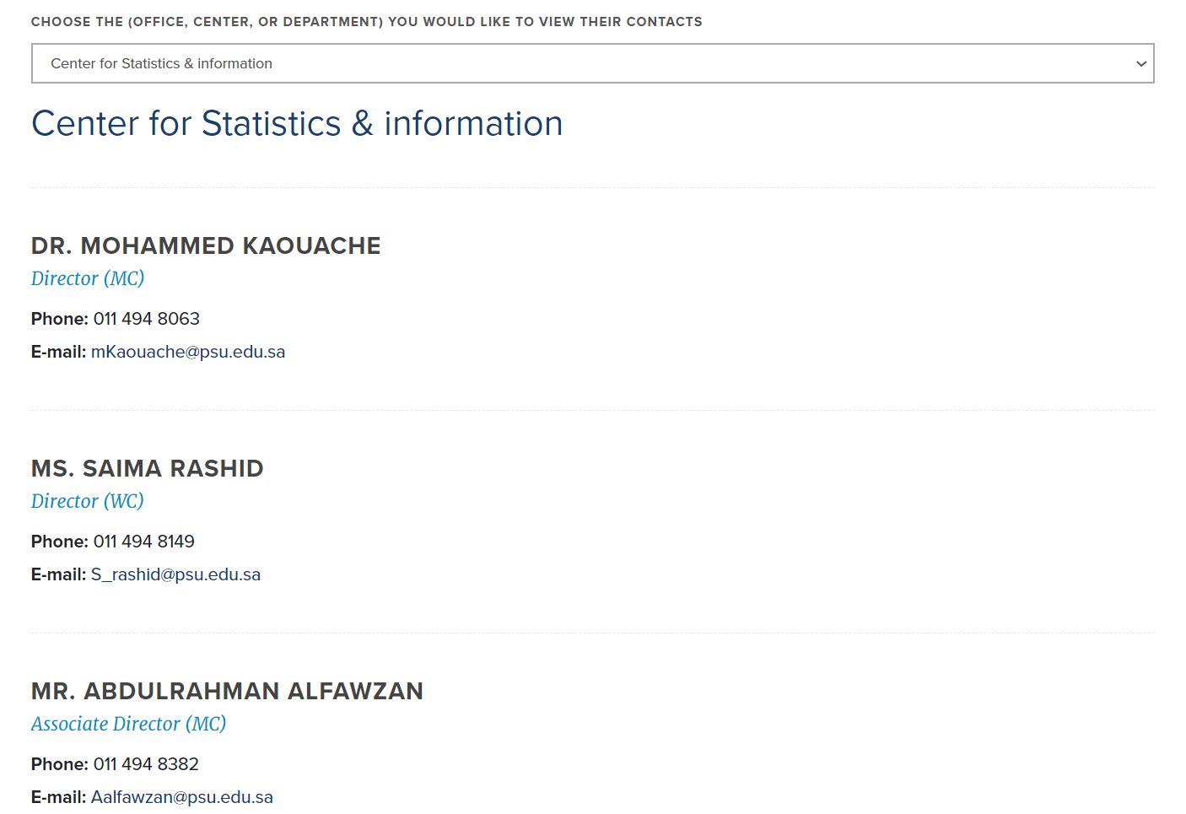

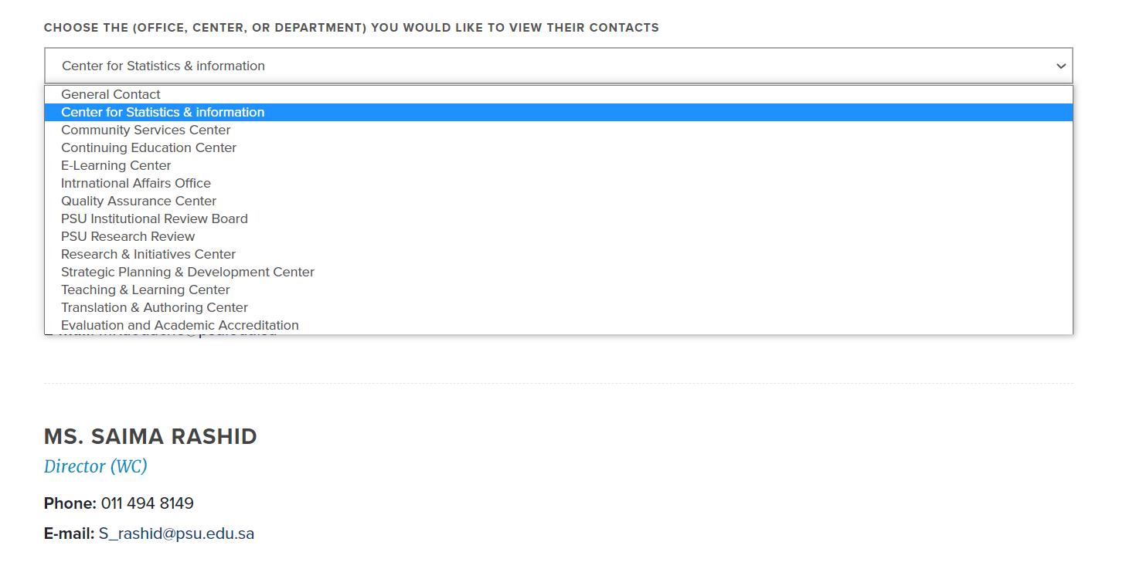

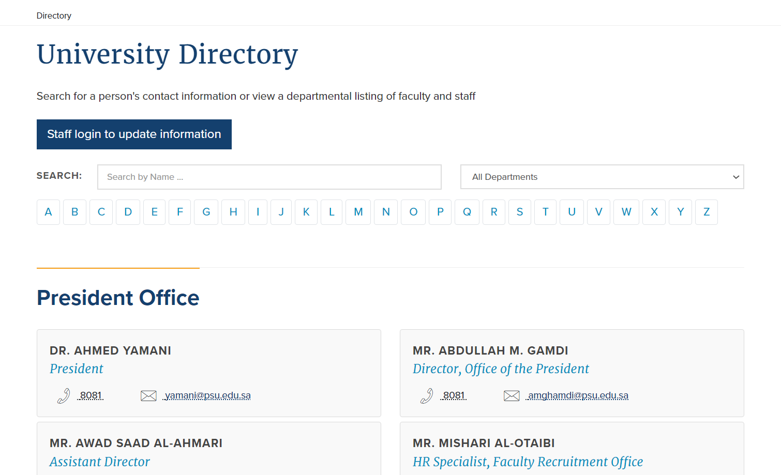

**Left Side Menu (frozen when scrolled):**

