Chapter 3 Design

Introduction

Design is a plan or activity specification to show the look and function or working of the system. Design specification describes or portrays how the systems can play out the necessities which is sketched out in functional requirements. Design can incorporate rules on testing specific necessities or review of limits or code. Here in the functional specification every single plot necessity must be addressed.

3.1 Tools.

Tools used to develop city health care website are:

* Sublime text.
* MYSQL.
* StarUML.
* Visual paradigm.
  1. Structural Model.

The selection of basic model to some extent mirrors the current dimension of improvement of structural mechanics and skill of the executor. Another factor influencing the determination in accessibility of computer equipment. It is the static structure of the system which exhibits the communication, relationship of the object. It involves the Entity Relationship and class diagram which is given underneath. Basic models of programming show the relationship of a system as far as the segments that make up that structure and their connections. Here we will center around class diagram for showing the classes structure in a software framework.

Class Diagram

Class diagram plots an overview of a framework by showing its classes, interface and the relationships among them. It makes an understanding of the model or design into code. It is also used for demonstrating that characterizes the principle obligations of the system.

Class diagram of city health care website:

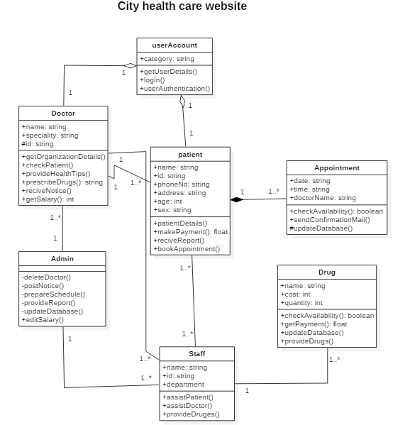

Figure: class diagram of city health care website.

Entity Relationship Diagram.

An entity-relationship diagram (ERD) is an information displaying technique that graphically illustrates an information systems entity and the connection between those entities. An entity-relation diagram (ERD) is an applied and authentic model of data used to represent the entity framework infrastructure.

Entity Relationship diagram of city health care website is below:

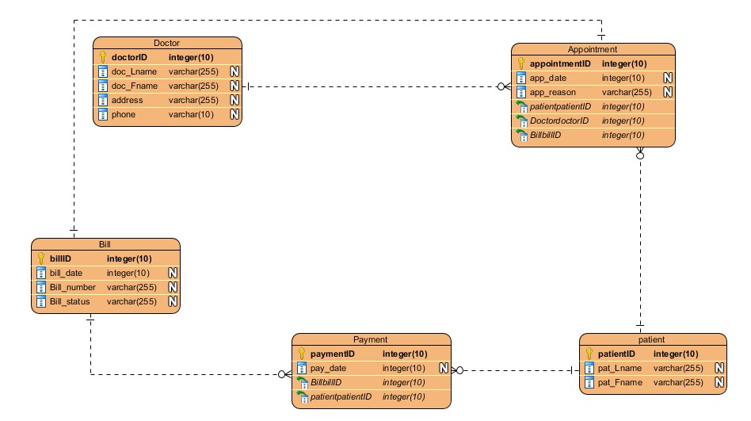

Figure: Entity Relationship diagram of city health care website.

Data Dictionary.

Data dictionary is a file or a set of files that contain a database metadata. The information word reference contains records about other objects in the database, such as data ownership, data relationship to other items and other information.

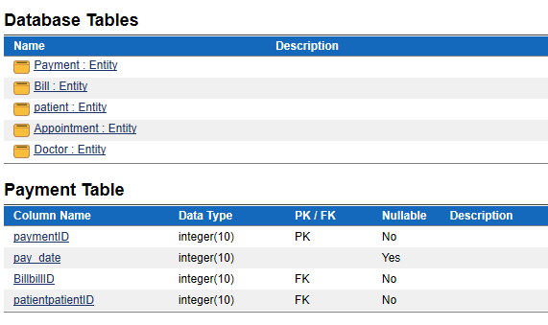

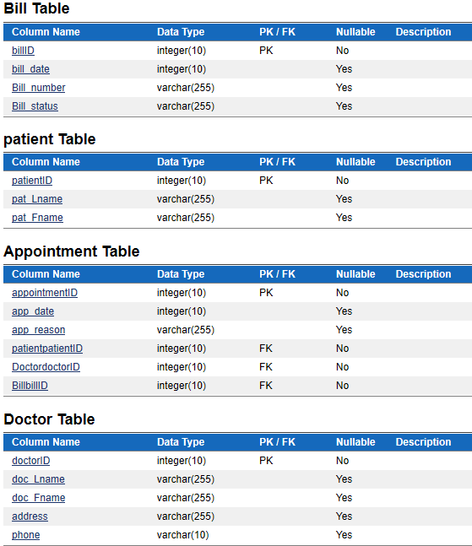

Data flow diagram.

Data flow diagram is method of representing a flow of data of a process or a system. The DFD additionally gives information about the outputs and inputs of every elements and the procedure itself. DFD has no control flow, there are no decision rules and no loops.

DFD of city health care website is given below:

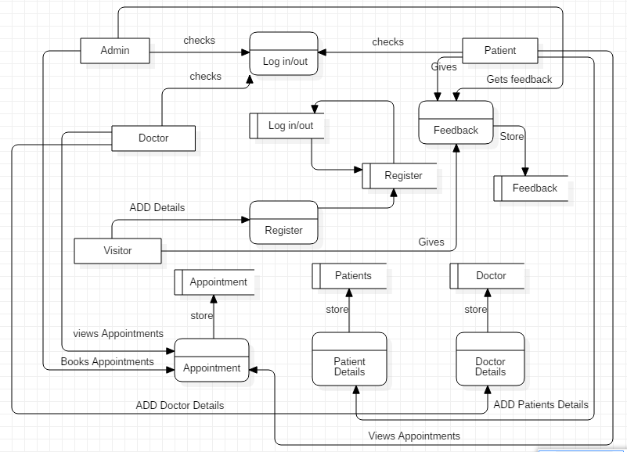

Figure: DFD of city health care website.

* 1. Behavioral Model.

It shows the cooperation’s between item to make some particular framework lead that is indicated as a use case.

Here we utilized activity diagram and sequence diagram are utilized to indicate participation between objects. Some importance of the behavioral models is:

* It described the controller structure of the system.
* It meets the ideal requirements of the system.
* Controller shape of system can be clarifying.

Activity Diagram

An activity diagram visually displays a series of actions or flow of control in a framework like a flowchart or a data flow diagram. Activity diagram are regularly used in business procedure modeling.

Activity diagram of city health care website is below:

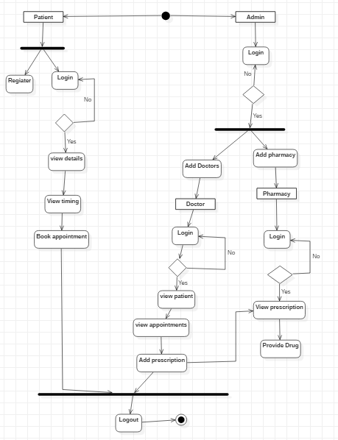

Figure: Activity diagram of city health care website.

Sequence Diagram

Sequence diagram represents objects and is utilized to characterize event sequence between objects for a specific result. A sequence diagram is a basic segment utilized in procedures related to analysis, design and documentation.

Sequence diagram for city health care website is given below:

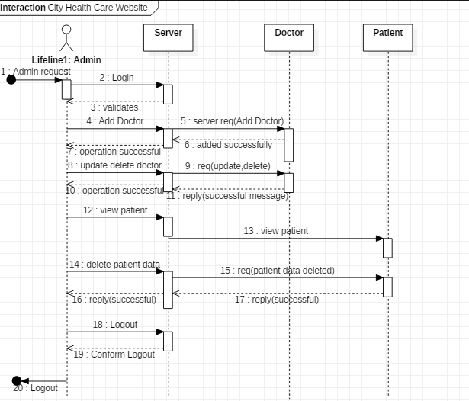

Figure: sequence diagram Admin.

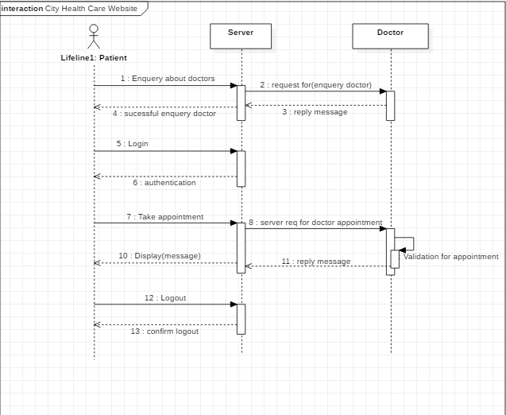

Figure: sequence diagram for patient.

* 1. UI Design

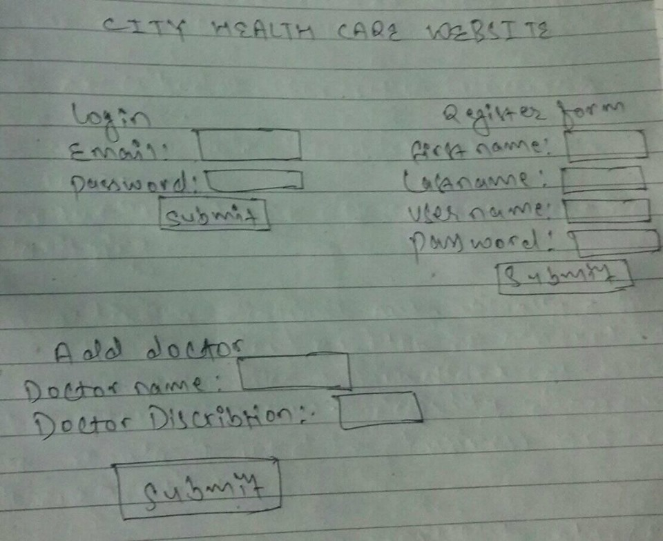

Conclusion:

At last the complete specification design of city health care website has presented. After this procedure of improvement will take place that designed in design stage.