**Chapter 5 Testing:**



Testing is a step process of evaluating standard(desired) outcome with the actual outcome/result with reference to many other factors such as efficiency, function, user-interface, portals, links etc. It is a mandatory step before launching any software, program, codes or even a physical product in order to discover the present errors, blunders, glitches and loops in the program that might affect the whole software. Thus, it a crucial step to identify, evaluate and execute the program before launching it as a good software/program.

5.1 Black Box Testing:

Black box testing refers to behavioral testing where the internals of the program are not checked but how does it function at the backend to the customers or users. Such testing is done for a well output from the program rather what does it include inside them.

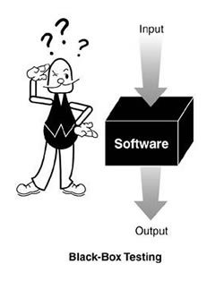

**Test Plan:**

Test plan is the way of executing the pre-program before it launches to the end customer/user where several factors are tested to see how the particular program works. The program is tested in several ways to see how robust and functional it is.

|  |  |  |  |  |
| --- | --- | --- | --- | --- |
| Test no | Test case | Test data | Expected result | Actual result |
| 1 | Admin login function | User name –  cityadmin  Password –  cityadmin | Full access | Access granted |
| 2 | Modify function | Add doctors | Doctor increment | Doctor added |
| 3 | Re-modify function | Delete doctors | Doctor decrement | Doctor deleted |
| 4 | Inquiry function | Visitor info. (no reg.) | full form filled details | Details received |
| 5 | Patient registration | Patient details | Registration status | Patient is able to register |
| 6 | Patient login | Patient credential | Login status | Successful |
| 7 | Doctor schedule for patient | Doctor time table | Accuracy | successful |
| 8 | Appointment status | Patient can view their appointment time | Must be real | Date sheet presented |
| 9 | Authenticate login | Patient cannot take appointment without login | Credential match | Authentication verified/false login rejected |
| 10 | User manual | User help post | User can see help post steps | Successful |

Table: Black-box test case table.

Here is my black-box testing:

1. Admin login function.

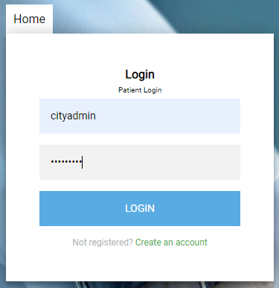

Admin login form.

1. Modify function.

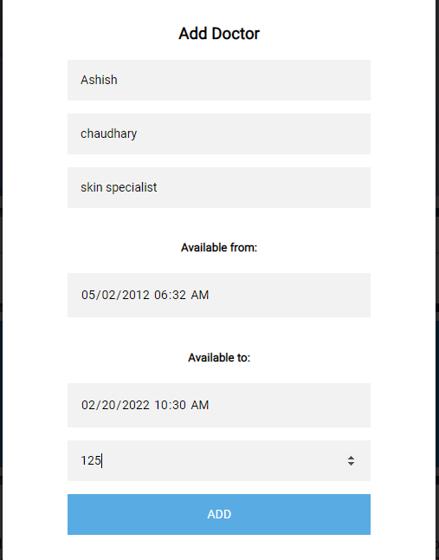

Admin panel for adding doctors.

1. Re-modify function.

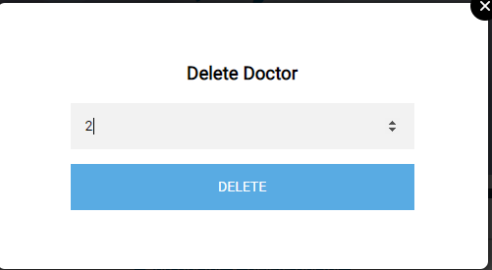

Admin panel for deleting doctor.

1. Inquiry function.

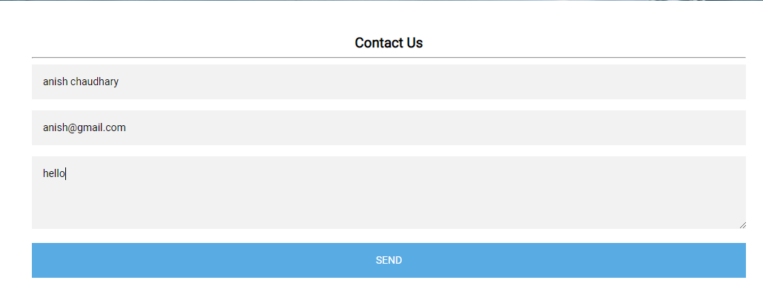

User inquiry form.

1. Patient registration.

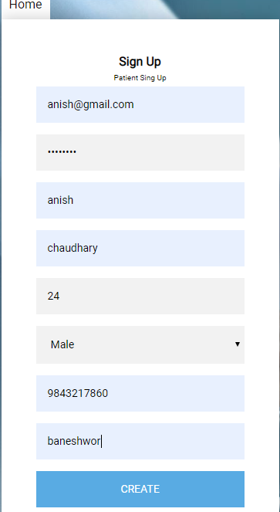

Patient registration form.

1. Patient login.

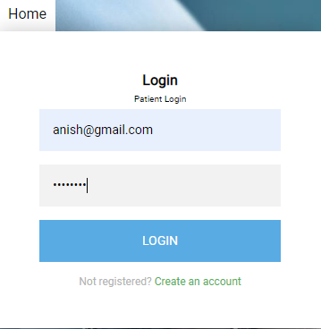

Patient login form.

1. Doctor schedule for patient.

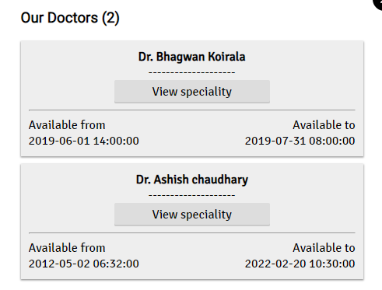

Doctor schedule for patient.

1. Appointment status

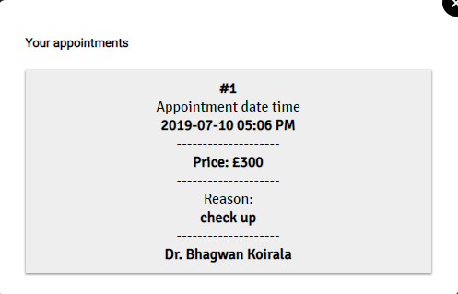

Patient can view their appointment status.

1. Authenticate login.

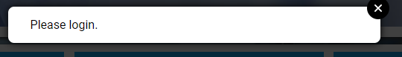

User authenticate login.

1. User manual.

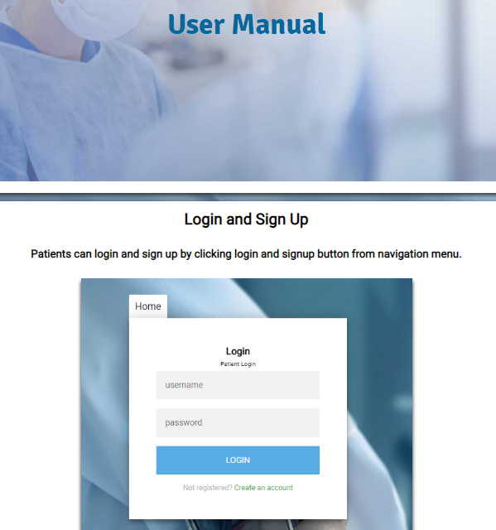

User manual form.

5.2 Unit Testing:

Unit testing is the discrete format of testing a software where the program is centered to one factor and function in order to make the program perform well at that certain area. For example: testing of program efficiency in calculating average only.