**Project Proposal on**

**City health care website**

Sundar Prasad chaudhary

00175001

Computing Project

Level 5 Diploma in Computing

Softwarica College of IT & E-Commerce

Kathmandu, Nepal

Table of Contents

Chapter 1 4

Introduction 4

Problem Identification 5

Chapter 2 6

Scope 6

Aims 7

Objectives 7

Development methodology. 8

Chapter 3 9

Project plan. 9

Work breakdown structure (WBS) / scheduling. 9

Milestones 10

Schedule 11

Chapter 4 12

Risk management 12

Chapter 5 13

Configuration management. 13

Conclusion 14

References 15

**List of figures**

Figure 1: Waterfall Model ...…………………………………………......... 8

Figure 2: WBS Structure ………………………………………………………. 9

Figure 3: Days division for Tasks ……………………………………………… 11

Figure 4: Gantt Chart of city health care website ………………………………………… 11

Figure 5: MBS on GitHub ………………………………………… 13

Figure 6: Tree Structure of MBS ………………………………………… 13

# Chapter 1

## Introduction

As we are living in the era of technology, this day’s people are very modern and technology based. We people do not like stand on long queue and wait for the turn. Everyone use technology like laptop, mobile phone, and internet for taking appointment or heath suggestions with doctor online. The proposed project “city health care website” whereby patient and doctor can share data in a safe way.

“City health care website” through the help of this website patient can share their health issue with the doctors in a safe way. Patient can also take health tips from the doctors. They can also know at what time doctors are available at the city health care and as per the schedule, they can take their appointment with the individual doctors.

You just need to register in the web and login to make appointment with the individual doctor. Patient can take appointment or share their health issue with the doctors 24hours a day from any part of the globe.

City health care website is very user-friendly web application where you can interact with system easily. Patient do not need to stand on long queue in order to checkup their health. Through this web system, you can get all the details of the doctor, timing of the doctor etc. online. I have used PHP for programming and MY SQL to manage database.

## Problem Identification

Many problems encounters during taking appoint of the doctors. They have to stand on a queue for long period to take doctor appointment. The patient need to visit to the doctor for even a minor health tips or suggestion and for which they need to have appointment to meet that individual doctor.

The proposed system will overcome this entire problem. This website enables you to take the free health tips, timing of the doctor arrivals and patient can share their health issue online.

The project aims building a website that is build using the most popular web programming language PHP. This helps to develop the skill of programming in PHP language and helps to develop overall system without error. So the knowledge of other module of the course will also be utilized to develop the complete project.

# Chapter 2

## Scope

The features of the project are listed below:

* User can register and login.
* User can take the appointment of the doctor from anywhere.
* User can see which doctor is available at what time.
* Patient can share their health issue with doctor online.
* Error free web with high usability.
* Messaging and notification.

The features that project will not have:

* Users’ needs internet facilities to use the system.
* Needs browser and website link to access the system.

The framework is worked in the PHP programming language and its supporting apparatuses. The internet is fabricated utilizing HTML and CSS. Advance GUI highlights and some approvals is finished utilizing java script. The fundamental rational is composed utilizing PHP language. The information is put away in MYSQL database. The frame work is facilitated locally in apache server utilizing XAMP control panel. The coding is done in the content tool subline text.

A completely practical website is wanted to be manufactured. Thus, there may be a portion of the specialized difficulties that may be confronted. PHP and different programing language are used. Thus, to utilize them together is a difficult thing. To make the framework mistake free and simple to get to is likewise another difficult factor. Making the framework strong and versatile is additionally a test. Limiting this test will assist the developer with building the frame work that will meet every one of the necessities of city health care website.

## Aims

To develop complete website that helps patient to take appointment of the doctors and share their health issue with doctors online.

## Objectives

* To develop the knowledge in web programming language and use the concept here.
* To utilize the knowledge of every module to develop single large project.
* To analyze the requirement of city health care website.
* To make design and implement it.
* Test the development system.
* Remove any error and take user feedback.

## Development methodology.

The task is little scale understudy venture with a portion of the highlights. The prerequisites of the undertaking and the framework that will be manufactured are additionally pretty much fixed. Thus, the advancement philosophy that will be utilized in this framework is "**Water fall model**". Waterfall model is the precise methodology where each stage must be finished to go to other advance. Waterfall model display is most appropriate in situation where the undertaking size is little, and the prerequisites are as of now known and won't be changed in future. This model is best for web application development and fits better with the system that uses database system.

Various stages of waterfall model are shown by the figure below:

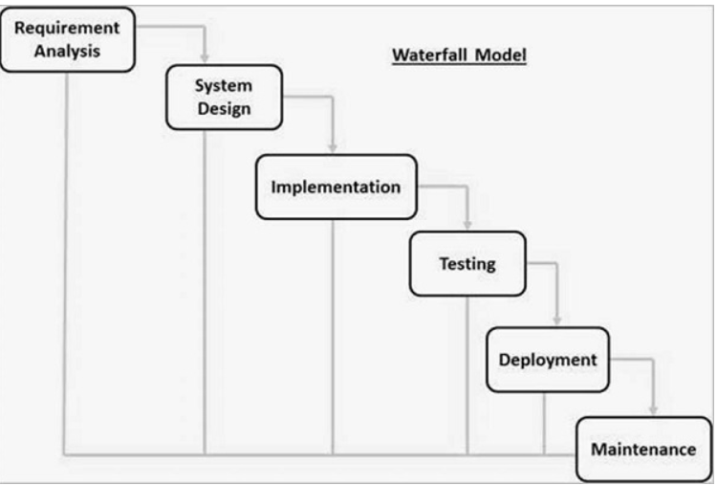

Figure 1: Stages of Waterfall Model.

# Chapter 3

## Project plan.

The making arrangements for the undertaking incorporates the arranging of the time so the task is created inside the given time allotment. The project is academic based, and a deadline is fix by the university and the different modules of the project must be deliver within time.

A thoroughly analysis is done on the different tasks and the time required to finish each task is decided. The Gantt chart is drawn using ProjectLibre to show time frame.

## Work breakdown structure (WBS) / scheduling.

Work breakdown structure.

Work breakdown structure is process of dividing complex project into small and manageable tasks. Usually, project manager use WBS for a project execution

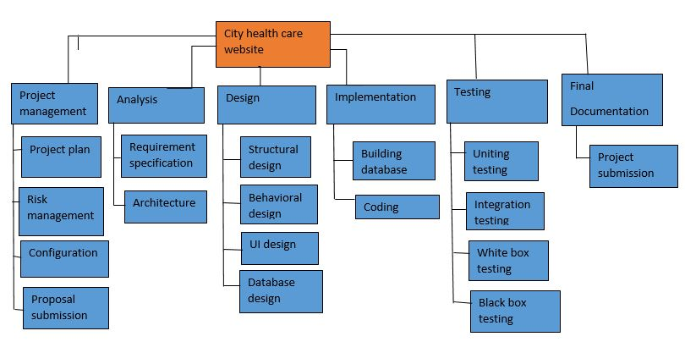

Figure 2: WBS Structure

## Milestones

The various milestones of the project are listed below along with the date of completion along with the number of days taken to complete the project.

|  |  |  |  |
| --- | --- | --- | --- |
| Milestones | Start date | Date of completion | No of days taken |
| Proposal | March 25, 2019 | April 9, 2019 | 16 Days |
| Analysis | April 10, 2019 | May 8, 2019 | 28 Days |
| Design | May 9, 2019 | June 3, 2019 | 25 Days |
| Implementation | June 4, 2019 | June 24, 2019 | 20 Days |
| Testing | June 25, 2019 | July 1, 2019 | 7 Days |
| Final documentation | July 2, 2019 | July 12, 2019 | 11 Days |

Table: Milestone of the project.

## Schedule

Gantt Chart is built as the part of scheduling. The Gantt Chart is presented below:

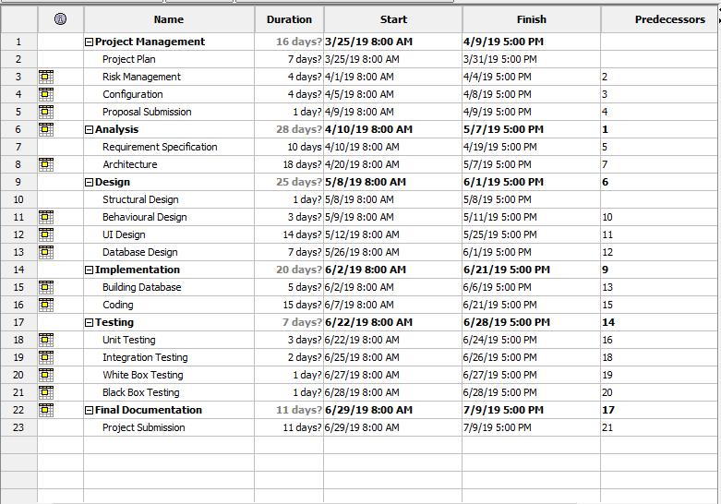

Figure 3: Days division for task.

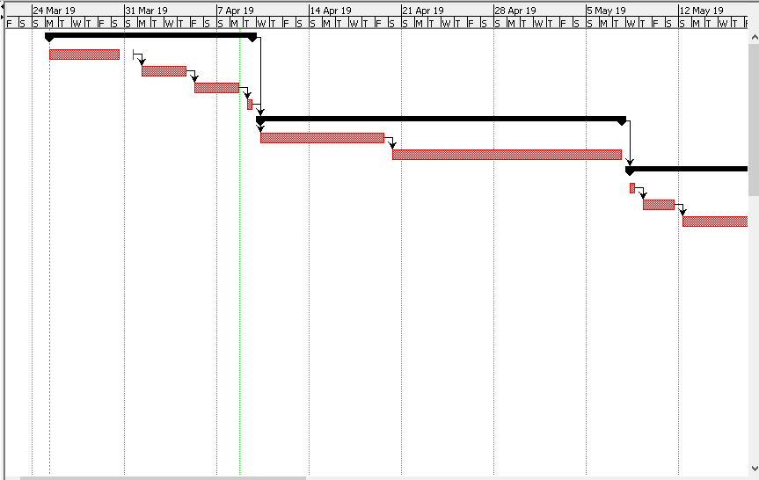

Figure 4: Gantt chart of city health care website.

# Chapter 4

## Risk management

Risk Management is the process of identify, analyzing of risk factor in project. It should be part of planning process to figure out risk in the project and control risk for future events. The risk that may affect the project progress must be minimized throughout the project lifecycle.

The formula (impact (I) = likelihood (L) * consequence (C )) is used to calculate the impact. The likelihood and consequences are defined as:

|  |  |
| --- | --- |
| **Likelihood (L)** | **Value** |
| Low | 1 |
| Medium | 2 |
| High | 3 |

|  |  |
| --- | --- |
| **Consequences (C )** | **Value** |
| Very Low | 1 |
| Low | 2 |
| Medium | 3 |
| High | 4 |
| Very High | 5 |

The risk that the project might have are:

|  |  |  |  |  |
| --- | --- | --- | --- | --- |
| **Risks** | **L** | **C** | **I** | **Action** |
| Project may not be completed on time | 2 | 5 | 10 | Each task should be completed on time |
| Scope can be too high | 3 | 3 | 9 | It should be done carefully |
| Requirements may not fulfill | 2 | 5 | 10 | Each requirement must be addressed |
| Resources may not be available | 2 | 5 | 10 | Should be borrowed or downloaded |
| Hardware or software crash | 1 | 5 | 5 | Proper backup of the work done and alternatives |
| System is difficult to use | 1 | 4 | 4 | Simple interface and user manual |

Table: Risk management analysis

# Chapter 5

## Configuration management.

Configuration management is involving practices of processing system changes systematically with updating system while maintain the system integrity. To achieve of goal of the system, configuration management should be implemented with details polices, procedures to manage to version.

# Conclusion

City health care website is a customized and user friendly a web application where you can take appointment of the doctor and take free health advice online. Patient can see the schedule of the doctor like which doctor is available at the city health care at what time. Patient can share their health issue direct with the doctors and this service is 24hours available.

Suitable breakdown and scheduling are done properly. Waterfall methodology is used for the project.

# References

www.tutorialspoint.com. (2019). *SDLC Waterfall Model*. [online] Available at: <https://www.tutorialspoint.com/sdlc/sdlc_waterfall_model.htm> [Accessed 1 April. 2019].

Gantt.com. (2018). *Gantt Chart definition? Gantt Chart Software, Information, and History*. [online] Available at: <http://www.gantt.com/> [Accessed 3 April. 2019].