**Lab#10 Exploring Spatial Patterning Using Precipitation Data**

In this lab, we will use spatial correlation tools to analyze spatial patterning based on precipitation data and locations. Please download data from Blackboard and save it in your Lab#10 folder. The data is the same as what we had for Lab#2.

**What you need to turn in:**

1. Z-score for spatial autocorrelation is:
2. In cluster&outlier analysis, how many stations have each one of the cluster/outlier types?
3. What are differences and similarities between two results from cluster&outlier analysis and hot spot analysis?
4. Adjusted R-squared of GLR model is:
5. Compare GLR and GWR results (you may refer to Relations between variables, distribution of standardized Residual et.), what are differences between these two models and why?

**Data Preparation:**

To avoid projection error, we firstly will define the projection for the data.

Go to Analysis > Geoprocessing > Tools > Project(Data Management Tools). Give the output Dataset name as sicfullelev_Project.shp. The Output Coordinate System is Current Map, which will then automatically change to User Local CS.

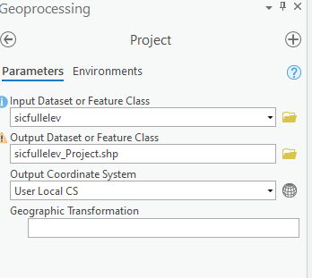

**Autocorrelation Analysis:**

We will use measure spatial autocorrelation based on feature locations and attribute values using the Global Moran's I statistic.

Go to Analysis > Geoprocessing > Tools > Spatial Autocorrelation(Global Moran`s I). Input feature class is the sicfullelev_project, input field is rainfall, choose inverse distance squared as Conceptualization of Spatial Relations. Distance method is Euclidean, Standardization is Row. Remember to generate Report.

Based on report, please answer question 1.

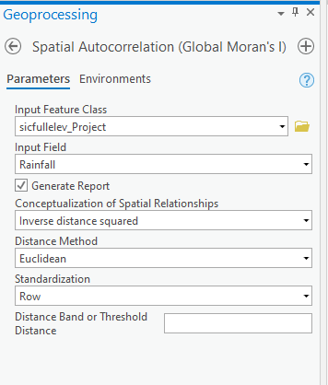

**Cluster Analysis:**

Next, let us analyze significant hot spots, cold spots and spatial outliers using the precipitation data.

Search for and open Cluster and Outlier Analysis(Anselin Local Moran`s I). the input feature class should be sicfullelev_project, the output feature class is Sicfullelev_Project_LocalMoranI.shp. set up the distance band or threshold distance as 10000. Number of permutations is 999. Attach the screenshot to the report.

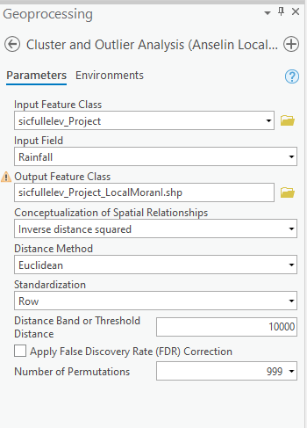

**Hot spot & cold spot analysis:**

This time, we will use Hot Spot Analysis (Getis-Ord Gi*) to analyze hot spots and cold spots distribution. Search for and open Hot Spot Analysis (Getis-Ord Gi*), for Conceptualization of Spatial Relationships, select Fixed distance band, which will guarantee each point has at least one neighbor. The threshold distance is 10000. Compare the its result with cluster and outlier analysis result, answer question 2.

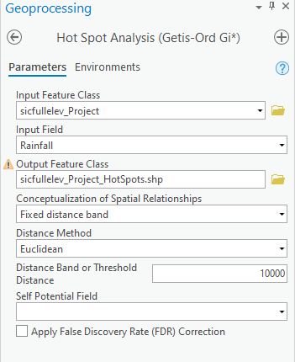

**Regression Analysis:**

Now, we will use regression analysis to generate predictions of a dependent variable to explanatory variables. Search for and open Generalized Linear Regression(GLR)(Spatial Statistics Tools). The dependent variable is rainfall and the explanatory variable is elevation. Model type is Gaussian. Give the output feature name as sicfullelev_Project_GLR.shp. Click Run and open view details > messages. Answer question 3.

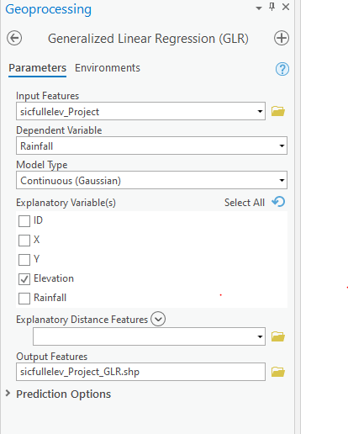

Compared with GLR analysis, we can also use Geographically weighted regression to analyze the correlation between rainfall and elevation.

Search for and open Geographically Weighted Regression(GWR)(spatial statistics tools). This time, give neighborhood type distance band. For neighborhood selection method, we will select golden search. In additional optional, we use Gaussian as local weighting scheme. The output features should be named 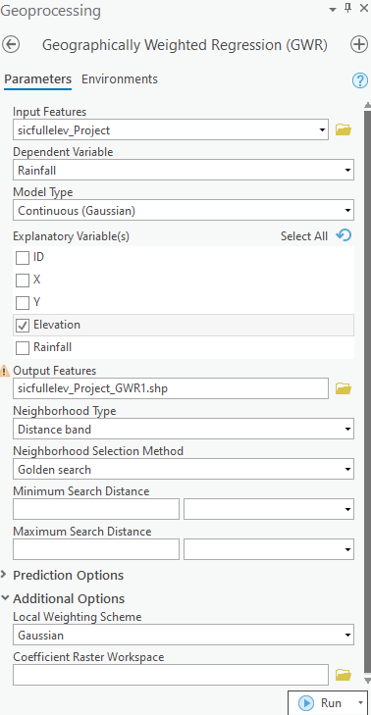as sicfullelev_Project_GWR.shp. Click Run.

Compare the Relationship between variables between GLR and GWR, answer question 4.

