**Lab 4: Focal Operations – Focal Operations, Removing DEM Errors, Wind Exposure, and Lake Edge Detection**

**Learning Objectives**

This lab will use neighborhood operators (i.e. focal operators) to examine an elevation surface, remove errors in a DEM, and analyze wind exposure. In the first part, you will learn how to bring an ASCII into Arc as a grid and confirm your understanding of focal statistics. In the second, you will use the slope tool and focal statistics to blur out errors in the DEM and examine how changing the window results in a changing image. In Part 3, you will perform a site suitability analysis for wind turbines using the slope, aspect, hillshade, and focal wedge tools. You can do all of these parts within the same or separate mxd’s, but be sure to save often.

**What you need to submit:**

**Lab 4: Answer Sheet** Name:

**Question 1**: Use your test raster layer to run the following three FOCAL operations (with a rectangular neighborhood of 3 by 3, cell size 10) and fill in the respective grids:

Focal Sum: test_sum:

|  |  |  |  |  |  |
| --- | --- | --- | --- | --- | --- |
|  |  |  |  |  |  |
|  |  |  |  |  |  |
|  |  |  |  |  |  |
|  |  |  |  |  |  |
|  |  |  |  |  |  |

Focal Maximum: test_max:

|  |  |  |  |  |  |
| --- | --- | --- | --- | --- | --- |
|  |  |  |  |  |  |
|  |  |  |  |  |  |
|  |  |  |  |  |  |
|  |  |  |  |  |  |
|  |  |  |  |  |  |

Focal Mean: test_mean:

|  |  |  |  |  |  |
| --- | --- | --- | --- | --- | --- |
|  |  |  |  |  |  |
|  |  |  |  |  |  |
|  |  |  |  |  |  |
|  |  |  |  |  |  |
|  |  |  |  |  |  |

**Question 2**: What was the size of the patches used to mosaic the image? (approximately): _______ Meters

**Question 3**: Are the artifacts (errors) still visible in silver3x3 and silver7x7?: _______ (true/false)

**Question 4**: How many cells have an elevation greater than or equal to 1000m?: _______ Cells

**Question 5**: How many cells have an aspect between 225o and 315o (see your GoodAspect raster layer)? _______ cells

**Question 6**: What is the total area (m2) of Good sites and blocked cells using a 10 cell radius (see your GoodSites10 raster layer)?  
Good Sites: _______ m2  
Blocked: _______ m2

**Question 7**: Calculate wind exposure using a wedge radius of 4 cells (120 meters). Use similar naming conventions (i.e: WindMean04, GoodWindExp04, GoodSites04, & Blocked04). What is the total area (m2) of the good sites and blocked cells?  
Good Sites: _______ m2  
Blocked: _______ m2

**Question 8**: Calculate wind exposure using a wedge radius of 20 cells (600 meters). Use similar naming conventions (i.e: WindMean20, GoodWindExp20, GoodSites20, & Blocked20). What is the total area (m2) of the good sites and blocked cells?  
Good Sites: _______ m2  
Blocked: _______ m2

**Extra Point**: Why did increasing the radius value to 20 in question 8 cause the wedge neighborhood computation time to increase so dramatically? (look at the time spent in geoprocessing > results) Be specific; only the best answers will get the full point!

# ****Materials****

|  |  |  |
| --- | --- | --- |
| Relevant part | Data Name | Description |
| Part 1 | Test.asc | ASCII Grid with sample values |
| Part 2 | silvrsub_f | DEM for Silverton, CO (30m cell size, elevation in feet) |
| Part 3 | wnw | DEM of NW part of Watauga Cnty (30m cell size, elevation in feet) |

# ****Part 1: Focal Operation Test****

## **Converting the ASCII file to a grid and run focal tools**

* Open ArcGIS Pro and make sure that the Spatial Analyst extension is activated.
* Change the workspace for the Spatial Analyst Tools by going to Geoprocessing > Environments…
* Under Workspace change the Current Workspace to your Lab4 folder.
* Rename the data frame as ASCII Grid.

If some of you forget what data frame is, refer to the following image.

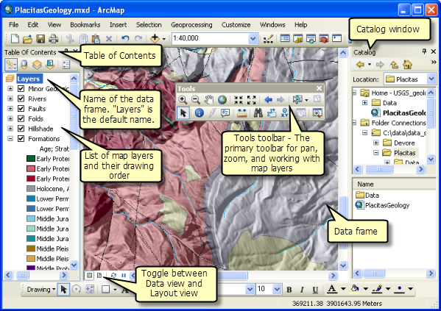

* Inspect the ASCII Grid file *test.asc* using a text editor such as notepad. We will use this small raster file to visually verify the results of several focal operations.
* Here are two ways to convert .asc to Raster.
* First, in geoprocessing Tools, search Copy Raster (Data Management Tools) , put test.asc as input Raster, and test as Output Raster Dataset. NoData Value as -9999.
* Set up environments as the image below.
* Save your output in lab04/part1, click Run. You could refer <https://pro.arcgis.com/en/pro-app/latest/tool-reference/data-management/copy-raster.htm> for more details about Copy Raster.

|  |  |
| --- | --- |
|  |  |

* Second, you could use python to run the ASCII to Raster tool. Open analysis > python > python window (you can try python Notebook as well). At the bottom, you will see a python window where you can type in the script to convert ASCII to Raster.
* Type the script:

import arcpy

arcpy.ASCIIToRaster_conversion("input path/test.asc", "out put path/test","FLOAT")

, and press ctrl + enter to run the code.

* You are highly recommended to save the output raster as test in your lab04\part01 folder as the following image shows.

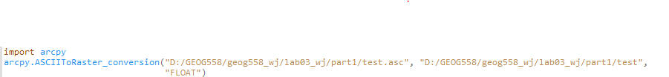

* The test raster will be added to the Table of Contents automatically. You can ignore any projection warnings you receive when adding these rasters.
* Use the analysis > geoprocessing > Tools > **Focal Statistics** tool (Spatial Analyst) to answer Question #1 on your assignment sheet.
* Note: input should be the raster you just created.

|  |  |
| --- | --- |
|  |  |

hint #1: change your layer symbology to show unique values. hint#2: Want to flex? You can label the rasters as shown below, and it’s good cartography practice. Useful tools: Raster to points (conversion tools), labelling properties, label, symbology, round() function to two decimal places.

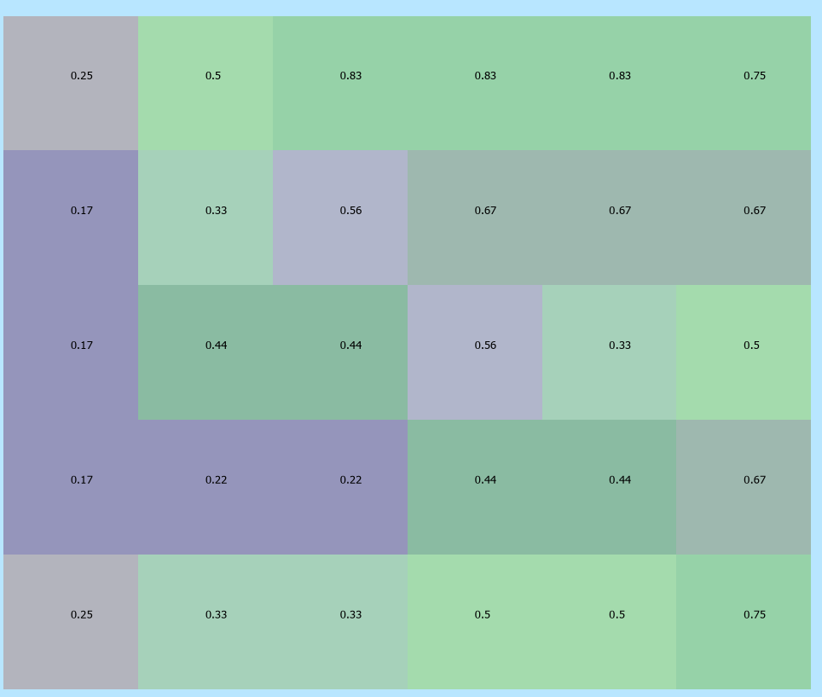

Hint: if you want to change symbology of certain layers, Right+click the layer > symbology > Symbol > properties

Save your document.

# ****Part 2: Removing DEM Errors****

## **Convert DEM from feet to meters**

First let’s lay down the foundation.

* Insert and rename a data frame to DEM Error Removal.
* Add the *silvrsub_f* grid to the data frame.
* This surface was created in rectangular patches and then mosaiced together, but the artifacts of mosaicing are not readily visible by simply viewing the DEM.
* Since the height is in feet and the cell sizes are in meters, you should put everything into the same unit using a local operation (i.e., Raster Calculator).

Hint: 1 foot = 0.3048 meters.

* Save the output to your lab04\part02 folder as: *silversub_m*.

## **Locate Artifacts (Errors) in the DEM**

Let’s start by calculating the slope for the raster to more easily identify the artifacts.

* Analysis > Tools > **Slope (spatial analyst)**, which is a focal operation we can use to find the linear artifacts in the *silversub_m* grid.
* In the slope dialog box, set the input raster as *silversub_m*.
* Leave the default values for output measurement and z factor.
* Save the output grid *silver_slope* in your lab04\part02 folder.

You should now be able to visually pick out the linear artifacts left from the mosaicing process. Using the measurement tool, determine the approximate size of the patches that were used to mosaic the image and answer Question #2 on your assignment sheet.

## **Removing DEM Errors**

Now try to eliminate the artifacts by smoothing the surface of *silversub_m* before deriving the slope. Go to analysis > Tools > **Focal Statistics** to compute the mean elevation value in a rectangular neighborhood of 3x3 cells and another of 7x7 cells.

* Use silversub_m as the input in both cases, making sure to name the output appropriately, something like *silver3x3* and *silver7x7*.
* Derive the slopes of these new surfaces as in step 2, and be sure to name them appropriately, something like *slope3x3* and *slope7x7* respectively.
* Answer Question #3 on your assignment sheet.

# ****Part 3: Wind Exposure Analysis****

## **Convert DEM from feet to meters**

First let’s lay down the foundation

* Insert a new dataframe and call it Wind Exposure Analysis.
* Add the *wnw* grid to the data frame.

This surface was created in rectangular patches and then mosaiced together, but the artifacts of mosaicing are not readily visible by simply viewing the DEM. Since the height is in feet and the cell sizes are in meters, you should put everything into the same unit, as was done in Part 2. Save the output to your lab04\part03 folder as: *wnm_m*

## **Obtaining Areas with Good Elevation**

* Select the cells where the elevation in *wnw_m* is greater than or equal to 1000m by creating the following expression in the Raster Calculator: “wnw_m” >= 1000
* Make the output raster a permanent layer named *GoodElevation*

## **Generating a Hillshade raster layer**

* Using Spatial Analyst, create a hillshade raster from your *wnw_m* DEM using the **Hillshade** tool
* Set *wnw_m* as your input surface, leave the default settings for azimuth and altitude, but set the Z factor to 3
* Save the output grid as *hillshade* in your lab04\part03 folder

## **Visualizing with hillshade**

Hillshades are useful for providing geographic context, but can overwhelm data which kind of defeats the purpose of making a map. One way to fix this is mask out no data values in your output layer, and make it slightly transparent. We’ll do this a few times in this lab so remember this sequence

* Display *GoodElevation* on top of *hillshade*
* Set the color of the bad elevations (0’s) to hollow (no color) by:
  + Rclicking on *GoodElivation*
  + Select symbology tab
  + Proceed with: 0 symbol and selecting No Color.
* Change the Transparency value of *GoodElivation* to approximately 40%
  + Highlight the layer > appearance > transparency

Answer Question #4 on your assignment sheet

## **Obtaining Areas with Good Aspect**

* Calculate the aspect from *wnw_m* DEM using the **Aspect** tool
* Save the output grid as aspect in your lab04\part03 folder
* Notice the range of angles assigned to each direction in the table of contents. Aspect values begin at 0 at due north and increase clockwise.
* Using Raster Calculator, select the cells with an aspect between 225o and 315o. This will give us the westward facing slopes.
* That expression should look like (225 <= “aspect”) & (“aspect” <= 315)
* Make the output raster a layer named *GoodAspect*
* Display the *GoodAspect* on top of *hillshade* (set symbology like you did for *GoodElivation*) and verify that it represents the western slopes.

Answer Question #5 on your assignment sheet.

## **Obtaining Wind Exposure Values**

Create a neighbor mean raster of *wnw_m* using a FocalMean operation.

* Use Focal Statistics with a wedge neighborhood (start angle 135, end angle 225, and a radius of 10 cells.

It is important to note here that the wedge neighborhood is measured differently than the aspect. The aspect measurement begins at 0 degrees due north and increases as we move clockwise. However, when computing a wedge neighborhood, we start at 0 degrees due east and increase as we move counterclockwise. Thus, the degree range here (135-225) represents the same degree range as indicated in the aspect range (225-315, 90 difference). This is simply due to inconsistencies in the way the ArcGIS software handles radial measurements.

* Save the output as *WindMean10*
* In Raster Calculator, select the cells whose elevations are higher than their neighbor mean (i.e., WindMean10)
  + _wnwm > WindMean10
  + Make the output a permanent raster named *GoodWindExp10*
* Display GoodWindExp10 on top of *hillshade*

## **Isolate the best sites and those that meet all the criteria except wind exposure**

* Using Raster Calculator, select the cells with good elevation (1’s), aspect (1’s), and wind exposure (1’s). Your expression can look like: (GoodElevation == 1) & (GoodAspect == 1) & (GoodWindExp10 == 1), or more simply GoodElevation * GoodAspect * GoodWindExp10.
* Make the output a permanent raster named *GoodSites10*.
* Use Raster Calculator, select the cells with good elevation (1’s), good aspect (1’s) and bad wind exposure (0’s) with the following expression: (GoodElevation == 1) & (GoodAspect == 1) & (GoodWindExp10 == 0).
* Make this a permanent raster named *Blocked10*, which indicate cells where the wind is blocked because of hills to the west.
* Answer questions #6 - #8 on your assignment sheet (you will need to repeat the steps above twice more using different radius values)