**Lab 6: Zonal Operations – Tornado Siren Coverage Analysis and Lake Volume Calculations**

**Learning Objective**

In this lab, we are interested in assessing how much of Douglas County is covered by tornado sirens. In other words, we want to know how many people can actually hear a tornado siren when it goes off. While the sirens for Douglas County were designed to be heard at distances of up to 5,800 feet, there might be areas in which people can’t hear them. Finally, we will use the zonal definitions of lake area created in lab 3 to calculate the height of the water from the DEM and turn the height and area into a volume estimation.

# ****What you need to submit****

**Lab 6: Answer Sheet**  
Name:

**Part 1:**  
Total Douglas County population:  
Number of people who can hear the tornado sirens:  
Number of people who cannot hear the tornado sirens:  
Percentage of the population that can hear the tornado sirens:  
Percentage of total population that cannot hear the tornado sirens:

Note: Your math should add up.

**Part 2:**

**Attach the map here.**

**Part 3:**  
How much water did the lake gain over the time period:  
Which period did the volume grow the fastest, 1995-2003 or 2003-2009?

Write a short (2-4 healthy paragraphs) analysis regarding this process. Some topics to touch on include how this analysis was performed.

* Would you expect a significantly different answer if you tweaked the methods?
* What are the sources of error in this process?
* How can we address those, and the uncertainty they add to our analysis?

**Materials**

|  |  |  |
| --- | --- | --- |
| Relevant part | Data Name | Description |
| Part 1 | censusblk.shp | Census blocks for Douglas County, Kansas |
| Part 1 | kansas2000censusblk.dbf | Database file containing census data, including population per block group |
| Part 1 | sirens.shp | Point shapefile with locations of tornado sirens in Douglas County, KS |
| Part 1 | roads.shp | Douglas County Roads |
| Part 1 | countybnd.shp | Douglas County Boundary |
| Part 2 | BaseData | Data downloaded in the first lab |
| Part 2 | NDWI_3.tif | NDWI threshold maps you created in Lab 2 |

# ****Part 1: Tornado siren coverage****

## **Create Buffers**

* In ArcGIS Pro, insert a new empty map, and add *countybnd.shp*, *roads.shp*, *censusblk.shp*, and *sirens.shp* from your Part1 folder to the empty map.
* Create buffers around the sirens using the **buffer** tool and the following settings:  
  + Input Features: sirens
  + Output Features: *sirens_buffer.shp* (make sure to save in your Part1 folder)
  + Linear Unit: 5800 feet
  + Dissolve Type: No Dissolve

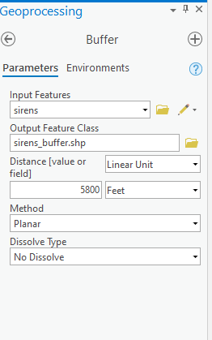

* Arrange layers so that you can see the siren points and buffers on top.
* Let’s remove the common polygon lines in the buffer. Search **Dissolve (Data Management) in geoprocessing Tools**. Use the following settings:
  + Input Features: *sirens_buffer*
  + Output Features: *sirens_buffer_dissolve.shp* (make sure to save in your Part1 folder)
  + Change the symbology of the layers to the colors and symbols of your choice, and arrange the layers accordingly.

Notice that you could have just used the dissolve type parameter in the buffer tool, but now you know where both are. Please refer to the following image as an example. You must finish a prettier map than mine.

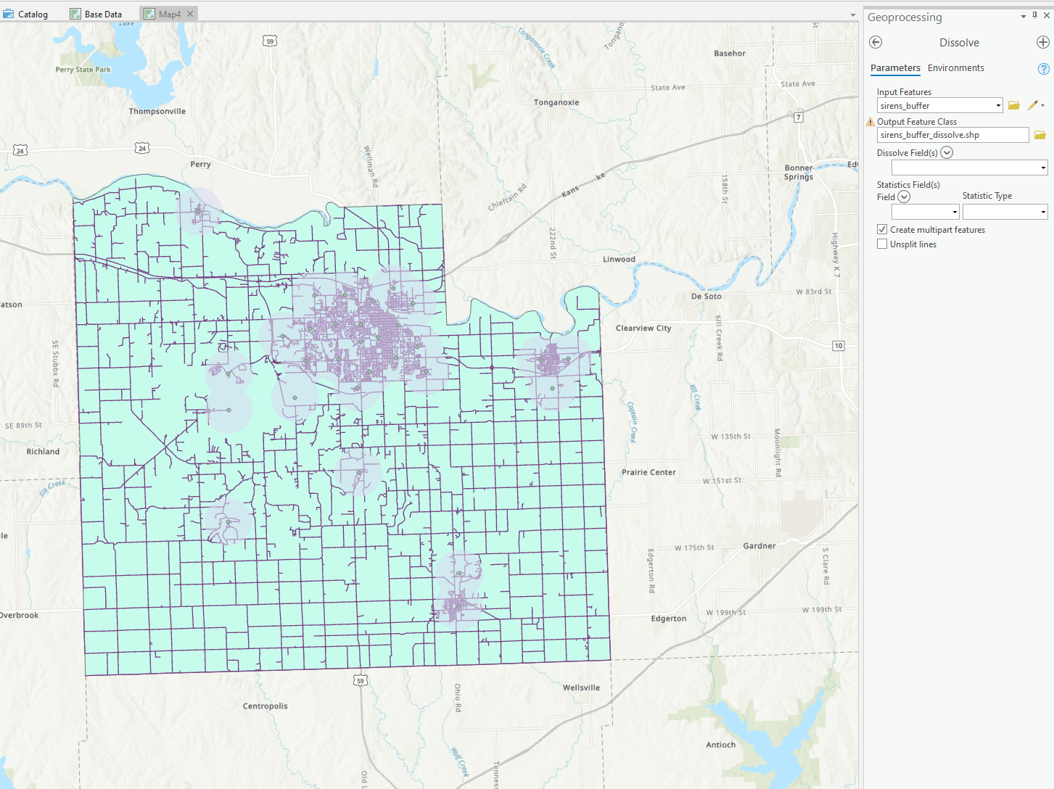

## **Finding the Percentage of Population Covered by Sirens**

* Add *kansas2000censusblk.dbf* to the data frame.
* Right-click the *censusblk* layer, select Joins and Relates, and select Add Join. Join the layer to *kansas2000censusblk.dbf* using the STFID field.

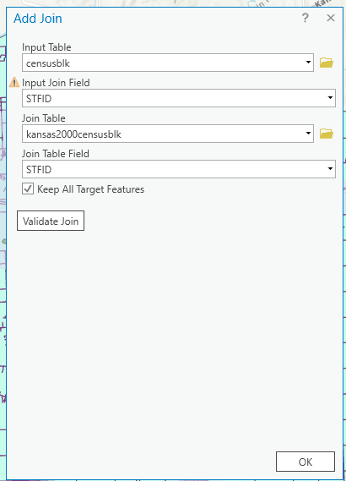

* Examine the attribute table of *censusblk* to make sure the join was successful. Do you see all sorts of demographic attributes? If so, the join was successful.
* Right-click the header of the *POP2000* attribute and select Statistics. Click Properties and you will see a Chart Properties window appears (usually on the right). The sum value is the number of people in Douglas County.
* Use Select by Location… to select the census blocks that are within the buffer zone. You can refer to the following image to check your operation.
  + Hint: blocks should be completely within the source layer feature. The result should be 1,590 census blocks selected.

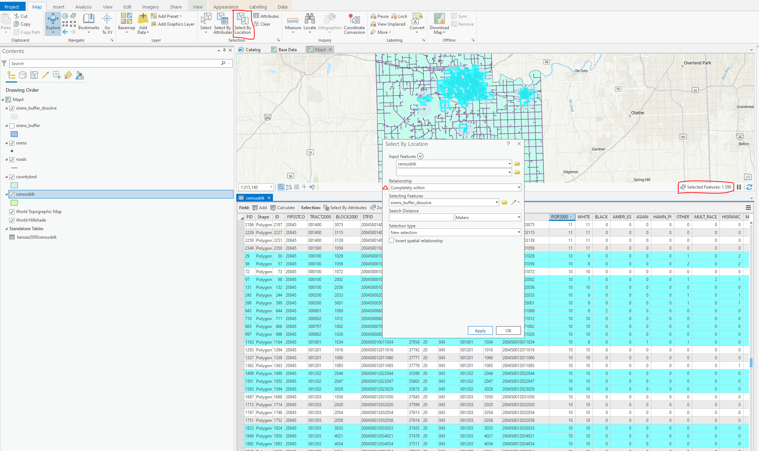

* Find the population in these census blocks by checking the statistics of POP2000 again. (It will give you statistics on the selected records.) Record this number.
* Find the population out of the range of sirens by clicking Switch on the top of the attribute table, and then using the **Statistics** tool again. Record this number.
* Switch the selection back (i.e., back to the blocks within range of the sirens) and close the attribute table.
* Answer the part 1 questions.

# ****Part 2: Lake Edge Detection****

Create a data frame/document for Part2. This document should have:

* AOI shapefile
* lake body classifications (*…NDWI_#.TIF*) )for 1995, 2003, and 2009.
* The RGB file for each year

## **Calculate the boundary of the lake in 1995 using a focal erosion process**

* Using the **Focal statistics** tool, calculate the focal minimum using a rectangular 3x3 grid.
* The input should be the *…_NDWI_3.TIF* created in Lab 2.
* Save the output in the 1995 BaseData folder and name the output as *…_NDWI_FMin.TIF*.

## **Calculate the difference between the two surfaces**

* Using raster calculator, subtract the focal min raster from the lake classification raster using an expression such as: “1995\LT05L1TP…_NDWI_3.TIF” - “1995\LT05L1TP…_NDWI_FMin.TIF”.
* Save the output of the map as *LT05_…_LakeBoundry.TIF*.
* Note if you encountered the error that the output file name length is over 13, one solution is to define the file type .tif in the end.

## **Perform the above steps for both 2003 and 2009**

## **Make a small map like so**

* Move to layout view
* Insert > New layout > customize page size
* Set the page dimensions to 11 in x 11 (File, page and print setup)
* Right-click the top ruler and click Add Guides.
* Use Add Guides to set up 3 inch grids, which aims to position different maps.
* To add grid lines, right click the top ruler and click Add Guide
* To insert map, go to Insert > Map Frame > Select your targeted map
* Text can be rotated in the properties
* Finally, export your map, go to Share > Layout 

Hint: you may need to create three separate maps with raw map layer, NDWI layer, and lakeboundry layer separately. And then add these layers to the layout.

I have created the template for you. Please finish the map and export.

# 

# ****Part 3: Lake Volume estimations****

Create a data frame/document for part2. This document should have:

* AOI shapefile.
* lake boundary classifications *(…NDWI_#.TIF)* )for 1995, 2003, and 2009.
* The RGB file for each year
* The elevation data

## **Isolate the lake boundary**

As you have already noticed, we need to isolate the lake boundary from any errant, misclassified pixels. We can do that a few different ways you can do this. For each image, redefine an AOI and use the raster clip to isolate the lake boundary. This is time consuming unsalable, and poorly reproducible. Here we will deploy a focal approach. Note that here, your numbers will differ from mine, region groups apply group numbers in a quasi-random fashion, and you may or may not have the same number of groups that I do.

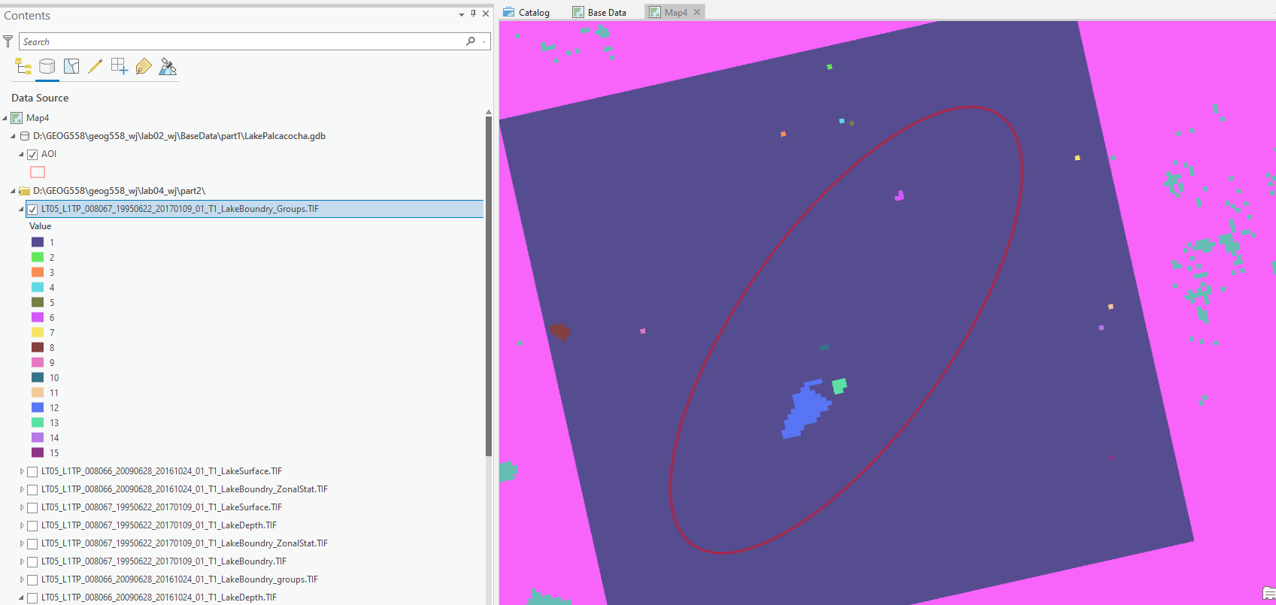

1995

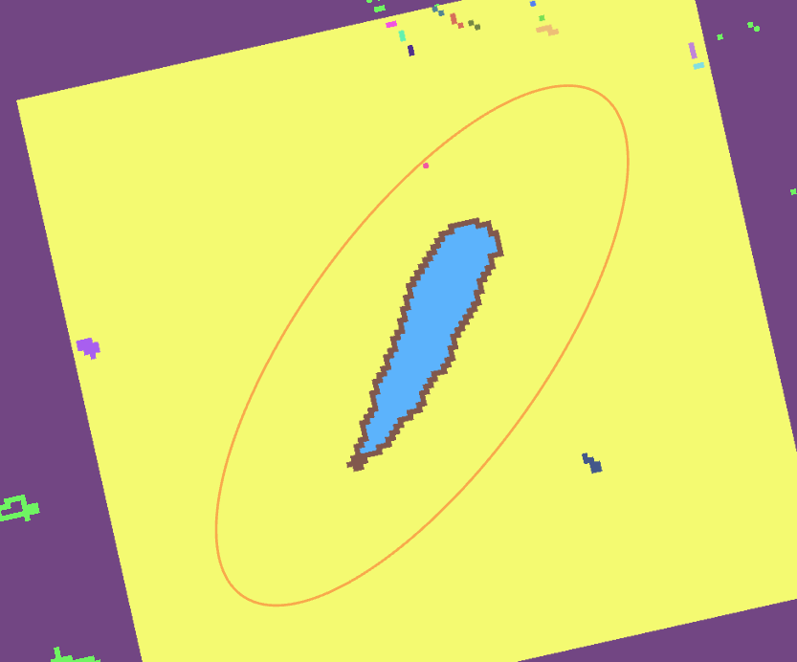

2009

* The more preferable way to do this is to use **region group**, a tool you will cover in much more depth later in the semester. For now, just know that it groups clusters of raster pixels into unique groups.
  + Use the *…LakeBoundary.tif* as the input raster
  + Save the output raster as *…groups.tif*
  + *Go to* Environments > Extent > Select AOI
  + Use Eight connectivity

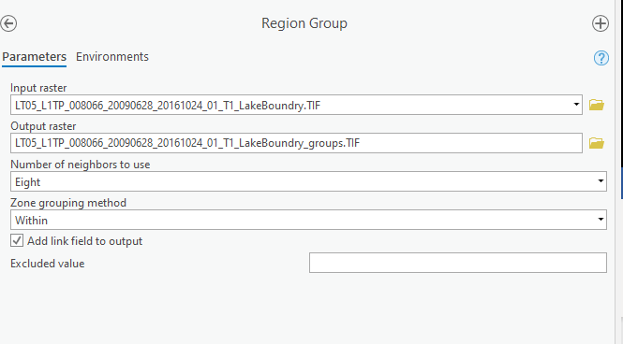

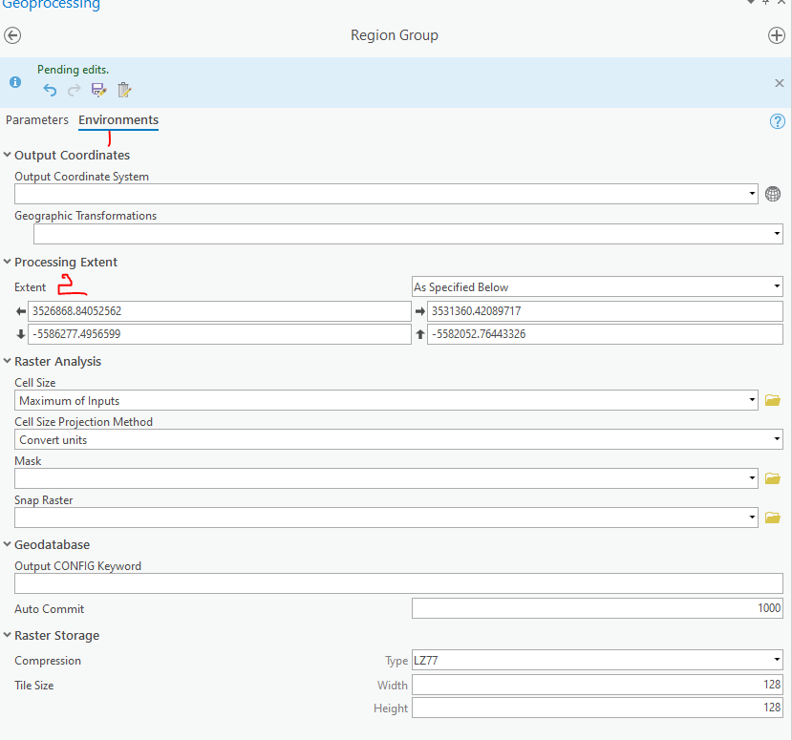

* In ArcMap, we can use the identify tool to pick out the value of the lake edge. In ArcGIS Pro, we can go to Map> Explore to check the pixel value. Note, you can either select topmost layer or selected layer. But make sure, you are check the right layer.
* Use the raster calculator to create a zone of just that value.
  + Hint: mine looks like *“LT05_L1TP_008067_19950622_20170109_01_T1_LakeBoundry_Group.TIF” == 12*.
  + **Overwrite** your lake boundary raster. If you fail to save the output raster, you may try to delete the old boundary folder first.

## **Calculate the height the water rises to on the terrain**

We will use zonal statistics and our newly created zone to calculate the (insert statistic here) value of the elevation data.

* Use the newly created lake boundary as our zonal definition.
* We want the statistics from the elevation data.
* Choose a statistic, I chose maximum but feel free to explore other options.
* Save the output as *…LakeBoundary_ZonalStat.tif*

This output is the “elevation” of the water, we then need to place this value in a raster that we can subtract from the DEM to calculate a lake depth at each pixel

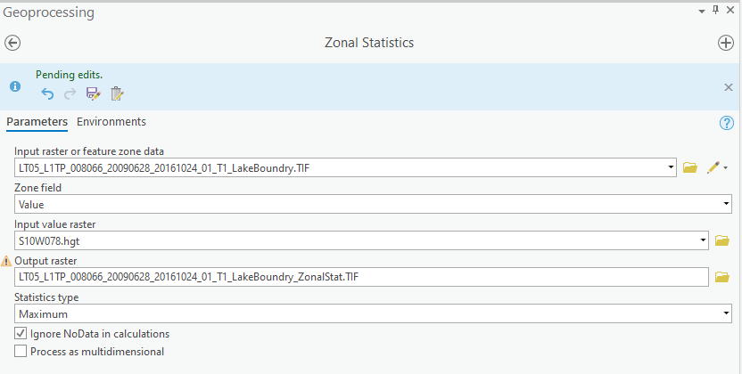

## **Create the lake surface elevation**

We need to use the same process as above to pick out just the lake.

* *(“…LakeBoundry_Group.TIF” == 10) | (“…LakeBoundry_Group.TIF” == 12)*

NOTE: That’s an | above, not a /. The “pipe” is computer shortcode for “OR”. Shift backslash on most keyboards. You need to have parentheses for each variable.

* Save the output as *…LakeRaster.tif*.

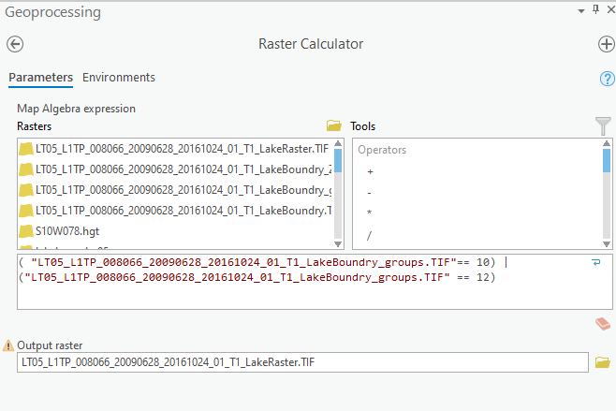

We then need to use the reclassify tool to turn the binary lake Raster classification into a lake elevation

* Turn 0’s into NODATA. (pay attention to capitalized letters)
* Turn 1’s into the value of the zonal statistic output calculated in the previous step.
* Save the output as *…LakeSurface.tif*

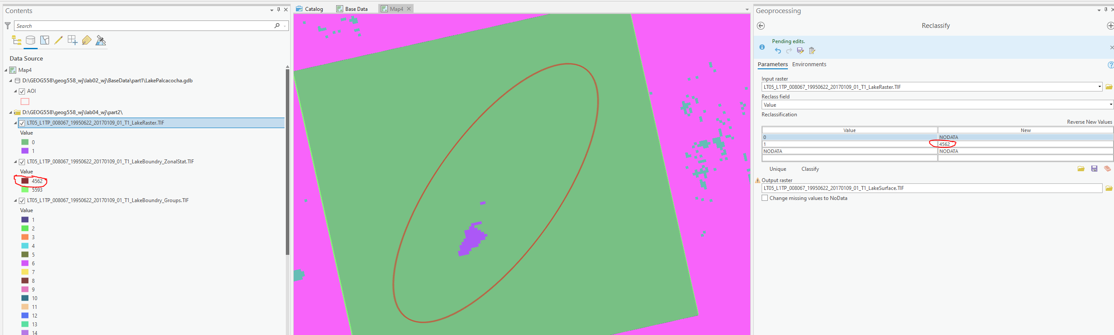

## **Calculate the lake depth and the lake volume**

1. We now need to subtract our two surfaces
   * Hint: RasterCalculator(lakeSurface – Elevation)
   * Save the output as *…LakeDepth.tif*.

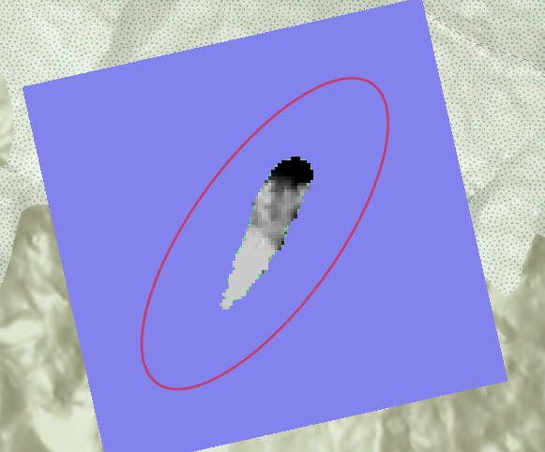

2009(You may find great difference between 1995 and 2009 lake depth, this is due to the great change of the water zone. )

1. Examine the attribute table of the subtraction grid (**R-click** on *LakeDepth* | **Open Attribute Table**).
2. Under Table View, SELECT Export Table. add New expression, which will select cells with an elevation difference greater than 0.

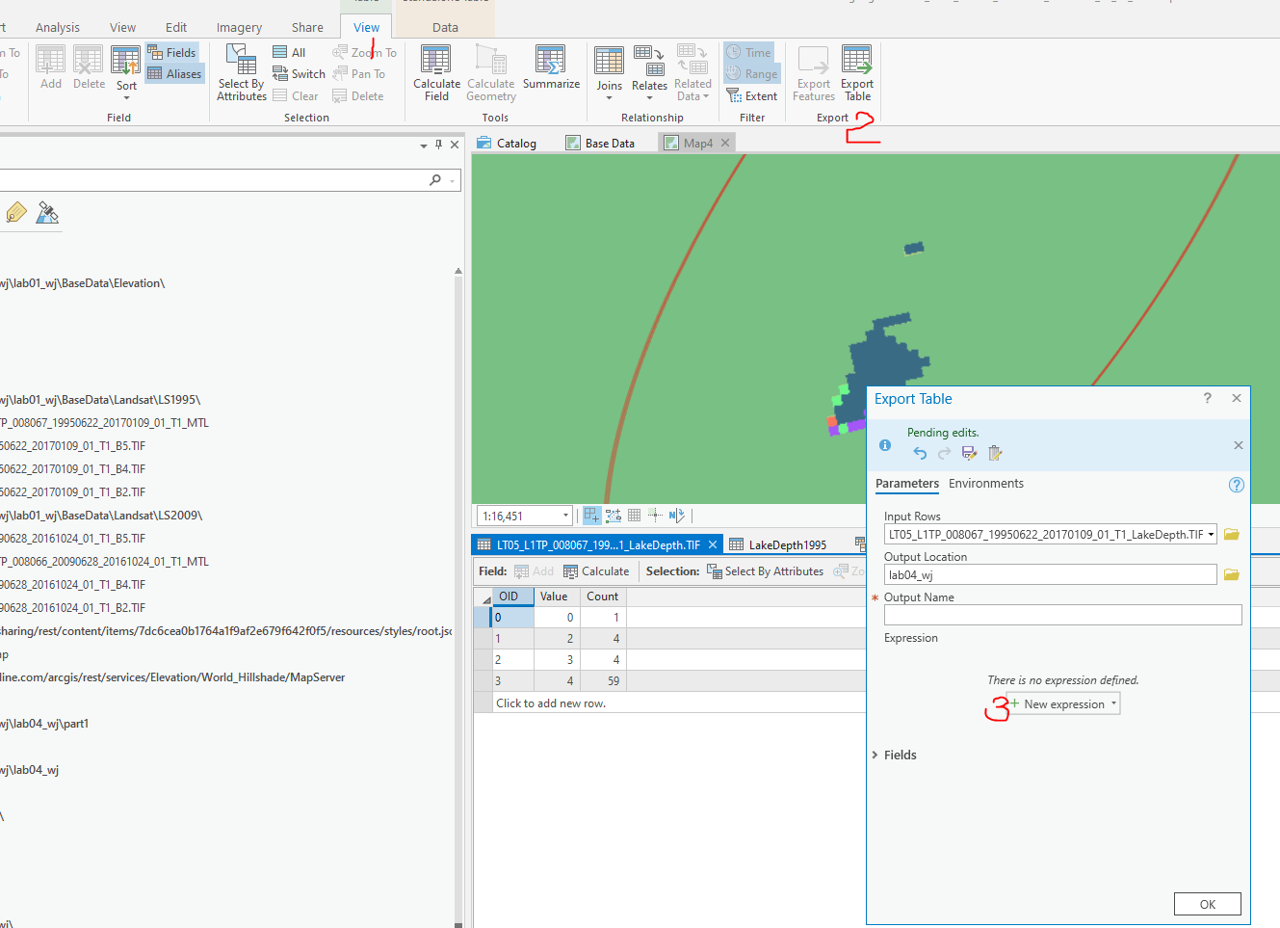

1. Export selected cells as a dBASE Table file named *LakeDepth1995.dbf*.
2. When asked if you want to add the table to your map, select Yes

If there were no errors but you cannot see *LakeDepth1995.dbf* in your Table of Contents, you need to switch to List By Data Source view 

1. Open *LakeDepth1995.dbf* **(R-click | Open)**
2. Add a new field **( Data> Fields > Table Options | Add Field)** and Click here to add a new field.

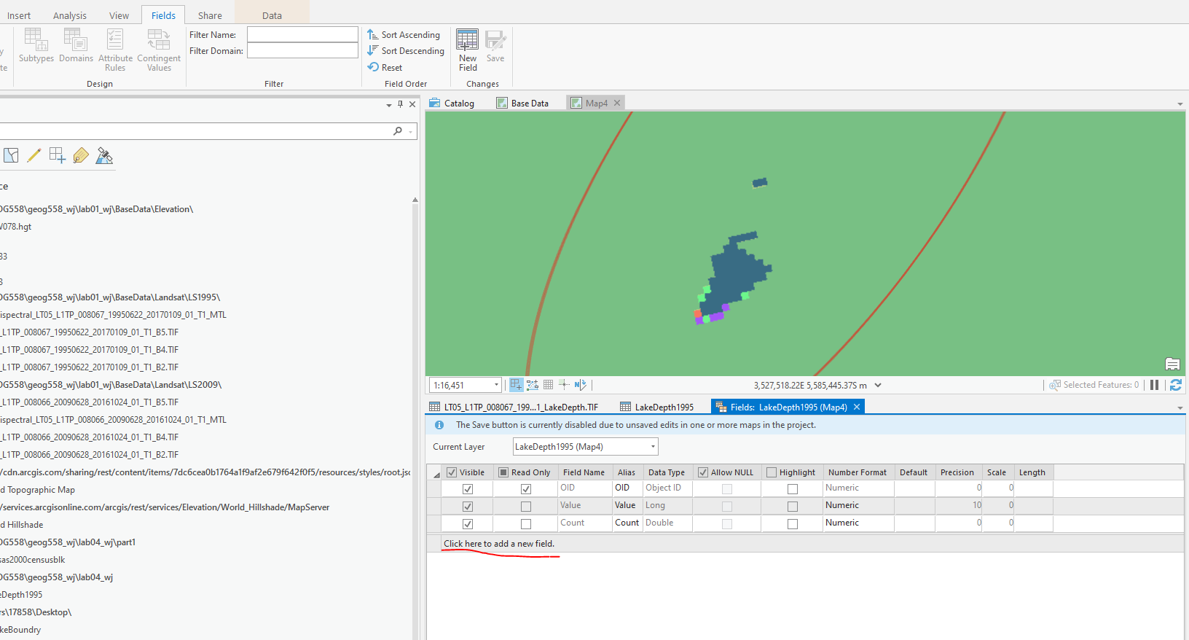

* + set the name to *Area*
  + type to float
  + precision to 6 .
  + scale to 1 and save all changes.
  + you could refer to this following chart to select Precision and Scale <https://pro.arcgis.com/en/pro-app/latest/help/data/geodatabases/overview/arcgis-field-data-types.htm>.

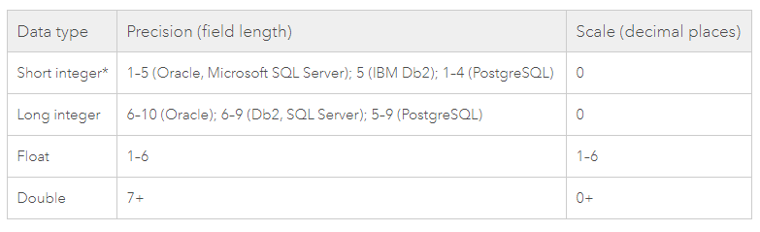

1. Calculate the surface area of *LakeDepth1995* using the following equation, *area = # of cells (count) * length of cell * width of cell*

Hint #1: (R-click column to be calculated, choose Field Calculator… if asked about calculating outside an Editing session, click Yes)  
Hint #2: the length and width of the cell comes from the cell size of the grid, since the cells are square, the values are the same.

1. Add a new field and…
   * set the name to *cell_vol*
   * type to double (double-precision floating-point numbers)
   * precision to 15
   * scale to 1 and then click OK

Note, precision (the maximum length of the field) and scale (the maximum number of decimal places)

1. Calculate the volume per cell of *LakeDepth1995* using the following equation: *cell_vol = depth (i.e., Value) * length of cell * width of cell*
2. Add a new field and…
   * set the name to *total_vol*
   * type to double
   * precision to 15
   * scale to 1 and then save.
   * Calculate the total volume of *LakeDepth1995* using the following equation: *total_vol = volume per cell (cell_vol) * total number of cells (count)*

To learn about ArcGIS field data types, you can refer to the link: <https://pro.arcgis.com/en/pro-app/latest/help/data/geodatabases/overview/arcgis-field-data-types.htm>

You will need to perform this process twice more for 2003 and 2009, answer the part 2 questions, and submit both parts to Blackboard.