**Lab 7 - Model Builder**

**Learning Objective**

As you have likely noticed, the process of delineating a lake follows a predictable workflow that could easily be automated, and because time is money, it would behoove us to create a script one could run which would create the needed outputs for us without all the tedious clicking and typing that would otherwise have to occur. Fortunately, ArcGIS has a mode, ModelBuilder, which enables us to visually create a workflow to connect our data to a series of operations without the need to actually code in python. To do this effectively, we need to modify our process somewhat, so the first part of this lab will walk us through the steps needed to perform this analysis on a single year, and part 2 will introduce the model builder interface and how this process can be automated and applied to each year we downloaded in lab 1. By the end of this lab you should have a firm grasp on the local, focal and zonal operations we need to use to create the lake, and how model builder can be used in numerous applications to speed up your workflows.

**What you need to submit**

Submit an image of both your analysis and a screenshot of your model to blackboard.

# ****Materials****

|  |  |
| --- | --- |
| Data Name | Description |
| BaseData | Data we downloaded as part of lab 1 |

Part 1: Performing our analysis for one year

First let’s lay down the foundation.

* Open ArcGIS and make sure that the Spatial Analyst extension is activated.
* Rename the default data frame to Base Data and add in the AOI, Bands 2 and 4, and the MTL file for each year.
* To force our model to calculate everything using a consistent grid size, change the geoprocessing > Environments settings to the following:
  + **Workspace**: Set both the Current workspace and Scratch workspaces to your lab07 folder.
  + **Processing Extent**: Use the folder icon and point it to your AOI shapefile. Use the folder icon next to snap raster to select the elevation dataset.
  + **Raster Analysis**: Select As specified below and type in 30.
  + Click OK.

As you discovered in Lab6, the **region group** tool was useful in creating a raster we could use to select the desired areas. However, the region values were quasi-random. Although we could in theory make a program and so this will not work if we are attempting to create a programmatic workflow. We will instead use a “seed” and the cost distance tool to classify which of the NDWI zones we want.

## **Create the LakeSeed shapefile**

* In the Catalogue window right click on your basedata geodatabase and create a new feature class.
* Call the class LakeSeed and make it a point feature. Click next.
* Click next until you reach the Field Names category.
* In the first empty Field Name box, type in VALUE and change the Data Type to Short Integer. In the field properties you can set the default value to 1.

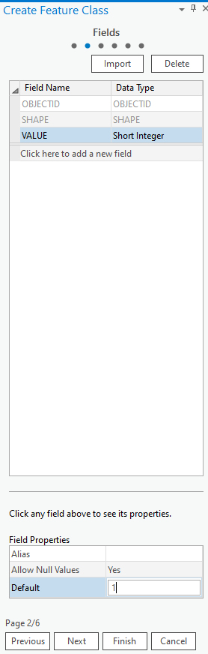

* Click next and select WGS 984 Web Mercator (auxiliary sphere) as your projection. Click Finish.
* Add the layer to your Lake map.
* Go to Edit > Create Features, click LakeSeed and choose the point tool.
* Create a single feature that will “intersect” all lake layers through time, so the center of the smallest lake extent is best.
* When finished, save edits.

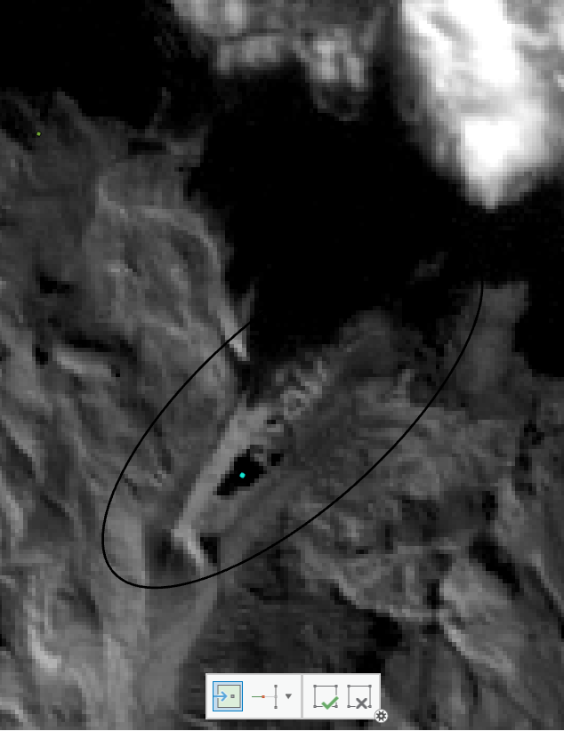

# ****Part 1B: Isolate the lake****:

## **Calculate and threshold NDWI (in one expression)**

Recall from previous lab that this expression needs appropriate parenthesis and the Float() attribute. However, we want to reverse the expression here so that **we want to classify as a lake has a 0 value, and everything else has a value of 1**. This way we can use the cost distance tool to traverse all connected lake pixels without inuring a cost.

* Hint: My expression looks like  
  *(Float(“1995\LT05_…_B2.TIF” - “1995\LT05_…_B4.TIF”) / Float(“1995\LT05_…_B2.TIF” + “1995\LT05_…_B4.TIF”)) <= 0.3*
* Call the output *NDWI_yyyy.tif*.

Use Reclassify, set the value as the following image and overwrite the NDWI_yyyy.

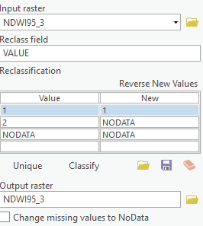

## **Use the LakeSeed to isolate just the NDWI zone we want**

* Use the search bar to find the **Cost Distance** tool.
* The source data is the *LakeSeed*.
* The input cost raster is the *NDWI_yyyy.tif* layer.
* Save the output as *Cost_yyyy.tif*.
* We want just the lake, so use raster calculator and get just the areas with 0 cost
  + Hint: *“Cost_yyyy.tif” >=0*
  + Save the raster as *Lake_yyyy.tif*
  + 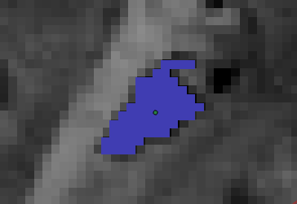

# ****Part 1C: Lake volume calculation****:

## **Calculate the boundary of the lake in 1995 using a focal erosion process**

* Using the **Focal statistics** tool, calculate the focal minimum using a rectangular 3x3 grid
* The input should be the *Lake_yyyy.tif* layer
* Save the output *Lake_yyyy_Fmin.tif*
* Using **raster calculator**, subtract the focal min raster from the lake classification raster to get just the boundary.
* *“1995\Lake_yyyy.tif” - “1995\Lake_yyyy_Fmin.tif”*
* Save the output of the map as *lakeEdge_yyyy.tif*

## **Calculate the height the water rises to on the terrain**

Then we will use **zonal statistics as table** (spatial analysis)and our newly created zone to calculate the (insert statistic here) value of the elevation data.

* Use the lake boundary (*lakeEdge_1995.tif*) as our zonal definition
* We want the statistics from the elevation data, so that goes in the “Input Value Raster” box
* Choose a statistic, I chose maximum but feel free to explore other options
* Save the output as *…LakeBoundary_ZonalStat*

## **Create the lake surface raster**

Use the **reclass by table** function (spatial analyst) to reclassify the *lake_1995* raster into a lake surface raster.

* Your input raster is *Lake_1995*.
* Your remap table is the table created from zonal statistics as table (*LakeBoundary_ZonalStat*)
* The From, to, and output value should fill in automagically, but in case they don’t think about what you are trying to accomplish.
  + The from and to value need to match, you are essentially joining tables together here, so both need to be VALUE
  + The Output field is the value that you are reclassifying to, so this should be MAX
  + Save the output as *LakeSurface_yyyy.tif*

We need just the lake elevations, and given the tools shown so far we could accomplish that by multiplying them with the Lake_1995 raster using raster calculator (to set the values we no longer want to 0), and then setting the 0 values to NoData. We can do this in 1 step through raster calculator using the Set **Null function**. The **Set Null(,)** function takes two arguments, a mask which sets the values to null and a raster with the values to set otherwise.

Hint: *SetNull(“Lake_yyyy” ==0, “LakeSurface_yyyy.tif”)*

* Save the output raster as LakeSurface

## **Calculate the volume**

* Subtract the DEM from the Lake Surface using the **raster calculator** tool

If you need the positive number, please use the expression:

abs( "lake_surface1995.tif" - "S10W078.hgt")

* + Save the output as *LakeVolume.tif*
* Use the **Add field** tool (data management) to create a new field
  + Call it volume
* Use the **Calculate Field** (Data Management) tool to calculate the volume of each cell
  + Hint: Depth(Value) * area (30*30) * Count
* Use the **summery table** to create a table of volume (an optional step, otherwise just know that you’ll need to sum the field yourself each time.

This process was time consuming, and the only thing that changes in this workflow (once we’ve chosen a place to analyses), is the input bands. This repetitious task is best completed using a function. In ArcGIS, functions can take the form of tools, and the visual programming interface called Model Builder.

# ****PART 2: Creating the model****

## **Set up the folders for the lab**

* In your lab folder in the Catalog pane, create a new File Geodatabase
* In that same lab folder, Right click and create a new > toolbox. Name it *LakeVolumeAnalysis.tbx*
* **Right click** on that toolbox and create a new > model.
* A blank Model window will appear. Take a moment to explore the tools. You can go to ArcGIS Desktop Help to find more information about each of the tools.
* Close the Model window.
* Right click on the model and
  + In the properties rename the model *LakeVolumeForAYear* for both name and label.
* Re-open the Model by R-clicking and selecting Edit…
* Under the Environments tab, set up workspace as lab07 part2 folder, extent as AOI. Remove all layers from the map

## **Starting a Model & Setting up the Workflow**

You will create a workflow diagram in the Model window that will show all the steps and operations/tools needed to delineate the sea level change. We start the process by dragging tools from Tools into the Model window to perform a specific operation.

* Open Tools and set up your model window and ArcMap window so that you can see both Tools and the model window at the same time.

To add data to your model, drag layers from the map **Contents** and datasets from **Project** into the model.

* Please add band 2 and band 4 rasters
* Right click on the resulting oval and rename it to Band 2 and 4 respectively
* Right click on it and make it a parameter by checking **Model Parameter** option from its popup menu (right-click). The letter **P** appears beside the variable, indicating it is a model parameter.
* Insert a new variable with insert > variable
  + Select Double
* Double click on it and give it a default value of 0.3
* Right click on it and make it a parameter as well.
* Use the search function to drag in the **raster calculator** tool into the model builder canvas
* Double click on the raster calculator tool and fill it out as appropriate using the steps above.
  + Make sure you use the drop downs to populate the raster calculator, pointing at the data is not appropriate here.
  + Hint: My expression looks like Float( "%95_Band2%" - "%95_Band4%") /Float( "%95_Band2%" + "%95_Band4%")<= float(%Double%)
  + Name the output *NDWI.tif*
* The bubbles should color themselves in if you entered everything in correctly. This means that the tools executed successfully, but be careful. Just because it ran doesn’t mean it is right. Your model should now look like so:
* 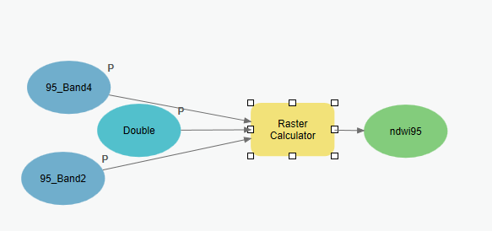

## **Build the rest of the workflow**

Build the rest of the workflow as defined above by dragging in tools using the same process. A few places of minor note. When you use functions in modelbuilder, you will most often want to use the layers which have a recycle symbol next to them. These are model variables, and in tool prompts they are bracketed by % signs. So for example when you add the **Set Null(,)** function, it should be parameterized as follows:*SetNull("%Lake_1995%” ==0, “%LakeSurface_yyyy.tif%")*