**Lab 05 - Cartographic Modeling**

**Learning Objective**

This lab will introduce local operations using cartographic modeling (map algebra). Part 1 is intended to show you how you can organize and display raster datasets in a usable format. Part 2 will walk you through how to calculate NDWI and perform a water area analysis. Part 3 you will model the geographic distribution of Kudzu in the conterminous United States and then compare your model to the actual geographic distribution, using Map Algebra and attribute table manipulation. I’ve prefaced each lab with the learning objectives of the exercise, what you need to submit to blackboard, a set of materials for the lab as appropriate, and then the instructions for the lab.

**What you need to submit:**

Hint: Copy and paste the questions below into a word document and submit it to blackboard

**Lab 2: Answer Sheet**  
Name:

**Part 1: Lake delineation and water classification**  
**Question 1**: Based on the results from 1995, which water delineation metric would you choose to perform this analysis, NDWI or MNDWI. Why?

**Question 2**: What is the area of the lake in 1995?

**Question 3**: Calculate the area of the lake for 2003 and 2009. Finish the table below and create a short graph of the area through time. Create a short map of the before/after.

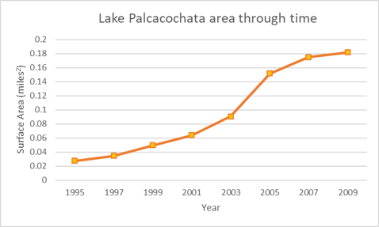

**Part 2: Composite images**  
**Question 4 (extra point)**: Create another graph of lake volume over time as was performed above.  
**Question 5**: What are some potential issues of using gap-filled imagery for scientific analysis?

**Part 3: Kudzu Suitability Analysis**  
**Question 6**: The minimum annual precipitation for Kudzu to survive is:________  
**Question 7**: The minimum frost free day for Kudzu to survive is:________  
**Question 8**: The total area (in m2) suitable for Kudzu to survive (according to your model) is:________ (m2)  
**Question 9**: Complete the following table:

|  |  |  |  |
| --- | --- | --- | --- |
|  | | Actual Kudzu Distribution | |
| No Kudzu | Kudzu |
| Your Model | No Kudzu | D:(00) | B:(10) |
| Kudzu | C:(01) | A:(11) |

Assess the accuracy of your model by filling in the following information. For more about confusion matrices look at [wikipedia](https://en.wikipedia.org/wiki/Confusion_matrix):

Accuracy - ((A+D)/(A+B+C+D)):  
False Positive Rate - (C/(A+C)):  
False Omission Rate - (B/(A+B)):  
MCC - (A*D-B*C)/sqrt((A+B)*(A+C)*(D+B)*(D+C)):

**Question 10**: Discuss some of the reasons for the inaccuracy of your model. In particular, examine why the error may be occurring. Also, looking at your kudzu_model layer, where geographically do you think this error is? (Hint: Consider the factors that your model did not include that could explain the geography of the model’s error)

**Materials introduction**

|  |  |  |
| --- | --- | --- |
| **Relevant part** | **Data Name** | **Description** |
| Part 1 | BaseData | Data we downloaded as part of lab 1 |
| Part 3 | usanpre25k | annual precipitation in mm (25000m grid) |
| Part 3 | usfrost25k | number of frost-free-days in conterminous US (25000m grid) |
| Part 3 | sample1.shp | point file showing locations of known presence/absence of Kudzu (to be used to make model) |
| Part 3 | sample2.shp | point file showing locations of known presence/absence of Kudzu (to be used for accuracy assessment) |

If you are short on space, you only need the .mpk from part 2, the LANDSAT tiles are ~20 gigs and are provided for reproducibilities sake.

# ****Part 1: Lake delineation and water classification****

* First, make sure you can overwrite data and the workspace is on Lab05 folder.
* From the 1995 year, add in the green, NIR, MIR, and MTL bands/images.

Hint#1: When performing the NDWI calculation, we refer to bands based their wavelength (e.g. green, NIR). However, when distributing data the bands are referred to by their number based on sensor properties (so in our case, LANDSAT 5 TM has 7 bands and change). GEE provides a nice, concice overview of a remote sensing products bands, see <https://developers.google.com/earth-engine/datasets/catalog/LANDSAT_LT05_C01_T1>  
  
Hint#2: A note about pyramids: You will want to build pyramids when you add raster images into ArcMap. You will notice that when this is done, ArcMap will create a file with a .ovr extension (look using the Windows file browser). We’ll talk about pyramids in class more, but as a cursory introduction, think about Google Maps. When you zoom out to look at the entire planet, there is no physical way to represent 30 meters on the screen. Instead, we take a generalization of all the pixels underneath the region and display those values in their place. Because Google sets the standards for mapping, there are generally 21 levels of images that are loaded in, with the top layer being zoom level 1, and increasing as you zoom in. See an interactive example of this concept in action at <https://www.maptiler.com/google-maps-coordinates-tile-bounds-projection/>

Select all 4 images using shift-click, and **right click > Group** to place them in a group. Highlight the group title, slowly left click the name and customize it as “LS1995”.

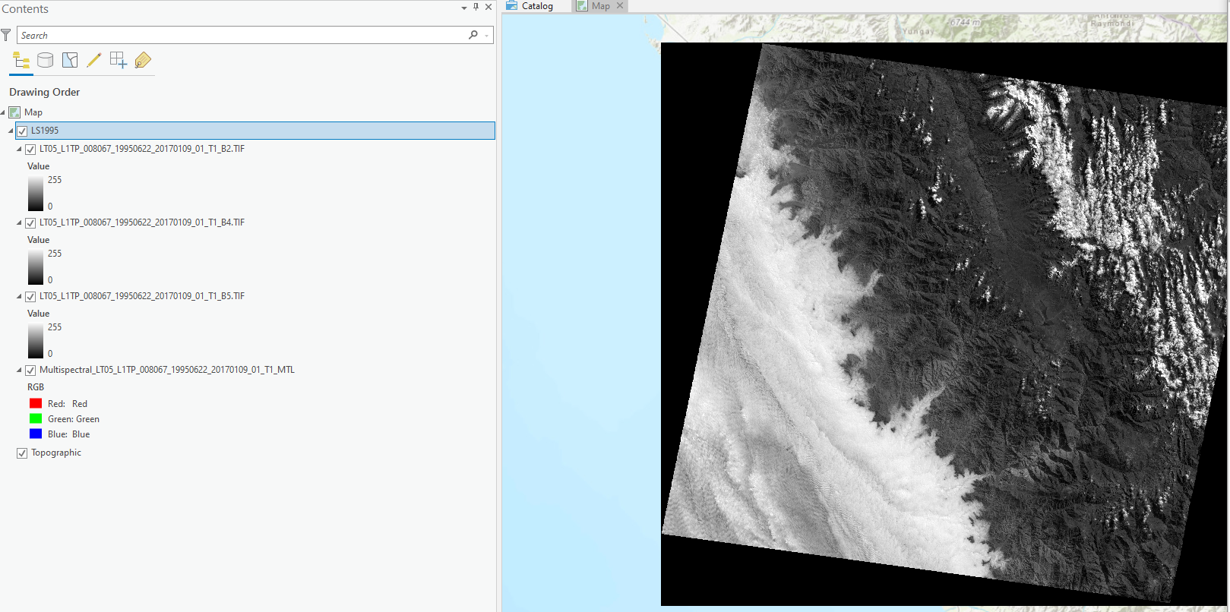

Then, let’s find our lake using the go to xy tool and copy/pasting the lat/long in: -9.3970552, -77.3802742. (Pay attention to the order of lat/long)

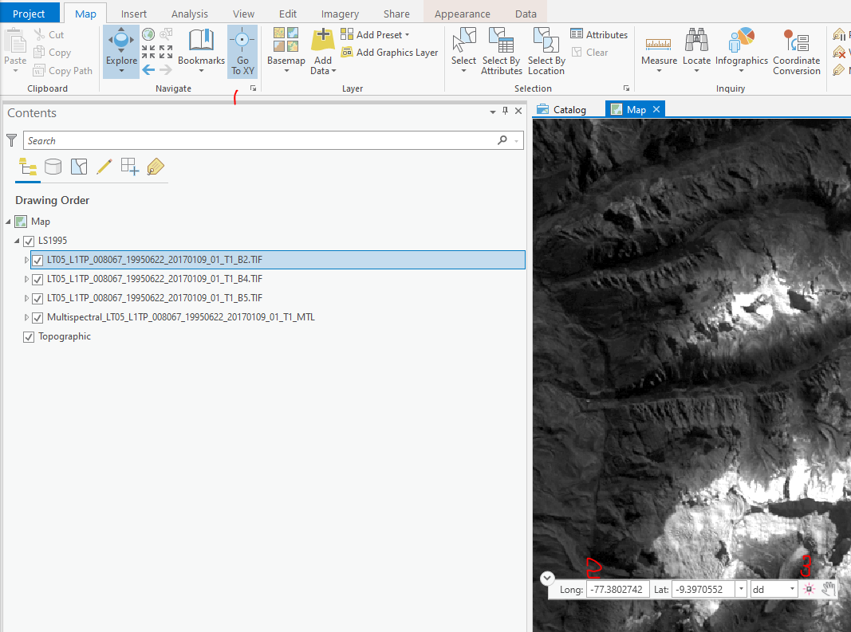

**Creating An Area of Interest (AOI)**

* We next need to create a shape representing the area of analysis. Go to Catalog, and right click on your BaseData folder and create a new File Geodatabase. Rename the database to *LakePalcacocha.gdb*
* Right click on the new geodatabase and go to New > Feature Class. Usually, a “Create Feature Class” window will pop-up on the right.
* Name the Feature Class AOI and set the type to polygon. Click next.
* Do not need to change fields in this lab. Click next.
* Find proper projected coordinate system for the map. Click Projected Coordinate System > UTM > WGS 1984 > North Hemisphere > WGS_1984_UTM_Zone_18N. Click through the 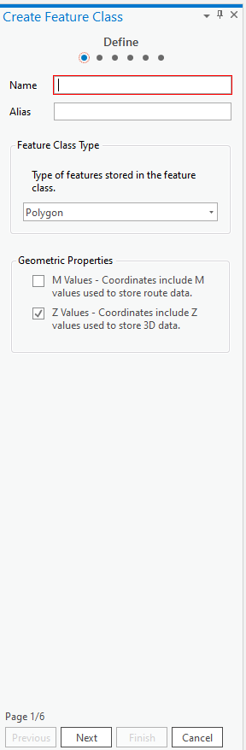rest of the setup dialog to finish.
* Then we need create the shapefile and import to our map. Highlight the .gdb we created just now, right click > Export > Feature Class to shape files. Input features is AOI. The output folder should be lab05 or the same folder in which you saved your images. Then, click run. Add this shapefile to your map. Assuming you were successful, you should now have a new layer called AOI in your TOC.
* Go to Edit tag > Features > Create. Make sure you are editing the AOI layer/LakePalcacocha.gdb database.

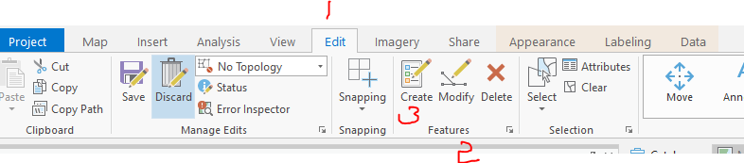

* If the opacity of AOI is 0%, it will cover part of the map. So, you can change the AOI opacity to 100% or other numbers from Appearance tag. In this lab, we need to set the AOI opacity 100%.

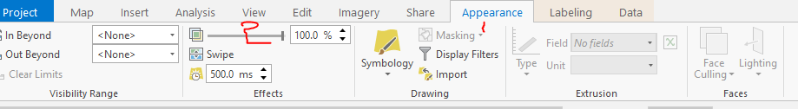

* In the Create Features window (usually on the right), select the Circle tool to create a small circle that encompasses the entirety of the lake. (Now you should have a better understanding about why we need to adjust the opacity) It is alright for our purposes if we include land area, but do not make it so large that it might include nearby lakes. This should look something like so:

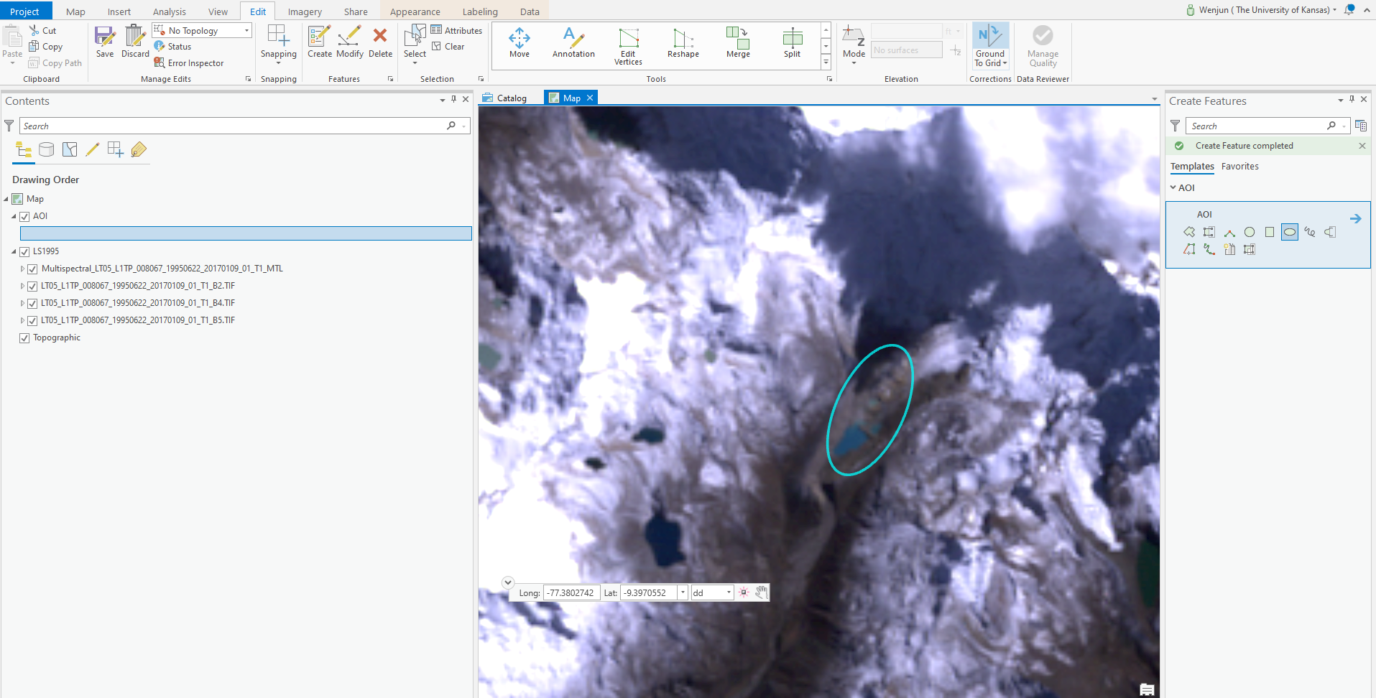

Click on the Save (Edit > Manage Edits). Save your edits when it prompts you to. Feel free to try other shapes in AOI. Mapping can be pretty as well as messy.

## **Calculating NDWI**

* The NWDI is defined as the normalized difference of the Green and Near Infrared bands of the Thematic Mapper. (See the [McFeeters paper in the International Journal Of Remote Sensing](https://www.tandfonline.com/doi/abs/10.1080/01431169608948714))

NDWI=(Green−NIR)/(Green+NIR)

* We will use the **raster calculator** tool to accomplish this. At this point we can also use the environmental settings to clip our data so we don’t process the whole scene.
* Go to Analysis > Geoprocessing > Environments
* Under workspace, point the Current and Scratch workspaces to our LakePalcacocha.gdb
* Under processing extent, set the extent to “Same as Layer AOI”. Click OK
* Under Analysis > Geoprocessing > Tools > search “Raster Calculator”
* use the prompts to calculate the NDWI.

Extension warnings? Did you take the time to read it? Warnings are a chance for programmers to communicate to you and in this case you should learn that you need to turn on spatial analysis under Customize > Extensions.

* Go ahead and try to enter in the expression above. Save the resulting raster using the folder icon under the Output Raster dialog box, click on the name of one of the other bands (to preserve the LANDSAT naming convention), and change the end of the file to *…NDWI.tif*.

You’ll notice that the resulting raster has a value of 0, and is entirely empty. This is because ArcGIS likes to save memory and forces raster calculations to integers. Fixing this just means we need to be more verbose and run the calculations as floats using Float() under the Math section. This conversion to integer occurs in both the numerator and denominator, so the float needs to wrap both of them separately. As Float(Green - NIR) / Float(Green + NIR)

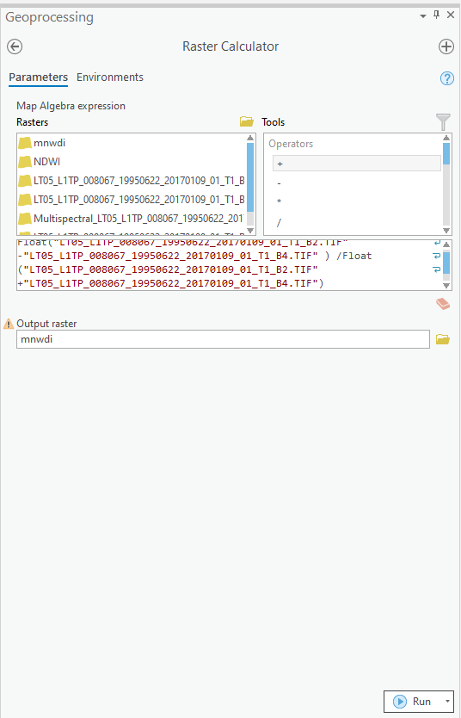

## **Calculating MNDWI**

* The MNWDI is defined as the normalized difference of the Green and Near Infrared bands of the Thematic Mapper. (See the [Xu paper, also in the International Journal Of Remote Sensing](https://www.tandfonline.com/doi/full/10.1080/01431160600589179))
* MNDWI=(Green−MIR)/(Green+MIR)
* Because this process is so similar to the NDWI (we use band 5, not band 4), it is easiest to pull the results up from our last raster calculator and change a few characters. Change all 4’s to 5’s and change the output file name to MNDWI.

## **Classifying and quantifying the change in water surface area**

* You’ve probably noticed by now, but the NDWI and MNDWI calculations return an image with valid values from -1 to 1, but this doesn’t tell us what is and is not water. To do that we need to classify the image into a binary water/not water schema. There are a variety of ways to do this that range in sophistication/robustness, but for our purposes, a simple threshold will suffice. This means we want classify all pixels with a NDWI/MNDWI value greater than or less than some value into water.
* Use the identify button and poke around the image to find a good threshold. I settled on 0.30 for example.
* You please use the raster calculator to select the cells greater than 0.30, and append the name of the NDWI layer with the threshold value (_…NDWI3.tif).
* 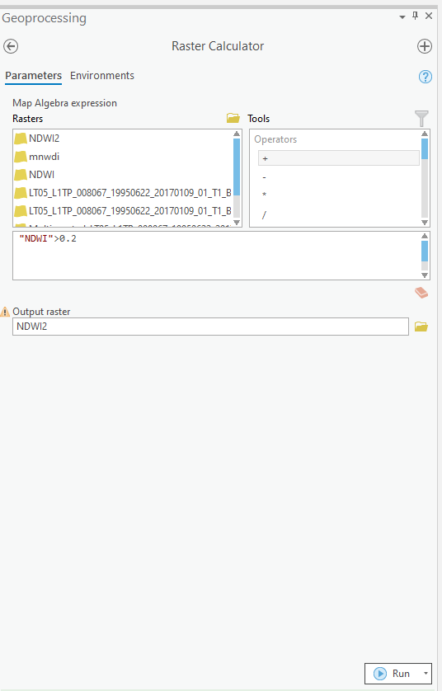

Examine the outputs (right click on the resulting layer and see the attribute table.) You now have enough information to answer Questions 1 - 3 above.

# ****Part 2: Simple Landsat Composites****

## **Creating a composite image**

One of the downfalls that plague many passive remote sensing platforms is the inability to penetrate cloud cover. Notice that although we didn’t happen to encounter cloud obfuscation in the first part of this lab, clouds are not uncommon. Let’s use water year 2005 as an example. I’ve taken the liberty of downloading and setting up data for you. Just download the Map package (part2) and double click to open.

* Because land/water has a lower reflectance across all bands as opposed to clouds, one of the simplest and most effective means of filtering out cloud cover is to take the local minimum from a raster stack.
* ArcGIS Pro has a tool called **Cell Statistics** which performs statistics for local operations. Either use the search tool or find it in Geoprocessing > Tools > Spatial Analyst Tools > Cell Statistics.
* We want to calculate the minimum of each band within the 4 seasons. Using band 4 for the winter (South America) as an example, the inputs should look like so:
* 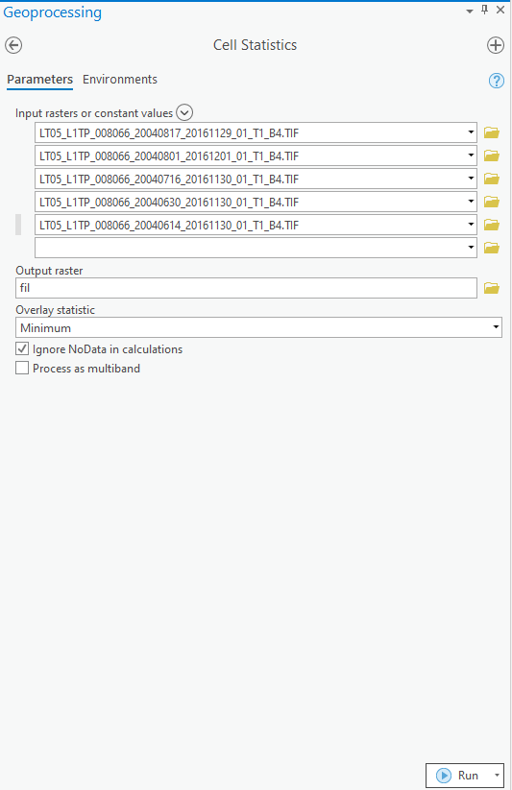

If you encountered error 99999 when running the tool, please check if your output raster is not in the home folder .

* I have gone ahead and taken the minimum of 3 of the 4 seasons. So you only need to calculate the minimums for the spring months.
* Perform the NDWI calculation, thresholding, and area measurement as was performed above.
* Answer questions 4 and 5 in the handout. Save and close ArcGIS Pro, we’re done looking at the lake for now.

# ****Part 3: Cartographic Modeling****

## **Establishing the model parameters**

* Start ArcGIS Pro and add u*sanpre25k*, *usfrost25k*, and *sample1* from your lab05\Part03 folder.
* extracting data for building Kudzu distribution model.
* Open the attribute table for sample1.
* The numbers in the “KUDZU” field represent presence or absence of Kudzu at that point (1 for presence, 0 for absence)
* You want to find the minimum annual precipitation (in mm) and the minimum frost-free days at each of these points. This information will be your source of input for modeling potential Kudzu distribution across the U.S.
* Close the attribute table.
* Geoprocessing Tools contains an **Extract values to points** tool that will add the value of a raster to a set of points. It then creates a new point file with an attribute holding that raster value.
* This tool requires three inputs and has two optional ones. You can find out more information about each of the inputs (this applies to other ArcTools as well) by clicking on the small question mark and then clicking on the field of interest.
* Set your Input point features to sample1 (You can either use the drop-down that shows all the point layers in the Table of Contents or the Browse file button to navigate to the file).
* Set your Input raster to usanpre25k.
* Set Output point features so that it saves the new file called sample1precip to your lab05\Part03 folder.
* Click Run (Be patient. This may take a while.).
* Your new point file will appear in the Table of Contents.
* Open the attribute table for sample1precip.
* Notice the new variable called RASTERVALU that contains the annual precipitation amount for that point
* **Repeat the above steps** to create a similar point file containing a RASTERVALU attribute for frost-free days at each point. Call it sample1frost.

By looking at the minimum precipitation and minimum number of frost-free days that Kudzu required for survival in the sample points, we can model (predict) its potential geographic expansion across the U.S. In order to do this, we need to get this information out of the datasets we just created. To find the minimum annual precipitation and minimum number of frost-free days required for Kudzu to survive:

* Open the attribute tables of your samples and perform an attribute query to select only those points with known Kudzu presence (“KUDZU” = 1)
* Show only the selected records using the table toggle button at the bottom. 
* Sort in ascending order the RASTERVALU field (R-Click on column heading). Answer #6 and #7 on your answer sheet.

## **Running the model**

* Create new grids based on the usanpre25k and usfrost25k grid using Raster Calculator
* *usanpre25k* >= minimum value** (**Minimum Value in question 6)
* From the *usanpre25k*, the new grid cells with an annual precipitation greater than or equal to the minimum annual precipitation will have a value of 1, while cells with an annual precipitation less than the minimum value will have a value of 0
* Save the grid as precipitation in your lab05\part03 folder
* *usfrost25k* >= minimum value** (**Minimum Value in question 7)
* From the *usfrost25k*, the new grid cells with a frost-free-days greater than or equal to the minimum frost-free-days will have a value of 1, while cells with a frost-free-days less than the minimum frost-free-days will have a value of 0
* Save the grid as frost in your lab05\part03 folder
* Predict the Kudzu U.S. distribution by multiplying the precipitation and frost grids. Save the output grid as *kudzu_model*.  
  Answer #8 on your answer sheet

## **Assessing the model**

* Add *sample2* to your ArcGIS Pro Table of Contents
* Using the Extract values to points tool, you now want to create a new point shapefile called *sample2check* that will have an attribute of actual presence (KUDZU) and one for predicted presence (RASTERVALU found by using *kudzu_model* as raster input)

After you have created *sample2check* you can quantify your accuracy in one of many ways. Here are two suggestions:

* Add a new field named check and perform the following calculation: check = [RASTERVALU] * 10 + [KUDZU]. The Check field should have the following outputs: 0, 1, 10, and 11 (0 and 1 represent 00 and 01 respectively)
* Perform attribute query using the AND operator 4 times, once for each possible combination. (i.g. KUDZU = 1 AND RASTERVALUE = 0)
* You could refer to the following image to check your map:

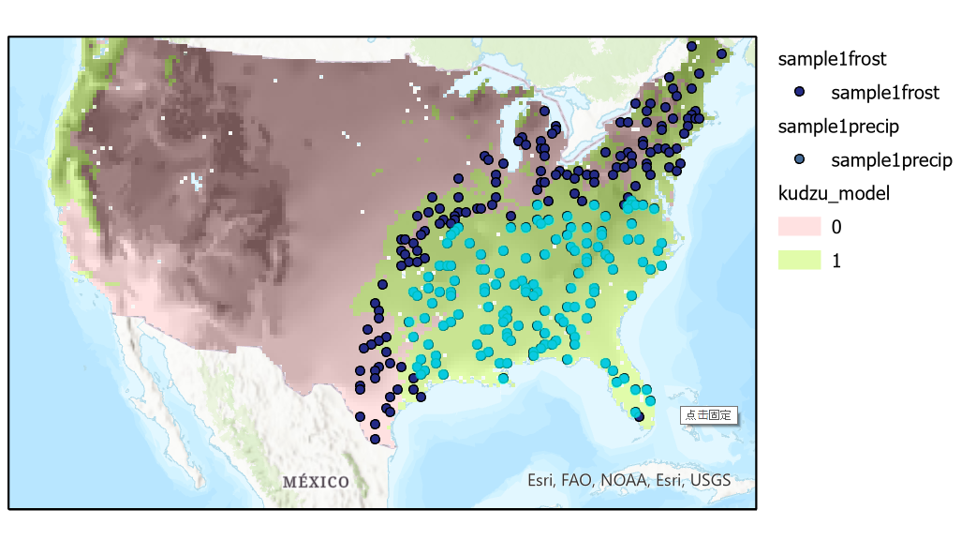

Complete #9 and #10 on your assignment sheet and TURN IT IN; your grade on this lab will be based entirely on your answers to the questions!

Hint: Need help answering question 10? Make a map like so! Useful tools: Raster to polygon, symbology as categories, rectangle as text, insert images. The following image can be a reference to answer question 10.

