**Lab#3 Cost Distance and Its Applications**

**What you need turn in:**

**Lab3: Answer Sheet**

**Name:**

**Question 1**: How many pixels are inundated?

**Assignment 2:** Screenshot from Part2.

**Extra Credit:** Export a map with title, legend,scale…

**Part 1**

In part 1, you will use cost distance to accomplish **delineating sea level rise inundation with ArcGIS Pro.**

1. Set the oceans to a one value source.
2. Use the Set null tool on the ocean raster
3. "Value" = 0
4. Your false or constant raster can be either the ocean raster or a value of 1
5. call the output “source.tif”

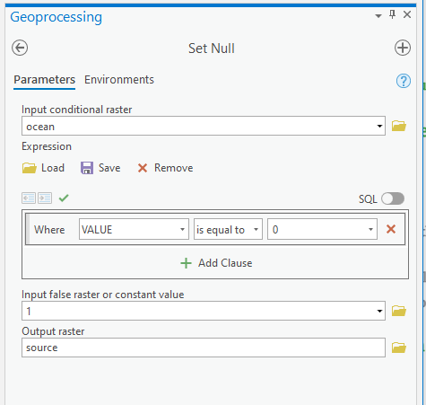

1. Set all elevations in the DEM which are above the sea level rise threshold.
2. Set null tool again, this time on elevation
3. "Value" > %Sea Level Rise% (in the manual case, 2)
4. Set the false raster to 1 (Friction should be the same everywhere otherwise)
5. Call the output “friction.tif”
6. Create the cost distance surface.

a. Cost distance tool…

b. Source is “source”. Cost is “friction”.

c. Call the output "distance.tif"

4. Remove the source cells to create a raster of just inundation.

a. Set null tool…

b. “Value” = 0

c. Again, set the value to 1 otherwise

d. Call the output “SLRbyCost.tif”

Answer question 1.

**Part 2: Fungus Diffusion Modeling (Cost Distance)**

**Learning Objectives**

This lab will introduce you to the concept of modeling a diffusion process using friction surfaces that change in space and time. Your goal is to model the diffusion of a fungus from its introduction at a seaport in Panama City, FL on January 1, 1989 throughout seven months of the calendar year (i.e., January through July).

**Getting started**

* Add all 7 precipitation grids, *fungus_origin*, *us48mask*, and *us48cities*.
* Go to **Geoprocessing | Environments…** and under **Raster Analysis** set **mask** to *us48mask*.
* Under **Processing Extent** set the **Extent** to Same as layer *us48mask*.
* Set the **current workspace and scratch workspace** to your *lab07/Part2* folder.
* Rearrange (if necessary) the precipitation raster layers in chronological order.
* Save your map as *lab7part2.mapx* (ArcGIS Pro has no *.mxd to export*). (how:highlight the dataframe> right click > save as map file)

**Modeling the diffusion process**

You will now model a diffusion process across a changing velocity surface. You will implement the time steps sequentially. The procedure for modeling diffusion across a dynamically changing environment involves the following steps:

1. Establish the origin (for the first run, it will be *fungus_origin*).
2. **Reclassify** the Nth month of precipitation to a velocity grid (units of meters per day) based on velocity for each precipitation range.
3. Identify the maximum value of precipitation for that month.

Hint: The table of contents shows the range at a glance.

|  |  |
| --- | --- |
| **Precipitation Amount** | **Rate of Movement** |
| < 100 mm/month | 0m/day |
| 100 - 200mm/month | 4000m/day |
| 200mm/month and greater | 7000m/day |

1. Use the **Reclassify** tool (Spatial Analyst Tools) to reclassify the precipitation for that month (e.g: *pre_01* for January) into a friction rate according to the following assumption about the disruption speeds.

Name the output *velocity_nn*.

If writing out the table each time is too tedious for you, you can click “Save…” just below the reclassification table and save the look-up table as a table named *diff_rate* which you can reuse.

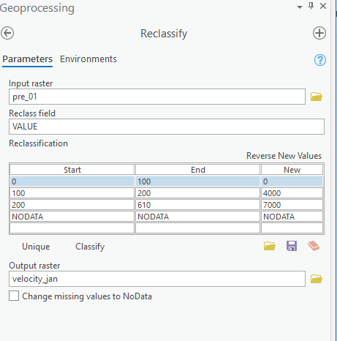

1. Create a Time per Unit Distance grid (days per meter).
2. Using the Raster Calculator (Spatial analyst), create the following expression: **1 / Float(“velocity_nn”)**
3. Name the output *friction_nn.tif*
4. Model the diffusion possible diffusion range for the Nth month by using the **Cost Distance** (Spatial Analyst Tools) operation.
5. Since fungus appeared from March, so the fungus_origin should be used as the origin for March output.
6. Name the output *diffuse_nn.tif*
7. For example: **this will change as you go**
   * + - Input Raster: *fungus_origin*
     + Input Cost raster: *friction_mar*
     + 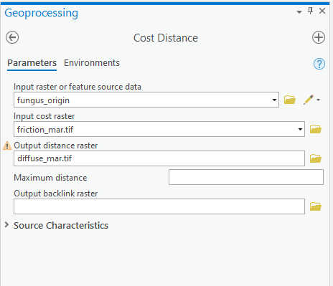Output Distance Raster: *diffuse_mar.tif*

1. Create a new origin raster by reclassifying the travel time raster (*diffuse_nn*) from the previous step based on the number of days in the month, again using the **Reclassify** tool. Your goal is to set all values less than or equal to the number of days in a particular month to a value of 1, and all other values to no data (make sure you set proper maximum value for each month based on the number of days). Name the output raster as *fungus_nn.tif* (e.g., fungus_mar.tif).

|  |  |
| --- | --- |
| Month | Days |
| Jan | 31 |
| Feb | 28 |
| Mar | 31 |
| Apr | 30 |
| May | 31 |
| Jun | 30 |
| Jly | 31 |

1. 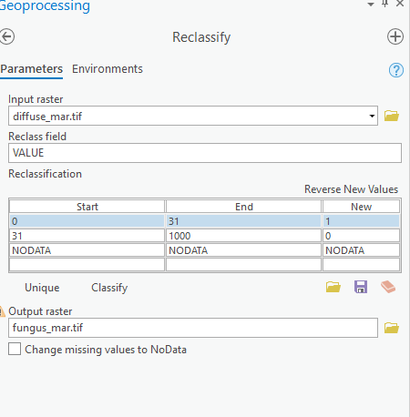Redo these processes for each successive month using the new fungus distribution (e.g., fungus_mar) as your new origin, and repeat this until you have modeled fungus diffusion through July (07).

Note: 1000 is a random number given by us to cover the range of day numbers.

* Save your map.
* Complete questions #3 – #4 on the assignment sheet.

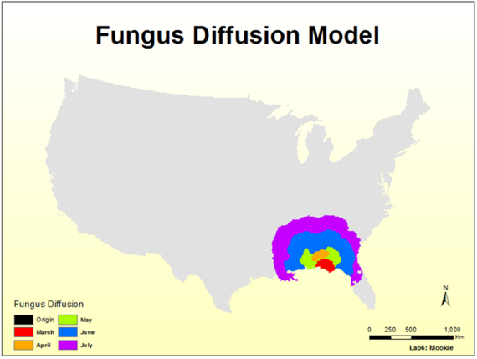

Just make fungus layers for each month (from March to July) visible as well as the us48mask layer. Change the symbology of us48mask layer as gray, similar with the image above. Screen shot your map and attach it in the report.

**Extra Credits** (10 pts): Work on the Layout View to create a composite map showing the area invaded by the fungus by the end of each month. In other words, the legend should have 6 possible values, one for each month (including the origin). Make the colors contrasting enough so that you can see the difference between them. Be sure to add your name, a title and a legend.

**Part3 Trace Shortest Path**

In this part, we will use transportation data of San Francisco to trace the shortest path between multiple points. The SanFrancisco database has one dataset named Transportation. Click Transportation and check its contents from the **Catalog.** You should see four feature classes and one network dataset. We will use this network dataset to trace the shortest path.

* Add Streets_ND to a new map.
* Change the data frame as lab03_part3.
* Right-click Streets_ND in the Contents pane and choose **Zoom To Layer** to view the San Francisco area. The area covered by the network dataset is where you can perform network analyses.

By default, network datasets built with traffic data show traffic conditions for the current time when they are added to the map. This network dataset includes historical traffic, so you are seeing typical traffic conditions for the current time and day of the week. Not all roads in this network dataset include traffic, so only the ones that do are shown by default.

* Next, let`s create the route layer. A route layer provides the structure and properties needed to set up and solve route problems. It also contains the results after solving.
* On the Analysis tab, in the Workflows group, click **Network Analysis > Route** Route.

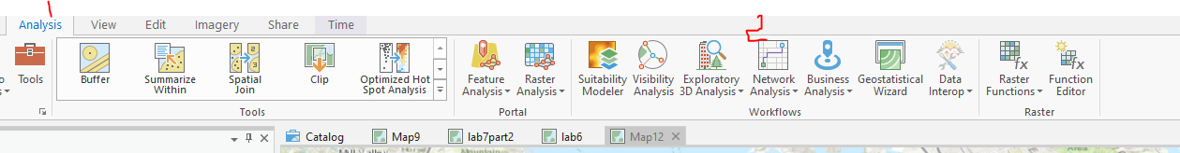

* The Route layer is added to the Contents pane. It includes several sublayers that hold the inputs and outputs of the analysis.

Note: To see or change the network data source that will be used to create the network analysis layer, on the Analysis tab, in the Workflows group, you can click the Network Analysis drop-down menu and look under Network Data Source.

* In the Contents pane, click **Route** to select the group layer.
* The Route tab appears in the Network Analyst group at the top of ArcGIS Pro. You will use these controls to define the route you want to generate.

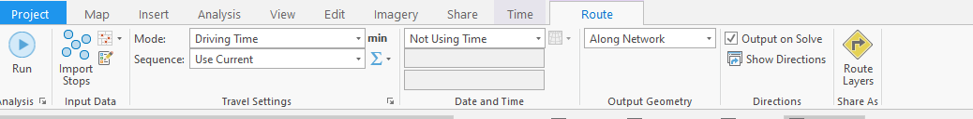

* In this lab, let`s create stops first. Suppose we need to visit these stops along a journey, the route solver finds the optimal path through the network, connecting the stops you designate.
* On the Edit tab, click **Create** .
* The Create Features pane appears, showing a list of layers that can be edited.
* Under Route: Stops, click **Stops**.
* Use the **Point tool** Point to create a few stops on the map in the area covered by the network dataset.
* On the Edit tab, click **Attributes** Attributes.
* The Attributes pane appears.
* On the **Route** tab, click **Run** **.**
* Let`s try something interesting to create a polygon/ line barrier on the route you already achieved.
* On the **Edit** tab, click **Create Features.**
* The Create Features pane appears, showing a list of layers that can be edited**.**
* **Under Route: Polygon Barriers, click Polygon Barriers.**
* Use the **Polygon** tool Polygon to draw a polygon on the map (double click to finish drawing). Make sure the polygon covers at least one street used by the route you already solved.
* On the **Route** tab, click **Run.**

Compare the difference between the routes without barrier and with barriers. It is time to create a line barrier yourselves and attach a screenshot of your map to the report. This is another “ugly” example by me.

