**Lab 11 Spatial Interpolation**

**Learning Objective**

When we deal with spatial analysis, one of the problems we have is getting data we collect in the field into a form we can analyze. Most field data are collected at discrete points (e.g., rain gages, GPS point collection, address points, ect.). There are several interpolation methods that allow us to take this point data and make it into a continuous surface. We will look at the Inverted Distance Weighting and Kriging methods in this lab.

Scenario: You have been hired by KGS to perform an analysis of water level in the High Plains Aquifer in Kansas. They have provided you with 2 shapefiles containing min, mean, and max water level depths from the surface for 1997 and 2017. Your job is to perform a volume comparison. You will need to interpolate a surface representing the water table elevation for each time period and determine the volume gained or lost over the 20-year period, create a map describing the status and change of the water table in Kansas, and a short report of your findings.

**What you need to submit**

**Lab 11: Answer Sheet**  
Question 1:  
What was your regression function?

Question 2:  
What is the interpretation of your regression function?

Question 3:  
What was your highest prediction standard error (hint: right click on the GA layer and “Change output to predicted Standard Error”)? How does this error compare with the distribution of the well heads?

Question 4:  
Subtract the two 1997 surfaces. What is the difference in volume between the two interpolation methods. Given that we extract [~3,655,000 acre-feet of water a year](https://www.usgs.gov/news/how-much-water-does-kansas-use), how important is the interpolation method in determining the change in volume?

Question 5:  
Pick one of the interpolations and submit your report below. This might include some or all of the following elements.

* A “Current” depth to water level map (example from Brownie Wilson of KGS below)
* A difference map describing the change in water level over the time period
* A short (1-2 paragraph) interpretation of the outcomes. This should address common questions an employer might ask including an interpretation of the data, how the map was created, a statement of accuracy, and potential sources of error.
* An example is as follows:

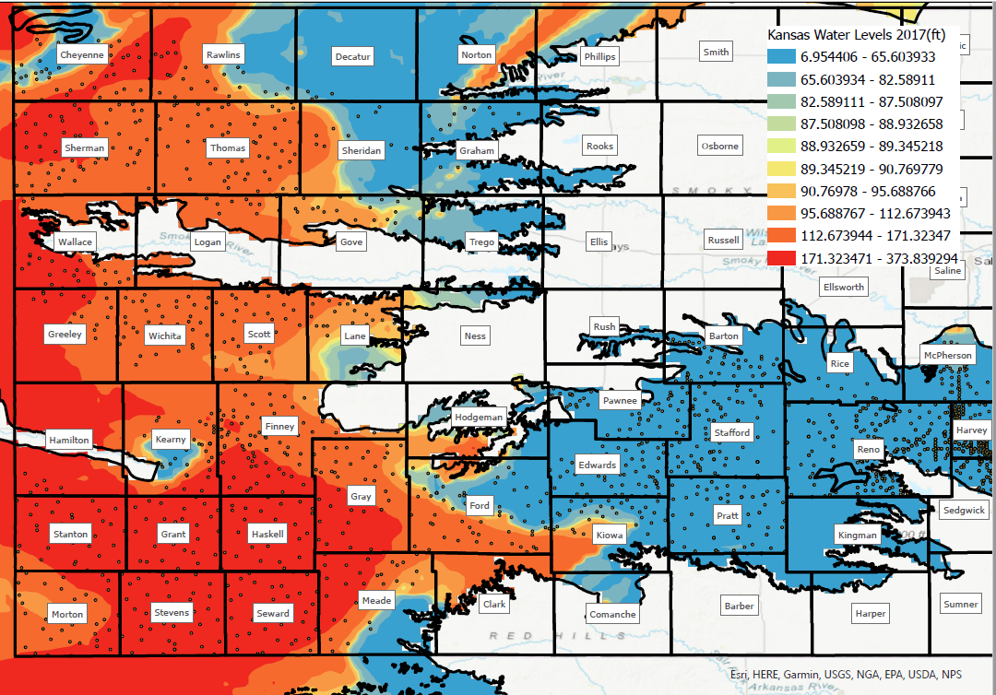

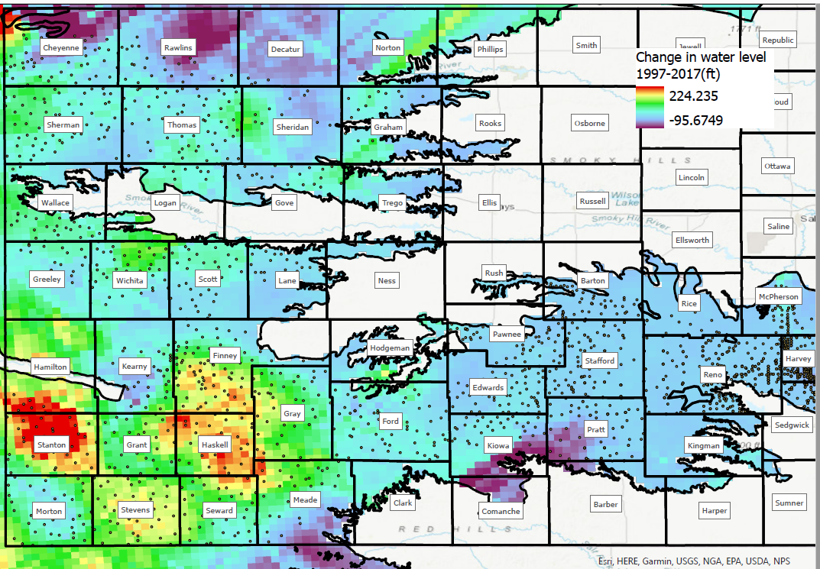

**Materials:**

|  |  |
| --- | --- |
| Data Name | Description |
| HPWells_1997.shp | Well depths for Kansas within the High Plains Aquifer from 1997 |
| HPWells_2017.shp | Well depths for Kansas within the High Planes Aquifer from 2017 |
| SelectedStates.shp | Boundaries for Kansas, Nebraska, Colorado |
| KSCounties.shp | Kansas counties from the 2010 TIGER database |
| KSPLSSSections.shp | Kansas PLSS Section shapefile |
| HPBounds_2010.shp | Outer boundary for the High Plains Aquifer |
| smalldata.zip | A subset of the data for Kansas Groundwater Management District 4 |

**Interpolating a surface using IDW**

* Go to Analysis | Workflows | Geostatistical Wizard
  + Highlight Inverse Distance Weighting
  + Select your Source Data (A well shapefile)
  + We want to model a water surface, so make your Data Field (I use avg depth)
  + Click Next
  + If a “Handing Coincidental Samples” prompt pops up, decide how you would like to handle this occurrence. Since I prefer “worst case” scenarios, I choose “Use Maximum”. Once you’ve chosen, click next.
  + This next window shows you how water levels will be modeled, but in a graphic form. Take a look at the help file for the statistical wizard to determine how the various inputs affect the statistic performed. Go ahead and click that button. I also want to include more samples in my interpolation so change maximum neighbors to 25 and minimum neighbors to 7.
  + The next page shows you the cross validation of your surface. This means that they take a point out of the prediction and compare it to the surface it would otherwise have been created without using it. When presenting results, most publications generally eschew printing the nuances of how they ran an interpolation tool in favor of reporting the regression function. Answer questions 1 and 2 below. When you are done click finish.
* The grid that the geostatistical wizard spits out is a format specific to the interpolation tools and is not easily manipulated as you have grown used to. Export it as a raster by R-clicking on the layer and going to Export Layer | to Raster…
  + Change the cell size to 500 and set the output raster to save it as IDWYYYY in your lab11 folder. Remember to set Extent and Mask as HPBounds_2010.

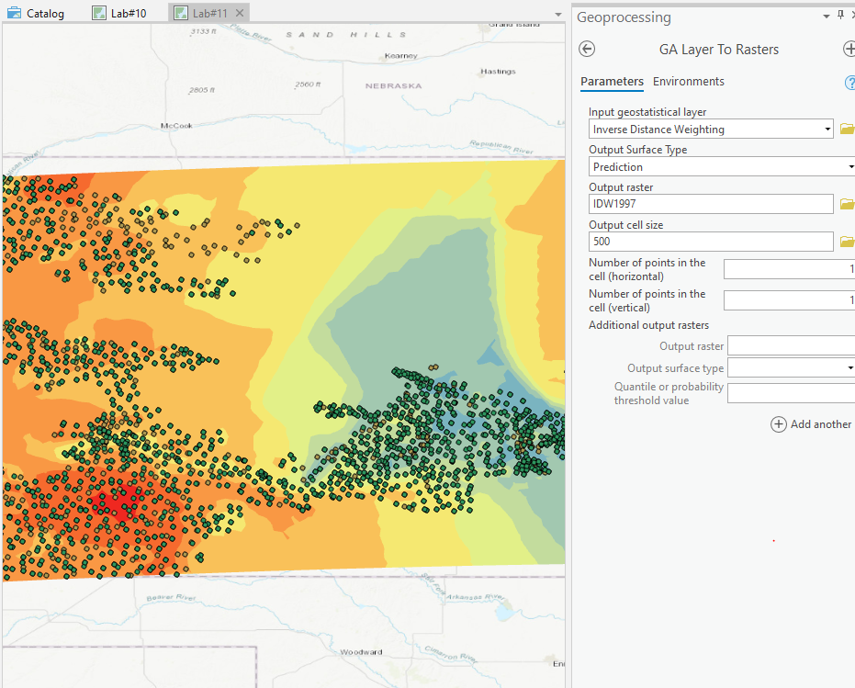

Your final raster layer should be looked like as follows:

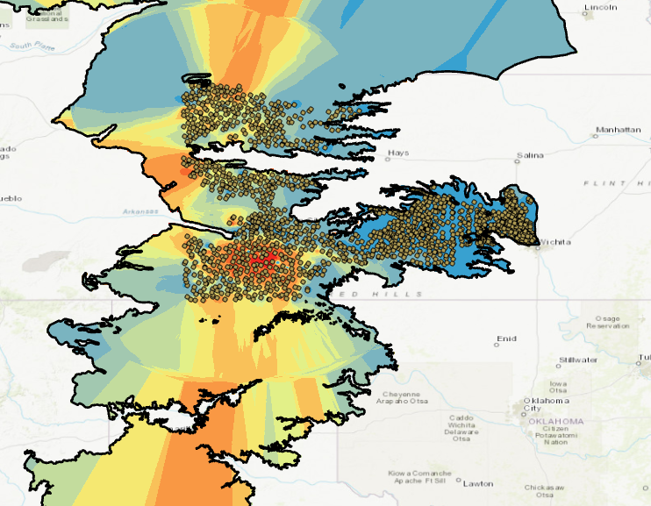

**Interpolating a surface via Kriging**

Quick Kriging refresher here: <https://gisgeography.com/kriging-interpolation-prediction/>

* Go to Analysis | Workflows| Geostatistical Wizard and choose Kriging / CoKriging
* For input Dataset1, select one Wells layer as source dataset. Data field can be Ave_DEPTH_.
* Click Next and select Use Maximum.
* Click Next. Make sure your type of Kriging is set to Simple Kriging and transformation type is Normal Score, and make sure the Output Type is Prediction.

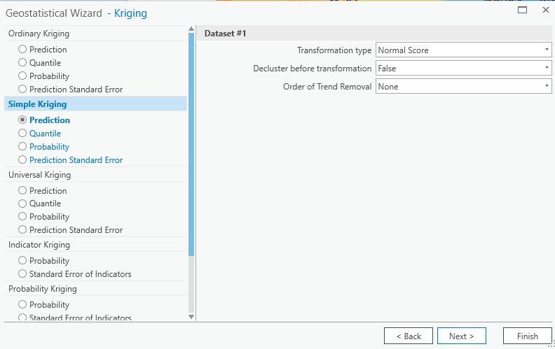

* Click Next. This next window is unique to Normal scores, walking you through the normalization parameters. ArcGIS does all the heavy lifting for you so take note of the parameters, look at the QQ plot, and then click Next.
* Again, the modeling window includes an “Optimize model” button, click that , wait a moment and then click Next.
* This visualization in the next window again shows the graphical representation of the interpolated surface in a graphic form. Click on the inset map to move the cross hairs to different portions of the aquifer. The circle around the cross hairs shows which area the model will take into account for that location. Leave all on this window to the set defaults and click Next.
* This next window shows you the model and the Prediction Errors. You can save this table to as a shapefile or copy the summary to clip board that you can open in Excel, which may have a helpful feature, depending on your purposes.

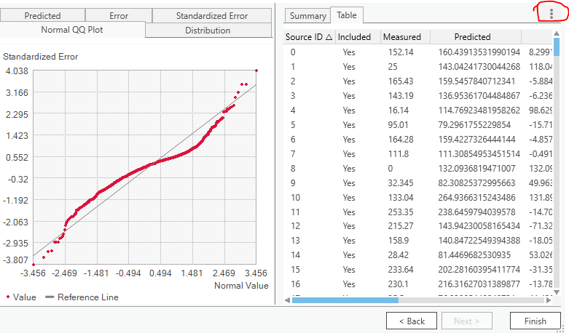

Click Finish

* Click OK on the Output Layer Information window and export the layer to a rater as above, using a name similar to KGYYYY. Remember to set up the extent and Mask as HPBounds_2010.

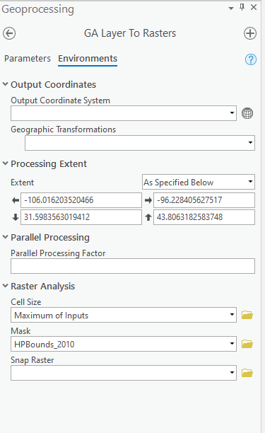

* Answer questions 3 below.

**Clip the rasters to the extent of the Aquifer**

Hint: clip tool. I use 1997 as an example.

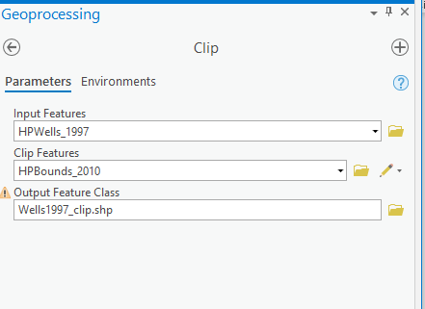

**Calculate Water volume difference between the two interpolation methods**

* Hint: raster calculator…
* If you don’t have an attribute table, you will need to do the following:
* Use Raster Calculator to first turn the raster into an integer while keeping some of our calulated presision. Save the raster as kg1997_int.
  + Hint: Int("KG1997.tif" * 1000).
* In ArcGIS Pro, you cannot build a raster attribute table for a raster dataset that is a pixel type of 32-bit floating point. Therefore, we need then go to Copy Raster, select 32 bit signed as pixel type.
* 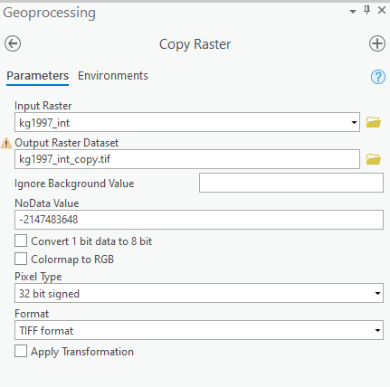
* Use the **Build Raster Attribute table** tool to generate the attribute table.

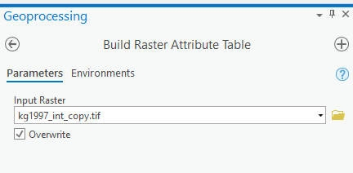

* Open the attribute table you just generated. Click Right Corner and export table named kg_1997_volume.
* 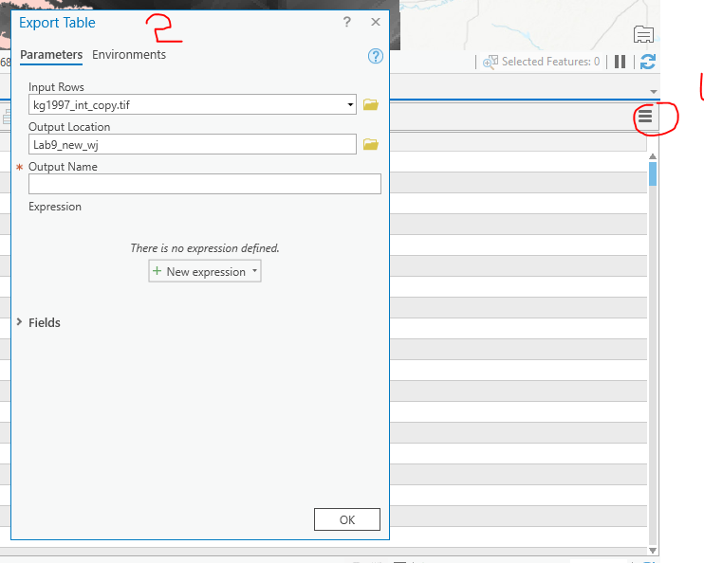
* Open kg1997_colume, create a new field called Volume, make it a float.
* Calculate volume using ((Value/1000)/3.28084)*Count*500*500
* Answer question 4

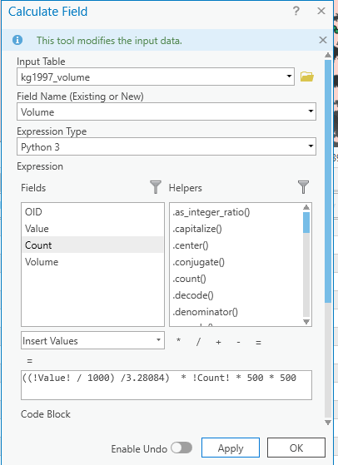

**6)** Pick an interpolation method and interpolate 2017 data using the same methods and parameters as above. Repeat Clip Raster and Calculate water volumes, and answer question 5 on the sheet.