**Minikube Cluster with Airflow and Trino**

All Config files are checked in here -

<https://github.com/alisabir7/ali_deployment>

Components Installed: MySQL, Trino and Airflow(with MySQL )

In this task I created 4 node Minikube cluster.

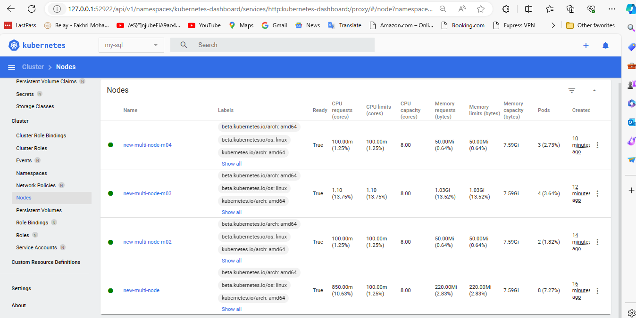

Following components were installed on the cluster.

1. **MySQL**

Adding pv and pvc for MySQL

kubectl apply -f mysql-pv.yaml

kubectl apply -f mysql-pvc.yaml

Adding deployments:

kubectl apply -f mysql-deployment.yaml

MySQL is launched with 1 cpu and 1000Mi memory in our minikube k8s cluster.

Below is the screenshot of it,

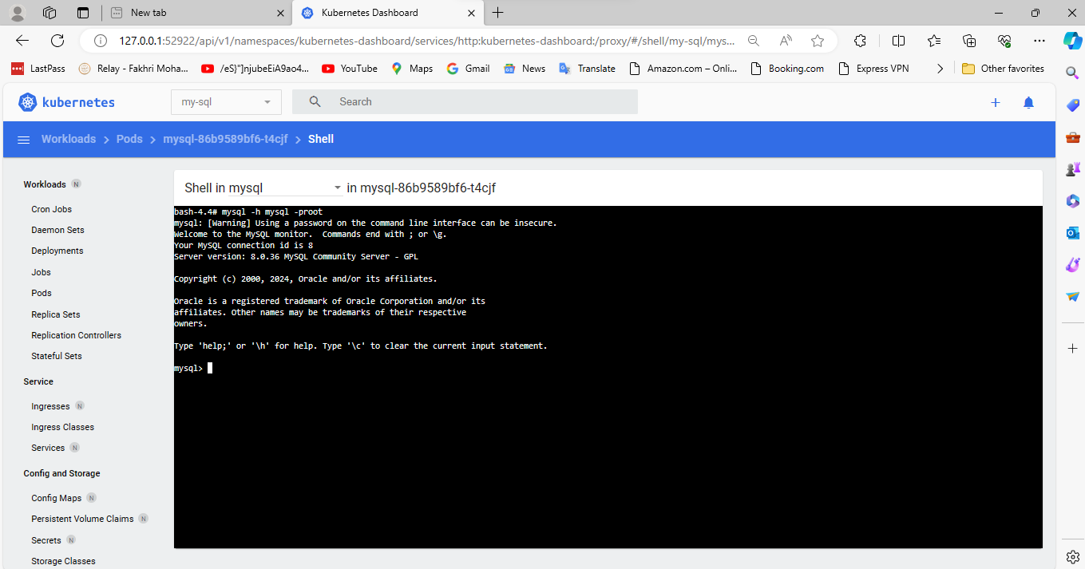

1. **Trino**

For trino I have used my own helm chart.

Link to my own trino helm chart-

<https://github.com/alisabir21/helm-chart/tree/main/trino-final2>

To install trino first add the repository,

helm repo add trino-repo <https://alisabir21.github.io/helm-chart/>

helm install stx trino-repo/trino -f values.yaml --namespace trino --create-namespace

The values.yaml already placed on the github repo.

This will create a trino with one master and one worker with mysql catalog.

Here is the ui.

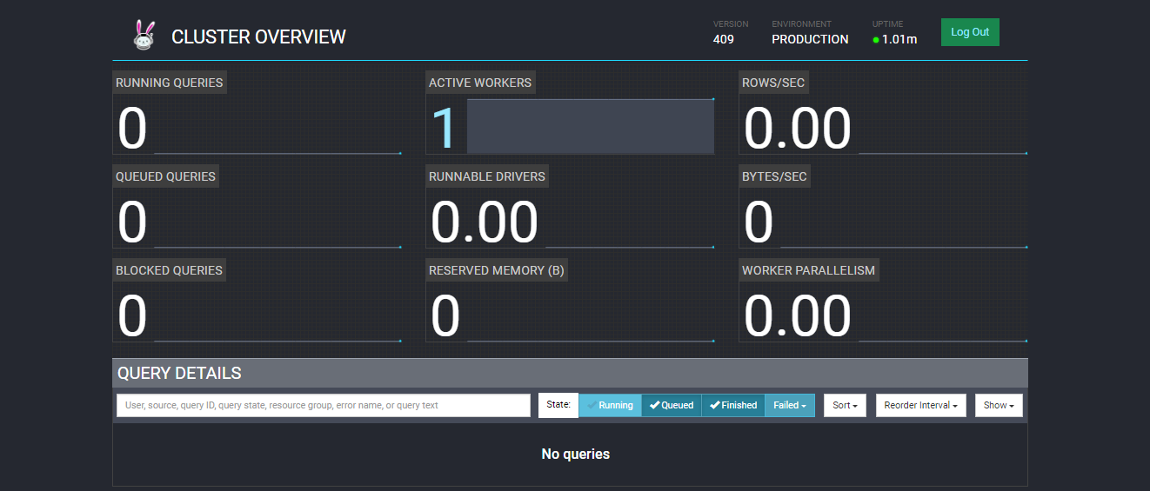

1. **Airflow:**

For airflow I used default helm chart and provided yaml..

For airflow I have used MySQL as the database.

Helm repo add apache-airflow <https://airflow.apache.org>

helm upgrade --install airflow apache-airflow/airflow -f airflow-base.yaml --namespace airflow --create-namespace

airflow-base.yaml already placed on github repo.

This will launch airflow with Web Server and Scheduler.

The UI can be seen below,

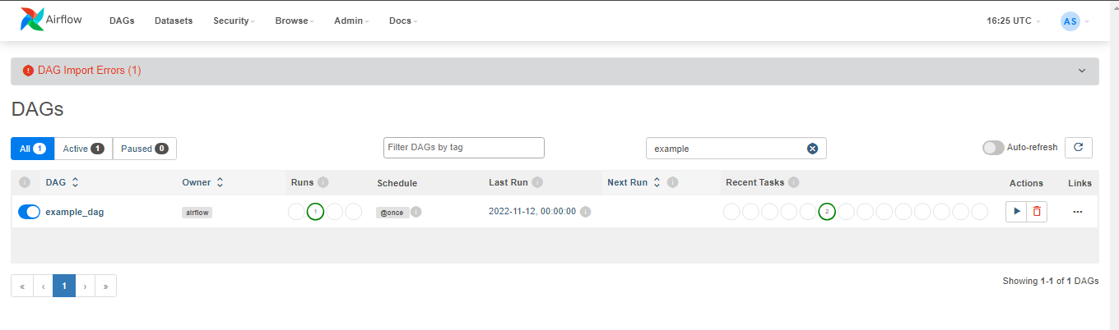

Sample dag(example_dag.py) that ran successfully,

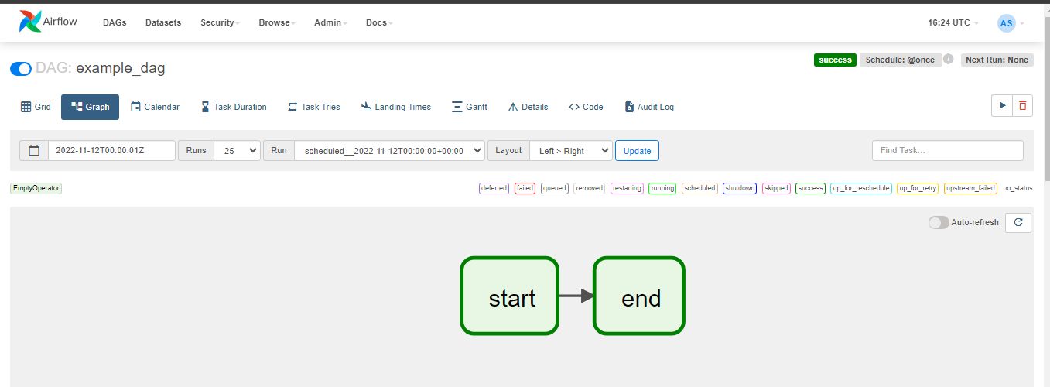

For another Dag (test_dag.py) that ran successfully

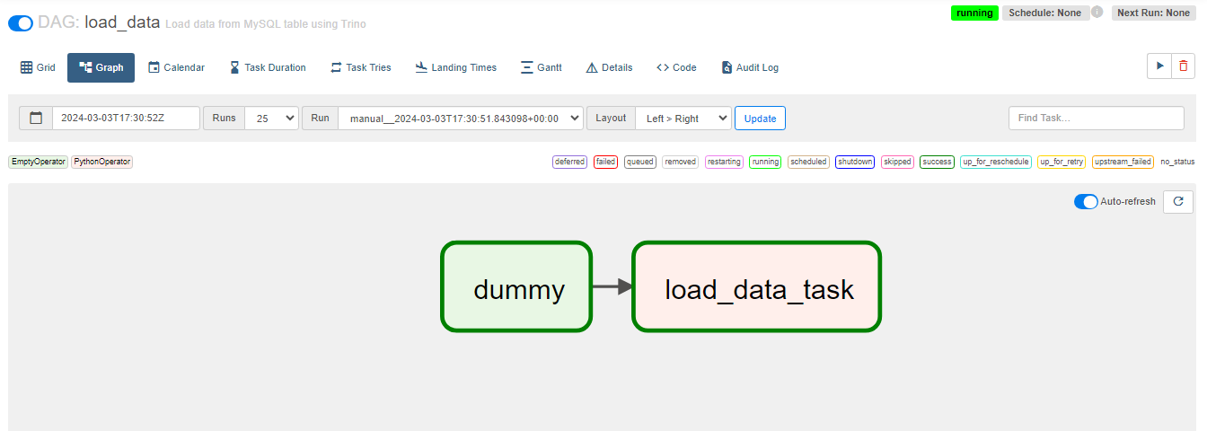

The query executed successfully on trino cluster.

