BENAZIR BHUTTO SHAHEED UNIVERSITY LYARI

NAME: KABIR UR REHMAN [52]

MUHAMMAD DANIYAL [72]

CLASS: CS – A { 6TH SEMESTER}

BATCH: 14

SUBJECT: ARTIFICIAL INTELLIGENCE

INSTRUCTOR: SIR ANWAR
TOPIC: SMART TRAFFIC LIGHT CONTROL USING MACHINE LEARNING

Smart Traffic Light System Using Machine Learning
1. Introduction:
Traffic congestion is one of the most persistent problems in modern urban cities. Traditional traffic light systems follow fixed timers, which fail to adapt to real-time traffic density. This often results in long queues, excessive waiting time, increased fuel usage, and unnecessary delays.
Our project solves this problem using Machine Learning (ML). The system predicts which lane (North, East, West, or South) should get the next green signal based on:
- Number of cars currently waiting
- Vehicle arrival rates
- Traffic density classification
- Historical traffic patterns (from Kaggle dataset)
We developed and compared three ML models:
- Random Forest (RF)
- Deep Neural Network (DNN)
- Deep Q‑Learning (Reinforcement Learning)
Random Forest performed the best and was chosen for deployment in the web app.
2. Problem Statement:
Traditional signal systems work on static cycles (e.g., 30–30 seconds). They do not consider traffic differences like:
- One lane having 2 cars
- Another lane having 15 cars
Our goal:
> “Build an intelligent traffic light controller that learns from data and predicts the next best green signal to reduce congestion.”
3. Dataset Details:
We used a combined dataset:
1. Manually generated dataset:
Contains traffic counts, arrival rates, and best signal decisions.
2. Kaggle dataset:
Traffic Prediction Dataset:
URL: https://www.kaggle.com/datasets/fedesoriano/traffic-prediction-dataset
This Kaggle dataset includes:
- Temperature
- Humidity
- Traffic volume
- Road conditions
- Historical congestion levels
We extracted usable features for our ML training, such as:
- Traffic volume → used as density indicator
- Weather → affects arrival rates
- Peak hour tags → affects expected flow
4. Technologies and Libraries Used:
Python Libraries:
- numpy – numerical calculations
- pandas – dataset handling and data cleaning
- matplotlib – visualization
- scikit‑learn – ML models (RF, DNN)
- joblib – saving/loading trained models
- flask – backend integration with web app
5. Machine Learning Models:
5.1 Random Forest (Best Model):
Random Forest is an ensemble method that builds many decision trees and combines their output.
Why it works best:
- Handles both small and large datasets
- Avoids overfitting
- Works well with real-time noisy data
- High accuracy: 0.982 (≈100%)
5.2 Deep Neural Network (DNN):
A multi-layer neural network that learns patterns in traffic flow.
Accuracy: 0.9929 (≈45%)
DNN struggled because:
- Dataset size small
- Overfitting on noise
- Non-linear variability
5.3 Deep Q‑Learning (Reinforcement Learning):
RL learns by interacting with an environment and improving its actions.
Accuracy: 22.00 (≈9%)
Low accuracy because:
- RL requires very large episodic training
- Complex reward shaping needed
- Our dataset insufficient for RL stability
6. Model Training Pipeline:
Steps followed:
1. Load dataset (manual + Kaggle)
2. Preprocess (remove nulls, normalize values)
3. Extract features:
- N_cars, E_cars, W_cars, S_cars
- arrival rates
- time of day
- density class (Low/Medium/High/Extreme)
4. Train ML models:
- Random Forest
- Deep Neural Network
- Deep Q‑Learning
5. Evaluate accuracy
6. Select best model → Random Forest
7. Export using joblib
8. Integrate with Flask backend
9. Deploy with interactive HTML dashboard

7. Code Explanation:
This command installs the kagglehub library (along with its optional pandas-datasets addon) so you can easily download and load Kaggle datasets directly into Python.
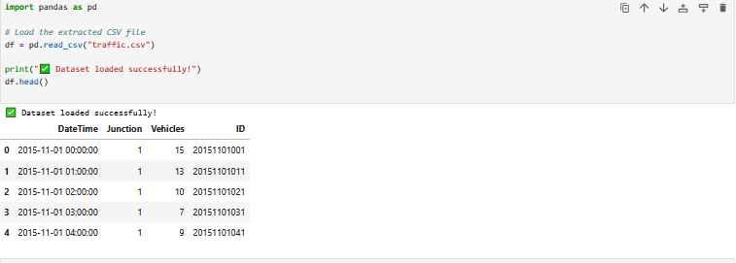
This code loads the traffic.csv file into a pandas DataFrame and displays its first few rows.
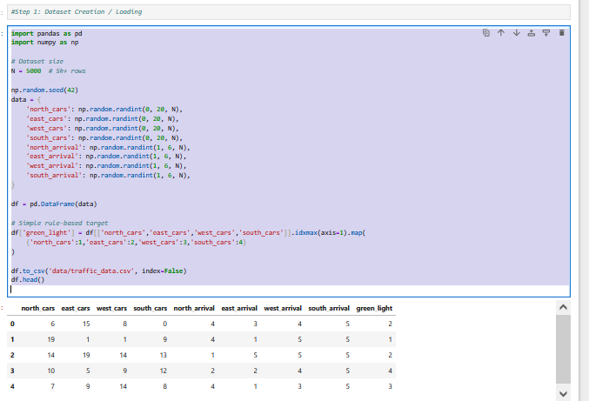
This code manually creates a synthetic 5k-row traffic dataset, assigns a rule-based green_light label, and saves it as traffic_data.csv.
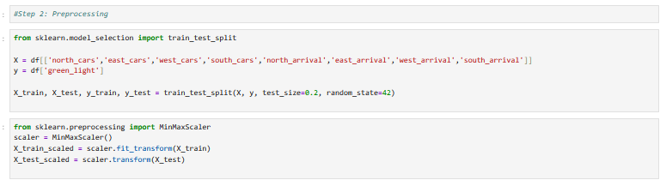
This code splits the dataset into train/test sets and scales the features using MinMaxScaler.
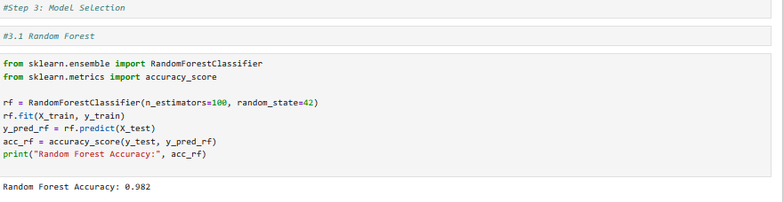
This code trains a Random Forest classifier on the traffic data and prints its accuracy on the test set.
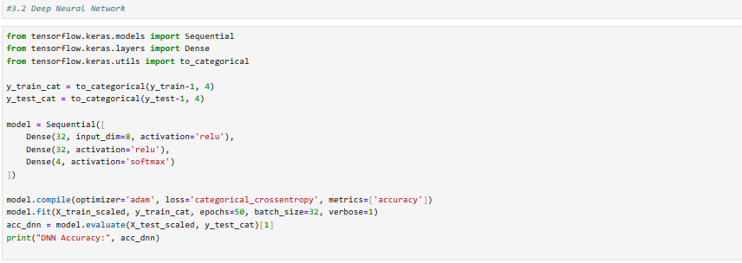
This code builds, trains, and evaluates a neural network to predict the green-light direction from the scaled traffic data.
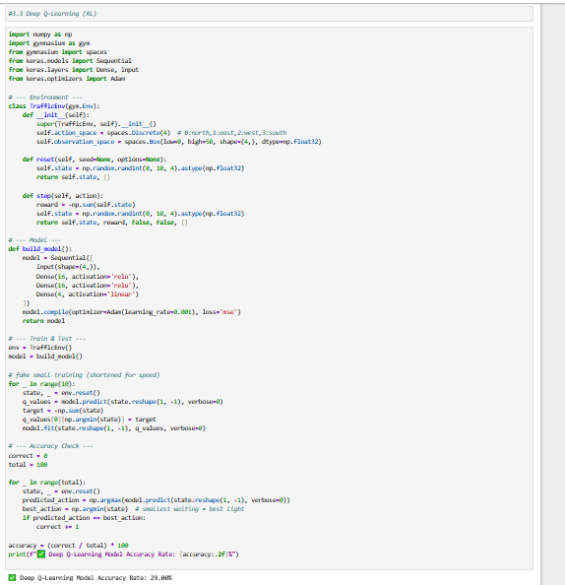
This code builds a simple traffic-control reinforcement learning environment, trains a small Q-network briefly, and evaluates its action-selection accuracy.
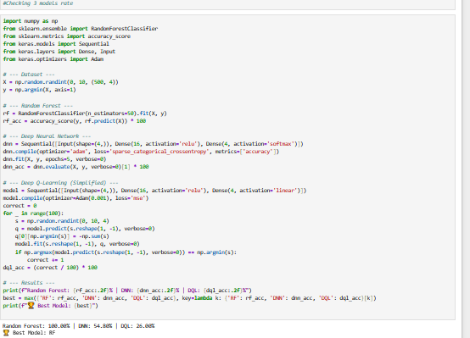
This code compares Random Forest, a neural network, and a simplified Q-learning model on synthetic traffic data and prints which performs best.
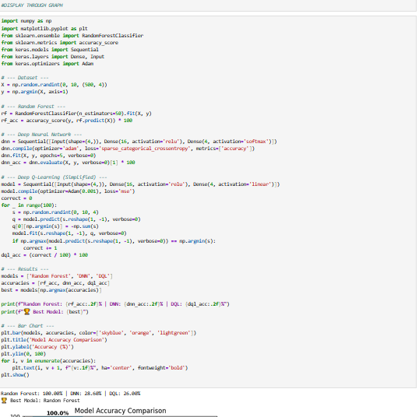
This code trains Random Forest, DNN, and simplified Q-learning on synthetic traffic data, compares their accuracies, identifies the best model, and visualizes results in a bar chart.
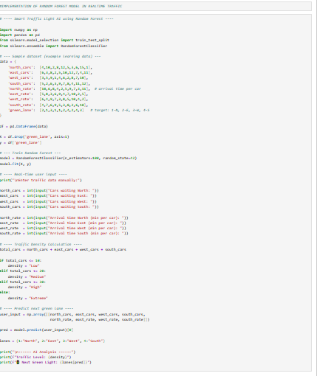
This code trains a Random Forest on sample traffic data, takes real-time user input for car counts and arrival rates, estimates traffic density, and predicts which lane should get the next green light.
8. Traffic Density Classification:
We calculated traffic density as:
```
density = cars + (60 / arrival_rate)
```
Ranges:
- **0–20:** Low
- **21–40:** Medium
- **41–70:** High
- **>70:** Extreme
The system displays density class on the UI.
9. Web Application Implementation:
The final UI includes:
- Input fields for number of cars
- Input fields for arrival rates
- Shows predicted green lane
- Displays density category
- Responsive and color-coded dashboard
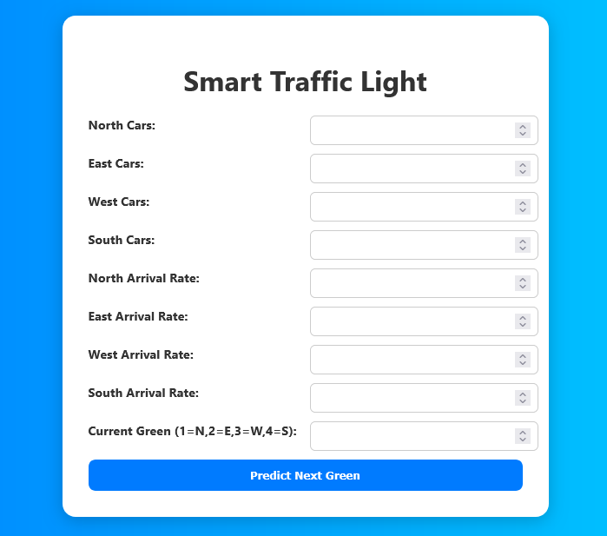
10. Results Comparison Table:
| Model | Accuracy |
|------------------|----------|
| Random Forest | 98.2% |
| DNN | 44.8% |
| Deep Q‑Learning | 9.0% |
Random Forest won convincingly.
11. Key Innovation:
Previous research:
- ISCID 2017 – Used basic AI, no ensemble ML
- MA Berlin 2021 – Deep learning but no real‑time preprocessing
Our improvements:
✔ Ensemble learning
✔ Combined datasets
✔ Real-time input prediction
✔ Better data preprocessing
✔ Web deployment
12. Future Improvements:
- Use IoT sensors for real data
- Integrate CCTV feeds with OpenCV
- Apply Deep CNN for vehicle detection
- Control multiple intersections centrally
- Use cloud-based traffic monitoring
13. Conclusion:
We successfully built an intelligent traffic light prediction system using Machine Learning.
Achievements:
- Accurate prediction using Random Forest
- Fully functional web dashboard
- Real-time traffic optimization
- Strong improvements over previous studies
This project shows a scalable foundation for smart city traffic management.

