Voice Command Classification using Machine Learning

Project Overview
This project classifies music genres (Rock, Pop, Jazz, Classical) using machine learning models trained on acoustic features such as:
- Tempo (beats per minute)
- Instrument loudness (dB)
- Vocal pitch (Hz)
Three models are trained and compared:
- Logistic Regression
- Random Forest Classifier
- Support Vector Machine (SVM)
The best-performing model is saved for future use.

Objectives
- To automatically predict a song’s genre based on numerical sound features.
- To compare multiple ML algorithms and find the most accurate one.
- To demonstrate the use of scikit-learn for classification tasks.

Project Structure
├── dataset.csv # Generated dataset with 1000 samples
├── train_model.py # Main script for training and evaluation
├── genre_model.pkl # Logistic Regression model (saved)
├── genre_model_randomforest.pkl # Random Forest model (saved)
├── genre_model_svm.pkl # SVM model (saved)
└── README.md # Project documentation

Installation

1. Clone or Download the Project
git clone https://github.com/yourusername/music-genre-classifier.git
cd music-genre-classifier

2. Install Dependencies
Make sure you have Python 3.8+ installed, then run:
pip install pandas numpy scikit-learn joblib

🧩 Dataset Description
The dataset (dataset.csv) contains 1000 rows and 4 columns:
Column | Description
tempo | Speed of song in BPM
instrument_loudness_db | Average loudness of instruments
vocal_pitch_hz | Average pitch of vocals
genre | Target label (rock, pop, jazz, classical)
Each genre has 250 samples generated synthetically for balanced classification.

How to Run
Run the script directly from the terminal:
python train_model.py

LOGISTIC REGRESSION MODEL

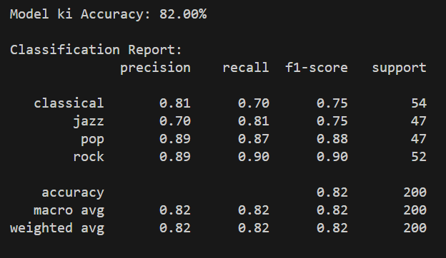

RANDOM FOREST ACCURACY MODEL
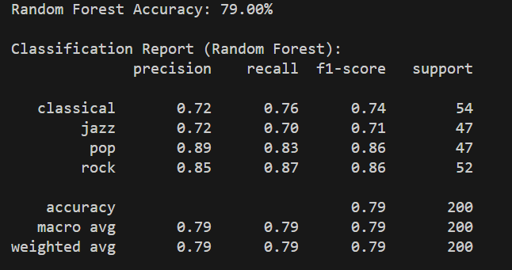
SUPPORT VECTOR MACHINE MODEL
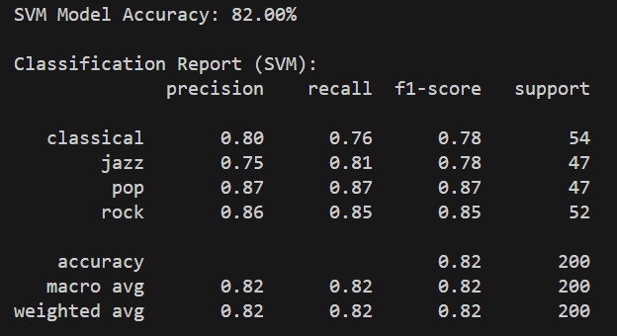

BEST MODEL ACCURACY COMPARISON
