Charting Crowdfunding

Ali Saghafi

2022

## Charting Crowdfunding

## Background

Crowdfunding platforms like Kickstarter and Indiegogo have been growing in success and popularity since they began in the late aughts. Everyone from indie creators to famous celebrities have utilized crowdfunding to launch new products and generate buzz, but not every project has found success.

Getting funded on a crowdfunding website requires meeting or exceeding the project's initial goal, so many organizations spend months looking through past projects in an attempt to discover some trick for finding success. For this week's homework, you will organize and analyze a database of 1,000 generated sample projects in order to uncover any hidden trends

**Given the provided data, what are three conclusions we can draw about crowdfunding campaigns?**

1. Top 3 of campaign base on category:

Theater

film & video

music

|  |  |  |  |  |  |
| --- | --- | --- | --- | --- | --- |
| **Count of outcome** | **Column Labels** |  |  |  |  |
| **Row Labels** | **canceled** | **failed** | **live** | **successful** | **Grand Total** |
| film & video | 11 | 60 | 5 | 102 | 178 |
| food | 4 | 20 |  | 22 | 46 |
| games | 1 | 23 | 3 | 21 | 48 |
| journalism |  |  |  | 4 | 4 |
| music | 10 | 66 |  | 99 | 175 |
| photography | 4 | 11 | 1 | 26 | 42 |
| publishing | 2 | 24 | 1 | 40 | 67 |
| technology | 2 | 28 | 2 | 64 | 96 |
| theater | 23 | 132 | 2 | 187 | 344 |
| **Grand Total** | **57** | **364** | **14** | **565** | **1000** |
|  |  |  |  |  |  |
|  |  |  |  |  |  |
|  |  |  |  |  |  |
|  |  |  |  |  |  |

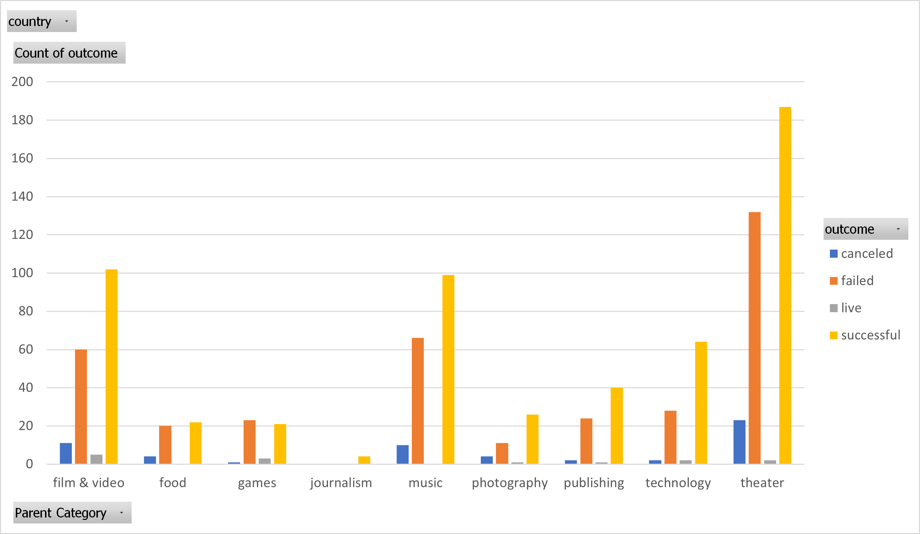

1. Only Journalism campaign without failed.
2. After Journalism campaign, food campaign has minimum failed
3. Top 3 campaign base on Goal (100% successful)

15000 to 19999

20000 to 24999

30000 to 34999

|  |  |  |  |  |  |  |  |  |
| --- | --- | --- | --- | --- | --- | --- | --- | --- |
| **Goal** | **Percentage Successful** | | **Percentage Failed** | | **Percentage Canceled** | |  | |
| Less than 1000 | 59 | | 39 | | 2 | |  | |
| 1000 to 4999 | 83 | | 16 | | 1 | |  | |
| 5000 to 9999 | 52 | | 40 | | 8 | |  | |
| 10000 to 14999 | 44 | | 56 | | 0 | |  | |
| 15000 to 19999 | 100 | | 0 | | 0 | |  | |
| 20000 to 24999 | 100 | | 0 | | 0 | |  | |
| 25000 to 29999 | 79 | | 21 | | 0 | |  | |
| 30000 to 34999 | 100 | | 0 | | 0 | |  | |
| 35000 to 39999 | 67 | | 25 | | 8 | |  | |
| 40000 to 44999 | 79 | | 21 | | 0 | |  | |
| 45000 to 49999 | 73 | | 27 | | 0 | |  | |
| Greater than or equal to 50000 | 37 | | 53 | | 9 | |  | |
|  |  |  | |  | |  | |  | |  |  |  |

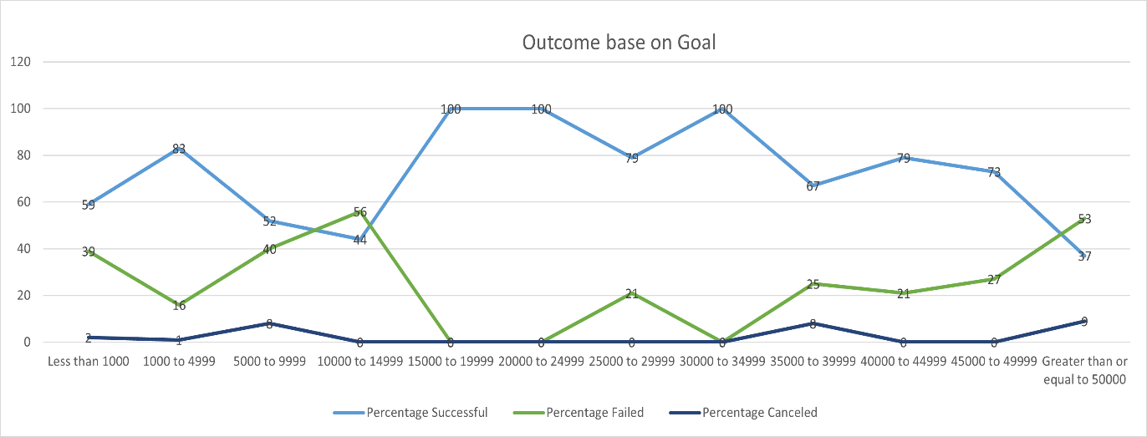

1. Worst goal is over 50000
2. USA the Top 0ne .

|  |  |  |  |  |  |
| --- | --- | --- | --- | --- | --- |
|  |  |  |  |  |  |
| **Count of outcome** | **Column Labels** |  |  |  |  |
| **Row Labels** | **canceled** | **failed** | **live** | **successful** | **Grand Total** |
| AU | 2 | 16 | 1 | 24 | 43 |
| CA | 2 | 19 | 1 | 22 | 44 |
| CH | 4 | 6 | 1 | 12 | 23 |
| DK | 1 | 12 | 1 | 17 | 31 |
| GB | 1 | 18 | 1 | 28 | 48 |
| IT | 3 | 19 |  | 26 | 48 |
| US | 44 | 274 | 9 | 436 | 763 |
| **Grand Total** | **57** | **364** | **14** | **565** | **1000** |
|  |  |  |  |  |  |

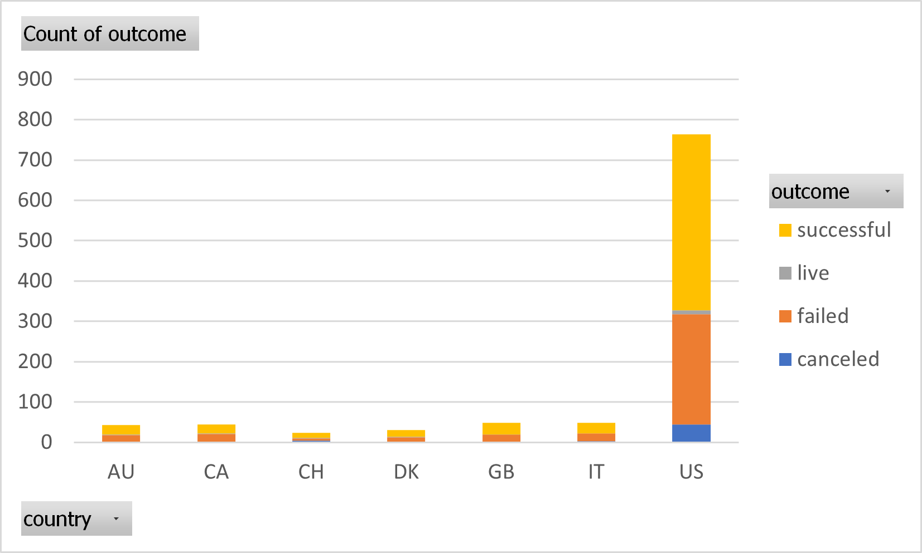

**What are some limitations of this dataset?**

Available data Only for 7 countries.

999 company

Limited to 2010 to 2020

Limited to category and subcategory

**What are some other possible tables and/or graphs that we could create, and what additional value would they provide?**

Create a new sheet (Report4) with a pivot table that will analyze your initial worksheet to count how many campaigns were successful, failed, canceled, or are currently live per **country**.

|  |  |  |  |  |  |  |
| --- | --- | --- | --- | --- | --- | --- |
|  |  |  |  |  |  |  |
| **Count of outcome** | **Column Labels** |  |  |  |  |  |
| **Row Labels** | **canceled** | **failed** | **live** | **successful** | **Grand Total** |  |
| AU | 2 | 16 | 1 | 24 | 43 |  |
| CA | 2 | 19 | 1 | 22 | 44 |  |
| CH | 4 | 6 | 1 | 12 | 23 |  |
| DK | 1 | 12 | 1 | 17 | 31 |  |
| GB | 1 | 18 | 1 | 28 | 48 |  |
| IT | 3 | 19 |  | 26 | 48 |  |
| US | 44 | 274 | 9 | 436 | 763 |  |
| **Grand Total** | **57** | **364** | **14** | **565** | **1000** |  |
|  |  |  |  |  |  |  |
|  |  |  |  |  |  |  |

