From Fragnancex

After successfully opening the software you will get windows like this.

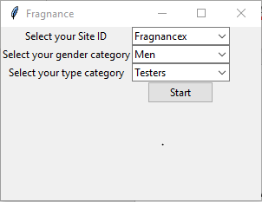

There are three components of this software.

1. Site ID: This is the website from where you will scrape data.
2. Gender: This will filter the data for specific gender like women etc.
3. Category: This is the option to filter in which category you want to scrape data. There are several categories from which you can scrape data.

After successfully choosing your gender and category press start button to start scrapping for the given inpupt.