1. Install python's latest version on your machine from https://www.python.org

2. Go to desktop.

i)Right click on ThisPC and click on Properties.

ii) Click on Advanced System settings.

iii) Click o Enviroment Variables.

iv) Set your system variable path by click on Edit button.

v) Set the path where your python is installed e.g( For default path is C:\Users\username\AppData\Local\Programs\Python\Python37-32 and also set path for scripts C:\Users\username\AppData\Local\Programs\Python\Python37-32\Scripts

vi) Click on OK.

3. If path is successfully set run cmd and type python to check it.

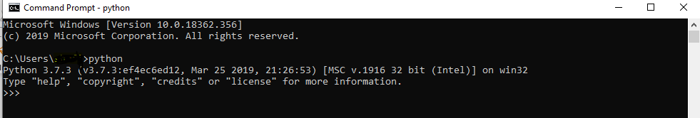

4. Check your path for the scripts is loaded or not. Type “pip –version” in cmd. If you got below screen it is done successfully.

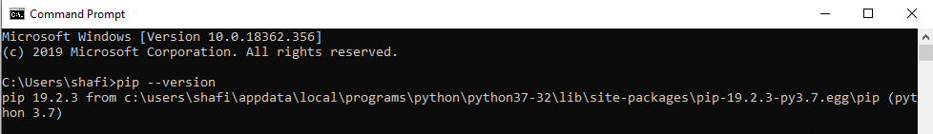

5. Open cmd type "pip install selenium". Make sure you have internet connection.

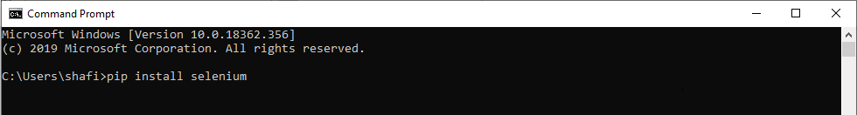

6. Copy ChromeDriver.exe from the ScrapeFromTwoSites folder and save to C:/Python(create folder python if doesn't exists)

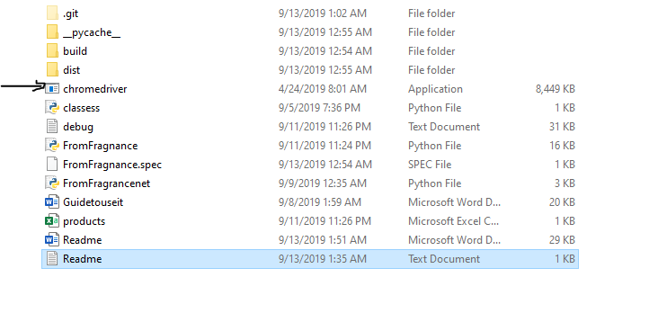

7. Go to dist inside ScrapeFromTwosites

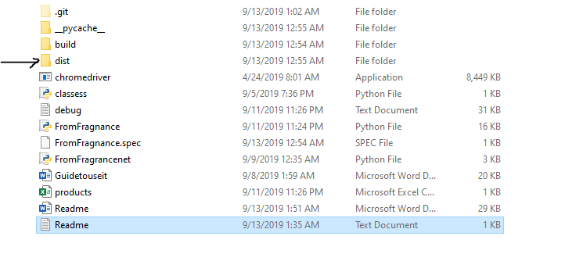

Open it and open the folder inside it. Run FromFragnance.py.

