Copyright [2017] [Universität Tübingen]

Licensed under the Apache License, Version 2.0 (the "License");
you may not use this file except in compliance with the License.
You may obtain a copy of the License at

http://www.apache.org/licenses/LICENSE-2.0

Unless required by applicable law or agreed to in writing, software
distributed under the License is distributed on an "AS IS" BASIS,
WITHOUT WARRANTIES OR CONDITIONS OF ANY KIND, either express or implied.
See the License for the specific language governing permissions and
limitations under the License.

MyKitchen project documentation

The Eberhard Karls University of Tübingen
Nino Avsajanishvili
11/04/17

Content
Content 2
Introduction 3
Server – xampp 3
Start and stop XAMPP using command line 3
Start and stop XAMPP using Control Panel 4
Increase upload size 4
Web browser 5
New folder structure 5
Registration form 5
Database 6

Introduction
The web application myKitchen is a 2D kitchen simulation in which the kitchen objects can be placed in kitchen cupboards. Project MyKitchen was developed as a Bachelor thesis by Marc Ehrener in HTML5 and implemented in PHP for further usability study. Mostly I have changed the JavaScript code, but the majority code of HTML and CSS has remained the same.
Evaluation of results depends on the user performance data such as time on task, number of clicks on kitchen objects and where the kitchen objects are placed. Results are saved into a CSV files and also in the database.
The language of website is German.

Server – xampp
XAMPP is is a simple, lightweight Apache distribution containing MariaDB (MySQL), PHP and Perl that makes it extremely easy for developers to create a local web server for testing and deployment purposes. It is free for downloading, easy for installation and using. XAMPP works equally well on Linux, Mac and Windows. Website to download XAMPP: https://www.apachefriends.org/index.html.
Installation works like any other software installation. After installation we need to turn on and turn off the apache server manually (it can also configured so that server starts automatically when the operating system starts).

Start and stop XAMPP (Apache) using command line

On Linux:
To start and stop Apache Server, you can use the command line on Linux:
sudo /opt/lampp/lampp start
- Wenn Zugriff verweigert wird: sudo chmod -R 777 /opt/lampp
- Wenn folgende Warnung kommt: Warning: World-writable config file '/opt/lampp/etc/my.cnf' is ignored

→ ariel[/opt/lampp/phpmyadmin]$sudo chmod -R 644 config.inc.php
and
sudo /opt/lampp/lampp stop

On terminal Mac OSX:
sudo /Applications/XAMPP/xamppfiles/xampp start
and
sudo /Applications/XAMPP/xamppfiles/xampp stop

Start and stop XAMPP using Control Panel
To start and to stop XAMPP run XAMPP Control Panel

On Linux
Xampp under Linux distributions doesn’t have the control panel GUI for starting or stopping the Server and its components. Actually, Xampp has a small python script that creates the GUI.
We can create Launcher for starting XAMPP GUI on Linux with following commands:
sudo apt-get install python-glade2
sudo gedit ~/Desktop/Xampp.desktop
The text editor will open simply paste the following code to the text editor and save it.
[Desktop Entry]
Encoding=UTF-8
Comment=Start and Stop XAMPP
Name=XAMPP Control Panel
Exec=gksudo python /opt/lampp/share/xampp-control-panel/xampp-control-panel.py
Icon=/opt/lampp/htdocs/favicon.ico
Categories=Application;Development;Web
Version=1.0
Terminal=false
Type=Application
Change the file permissions so that it can execute.
sudo chmod [g]o+x ~/Desktop/Xampp.desktop
If it doesn't work:
sudo chmod 777 ~/Desktop/Xampp.desktop
works.
There is Xampp icon in Desktop, double-click that icon XAMPP Control panel will open.
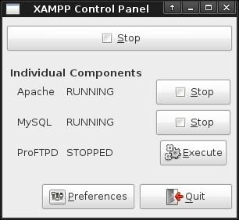

On Windows

Xampp on windows has graphical interface. Open XAMPP Control Panel by right-click on xampp-cotrol.exe and select Run as administrator: ← weder sudo run XAMPP
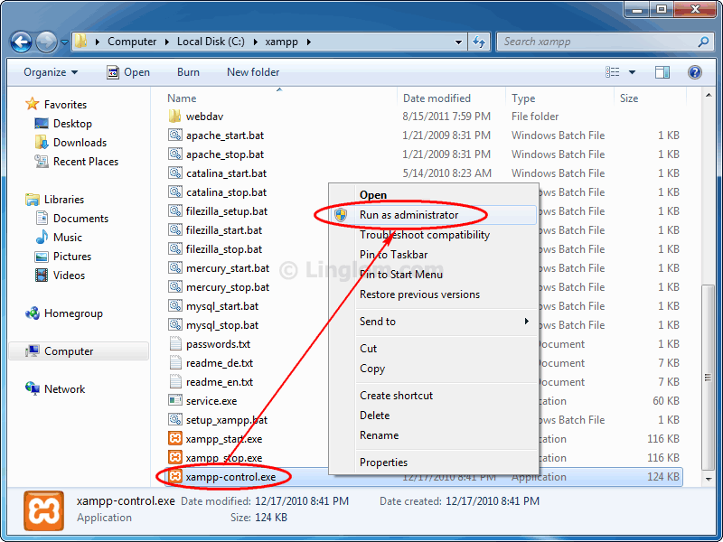
On XAMPP Control Panel Application, select Svc checkbox of Apache and MySQL and click OK. This will install Apache and MySQL as a service on this computer.
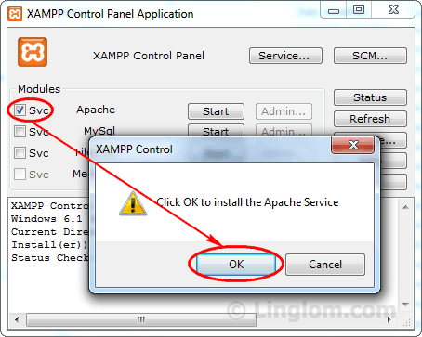 | 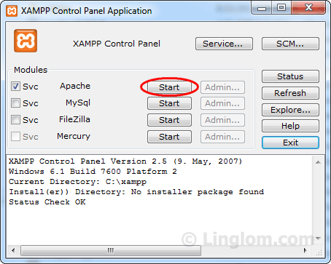  Start Apache and MySQL services.

noch sudo Run XAMPP (Control Panel) funktionieren

Increase upload size
PHP has several configuration options to limit resources consumed by scripts. By default, PHP is set to allow uploads of files with a size of 2MB or less.
The following default values should be increased in php.ini (in the folder /opt/lampp/etc/php.ini on Linux, in XAMPP/xamppfiles/etc/php.ini on Mac, and in the xampp\php\php.ini-Folder on Windows):
memory_limit = 32M
upload_max_filesize = 24M
post_max_size = 32M
After making these changes restart Apache.
post_max_size should be greater than upload_max_size and memory_limit larger than post_max_size.

New folder structure
There is the folder called htdocs under XAMPP root directory (/opt/lampp/htdocs), where you have to copy the folder myKitchen with content in order to avoid any conflicts.
For a better overview old folder structure is slightly modified. I placed CSS files in a folder stylesheets, JavaScript in js and images as before in folder images. In img you will find all the pictures of the kitchen itself, e.g. of the shelves and the oven. The file mykitchen.sql and file with calculated distances between kitchen cupboards are in a folder db, exported test results in the folder userdaten.
For file and image names are not used capital letters, umlauts and other special characters.

Web browser
The application works on Chromium, Google Chrome, Safari, Internet Explorer 11 and Mozilla Firefox. Access of the web site in the web browser via the URL: http://localhost/myKitchen/index.php or http://localhost/myKitchen.
Wenn Zugriff verweigert: ariel[/opt/lampp/htdocs]$sudo chmod -R 777 myKitchen/

Registration form
The home index page is a registration form page.
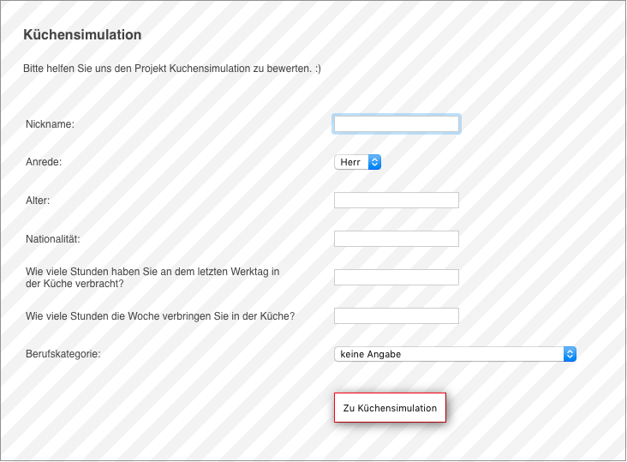
Required fields are nickname, age, nationality and how many hours does user spend in the kitchen. For other input fields are used default values.

Kitchen cabinet dimensions
For the space calculation we use standard kitchen cabinet dimensions (Width, Height, Depth).
For normal size shelves (40 cm, 40 cm, 20 cm), for small shelves (30 cm, 20 cm, 30 cm). Height for small drawers is 8 cm and for big drawer – 10 cm. ← Das dürfte nicht mehr aktuell sein. Bitte aktualisieren!

Database
When a PHP application makes a database connection it needs password. If database password for MariaDB is set, it should be changed PHP value $pass on line number 160 in the file mykitchen.php.

Create database via command line
We can create the database with following commands:
CREATE DATABASE IF NOT EXISTS mykitchen_db;
USE mykitchen_db;
With the command we can run the file in mysql shell
> mysql myKitchen_db < {path}/mykitchen.sql
or if password is set, then
> mysql -u {username (e.g. root)} -p mykitchen_db < {path}/mykitchen.sql

On Mac it easily works on terminal:
> C:\xampp\mysql\bin\mysql -u {username} -p {password} {database name} < {path}/mykitchen.sql

Create database and tables using PhpMyAdmin
PhpMyAdmin is a popular web-based administration tool used to administrate MySQL servers and databases. We start Apache and MySQL and open URL: http://localhost/phpmyadmin in web browser. The phpMyAdmin login screen should appear:
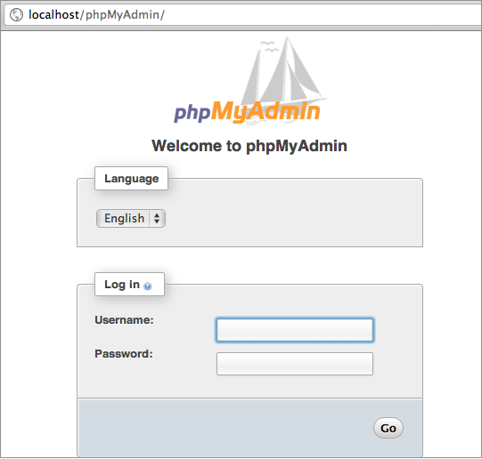
We need to provide valid MySQL user (root for MySQL user) and password. After login we will see all databases and tables on that MySQL server and can easily create new database and tables:
