Economic indicators disaggregation

Overview
The procedure described a method for disaggregating economic indicators for fishing fleets at a spatial level, specifically for GSA6 (Spain). The workflow integrated economic data from the EU DCF Annual Economic Report (AER) with spatial fishing effort data from the EU DCF Fisheries Data Collection (FDI).

Step-by-step methodology

Data loading and setup
Target Parameters: The analysis focused on GSA6, Spain, the Mediterranean and Black Sea (MBS) supra-region, and Bottom Otter Trawl (OTB) gear.
Geospatial Infrastructure: EU DCF FDI spatial grid (c-squares) intersected with the GSA 6 boundaries.
Data Sources:
- EU DCF AER: Socio-economic data at the fleet segment level.
- EU DCF FDI: Spatial fishing effort data (fishing days) and landings (kg and value) per c-square.
- Standardising and Harmonising fields

The preprocessing phase started by standardising country names and supra-region labels to ensure consistency across all data sources. This was followed by gear mapping, in which gear types such as DTS are recorded to OTB to facilitate precise alignment of economic indicators with effort datasets. Finally, the procedure filtered essential variables, taking only fishing days, energy costs, energy consumption, gross value of landings, personnel costs, and repair expenses for the subsequent analysis.
- Join AER - FDI
The second stage of the analysis involved merging the EU DCF AER and EU DCF FDI datasets. The fields that are used to combine the two sub-datasets were: (1) country_name, (2) year, (3) fishing_tech, (4) vessel_length. We obtained a new dataframe that aligns the Total Fishing Days values from EU DCF AER and EU DCF FDI. In addition, the percentage of the corresponding composition of the Fishing days from EU DCF FDI by fishing technique was reported. Finally, the relationship of the Fishing Days values from the two data sources is computed (Fig. 1).
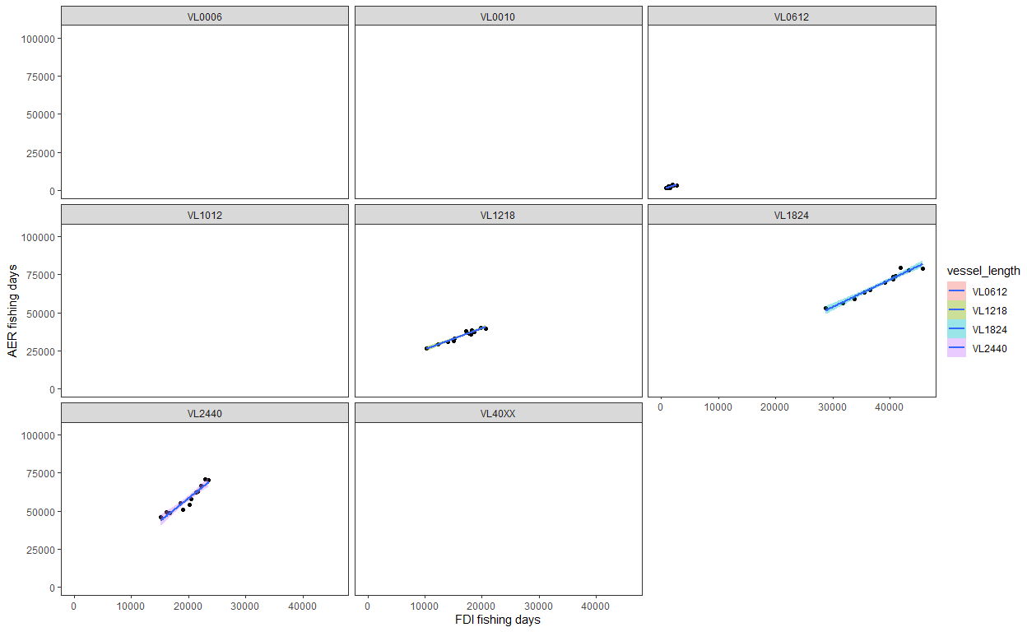
Figure 1 – Scatterplot of the values of fishing days reported in the EU DCF Annual Economic Report (AER) and Fisheries Dependent Information (FDI). Vessel length categories derived from the two merging datasets.
The analysis revealed a significant correlation between AER and FDI fishing effort (days) for specific vessel length segments. Consequently, length classes that lacked a clear correspondence or a verified relationship between the two datasets were excluded from the study (VL0006, VL0010, VL1012, VL40XX).
- Fitting linear regression models using economic variables from the EU DCF AER dataset
Energy Consumption Model: Once the correlation between AER and FDI fishing days was validated, the Sala et al. (2022) energy consumption model was applied to the AER dataset. The model used fishing days by vessel length to estimate daily fuel consumption (${EC}_{vt})$(Fig. 2), which was then used to calculate the corresponding energy costs.
$$AER{ EC}_{vl} =q+β_{EC}*{AER Fishing Days}_{vl}$$
Where $β_{EC}$ is the slope, q is the intercept of the regression model, and vl denotes the vessel length category.
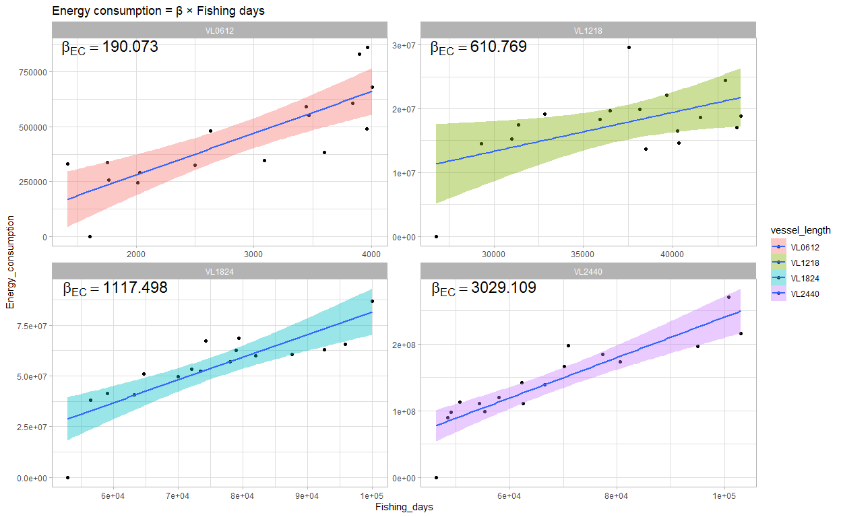
Figure 2 – Scatterplot correlation between fishing days and energy consumption derived from the EU DCF Annual Economic Report (AER) for the selected vessel length classes.
The slope ($β_{EC}$) was estimated and stored in a coefficient table, retaining only statistically significant and valid estimates for each length class.
Subsequently, the analysis assessed the economic efficiency associated with fuel consumption by modelling the relationship between Energy Consumption and Energy Costs (Fig. 3). The cost coefficient ($β_{ECost})$ was estimated for each vessel length class using the formula:
$$AER Energy Costs={q+ β}_{ECost}​*AER {EC}_{vl}$$
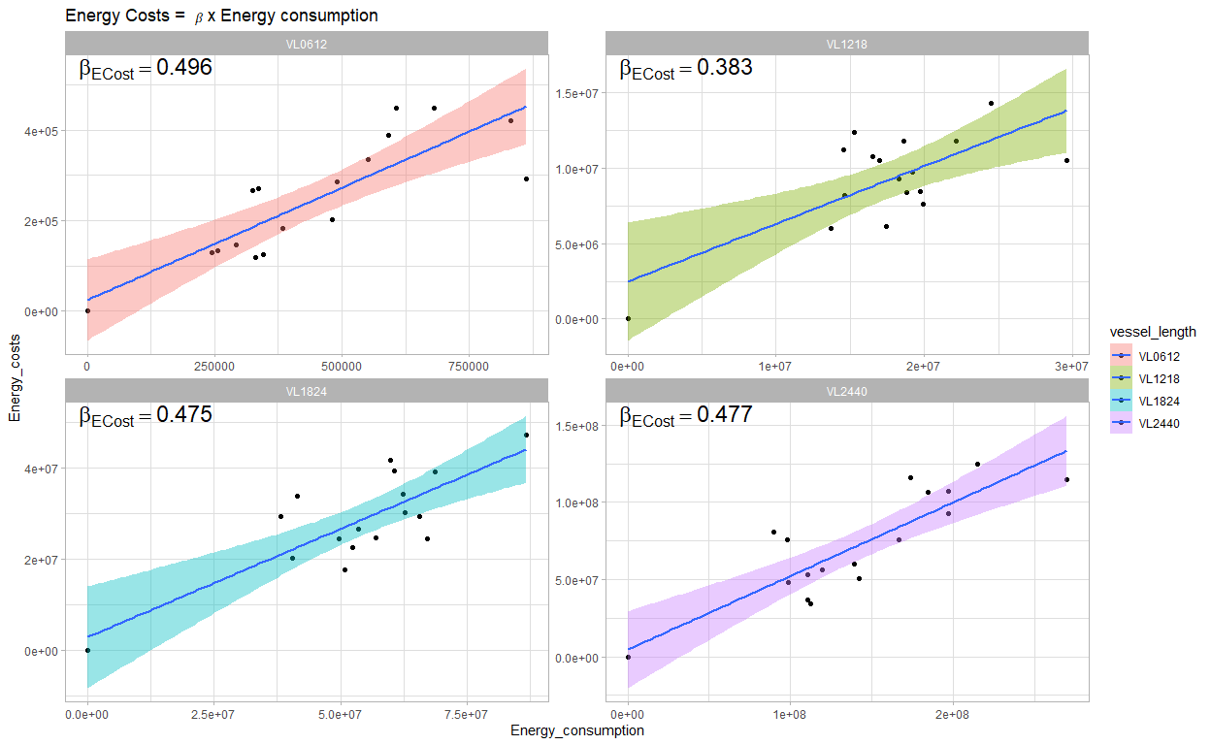
Figure 3 - Scatterplot correlation between energy consumption and energy costs derived from the EU DCF Annual Economic Report (AER) for the selected vessel length classes.
- Spatial disaggregation
This section of the procedure describes the spatial disaggregation of economic variables and the calculation of key performance indicators at the grid level (c-square) (Fig. 4).
- Energy Consumption and Energy Costs: At this stage, the derived regression slopes ($β_{EC}, β_{ECost})$ were used to project economic indicators onto the FDI spatial framework. By utilising the total fishing days (totfishdays) from the FDI dataset, high-resolution estimates for energy consumption and costs were calculated as follows:
$$FDI Energy consumption= β_{EC}*totfishdays$$
$$FDI Energy Costs= β_{ECost}* Energy consumption$$
Effort share: The fishing effort (fishing days) from the FDI dataset is processed to determine the relative weight of each spatial unit. Effort is aggregated by c-square, year, vessel length, gear type, and supra-region. After, an effort-share coefficient is derived for each c-square. This represents the proportion of fishing days in a specific cell relative to the total effort of that fleet segment.
At this stage, AER data was once again utilised to allocate revenues and costs. The datasets are merged according to year, vessel length, and gear type. Each economic variable—including Gross Value of Landings (GVL), Other Income, Repair & Maintenance costs, Variable and Non-variable costs, and Personnel costs—is scaled by this effort share. This assigned a specific weight to each c-square based on the fishing effort intensity recorded within that cell.
Finally, high-resolution economic performance metrics are calculated for each spatial unit:
- Gross Value Added (GVA): GVA is defined as the value that fisheries have added to the goods and services they have provided. It can thus be stated that the difference between the income of producers (Gross Value of Landings (GVL) + other income) and the costs they face (energy, repairs, and other variable/non-variable costs) is the value they have added:
$$GVA=(GVL+Other Income)-(FDI Energy Costs+Repair +Variable Costs+Fixed Costs)$$
- Gross Profit: This metric measures the operating profitability of each cell. It is derived by subtracting labour costs (personnel costs and the value of unpaid labour) from the GVA:
$$Gross Profit=GVA-(Personnel Costs+Unpaid Labor)$$
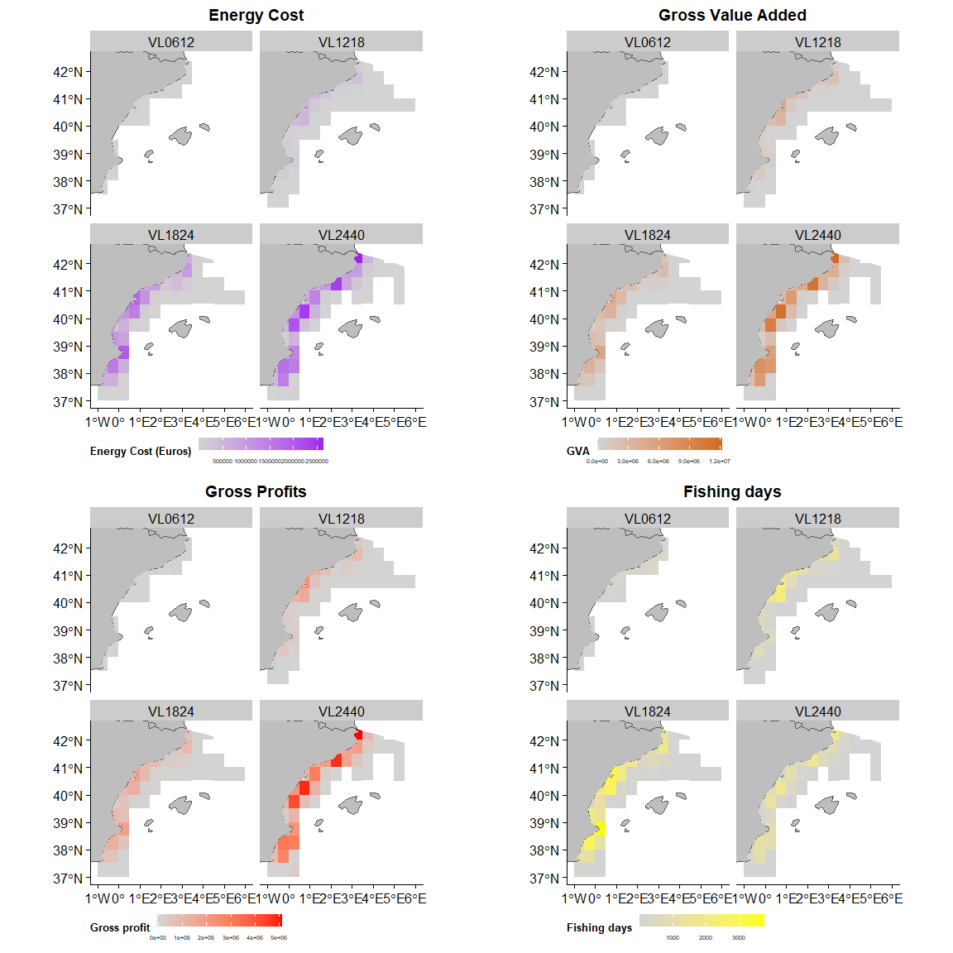
Figure 4 – Result of the spatial disaggregation of economic variables and of key performance indicators at the grid level (c-square) in the Western Mediterranean Sea (GSA6).
- Fuel indicators
This section of the methodology describes the integration of biological landings data with previously derived economic indicators to assess the fuel intensity and fuel efficiency of the fishing fleet in GSA 6.
- Fuel intensity (FUI) and Fuel Efficiency (FE)
To ensure the robustness of the spatial analysis, the FDI landings dataset was subjected to a rigorous filtering process.
- Data Cleaning: All records with a landing weight of 0 were removed.
- Temporal Consistency: To minimise noise from occasional or rare species, only species present throughout the entire study period were retained. This was achieved by identifying species consistently reported across all years for each gear and vessel length segment.
- Aggregation: Species-specific data were aggregated at the grid level (c-square). Landing weights were converted to kilograms (kg) and synchronised with the temporal scale of the economic indicators.
Subsequently, after harmonising the datasets, total landings were calculated for each spatial unit, year, and vessel length. This total weight was used to estimate the Fuel Use Intensity (FUI), defined as the amount of fuel consumed per unit of biomass landed (litres of fuel per tonne of landed fish):
${FUI}_{i}=\frac{{Energy Consumption (l)}_{i}}{{Total Landings (kg)}_{i}}$​​
Where i represents a specific c-square. High FUI values reflect a higher energy consumption per kilogram of fish produced, whereas low FUI values indicate greater operational efficiency (Fig. 5).
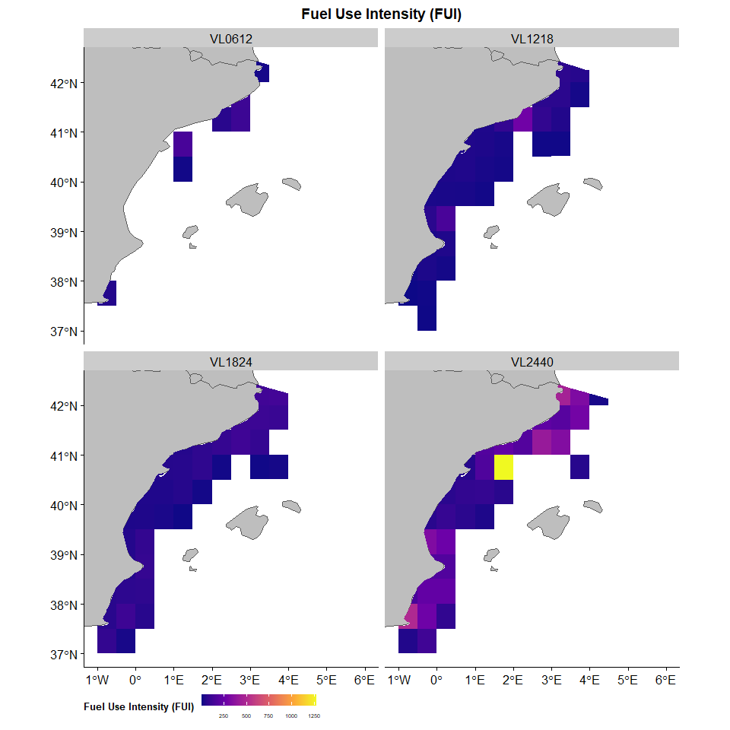
Figure 5 - Result of the spatial disaggregation Fuel Use Intensity (FUI) at the grid level (c-square) in the Western Mediterranean Sea (GSA6).
- Fuel Efficiency
Additionally, the landing values were computed for each spatial unit, year, and vessel length. This total value was used to estimate Fuel Efficiency (FE), defined as the ratio of fuel costs to revenue, reflecting economic exposure and vulnerability to price fluctuations:
${FE}_{i}=\frac{{Energy Costs}_{i}}{{Total Landings Value}_{i}}$​​
Where i represents a specific c-square. High FE values reflect a higher energy cost per value of fish produced, whereas low FE values indicate greater operational efficiency.
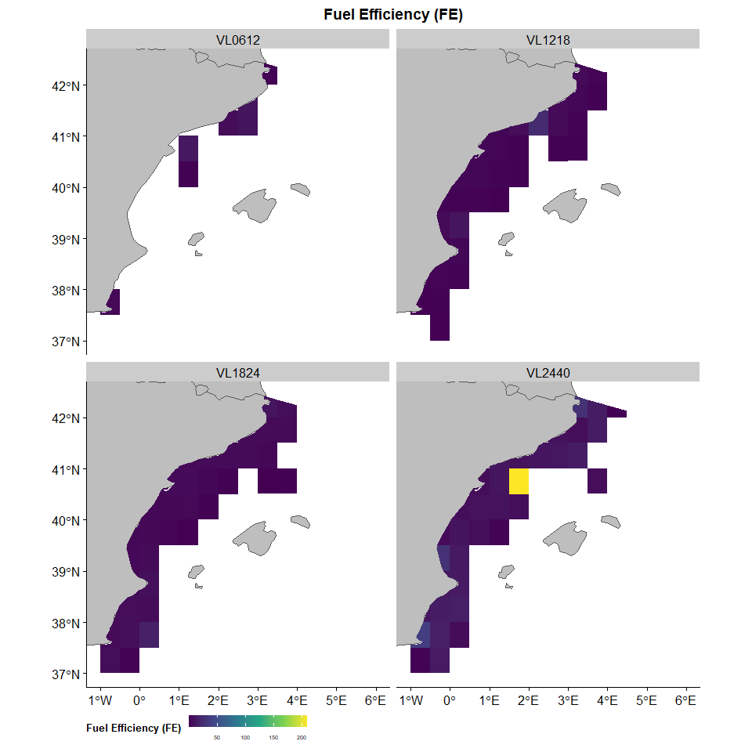
Figure 6 - Result of the spatial disaggregation Fuel Efficiency (FE) at the grid level (c-square) in the Western Mediterranean Sea (GSA6).

