PART A)

Seq1: | Begin → | I0→ | I0 → | D1→ | I1→ | M2→ | M3→ | M4→ | I4→ | End
Seq2: | Begin → | I0→ | I0 → | M1→ | I1→ | M2→ | M3→ | M4→ | I4→ | I4→ | End
Seq3: | Begin → | I0→ | M1 → | I1→ | M2→ | I2→ | M3→ | M4→ | End
Seq4: | Begin → | I0→ | I0 → | M1→ | M2→ | D3→ | M4→ | I4→ | I4→ | I4→ | End
Seq5: | Begin → | I0→ | D1 → | I1→ | M2→ | M3→ | M4→ | End
Seq6: | Begin → | I0→ | I0 → | M1→ | M2→ | I2→ | M3→ | M4→ | I4→ | I4→ | End
Seq7: | Begin → | I0→ | I0 → | M1→ | M2→ | I2→ | M3→ | M4→ | End
Seq8: | Begin → | I0→ | I0 → | M1→ | M2→ | M3→ | D4→ | I4→ | End

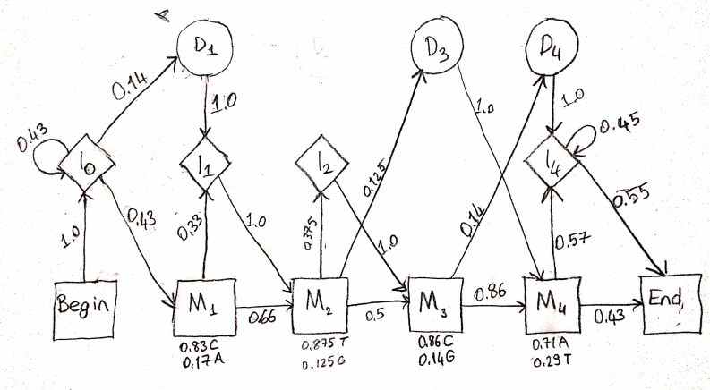

PART B)

 | - | C | T | C | T | G | A
BEGİN | 1.0 | 0.0 | 0.0 | 0.0 | 0.0 | 0.0 | 0.0
I0 | 0.0 | 1*0.25 =0.25 | 0.25*0.43*0.25=  0.026 | 0.026*0.43*0.25=  0.27E-2 | 0.27E-2*0.25*0.43=0.29E-3 | 0.29E-3*0.25*0.43=0.31E-4 | 0.31E-4*0.25*0.43=  0.33E-5
I1 | 0.0 | 0.0 | 0.035*0.25=  0.00875 | 0.36E-2*0.25*  1.0=  0.9E-3 | 0.0093*0.33*0.25=  0.77E-3 | 0.41E-3*0.25=  0.1E-3 | 0.43E-4*0.25=  0.11E-4
I2 | 0.0 | 0.0 | 0.0 | 0.0 | 0.375*0.25*0.0=  0.0 | 0.375*0.25*0.54E-2=  0.51E-3 | 0.375*0.25*0.96E-4=  0.9E-5
I4 | 0.0 | 0.0 | 0.0 | 0.0 | 0.0 | 0.0 | 0.53E-4*0.25=  0.13E-4
D1 | 0.0 | 0.25*0.14 =  0.035 | 0.026*0.14=  0.36E-2 | 0.27E-2*0.14=  0.38E-3 | 0.29E-2*0.14  =  0.41E-3 | 0.31E-3*0.14=  0.43E-4 | 0.33E-5*0.14=  4.62E-7
D3 | 0.0 | 0.125*0.0=  0.0 | 0.125*0.0=  0.0 | 0.125*0.0=  0.0 | 0.125*0.54E-2=  0.67E-3 | 0.125*0.96E-4=  0.12E-4 | 0.125*0.0=  0.0
D4 | 0.0 | 0.14*0.0=  0.0 | 0.14*0.0=  0.0 | 0.14*0.0=  0.0 | 0.14*0.0  =  0.0 | 0.14*0.38E-3=  0.53E-4 | 0.14*0.0  =  0.0
M1 | 0.0 | 0.43*0.0 =  0.0 | 0.43*0.25*0 =  0.0 | 0.43*0.026*0.83 =0.93E-2 | 0.43*0.93E-2*0=  0.0 | 0.0 | 0.43*0.31E-4*0.17 =0.23E-5
M2 | 0.0 | 0.0 | 0.0 | 0.03*0.125*0.0=  0.0 | 0.93E-2*0.66*0.875=0.54E-2 | 0.77E-3*0.125=  0.96E-4 | 0.0
M3 | 0.0 | 0.0 | 0.0 | 0.0 | 0.0 | 0.54E-2*0.5*0.14=  0.38E-3 | 0.0
M4 | 0.0 | 0.0 | 0.0 | 0.0 | 0.0 | 0.0 | 0.38E-3*0.86*0.71=  0.23E-3
END | 0.0 | 0.0 | 0.0 | 0.0 | 0.0 | 0.0 | 0.23E-3*0.43=  0.99E-4

BEST PATH
Begin → I0 →I0 → M1→ M2→ M3→ D4→ I4→ END
The probability associated with the best path is 0.99E-4

C | T | - | C | - | T | - | G | - | - | A | -
G | G | - | - | T | T | - | G | A | - | G | -
- | C | T | A | T | T | - | C | A | C | - | A
- | G | - | C | A | T | G | C | A | - | - | -
- | A | G | C | - | T | - | - | A | C | G | A
- | T | - | - | G | T | - | C | T | - | - | -
- | T | A | C | - | T | A | C | A | - | A | A
G | G | - | C | - | G | T | C | T | - | - | -
A | C | - | C | - | T | - | C | - | - | G | -
 |  |  | * |  | * |  | * | *

