**How much does it cost to be a woman in Europe?**

**How much money women spend in their lifetime for feminine products across Europe?**

First, I chose the countries I wanted to compare, because I am from Latvia, I decided to pick European Union member states.

51% of population in European Union consist of females.

**How much does feminine products cost in Europe?**

I gathered prices of pads and tampons from online stores in each country and averaged it.

With the lowest cost per unit 0,10€ in Poland and the highest cost 0,20€ in Greece and Denmark.

**Cost of “Luxury.”**

The average woman menstruates from age 13 until age 51, about once a month, with each period lasting from three to seven days. All in all, this equals **456 periods** over a span of**38 years**, which amounts to roughly 2,280 days of your life spent bleeding. One would typically use 3 to 5 pads or tampons a day.

Based on this I created formula **“Lifetime period cost.”**

2280days of periods in lifetime * 4 units a day = 9120 units in lifetime.

While researching I came across Period calculator. If you want to find cost of your periods go: <https://www.omnicalculator.com/everyday-life/period-products-cost>

**Tampons and pads are necessities, yet still some countries tax them as luxuries.**

I gathered data on “Period tax” and compared it to the ‘’Lifetime period cost.’’

Countries with the highest lifetime period cost were Austria 1694€ with tax at 10%, Greece 1778€ with tax at 10%, Denmark 1819€ with tax at 25%.

Countries with the Lowest cost are Poland 923€ with tax at 5%, Germany 978€ with tax at 7%, and Slovakia 995€ with tax at 10%.

I didn’t find a strong correlation between tax and cost here.

***Menstrual cost Index for a low-income woman.***

I divided yearly menstrual cost with minimum yearly salary. (In a few countries there is no minimum salary, so I used google to approximate minimum salary.)

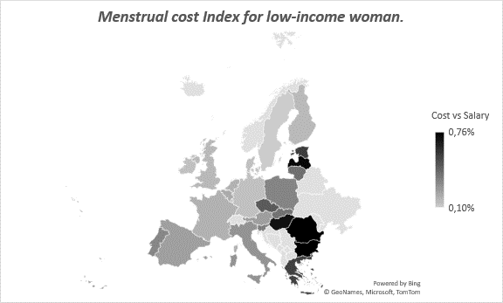

The more expensive the cost compared with minimum salary the darker the color.

**Our winners are Romania, Bulgaria, Latvia, Hungary with an average minimum salary of just 424 €.** We see that in countries with lowest salaries females spend 0.74%-0,76% of their yearly minimum salary while in Sweden it would be only 0,10%.

**Tax CHANGES .**

Since year 2018, 8 member countries in EU have lower their “period” tax but **in 6 of these countries, this rate STILL is over 20%.**

**Tampon shortage and price increases.**

Costs are soaring for components such as plastics, fluff pulp and cotton, leading to price hikes for pads and tampons

The increases are squeezing especially low-income consumers. Unlike with shampoo or razors, though, people with monthly periods can’t easily cut back on consumption or wait for prices to decline.

~Bloomberg By [Daniela Sirtori-Cortina](https://www.bloomberg.com/authors/AUy5-DTjSI4/daniela-sirtoricortina) and [Olivia Rockeman](https://www.bloomberg.com/authors/AUHPm4QPhEg/olivia-rockeman)

June 9, 2022

**What are the alternatives in this sex-based discrimination?**

**Period underwear**. Most pairs can typically last between two and four years needs to be washed after one day of use. In 5 years, you need 4 pairs minimum which would total of 88**€** and that’s without washing cost. Compared to 122€ spent in Poland, they don’t seem to offer that much savings.

**Menstrual cups** are made to last a minimum of five years or more. After use you just need to wash them. In 5 years, you need to one. (~18 **€)**

Summary.

51% of population in European Union consist of females.

Feminine products have the lowest cost of 0,10€ per unit in Poland and the highest cost of 0,20€ per unitin Greece.

Average lifetime period cost in EU is 1352€.

Countries with the highest lifetime period cost were Austria 1694€ with tax at 10%, Greece 1778€ with tax at 10%, Denmark 1819€ with tax at 25%.

Countries with the lowest lifetime period cost are Poland 923€ with tax at 5%, Germany 978€ with tax at 7%, and Slovakia 995€ with tax at 10%.

The costliest periods are in Denmark 1818€, Greece 1778€ and Austria 1694€

We see that in countries with lowest salaries females have the hardest time affording tampons and pads. **Romania, Bulgaria, Latvia, Hungary has the highest *Menstrual cost Index for low-income woman* with average minimum salary of just 424 €, they have to spend 0.71%-0.76% of their salary.**

Since the year 2018, 8 EU member states lowered their “period” tax but in 6 of these countries, this rate STILL is over 20%.

**Menstrual cups** are [most cost-effective period product available](https://global.rubycup.com/collections/all/products/menstrual-cup) on average saving us around 90%.

**Interesting facts.**

On November 24th 2020, Scotland became the first country in the world to provide free pads and tampons.

In the UK, menstrual products are now tax-exempt. (Several countries joined the UK– including Australia, Canada, Colombia, India, Kenya and Rwanda.)

In the year 2021 Croatian government rejects to Lower VAT on Period Products twice. However, Croatia applies a reduced 5 per cent VAT rate on daily newspapers and cinema tickets.