
Lab Number: 12 Date: 2025/08/27
Title:DNS and Web Server Configuration using Packet
Tracer
Theory:
- DNS & Web Server
DNS (Domain Name System): DNS is a system that translates human-readable domain names (like google.com) into numeric IP addresses (such as 192.168.1.1) that computers use to communicate. By converting these domain names into IP addresses, DNS simplifies how users navigate the internet, eliminating the need to remember complex numeric addresses. When a user types a domain name into their browser, DNS works in the background to locate the corresponding IP address, allowing the requested web page to be accessed quickly and easily.

Web Server: A webserver is a computer system responsible for hosting websites and delivering web pages to users upon request. When a user enters a URL or clicks a link, the web server processes the request, retrieves the appropriate files (such as HTML, images, or scripts), and sends them to the user’s browser. Web servers manage these requests through HTTP or HTTPs protocols. They handle both static content (like basic web pages) and dynamic content generated by server-side application. In short, web servers ensure that web content is available and delivered efficiently to users.
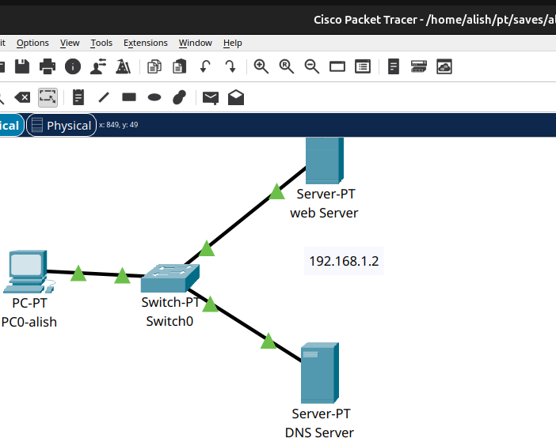
- Network Diagram

Fig: Network Diagram
Implementation Sequence
- Configuring DNS Server and Web Server
Web Server Configuration:
Step 1: Go to the Web Server and click on the Desktop tab.
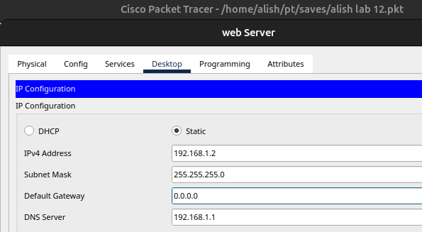
Step 2: Set the IP Address to 192.168.1.2 and the Subnet Mask to 255.255.255.0

Fig: Configuring web server

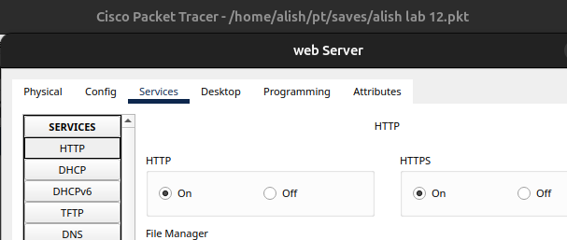
Step 3: Click on the Services tab, then navigate to HTTP and turn it ON.

Fig: Turning ON HTTP

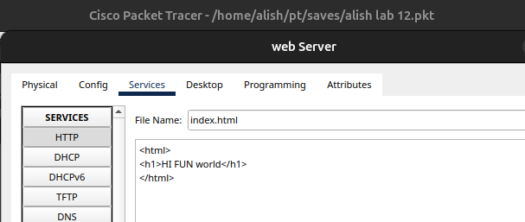
Step 4: And go to index.html, click edit, make the necessary changes to the file, and click Save.

Fig: Configuring index.html file
DNS Server Configuration:
Step 1: Go to the Desktop tab and set the IP Address to 192.168.1.1, the Subnet Mask to 255.255.255.0, and the DNS Server to 192.168.1.1
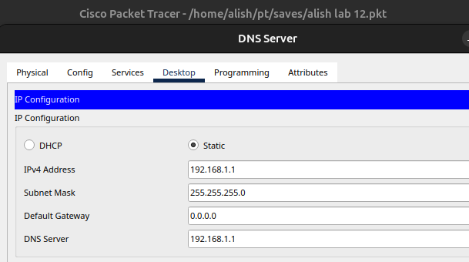

Fig: Configuring DNS server

Step 2: After that go to services and check the DNS Service if on option in not ticked tick it
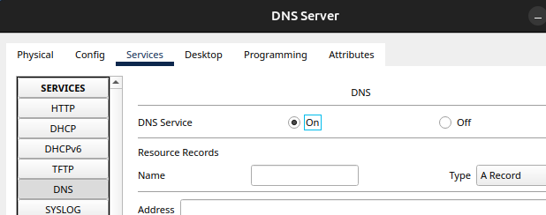
Fig:Service of DNS server

STEP 3: Now, the website we created in web server should name so we name it cisco and insert the ip of our web server 192.168.1.2 and add it
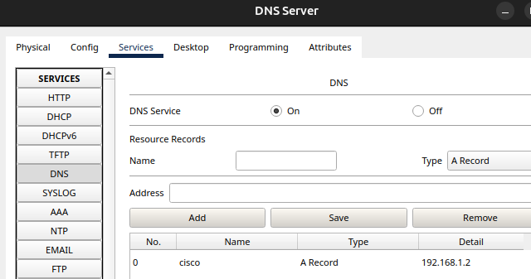
Fig:adding the website name in DNS server
PC Configuration:
Step 1: Go to the PC, then navigate to the Desktop tab.
Step 2: Set the IP Address to 193.168.1.3, the Subnet Mask to 255.255.255.0, and the DNS Server to 193.168.1.2
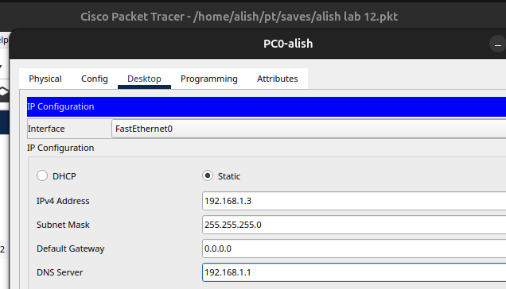

Fig: IP configuration on PC
Step 3:Now, go to web browser option now you can enter the name of the website cisco or the ip address of the web server where the website is
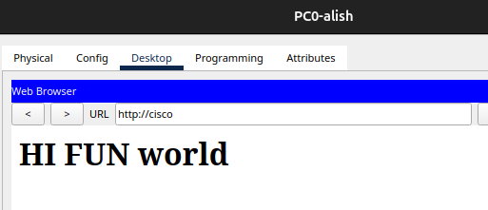
Fig: entering the name of the website
Step 4: Now, check with the ip address to
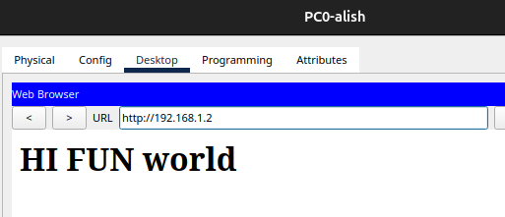
Fig: checking with the ip address of web server

Testing Web Server on PC
Step 1: Go to the Desktop, click on Web Browser, and in the URL tab, enter the IP address of the Web Server, i.e., 193.168.1.2

Fig: Checking WEB server on PC

Web Server in DNS Server Configuration
Step 1: Go to the DNS Server then click on Services, then select DNS.
Step 2: In the Name field, type google.com, enter the IP address of the Web Server in Address field, i.e. 193.168.1.1 then click add and then save.
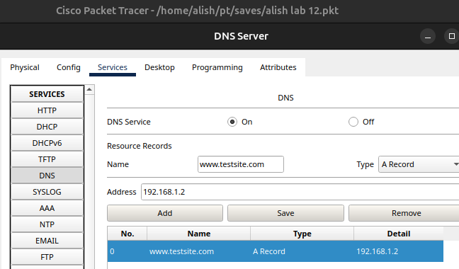

Fig: Adding WEB server on DNS server
Testing Web Server on PC after configuring in DNS
Step 1: Go to the Desktop, click on Web Browser, and in the URL tab, type google.com to access the webpage served by the Web Server.
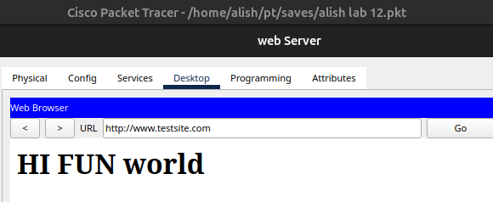
Fig: Checking Web Server after configuration in DNS
From above picture, we can verify that whether we type Name or IP address we will get the same web page.
Addressing Table:
Device | Interface | IPv4 Address | Subnet
Alish | NIC | 192.168.1.3 | 255.255.255.0
Web Server | NIC | 192.168.1.2 | 255.255.255.0
DNS Server | NIC | 192.168.1.1 | 255.255.255.0
The addressing table of this lab is as follows:

Conclusion
In this lab, we demonstrate how DNS simplifies the process of accessing web services by resolving human-readable domain names into machine-friendly IP addresses. The configuration in Packet Tracer illustrates how DNS and web servers can be set up and function together within a network, making it easier for users to access web resources using familiar domain names.

