Module: Cloud Security and Virtualization
- Why do virtual machines (VMs) increase the potential attack surface?
Ans) More computers increase the risk of compromise.
2) Why is it important to secure all virtual machines (VMs) on a hypervisor?
Ans) To prevent privilege escalation and VM escape
What is an example of Infrastructure-as-a-Service (IaaS)?
Ans) A virtual machine (VM)
4) Which two roles are responsible for securing cloud applications? (Choose two.)
Ans ) -Application developer
- Cloud provider
5) What is a common threat to cloud environments?
Ans ) Data loss
6) Which type of proxy sits in front of the protected server and brokers connections before allowing traffic to pass to its destination?
Ans ) Reverse proxy
7) Which three security devices are hosted in the cloud? (Choose three.)
Ans ) A firewall
An email gateway
An antivirus scanner
8) Which two protocols can you use as a single sign-on (SSO) protocol for cloud applications? (Choose two.)
Ans ) -Secure Assertion Markup Language (SAML)
-Open Authorization (OAuth)
9) What is a multi-cloud environment?
Ans ) An environment that has applications hosted on different cloud platforms and vendors.

10) Which two security services can be performed as Security-as-a-Service (SECaaS)? (Choose two.)
Ans ) - Intrusion detection and prevention (IDP)
- Security information and event management (SIEM)
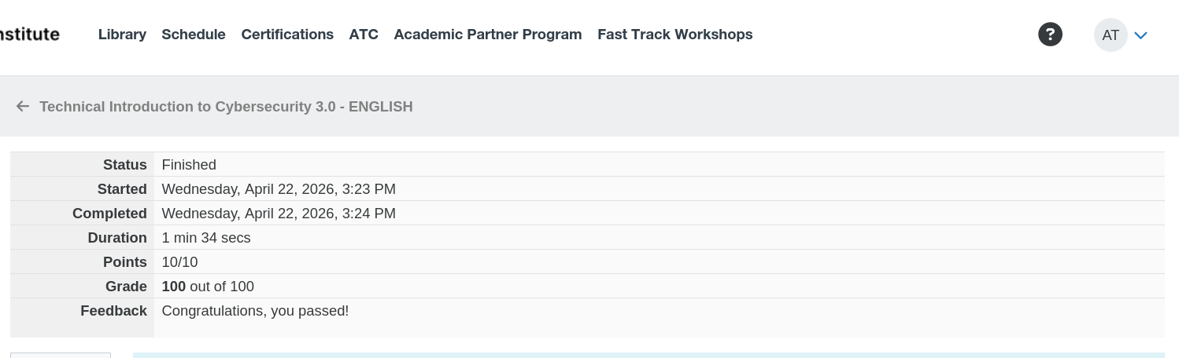
Alish

