Module 2 : Secure Network
- Why knowing the source IPs of an attack may not be relevant? (Choose two.)
Ans ) - Attackers can use botnets.
- Source IPs can be spoofed.
2) Which network is enclosed by the security perimeter?
Ans ) The trusted network
3) A security architect would like to add in a network a device able to understand the application layers protocols. Which device should be added?
Ans ) A Next Generation FireWall (NGFW)
4) What was missing in the early sandbox generation? (Choose two.)
Ans ) -An integration with other security devices
- Automation and artificial intelligence
5) Which principles are part of the Zero-Trust security model? (Choose two.)
Ans) - Assume that your network is breached
- Implement least privilege

6) Which challenges brought the evolution from a network model with a single, dedicated service provider to Software Defined Wide Area Network (SD-WAN)? (Choose two.)
Ans ) - Demand for more cloud applications and services
- Reliability
7) Which implementation should be done by a security architect to limit network threats in a network? (Choose two.)
Ans) - Zero trust
- Network segmentation
8) What does Secure Multipurpose Internet Mail Extensions (S/MIME) bring over MIME? (Choose two.)
Ans )- Authentication with digital signature
- Confidentiality with encryption
9) View the following exhibit:
What will be at least checked by the firewall upon receiving the server reply packet?
Ans )The packet five-tuple
10) A network architect must implement security in a network including Internet of Things (IoT), Bring your own Device (ByoD), and cloud-based workstations. Which model should the architect put in place?
Ans ) - Security perimeter
-Zero trust
11) What are two core capabilities of Secure Access Service Edge (SASE)? (Choose two.)
Ans ) - Zero-Trust network access
- Data loss prevention
12) Why may a security architect add a sandbox in a network? (Choose two.)
Ans) - To detect zero day attacks
- To share threat intelligence with other security devices
13 ) What are objectives of Software Defined Wide Area Network (SD-WAN)? (Choose two.)
Ans ) - Greater reliability
- Lower latency

14) How can a security architect segment a network? (Choose two.)
Ans ) - Through Virtual Local Area Networks (VLANs)
- Through Software Defined Wide Area Network (SD-WAN)

15 ) Which type of attack is handled only by the latest sandbox generation?
Ans ) AI-driven attacks

16) How could the traffic be filtered at the security perimeter? (Choose two.)
Ans ) - By acting as an application layer gateway
- By performing packet filtering at transport layer
17) What does Secure Access Service Edge (SASE) offer to remote off-net users compared to on-net?
Ans ) The same security policies no matter their location
18) How can a security engineer secure switching and ports?
Ans ) By configuring static or sticky Media Access Control (MAC) address entries in the Content Addressable Memory (CAM) table
19) Why should a user prefer a security protocol over a non secured one?
Ans) It adds confidentiality.
20) What are the benefits for a bank in taking a Next Generation FireWall (NGFW) to secure its network? (Choose two.)
Ans ) - Further analysis can be performed with a sandbox.
- Malicious content is checked through Deep Packet Inspection (DPI).
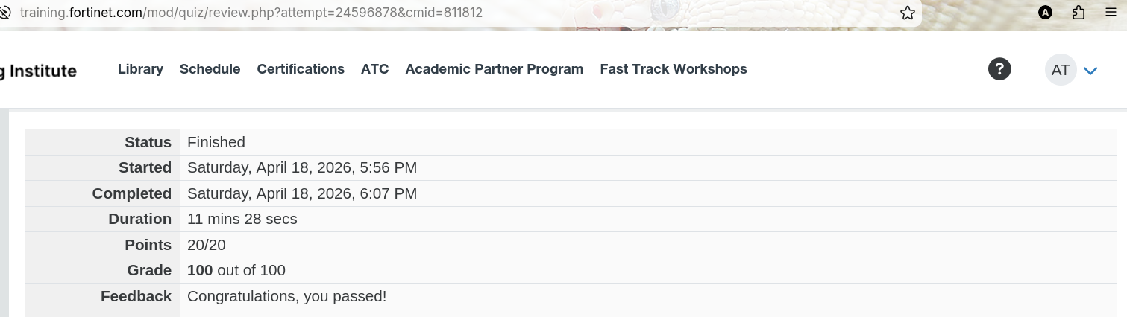
-ALISH

