Module: Secure Remote Access
- Which two security features can be implemented by IPsec VPN? (Choose two.)
Ans ) -Packet authentication
- Packet encryption
2) Which statement best describes the zero trust approach that is the basis for ZTNA design?
Ans ) Nothing can be trusted inside or outside the network.
3) Which characteristic differentiates ZTNA from VPN?
Ans ) The zero trust concept
4) Which characteristic differentiates SSL VPN from IPsec VPN and ZTNA?
Ans ) SSL VPN does not require specialized client software.
5) In SSL VPN, what is used to authenticate the web server to the browser?
Ans )The web server’s digital certificate
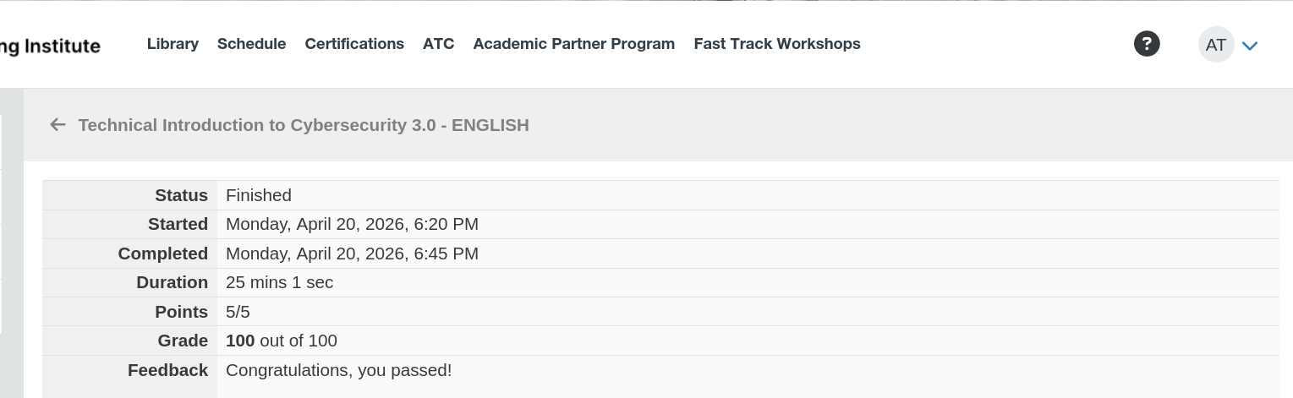
-ALISH

