Module 1 : Cryptography and Public Key
- What ingredient is added during the BCRYPT key stretching process to increase entropy?
Ans) - Salt
2) Which security requirement does encryption satisfy?
Ans . Confidentiality
3) Identify three cipher method types. (Choose three.)
Ans ) -One-time pad
-Substitution
- Transpositional

4) Which statement best describes cryptography?
Ans ) The study of writing or solving codes
5) Which statement best describes encryption?
Ans ) The process of converting plaintext to ciphertext
6) Which two features are characteristics of hashing? (Choose two.)
Ans ) - Non-reversible process
- Fixed-length output value
7) Which cipher type is used by computers to encrypt data?
Ans ) Stream
8) Identify two symmetric algorithms. (Choose two.)
Ans ) - IDEA
- AES
9) In a PKI, what is the ultimate source of trust?
Ans )The private key of the root CA
10) During the encryption process, where symmetric and asymmetric cryptography are used, which key is used to encrypt the session (symmetric) key?
Ans ) The receiver’s public key
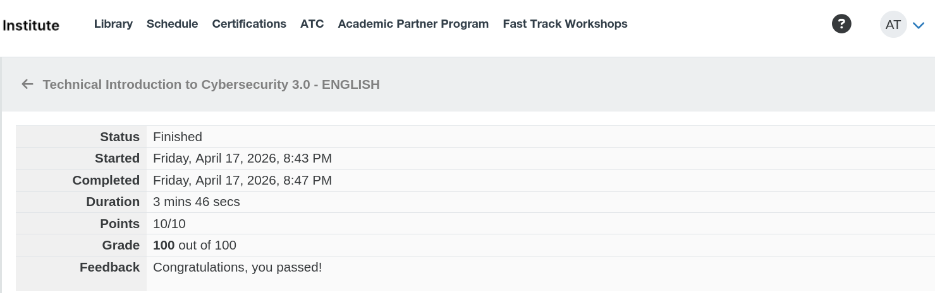
- Alish

