Module 3: Authentication and Access Control
- What does a NAC use to identify attached devices and allow access?
Ans) Device profile
2) Which protocol can perform SSO?
Ans) Kerberos
3) Which two are performed by the supplicant in 802.1x authentication? (Choose two.)
Ans)- Connecting to a network
- Providing identity
4) Which two are the responsibilities of an authentication governing body? (Choose two.)
Ans) - Creating disaster recovery policies
- Reviewing the password strength policy
5) In SSO authentication, which two entities know the unhashed credentials? (Choose two.)
Ans) - Identity provider
- User

6) Which one makes the allow or deny decision in the authentication process?
Ans) Authentication server

7) Which is an example of a possession-based authentication method?
Ans) Texting a one-time code through SMS
8)Which two are aspects of the principle of least privilege? (Choose two.)
Ans) -Allowing only what users and devices need
- Reducing error by minimizing access
9) Which two should be selected to create secure multi-factor authentication to access a computer system? (Choose two.)
Ans) - Password
-Smart Card

10) Which type of access control scheme does a NAC apply?
Ans ) Attribute-based access control
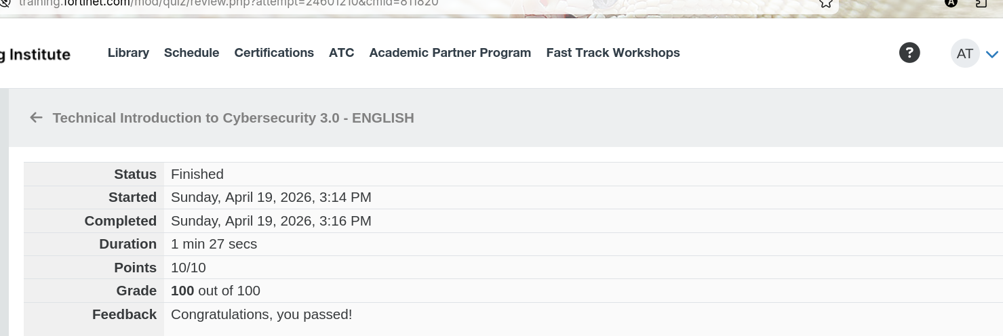
-Alish

