Theory
A VLAN is a logical grouping of devices within a physical network, created to segment network traffic for better performance, security, and management. Devices in the same VLAN can communicate as if they were on the same physical LAN, regardless of their actual location. VLANs are configured on switches using VLAN IDs and help reduce broadcast domains, improve network efficiency, and enhance security by isolating traffic.
VLAN Trunking
VLAN trunking is a technique used to carry traffic from multiple VLANs across a single network link between switches or between a switch and a router. Instead of creating separate physical connections for each VLAN, trunking allows one link to transport multiple VLANs using tags (like IEEE 802.1Q). This helps in efficient use of network resources and enables communication between devices in different VLANs while keeping their traffic logically separated.
VLAN Architecture
VLAN architecture defines how devices are logically segmented within a network to improve performance, security, and management. It consists of:
- End Devices: Computers, printers, and other network devices assigned to a specific VLAN.
- Access Layer Switches: Connect end devices and assign them to VLANs via access ports.
- Trunk Links: Carry traffic from multiple VLANs between switches or to routers.
- Router or Layer 3 Switch: Enables communication between VLANs (inter-VLAN routing).
- VLAN IDs: Unique identifiers (1–4094) used to tag frames and distinguish VLAN traffic.
This architecture ensures that devices in the same VLAN communicate as if they are on the same physical network, while isolating traffic between different VLANs.

Component Used
Hardware: Switches (2), Ethernet Cables, End Devices (4)
Software: Cisco Packet Tracer
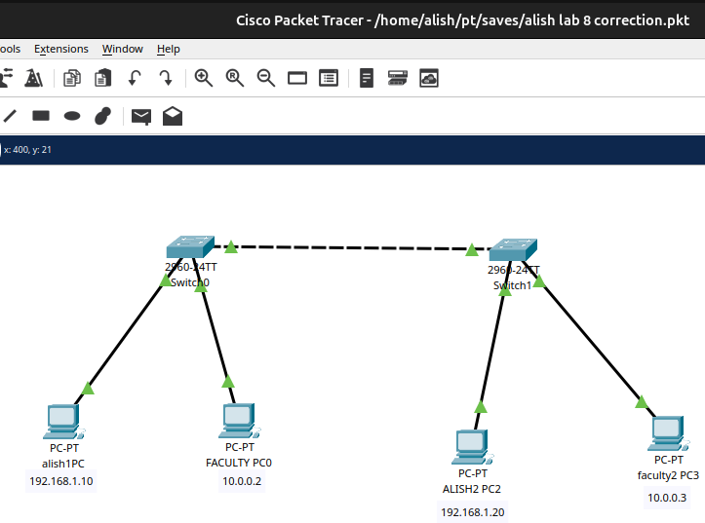
Figure: Network Map for VLAN
Procedure
The procedure for creating the LAN network using Cisco Packet Tracer is shown in the image:
Step 1: Launch Cisco Packet Tracer
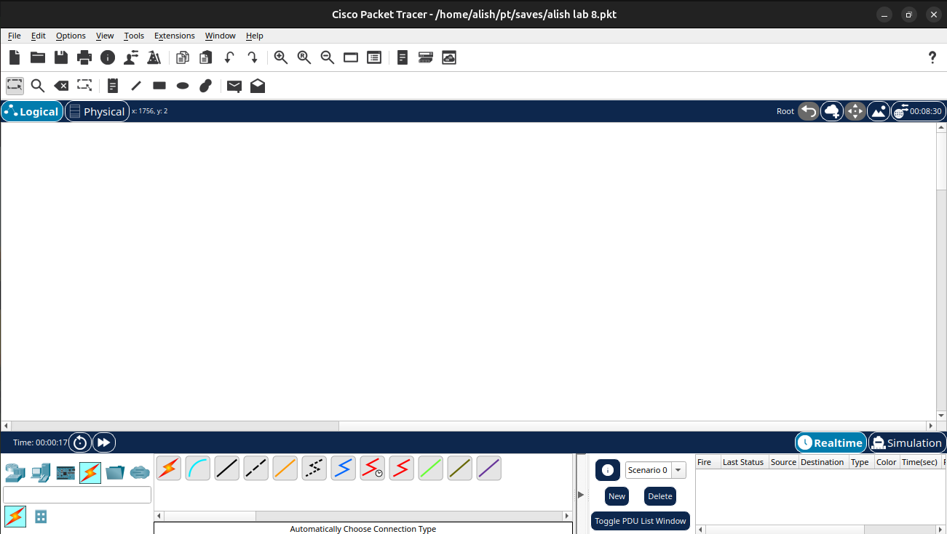
Figure: Workspace for Network Design

Step 2: Add the network devices to the workspace
2.1 From the Device-Type Selection box, choose the following devices and add them to the workspace:
2.2 One 2960-24TT Switch
2.3 Four PCs (labeled PC0, PC1, PC2 and PC3)
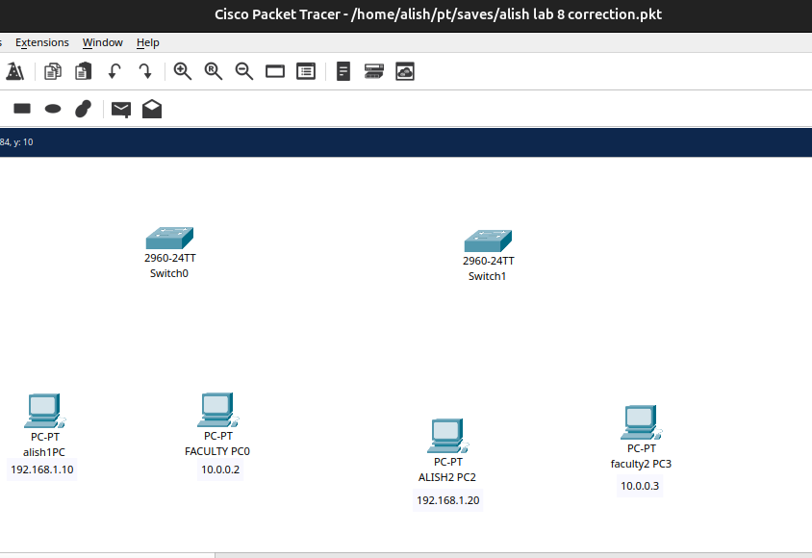
Figure: Switches and PC’s for VLAN
Step 3: Connect the devices
3.1 Use the copper straight-through cable to connect each PC to one of the available ports on the switch.
3.2 Ensure that each connection is made properly
Figure: Connection between Switches and PC’s
Step 4: Configure IP address
4.1 Right-click on each PC and select “IP Configuration”.
4.2 In the IP Configuration window, enter the IP address as (192.168.1.10) and 10.0.0.2) for swich0 connected with Alish1 and Faculty1 and for Switch1(192.168.1.20,10.0.0.3) for its Alish2 and Faculty2 , subnet mask and default gateway for each PC.
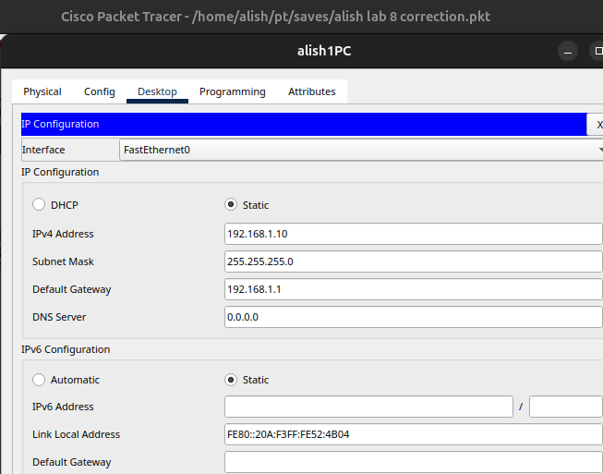
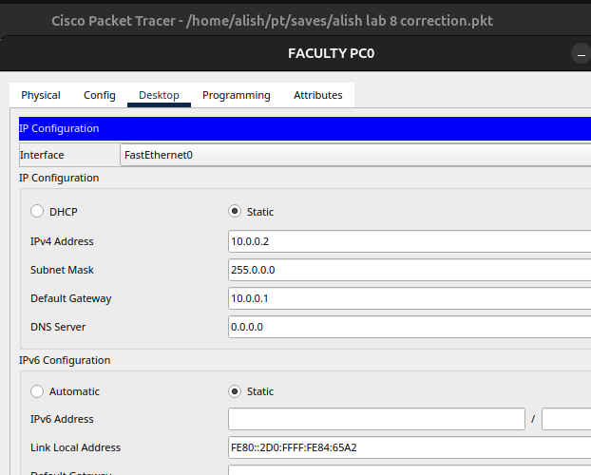
Figure: IP Configuration
Figure: IP Configuration

Step 5: Configuring VLANs
5.1 Create VLAN on both Switches & assign Port to both switches.
5.2 Create trunkation in the both switches.

Code for VLAN Configurations:
Switch>en
Switch#config t
Switch(config)#vlan 10
Switch(config-vlan)#name Alish1
Switch(config-vlan)#vlan 20
Switch(config-vlan)#name Faculty1
Switch(config-vlan)#exit
Switch(config)#exit

Code for Assigning ports:
Switch#config t
Switch(config) #int fa 0/1
Switch(config-if) #switchport mode access
Switch(config-if) #switchport access vlan 10
Switch(config-if) #int fa 0/2
Switch(config-if) #switchport access vlan 20
Switch(config-if) #exit
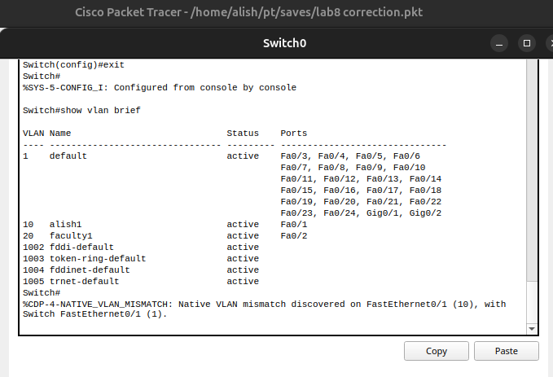
Switch(config)#exit

Assigning port to VLAN in Switch0

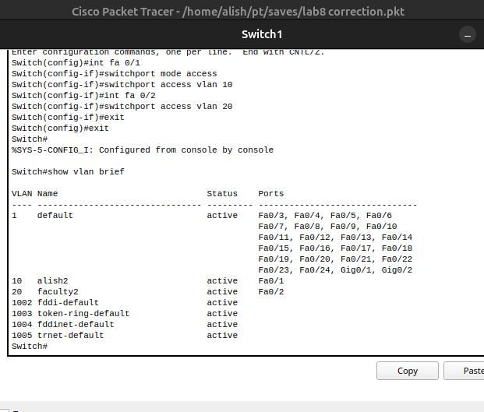

Assigning port on VLAN on Switch 1

Code for Trunking Switches:
Switch#config t
Switch(config) #int fa 0/3
Switch(config-if) #switchport mode trunk
Switch(config-if) #exit
Switch(config) #exit
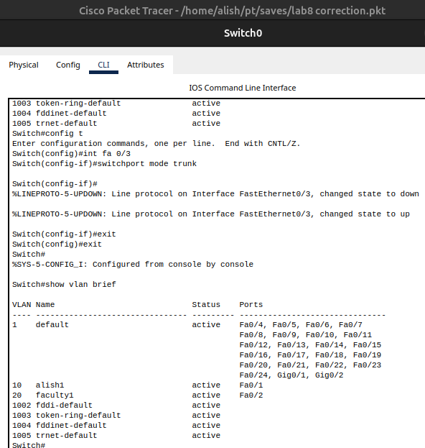

Figure:Configuring trunking between switches

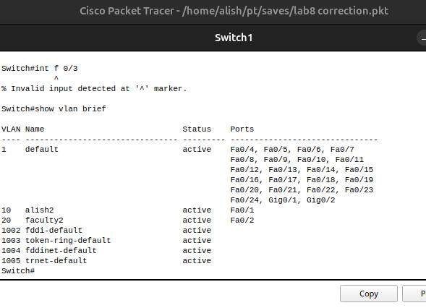
Figure: Configuring trunking between switches

6: Testing and Validation
6.1 Use the ping command from each PC to check network connectivity.
6.2 Open Command Prompt and type ping < IP address of another PC >.
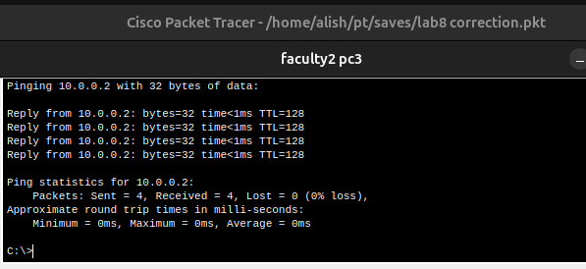
6.3 If replies are received, the connection is successful.
Figure: Connectivity test between network Faculty2 10.0.0.2 and Faculty1 10.0.0.1
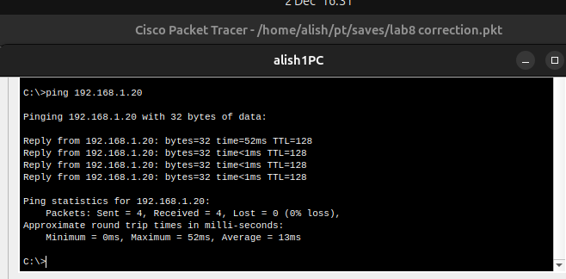
Figure: Connectivity test between network Alish1 192.168.1.10 and Alish2 192.168.1.12
6.4 We can’t ping Alish1 and Faculty1 as VLAN10 (Alish) and VLAN 20 (Faculty1)
As are in separate VLANS
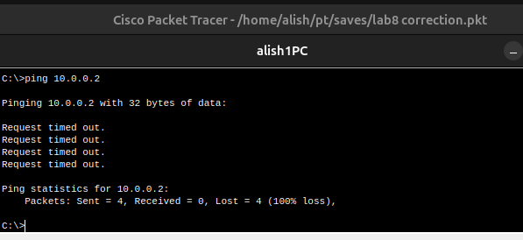
Figure:Connectivity failure between Alish1(192.168.10) and Faculty1
(10.0.0.2)

Addressing Table:
Device | Interface | IPv4 Address | Subnet mask | Switch port | VLAN | VLAN  NO. | Link
Alish1 | NIC | 192.168.1.10 | 255.255.255.0 | Switch 0 fa0/1 | 10 | Alish1 | Access
Alish2 | NIC | 192.168.1.20 | 255.255.255.0 | Switch 0 fa0/1 | 10 | Alish2 | Access
Faculty 1 | NIC | 10.0.0.2 | 255.0.0.0 | Switch 0 fa0/2 | 20 | Faculty 1 | Access
Faculty 2 | NIC | 10.0.0.3 | 255.0.0.0 | Switch 0 fa0/2 | 20 | Faculty 2 | Access

Conclusion
In this lab, VLANs were successfully configured to logically segment a network using Cisco Packet Tracer. Access ports were assigned to specific VLANs, and trunk links were set up to allow multiple VLANs to communicate across switches. The lab demonstrated how VLANs improve network management, enhance security, and reduce broadcast traffic. Overall, the experiment reinforced the understanding of VLAN architecture, trunking, and inter-VLAN communication.

