Introduction
Based on the digital evidence gathered and analyzed through the "Autopsy" program, it has been revealed that two individuals, Bob Hunter and Billy Ray, engaged in monitoring and surveillance of two girls. They surreptitiously took photographs of the girls, subsequently planning to abduct them with the intention of leveraging their fathers for ransom. Furthermore, the duo collaborated to create a website, where they posted the pictures of the targeted girls and initiated communication with their respective parents.
The investigation, conducted on the Hunter XP for Dongled v6.E01 image, focused on a single computer system comprising three volumes. The primary goal was to uncover evidence regarding the device's involvement in the initiation of criminal activities.
Alish Mahat, the author of the report, meticulously detailed the findings, exposing the owner of the device's potential connection to extortion and stalking activities. The report also highlighted possible associations with criminal endeavors. Notably, it was deduced from the collected information on the device and emails that the two females involved are Christina and Sabrina. The names and messages indicated that Sabrina's father is Ted Dewercs, while Christina's father is John Detsiwt. Additionally, it was revealed that the perpetrators initially misidentified Christina as Kim.

Evidence Summary
On 13/12/2023, an examination was conducted on the evidence item Hunter XP for Dongled v6.E01. The hash (dfcfe9ab9a60c6ad4a314656b687226b) confirmed the integrity of the evidence, indicating no tampering throughout the investigation.
The investigation revealed information linked to the use of the device for storing images of victims captured in situations where they were unaware of being photographed. Recovery of deleted directories and CD-burning data provided insights into this aspect. Analysis of User directories, Registry Keys, Internet history, and social media accounts pointed towards the predominant use of the device by an individual named Bob Hunter.
Additionally, the evidence hard drive contained email exchanges between Mr. Bob Hunter and Mr. John Dewsit and Mr. Ted Dewercs, involving demands for payment. Emails between Mr. Bob and accomplices with usernames billyray150 and chaser1191 provided key information about the committed crime.
Furthermore, examination of Internet history and cache unveiled evidence indicating an interest in purchasing anti-forensics tools such as BestWipe and BestCrypt for secure data wiping and encryption.

Examination Summary
Autopsy (V 4.20.0 RELEASE), an open-source forensics examination platform, and AccessData FTK Imager 4.7.1.2, a versatile imager and extraction tool, and RegRipper 3.0, a command-line tool for Windows registry analysis, were used for the examination. These tools were chosen for their widespread acceptance in the digital forensics’ community.
The examination focused on data of interest, including emails, internet messaging, local cache, and user-created content like images and text files. Logical file system analysis in Autopsy was utilized to explore any file extension mismatches, hidden content, and the recovery of deleted files. Files not viewable within the Autopsy platform were extracted and reviewed using external tools compatible with the data format.

File System Examination Summary:
SAM File (/WINDOWS/system32/config/SAM):
There are five user accounts: Bob Hunter, Administrator, Guest, HelpAssistant, and SUPPORT_388945a0.
Bob Hunter accessed the system, and no login failures were found. The Guest account's last login details were not provided.
System File (/WINDOWS/system32/config/System):
The system runs Microsoft Windows XP with build 1.511.1, installed on February 28, 2002, at 10:02:39 PM. The time zone is set to Central Standard Time GMT +00 UTC
Case Relevant Findings:
Images:
A directory named "Hunter Pics" in /Documents and Settings/Bob Hunter/Local Settings/Application Data/Microsoft/CD Burning/ contains sub-directories for Christina Detswit and Sabrina Dewercs. These directories hold images capturing subjects in situations where they may be unaware of being photographed.
Emails:
Outlook records "Outbox.dbx," "Billy.dbx," "Hotmail- Bank Information.dbx," and "Inbox.dbx" reveal detailed conversations. Notably, an email exchange between billyray150@hotmail.com and chaser1191@hotmail.com includes the exchange of aforementioned images. Subsequent exchanges involve ted.dewercs@encase.com and john.detsiwt@encase.com regarding payment demands.
Internet Messaging:
The directory /Program Files/America Online 7.0/download/ contains logs of AOL messenger communications (Hunter.log) between usernames Chaser1191 and Billy Ray 0001 discussing matters related to "contacting family" and "scaring up some good amount of $$$." Another file (Special Interests -Tech Chat.log) indicates Chaser1991's inquiry about secure wiping utilities.
Print Artifacts:
Under /WINDOWS/system32/spool/PRINTERS/ are spool files. Notably, the file 00011.SPL shows registration for Xdrive, while 00018.SPL involves an email sent to john.detsiwt@encase.com. File 00020.SPL suggests initiation of a printing job for a website related to a secure wiping tool.
Miscellaneous Artifacts:
A file named todo.bak under RECYCLER/S-1-5-21-1229272821-1580818891-854245398-1004/Df1040/HunterB/todo/ suggests an agenda, including sending information to Billyray and setting up a bank account.
RECYCLER/S-1-5-21-1229272821-1580818891-854245398-1004/Df1040/HunterB/memopad/memopad.bak contains social media usernames and passwords for chaser1191 and bob_hunter1191. A text snippet indicates future plans related to the victims and a proposed ransom of $500,000. These findings provide crucial insights into the user activities on the system, revealing potential criminal activities involving stalking, extortion, and planned kidnapping.

Summary of Findings:
Ownership and User Activities:
The device belongs to Bob Hunter. Social media accounts, email exchanges, and memo texts on the device point to Bob Hunter's active involvement in planning and executing the tracking and photographing of Christina Detswit and Sabrina Dewercs without their knowledge.
Criminal Intentions:
Bob Hunter and accomplice Billy engaged in tracking, following, and photographing Christina and Sabrina. Plans for the abduction of the two girls were discovered, indicating a premeditated criminal activity. The suspects worked on gathering information about the victims and collecting compromising photos, with the intent of blackmailing their respective fathers.
Extortion Attempts:
Email exchanges found on the device reveal demands for monetary payments, with targets identified as ted.dewercs@encase.com and john.detsiwt@encase.com. Mr. John Detsiwt, father of Christina, and friend of Mr. Ted Dewercs (father of Sabrina), were specifically mentioned in the communication.
Use of Anti-Forensic Tools:
Suggestions of an attempt to use anti-forensic tools by Bob Hunter were found in his Internet history and print records. Specific tools mentioned include BestWipe and BestCrypt, indicating an effort to secure wiping of data and encryption to evade forensic scrutiny.
In conclusion, the digital evidence suggests that Bob Hunter and his accomplice, Billy, engaged in a series of criminal activities involving stalking, surveillance, and extortion. The victims, Christina Detswit and Sabrina Dewercs, were targeted for abduction, with the intention of using compromising photos to blackmail their fathers. The investigation has uncovered a comprehensive trail of evidence, linking the suspects to the planning and execution of these illicit activities.

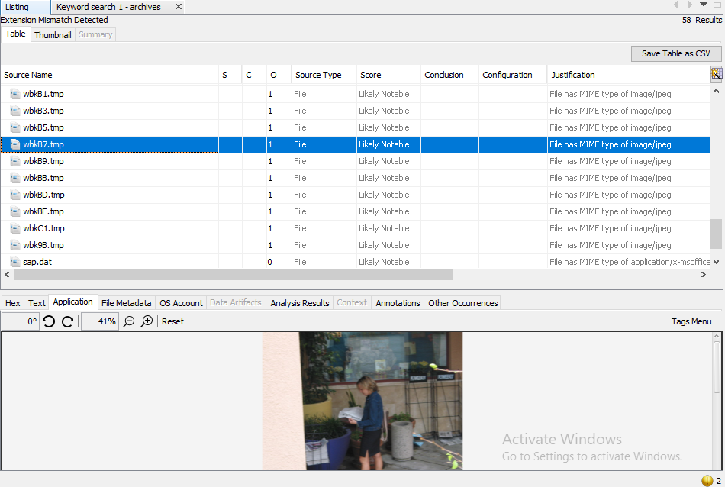
Some Evidences related to victim found in the PC
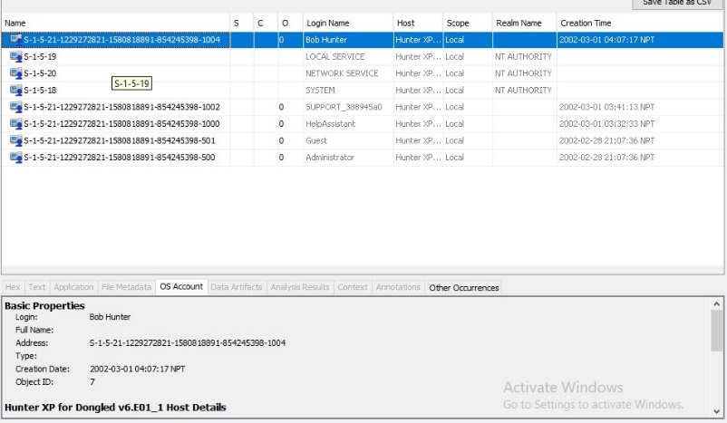
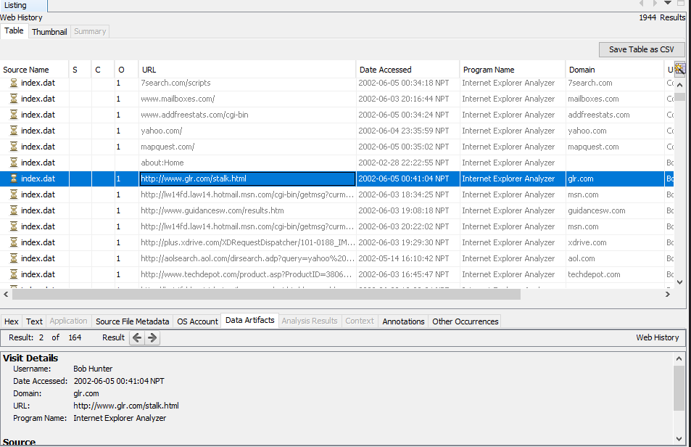
Number of users in the Pc
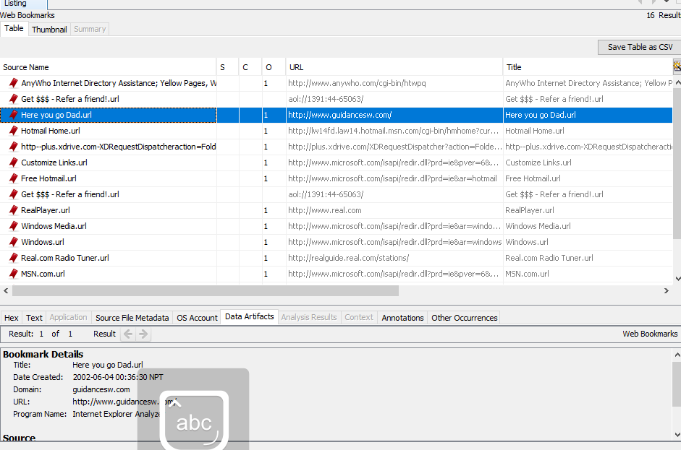

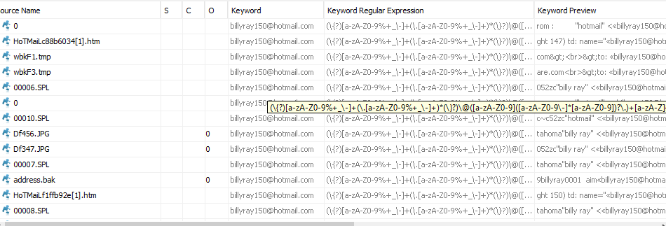
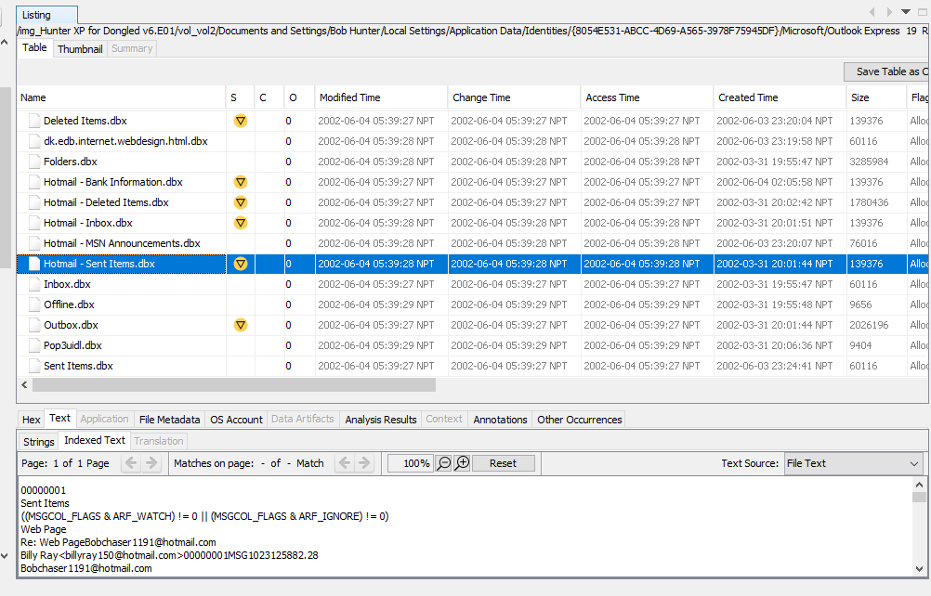

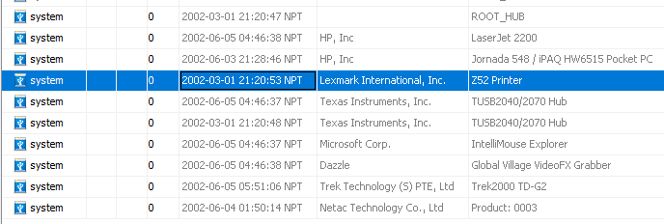
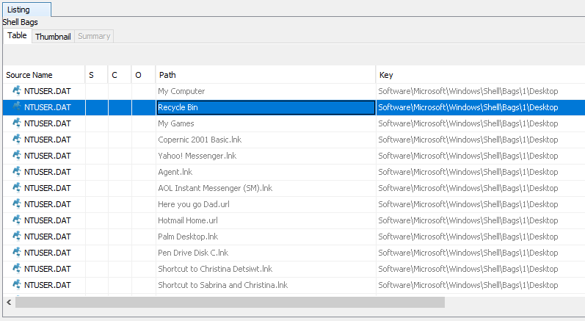

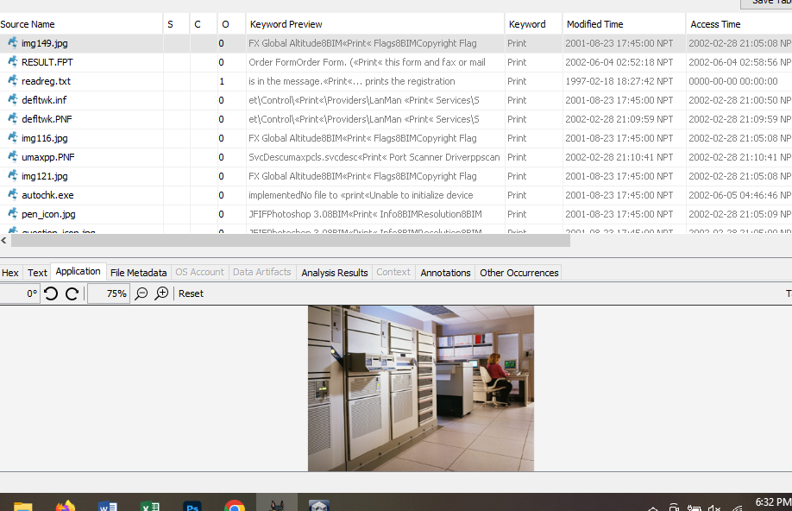
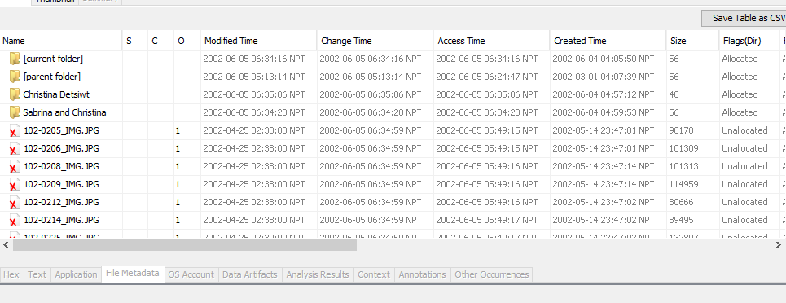

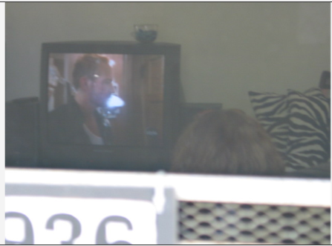
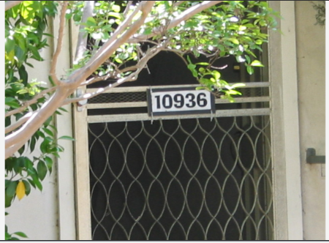
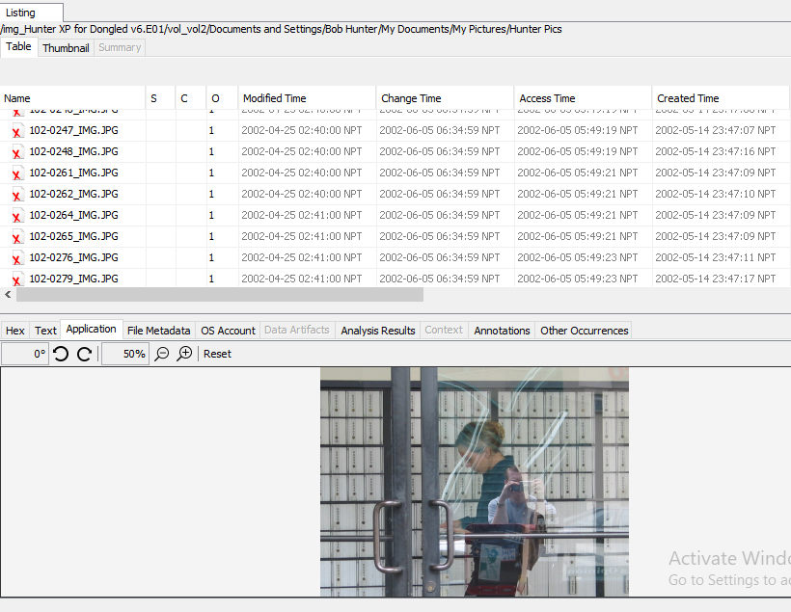

Picture found in the pc with the house number

As a person can be seen taking picture of victim without concern
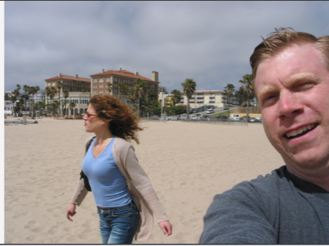
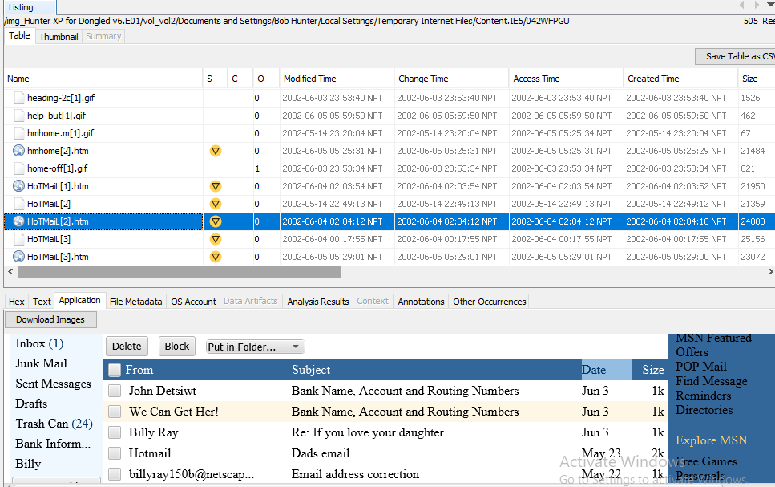

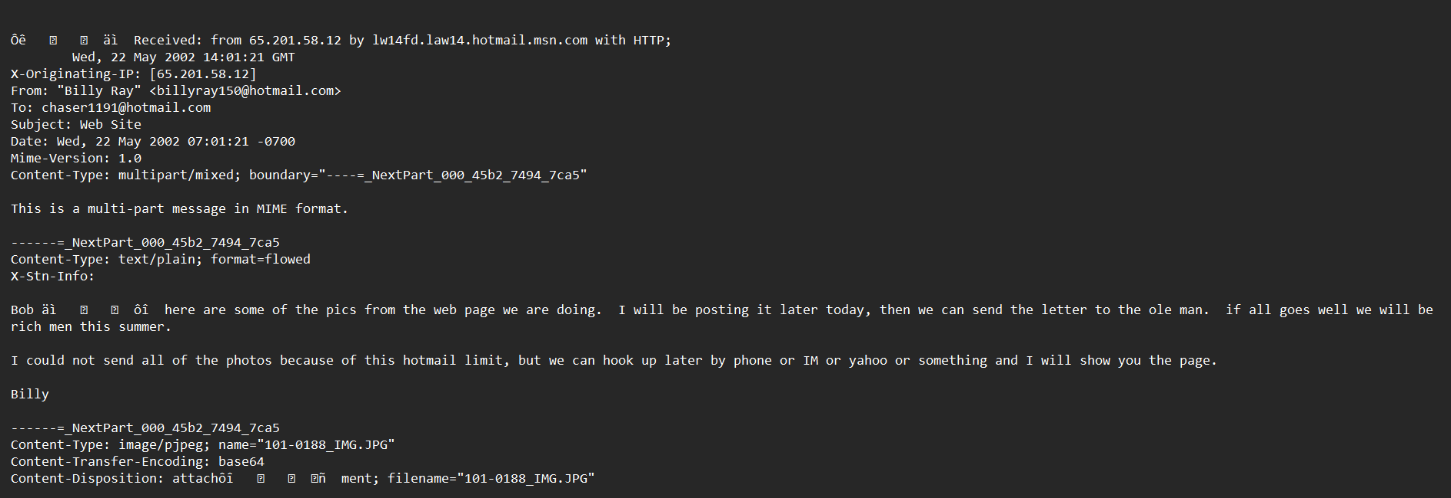

Photographs of the victim discovered on the user's computer.

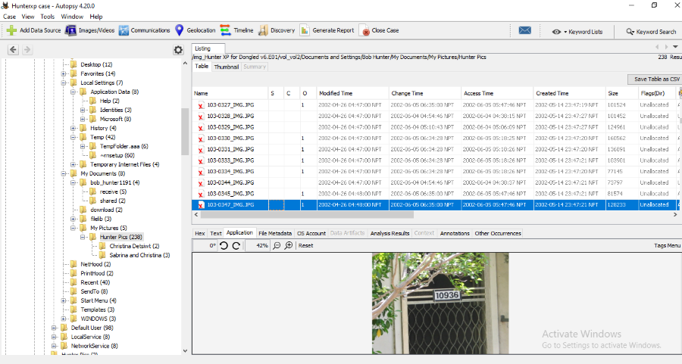


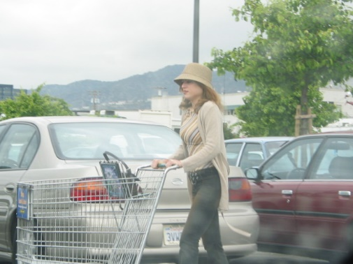




Conversation where they have confessed that they have taken the photos of victim
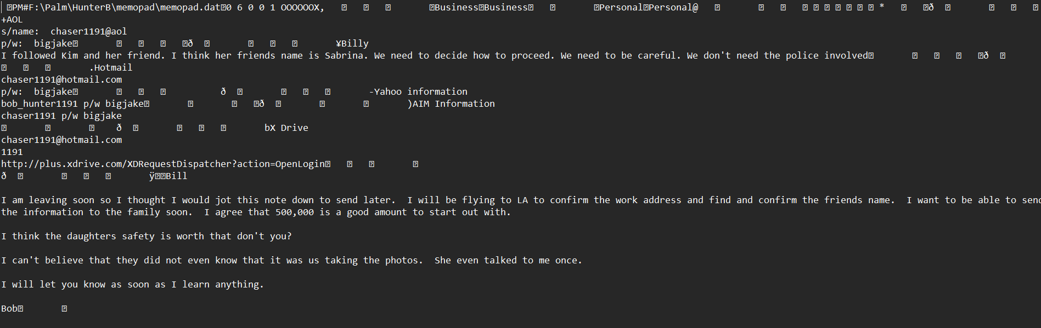
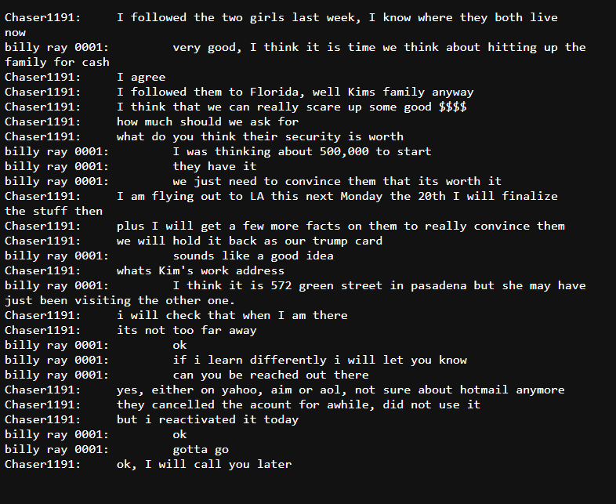

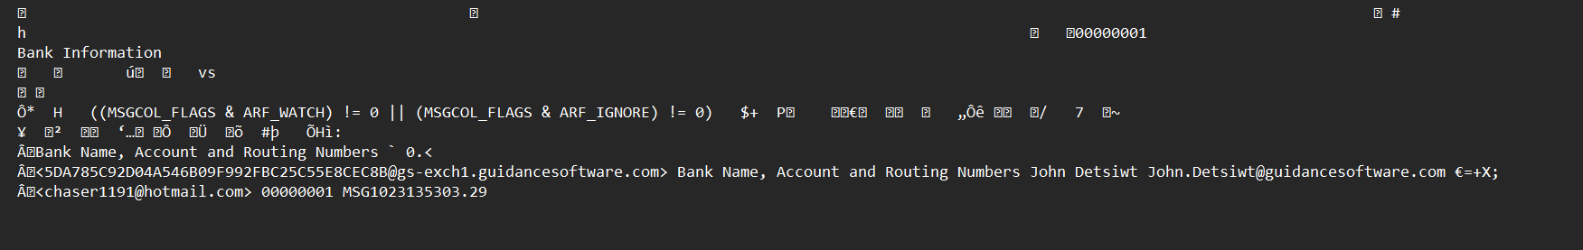

Indications of a user attempting to eliminate data from computer.
