Digital Forensic Investigation Report
Investigator: Alish Mahat (23000965)
Date/Time of investigation: 30 December 2025
Place: Kathmandu, Nepal
Case: Political Defamation and Harassment - Case 1

Contents
Contents 2
Investigator Details 3
Summary 3
Evidence Investigated 3
Software Utilised 3
Forensic Analysis 4
Relevant Findings 5
Forensic Examiner’s Conclusion 5
Appendices 8

Investigator Details
- Investigator: Alish Mahat
- Qualifications: Currently studying BSc (Hons) Cybersecurity and Digital Forensics
- Experience: Skilled in using forensic tools such as Autopsy, FTK Imager, and Regripper to conduct digital forensic investigations.

Summary
This report records the outcome of a digital forensic examination performed on a Windows XP forensic image (E01 format) that is associated with the suspect, Rahul. The examination was triggered by suspicions that the suspect prepared and created politically defamatory meme-based content about Manoj Oli, a political candidate for the Jhapa constituency in the upcoming 2082 elections.
The scope of the investigation was on identifying artefacts which show intent, preparation, creation and concealing of defamatory content. The analysis showed multiple digital artefacts, such as planning documents, image files, scripts, encrypted containers and artefacts on the systems, which together suggest deliberate and methodical behaviour. Evidence of concealment through encryption, file renaming and alternate data streams and deletion was also found.

Evidence Investigated
The examination dealt with a variety of evidential artefacts grouped into the following categories:
- Planning and intent artefacts (text documents, search-related files, archives)
- Memes creation and image content artefacts
- Concealment, anti forensic artefacts (encryption, scripts, password storage)
- Supporting system artefacts (USB activity, deleted files, data recovered)
All the evidence was reviewed from a verified forensic image and data integrity was preserved throughout the investigation.

Software Utilised
- Autopsy (v4.21.0): Used as the main forensic analysis platform for file system analysis, timeline examination, deleted file recovery, keyword search, and encryption detection.
- AccessData FTK Imager (v3.1.2.0): Used to check image integrity, to preview files and for secondary validation of key artefacts.
- RegRipper (v4.0): Used to analyse extracted Windows registry hives to find system and user related activity.
- VeraCrypt(v1.25.9): Used for identifying and mounting encrypted container files that have been found during analysis.
- 7zip(v25.01): used to extract the zip files.

Forensic Analysis
The forensic image was then loaded into Autopsy and its integrity was verified by using cryptographic hash values. The system time zone was verified before analysis in order to ensure correct interpretation of timestamps.
The structured examination was carried out and started with user directories and system folders analysis. Registry artefacts were analysed to establish user activity and system configuration. Keyword searches relevant to the investigation were done and file signature analysis was used to identify renamed or disguised files.
Deleted files were analyzed using recycle bin and data carving. High entropy files were discovered and evaluated for encryption to discover and mount an encrypted container in VeraCrypt. Script files and compressed archives were also examined with the aim of establishing their relevance to the case.

Relevant Findings
Theme 1: Planning to Defame
A text document called Goal.txt was found in the suspect's personal documents. The content of this file set out explicit goal to create memes targeting Manoj Oli, suggesting that there was clear intent rather than accidental or passive behaviour. This document gives direct insight to the suspect's motivation, planning.
Additional supporting artefact included files relating to internet search activity relating to meme creation and political figures as well as a compressed archive (backup.zip) containing preparatory materials. Collectively, these artefacts show that there was deliberate planning and research before the creation of the defamatory content.
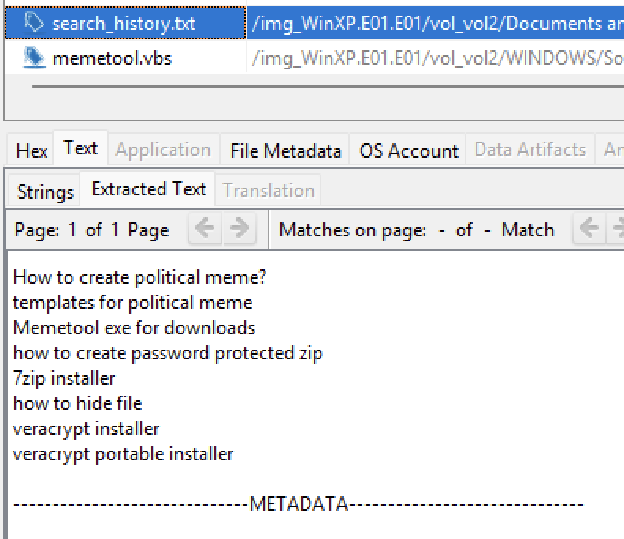
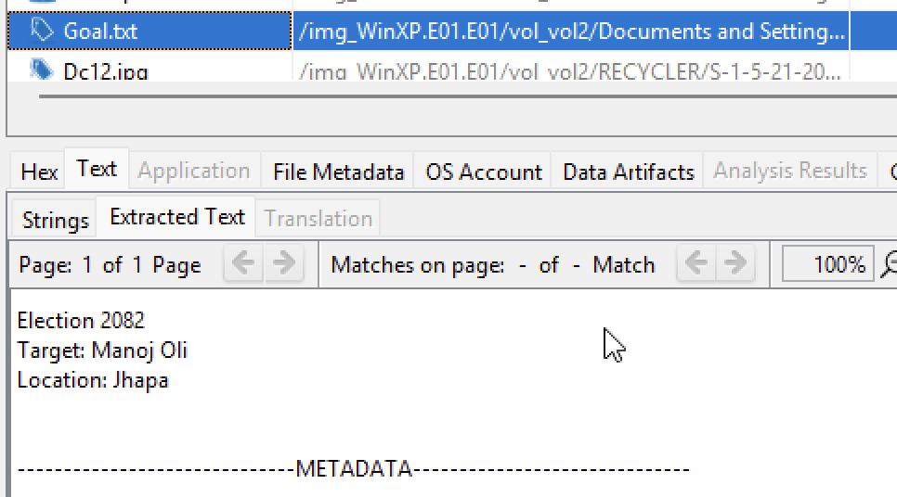
Figure 1: Goal.txt
Figure 2: search artifacts

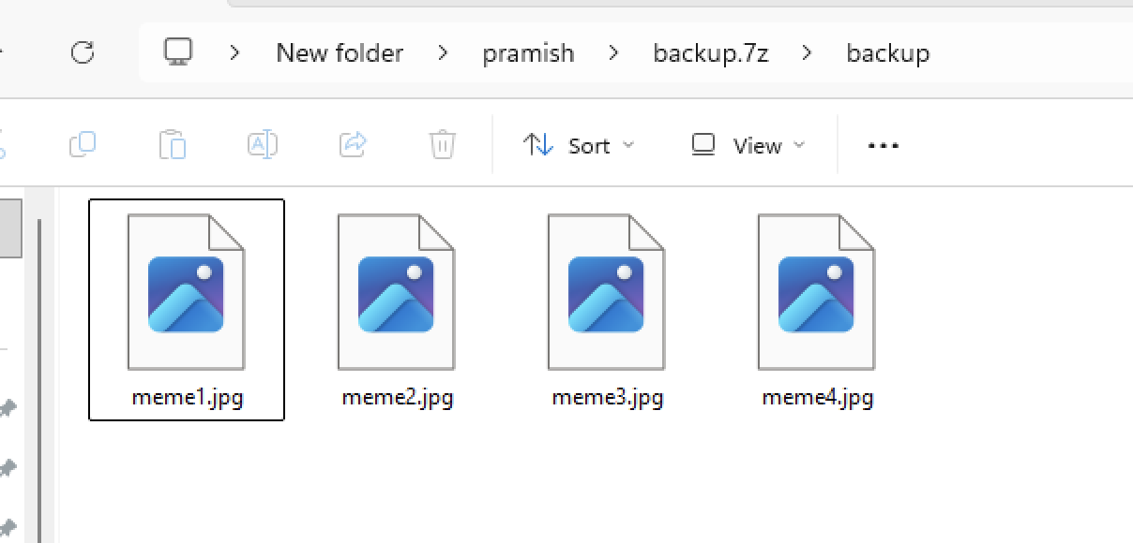

Figure 3: backup.zip contents

Theme 2 Meme Creation and Targeted Content
Several image files containing meme-based content were recovered during the examination. These images showed content aimed specifically at Manoj Oli, and thus also in line with the allegation of political defamation. One meme image (meme2.jpg) was in an accessible system directory, suggesting that it is ready for use or distribution.
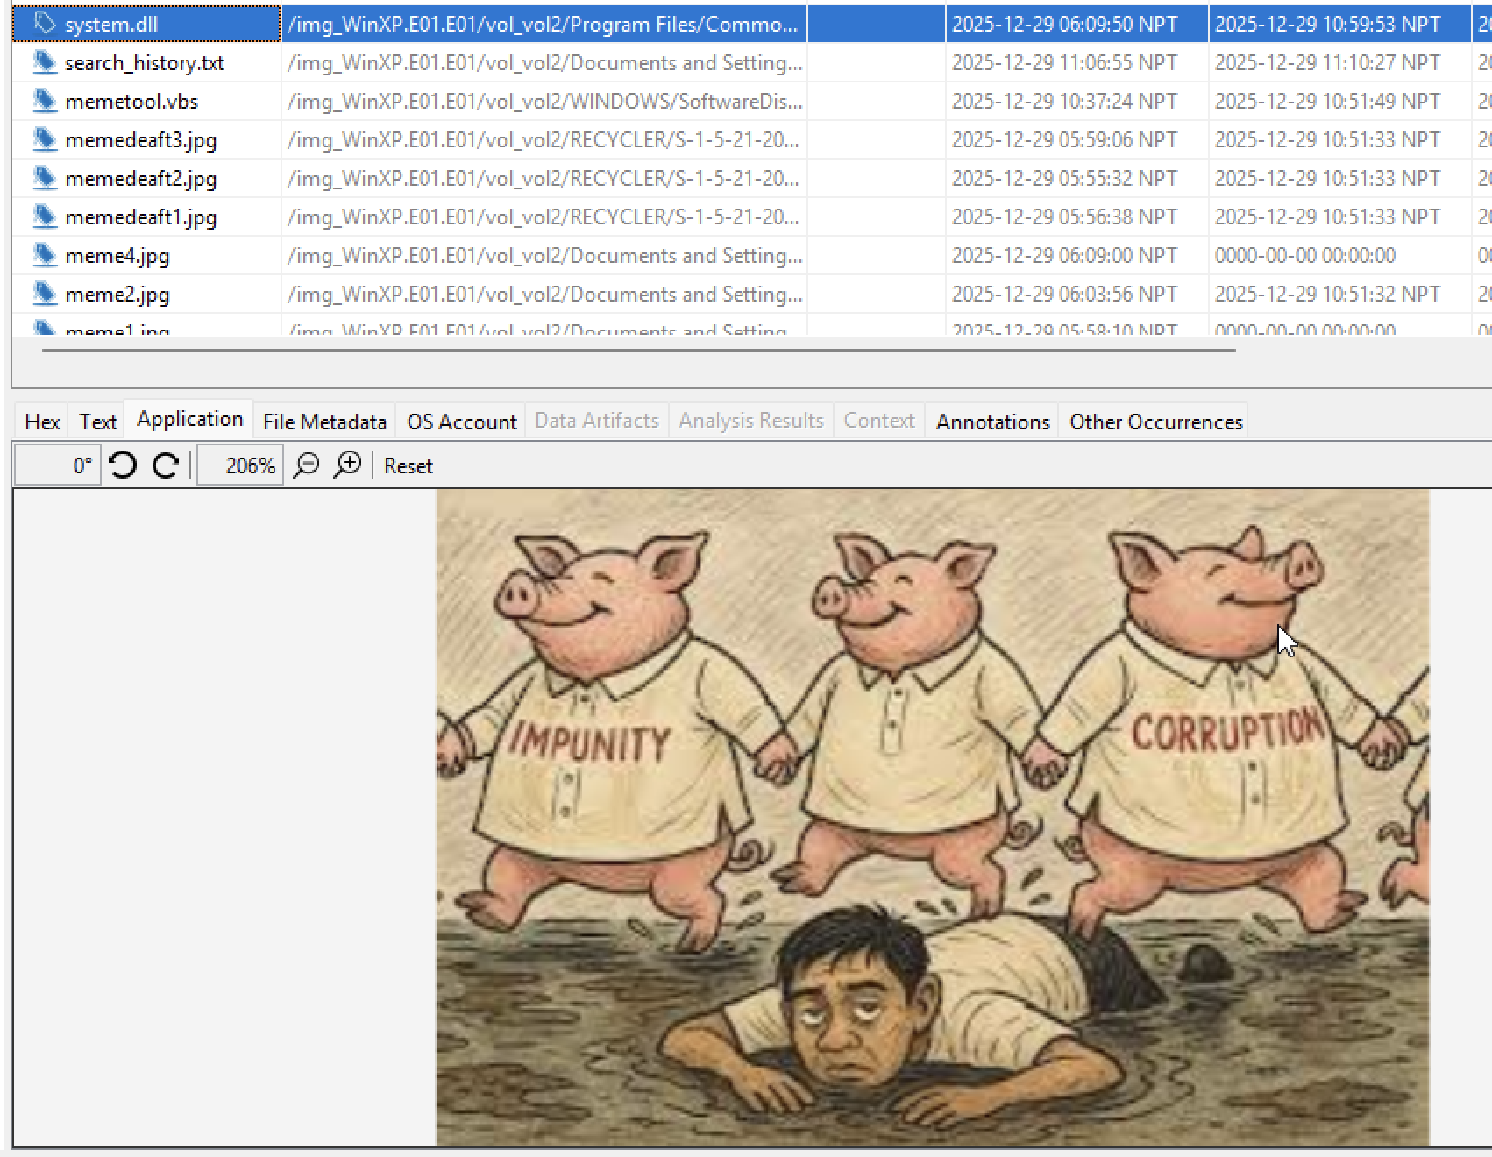
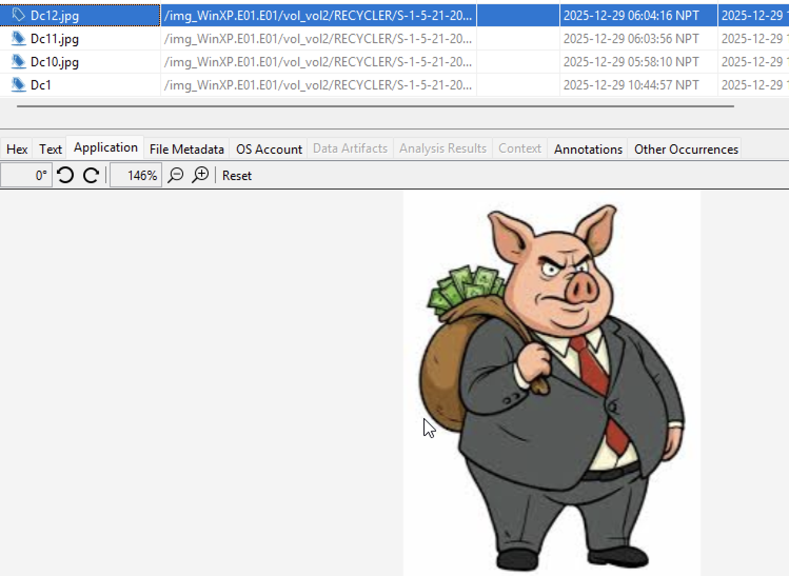
Further images were found from deleted locations and unallocated space, including one file which had been named originally as meme1.jpg. A file called system.dll was also detected as a renamed image file using signature mismatch analysis suggesting a desire to try and hide the true nature of the contents.
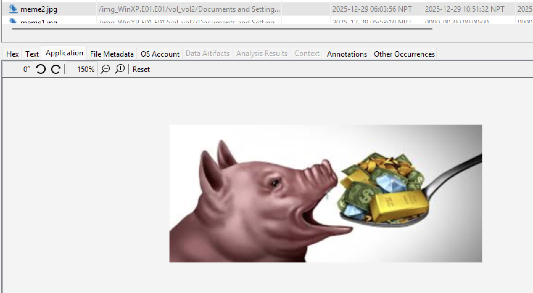
Figure 4: meme2.jpg
Figure 5: some deleted memes

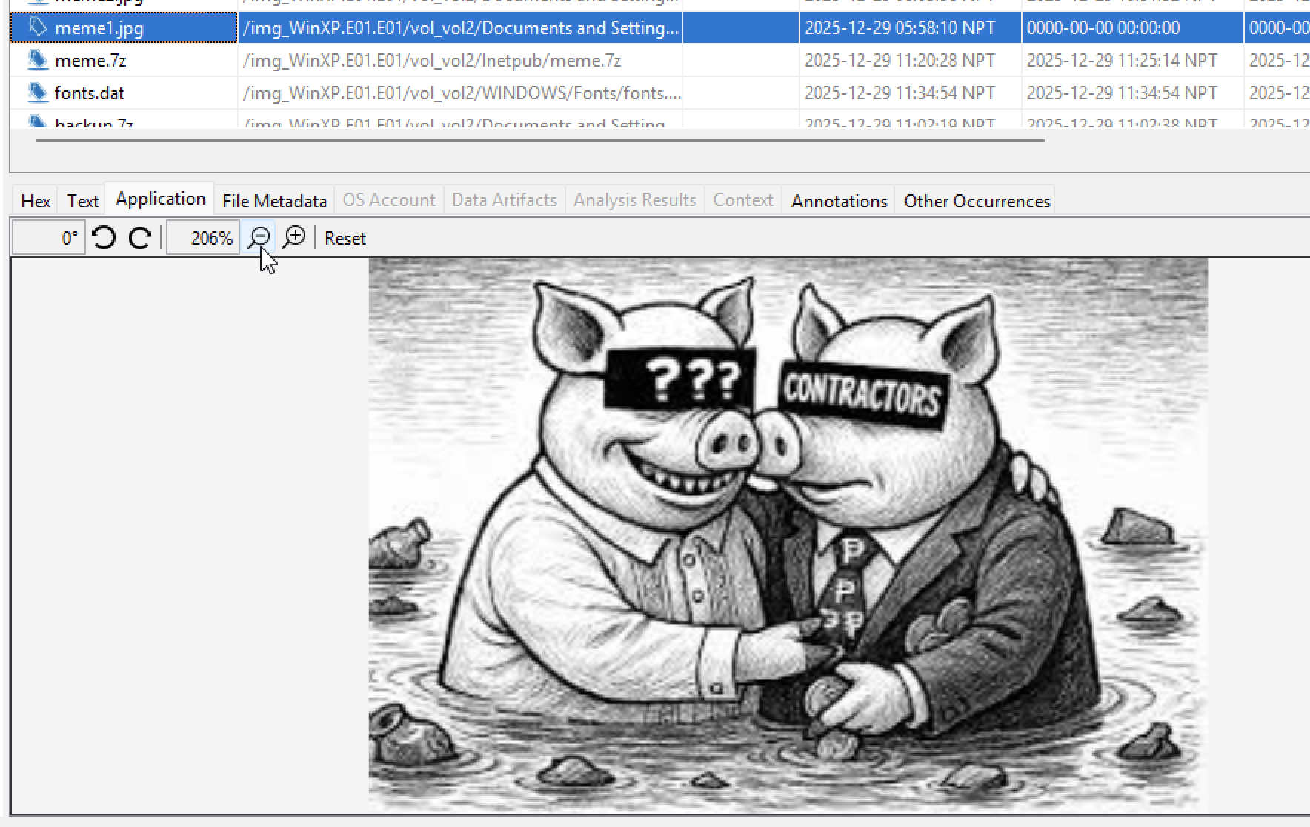

Figure 6: renamed to system.dll
Figure 7: meme1.jpg

Theme 3 Hiding and Anti-Forensic Behaviour
The examination discovered a number of techniques to conceal evidence. A high entropy file called fonts.dat was found in a system directory and was confirmed to be an encrypted container. This container was successfully mounted with VeraCrypt and it contained additional meme images and a reminder text file.
A password-protected archive (meme.zip) was identified too. Password-related information was found via associated text and script artefacts, including the use of an alternate data stream for hiding sensitive information. A script file (memetool.vbs) further recommended the use of automated or assisted meme creation tools.

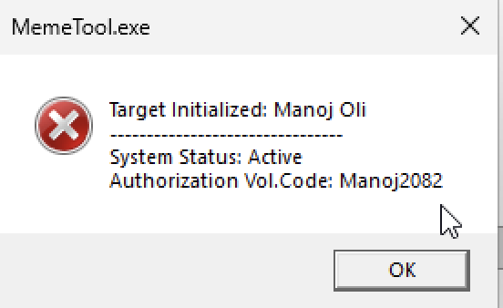
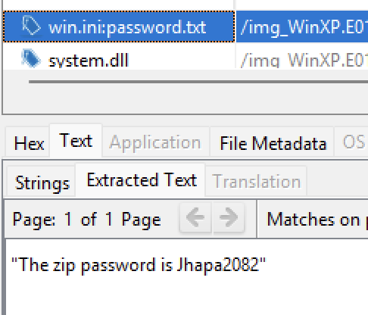
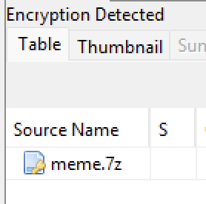
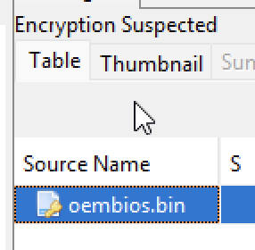

Figure 8: password found
Figure 9: encyption files
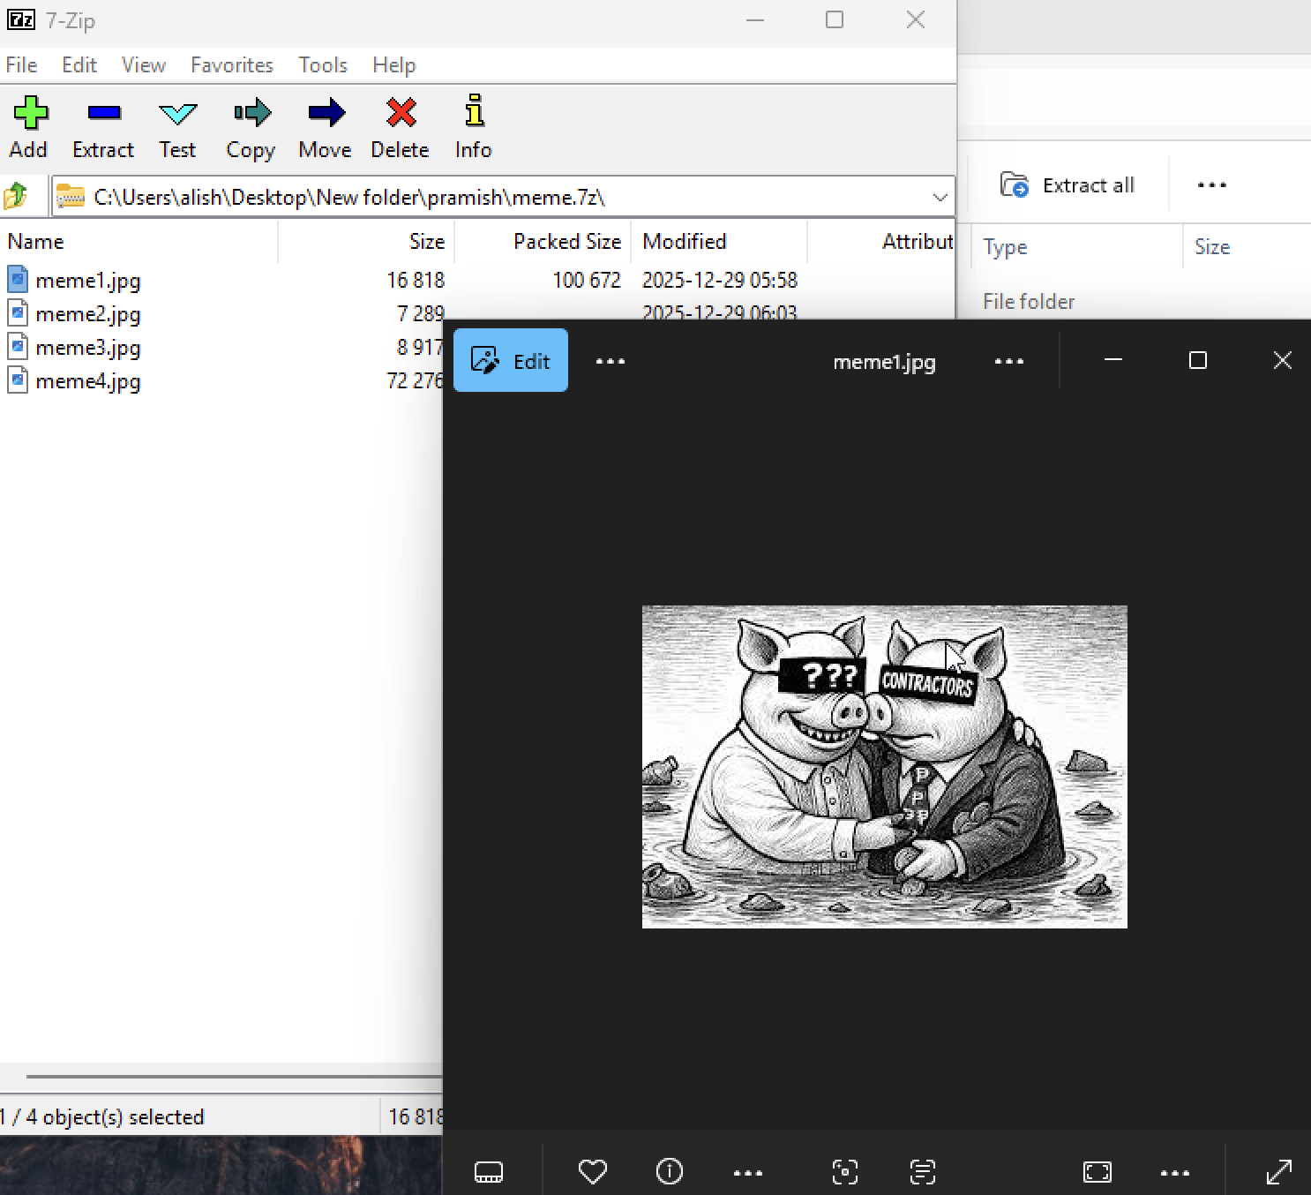
Figure 10: meme.zip content
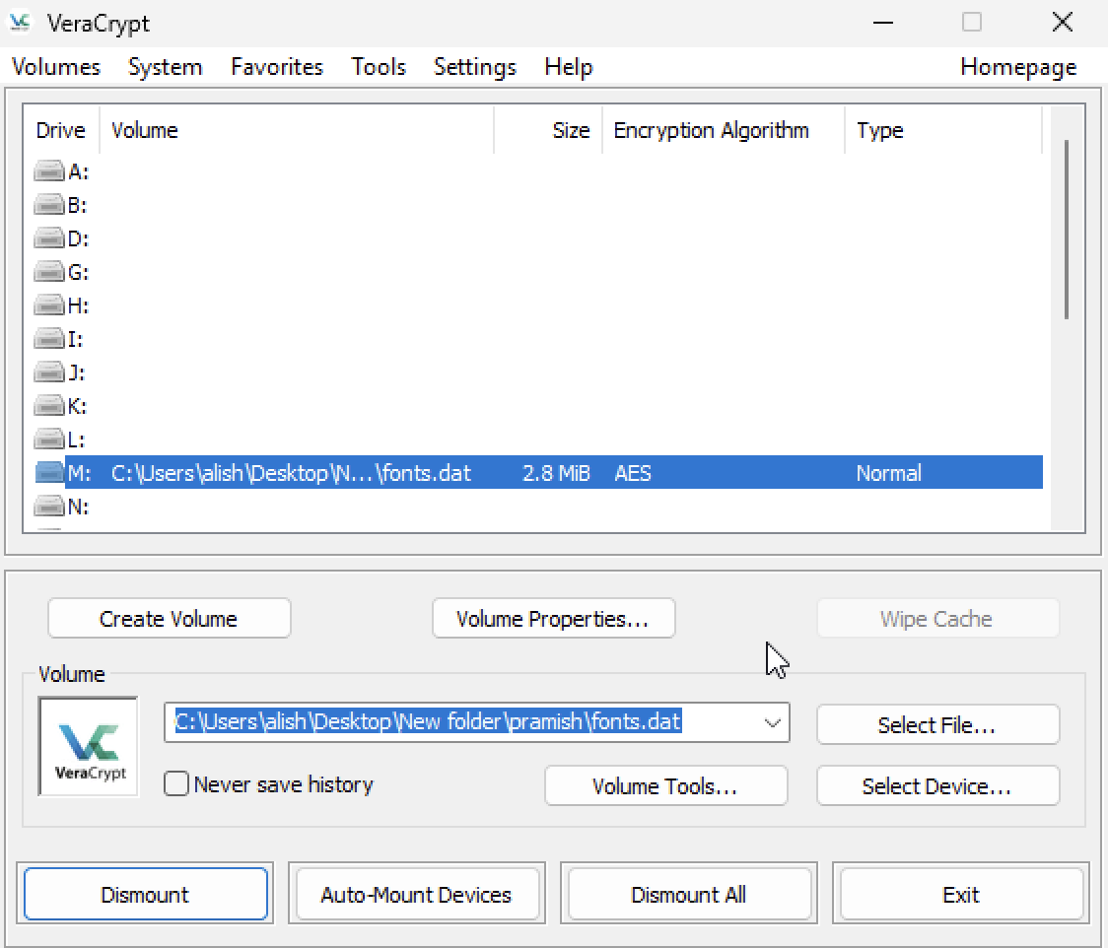

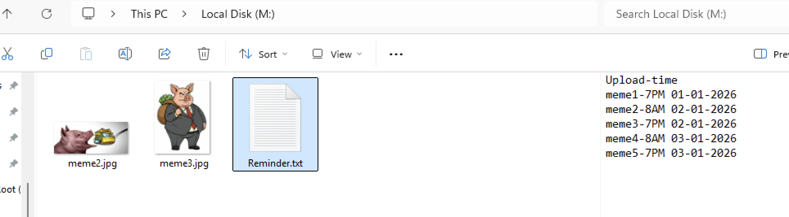

Figure 11: encypted container

Theme 4: Underpinning System Artefacts
Supporting artefacts discovered which offer context to suspect activity. Shortcut files suggested interaction with external storage devices, which suggests possible file transfer or preparation for distribution. Deleted files within the recycle bin and unallocated space show the attempt to remove or hide away evidence after content-creation.

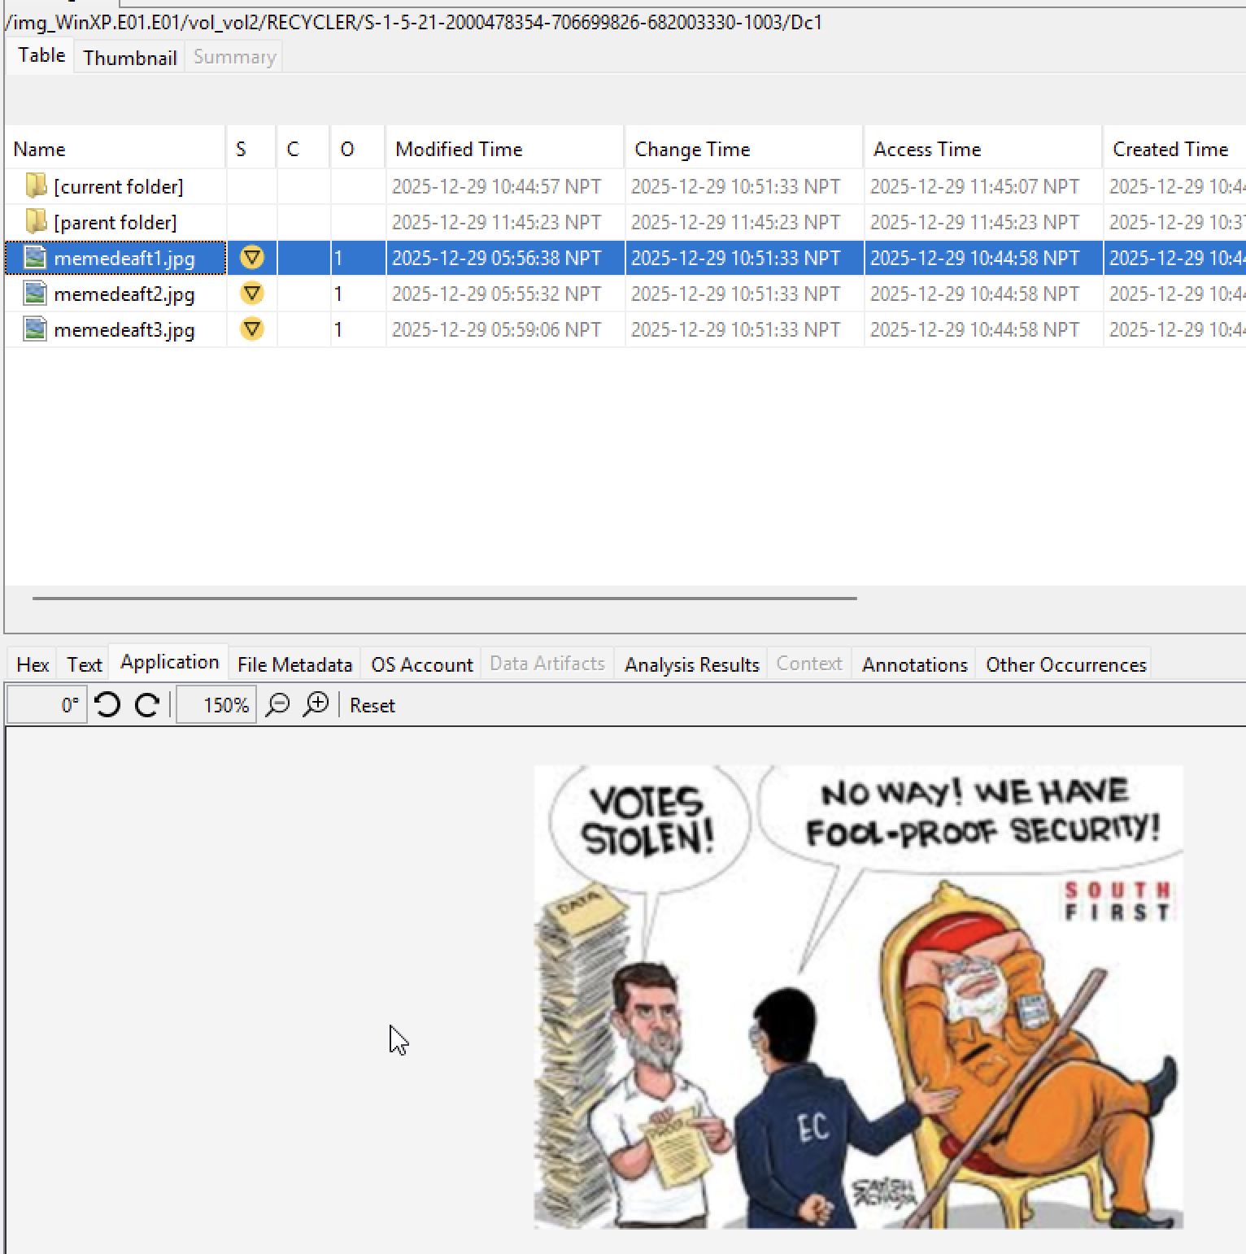
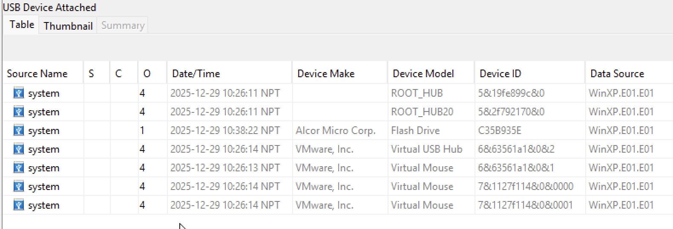
Figure 12: Deleted files
Figure 13: USB artifacts

Forensic Examiner’s Conclusion
Based on the sum of the evidence reviewed, it is my professional opinion that the artefacts identified within the forensic image suggest deliberate planning, creating and concealing of politically defamatory meme content targeting Manoj Oli. The existence of intent-related documents, as well as targeted images, creation tools, encrypted storage, and multiple concealment techniques, all point to this conclusion.

This opinion is based on the digital evidence examined only and does not constitute a determination of legal guilt. The findings are presented to help the investigators and legal authorities to understand the digital activities associated with this case.

Appendices
(Submitted in zip file)
- Html report
- Contemporaneous Notes

