Q1. List the first name, last name, department name and current job title of all staff.

SELECT first_name, last_name, department_name, job_title

FROM (staff NATURAL JOIN departments)NATURAL JOIN jobs;

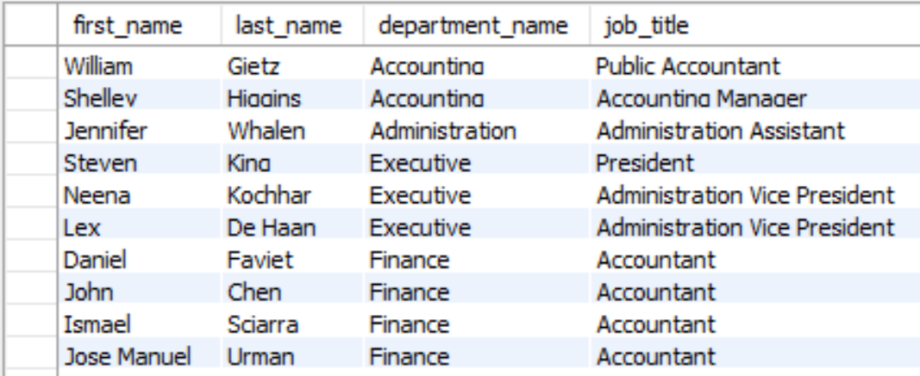

106 Rows returned

Q2. List every country name and the number of staff in each country. Order the result by country name.

SELECT country_name, count(staff_id)

FROM ((countries NATURAL JOIN locations) NATURAL JOIN departments) NATURAL JOIN staff

GROUP BY country_name

ORDER BY country_name;

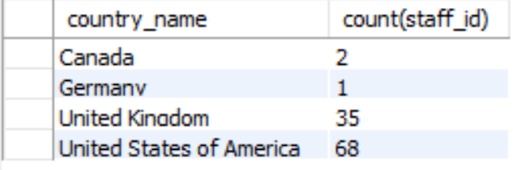

4 Rows returned

Q3. Who has spent the shortest amount of time in a job? Print their name (first and last name), how long the job lasted in days and the job title.

SELECT concat(first_name,' ', last_name) AS name, end_date - start_date, job_title

FROM (job_history NATURAL JOIN jobs) INNER JOIN staff

ON job_history.staff_id = staff.staff_id

ORDER by (end_date - start_date) DESC

LIMIT 1;

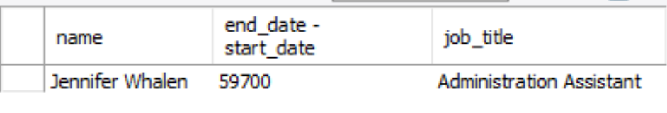

1 Row returned

Q4. For all supervisors who supervise five or more staff, list their first name, last name, job title, and the number of staff members they supervise.

SELECT supervisor.first_name, supervisor.last_name, jobs.job_title, count(wrk.staff_id)

FROM staff wrk INNER JOIN staff supervisor

ON wrk.supervisor_id = supervisor.staff_id

INNER JOIN jobs

ON supervisor.job_id = jobs.job_id

GROUP BY wrk.supervisor_id

HAVING count(wrk.staff_id)>=5;

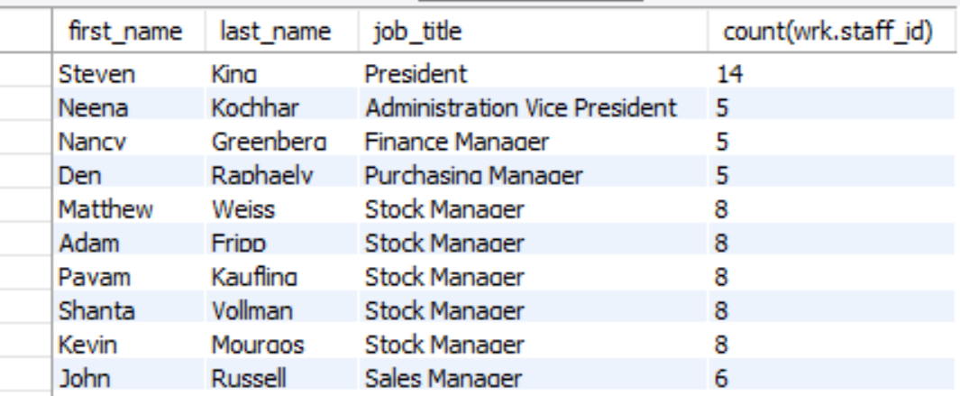

14 Rows returned

Q5. Print department names of departments that currently have neither a manager nor any staff.

SELECT department_name

FROM departments

WHERE department_id NOT IN

(SELECT department_id

FROM departments NATURAL JOIN staff);



16 Rows returned

Q6. Which region has the most locations? Print the region name, as well as the total number of locations in that region.

SELECT region_name, count(location_id)

FROM (locations NATURAL JOIN countries) NATURAL JOIN regions

GROUP BY region_name

ORDER BY count(location_id) DESC

LIMIT 1;



1 Row returned

Q7. Some staff members are eligible for a commission. Find the names of staff who will exceed the maximum salary for their job title if they achieve their commission. The calculation of a staff member’s total income if the commission is achieved is their salary multiplied by the commission percent and added onto their original salary. List the staff member’s first name, last name and the amount by which they will exceed the maximum salary for their current job role. Order the results from the highest amount to lowest.

SELECT first_name, last_name, salary*commission_pct+salary-max_salary AS exceeded_amount

FROM staff NATURAL JOIN jobs

WHERE salary*commission_pct+salary > max_salary

ORDER by exceeded_amount DESC;

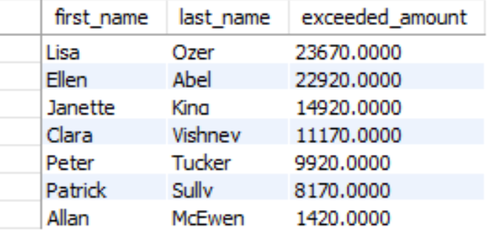

7 Rows returned

Q8. List the cities, country names and region names for cities outside the United States of America and Europe where no staff work.

SELECT city, country_name, region_name

FROM locations NATURAL JOIN countries NATURAL JOIN regions

WHERE (city NOT IN

(SELECT city

FROM staff NATURAL JOIN departments NATURAL JOIN locations

GROUP by city))

AND (country_name != 'United States of America')

AND (region_name != 'Europe');

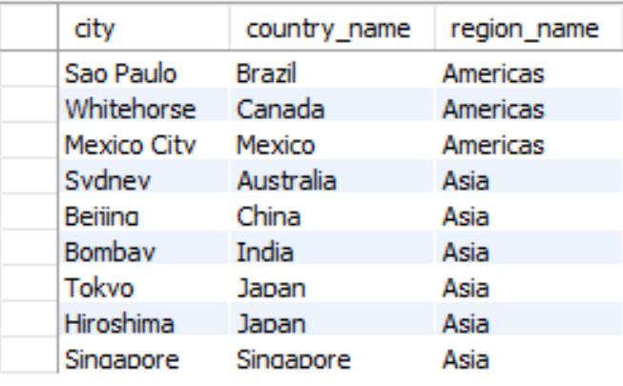

9 Rows returned

Q9. Print job titles, the date the jobs ended, and the current manager’s first and last name for all jobs that ended in 2006 which are currently not managed by Steven King.

SELECT job_title, end_date, staff.first_name, staff.last_name

FROM departments NATURAL JOIN job_history NATURAL JOIN jobs

INNER JOIN staff

ON departments.manager_id= staff.staff_id

WHERE (end_date LIKE '2006%')

AND (staff.first_name != 'Steven')

AND (staff.last_name != 'King');



2 Rows returned

Q10. Print the first name, last name and current salary for all staff who held more than one job position prior to their current position, and whose current salary is below the average value of maximum salaries for all positions they held in the past prior to their current position.

SELECT first_name, last_name, salary

FROM job_history INNER JOIN staff

ON job_history.staff_id = staff.staff_id

INNER JOIN jobs

ON job_history.job_id = jobs.job_id

WHERE staff.staff_id IN

(SELECT job_history.staff_id

FROM job_history NATURAL JOIN jobs

GROUP by job_history.staff_id

HAVING avg(max_salary) > salary)

GROUP by job_history.staff_id

HAVING count(job_history.staff_id)>1;

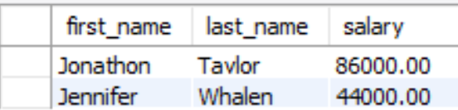

2 Rows returned