1. Introduction
This report describes the Loan ML App, a full-stack machine learning project built on a loan applicant dataset. The system trains several scikit-learn models, serves them through a FastAPI backend, and lets a user try them from a simple web page. It answers two practical questions about a loan applicant:
- Regression: how much loan (loan_amount) is this applicant likely to get?
- Classification: will the loan be approved or rejected (loan_status)?

2. Objectives
- Prepare a clean, model-ready loan dataset.
- Train and compare multiple regression and classification algorithms on the same train/test split.
- Save the trained models so they can be reused without retraining.
- Expose the models through a REST API with input validation.
- Provide a web interface where a user can choose a model, enter applicant details and see a prediction.

3. Dataset
The project uses the file data/processed/cleaned_LOAN.csv, a final, already-cleaned dataset. It contains 4,269 applicants and 8 columns. There are no missing values and no duplicate rows. Of the applicants, 2,656 (about 62%) were approved and 1,613 (about 38%) were rejected, so the classes are moderately imbalanced.

3.1 Attributes
Column | Meaning
education | 1 = Graduate, 0 = Not Graduate
self_employed | 1 = Yes, 0 = No
income_annum | Annual income of the applicant
loan_amount | Loan amount requested or granted (regression target)
loan_term | Loan term in years (2 to 20)
cibil_score | Credit score (300 to 900)
bank_asset_value | Value of the applicant's bank assets
loan_status | 1 = Approved, 0 = Rejected (classification target)

3.2 Summary statistics
Feature | Mean | Std. dev. | Min | Max
income_annum | 5,059,124 | 2,806,840 | 200,000 | 9,900,000
loan_amount | 15,133,450 | 9,043,363 | 300,000 | 39,500,000
loan_term (years) | 10.9 | 5.7 | 2 | 20
cibil_score | 599.9 | 172.4 | 300 | 900
bank_asset_value | 4,976,692 | 3,250,186 | 0 | 14,700,000
Table 1: Summary of the numeric features (education and self_employed are balanced about 50/50).

3.3 Key observations
- Credit score drives approval. cibil_score has a correlation of 0.77 with loan_status. Approved applicants average a score of about 703, rejected ones about 429.
- Loan amount follows income and assets. loan_amount correlates 0.93 with income_annum and 0.79 with bank_asset_value.
- Income and assets are linked. income_annum and bank_asset_value correlate 0.85 with each other.
- Weak signals. education and self_employed show almost no correlation with any other column, and loan_term has a small negative correlation (-0.11) with approval.
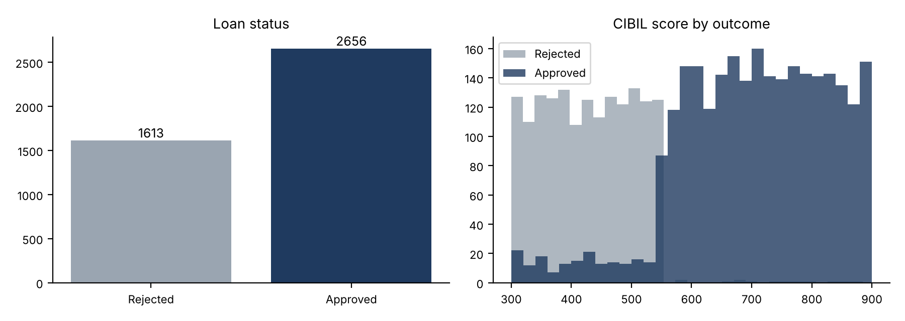
Figure 1: Class balance (left) and CIBIL score distribution by outcome (right).

4. Methodology
All training happens in src/train.py. The script reads the cleaned CSV, trains every model, scores it on held-out data and saves it with joblib together with its feature list and display name. Test scores are written to models/metrics.json so the API and web page can display them.

4.1 Data split
Both tasks use an 80/20 train/test split with random_state=42. The classification split is stratified so that the training and test sets keep the same approved/rejected ratio.

4.2 Features
- Regression inputs: education, self_employed, income_annum, loan_term, cibil_score, bank_asset_value. Target: loan_amount.
- Classification inputs: the same six features plus loan_amount. Target: loan_status.

4.3 Scaling
Income and loan values are in the millions while the CIBIL score is only about 300 to 900. The Logistic Regression and SVM models are therefore wrapped in a pipeline with StandardScaler. The SVR also scales the target (loan_amount, which is in the tens of millions) using TransformedTargetRegressor. Tree-based models and Naive Bayes do not need scaling and are used as they are.

4.4 Evaluation metrics
Regression models are scored with R² on the test set. Classification models are scored with accuracy on the test set.

5. Models

5.1 Regression: predicting loan_amount
Model | Configuration | R² (test)
Linear Regression | Default | 0.8513
Decision Tree | max_depth = 8 | 0.8278
Random Forest | 200 trees | 0.8443
SVM (SVR) | Linear kernel, C = 1.0, scaled X and y | 0.8511
Table 2: Regression results.

5.2 Classification: predicting loan_status
Model | Configuration | Accuracy (test)
Logistic Regression | Scaled, max_iter = 1000 | 91.22%
Decision Tree | max_depth = 6 | 97.31%
Naive Bayes | Gaussian | 75.64%
Random Forest | 200 trees | 98.36%
SVM (SVC) | RBF kernel, probability = True, scaled | 94.96%
Table 3: Classification results (best model highlighted).
Naive Bayes is a classification-only algorithm, so it has no regression version and appears in the model menu only for the approval task.

6. Results and Discussion
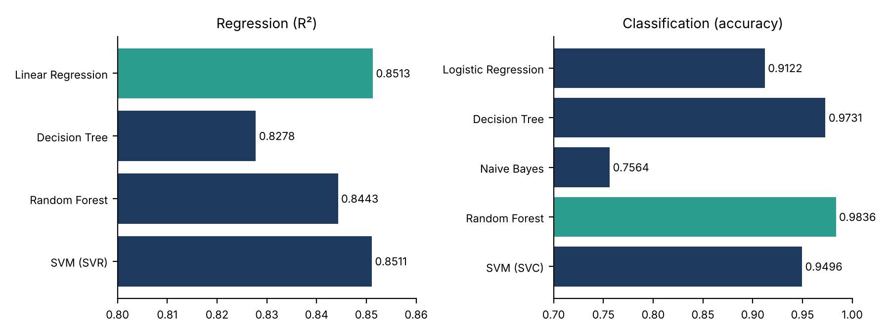
Figure 2: Test scores for all models. The best model in each task is shown in green.
- Regression. All four models land between 0.83 and 0.85 R². Linear Regression (0.8513) and the linear SVR (0.8511) are essentially tied for best. This fits the data: loan_amount is strongly and roughly linearly related to income and assets, so the more flexible trees add little.
- Classification. Tree-based models perform best. Random Forest is the top model at 98.36% accuracy, followed by the Decision Tree at 97.31%. Logistic Regression (91.22%) and the RBF SVM (94.96%) are behind, and Gaussian Naive Bayes is clearly weakest at 75.64%, likely because its independence and normality assumptions do not suit these features.
- Overall. Random Forest is the recommended model for approval prediction, and Linear Regression is a good, simple choice for amount prediction.

7. System Architecture
The data flows from the CSV file through the training script into saved models, which the backend loads and the web page queries:
cleaned_LOAN.csv → src/train.py → models/*.joblib + metrics.json → main.py (FastAPI) ↔ frontend/index.html

7.1 Backend (main.py)
The backend is a FastAPI application served by Uvicorn on http://127.0.0.1:8001. At startup it loads every saved regression and classification model plus metrics.json. If the saved models are missing, or were saved by a different scikit-learn version and fail to load, it automatically runs src/train.py to retrain them. CORS is enabled so the page also works when opened from elsewhere.

7.2 API endpoints
Method | Endpoint | Description
GET | / | Serves the frontend page
GET | /models | Lists available models and their test scores
POST | /predict/regression?model=... | Predicts loan_amount
POST | /predict/classification?model=... | Predicts approval status with a confidence score

Valid model values are linear, decision_tree, random_forest and svm for regression, plus naive_bayes for classification. If model is left out it defaults to linear; an unknown name returns a 404 that lists the valid choices.

7.3 Input validation
Request bodies are validated with Pydantic: education and self_employed must be 0 or 1, cibil_score must be between 300 and 900, loan_term must be at least 1, and income, assets and loan amount must be non-negative. The regression output is clipped at zero. For classification, the response includes the label (Approved or Rejected) and the model's probability for the predicted class as confidence.

7.4 Example request
POST /predict/classification?model=svm
{"education":1,"self_employed":0,"income_annum":9600000,"loan_amount":29900000,
"loan_term":12,"cibil_score":778,"bank_asset_value":8000000}
The response contains the model name, its test accuracy, the predicted loan_status, the label and the confidence.

8. Frontend
frontend/index.html is a single page built with HTML, CSS and JavaScript and served by main.py. The user selects a model from a dropdown (Linear/Logistic, Decision Tree, Naive Bayes, Random Forest or SVM) and fills in a form:
- Regression form: applicant details only; clicking Predict amount returns an estimated loan amount.
- Classification form: applicant details plus the loan amount; clicking Predict status returns Approved or Rejected with a confidence score.

9. Project Structure
Path | Purpose
data/processed/cleaned_LOAN.csv | Dataset used for modeling
src/train.py | Trains and saves all models and metrics
models/ | Nine saved .joblib models and metrics.json
main.py | FastAPI backend
frontend/index.html | Web page served by the backend
requirements.txt | Dependencies
README.md | Project documentation

9.1 Technology stack
- Python and pandas for data handling
- scikit-learn for models, pipelines and metrics
- joblib for saving and loading models
- FastAPI and Uvicorn for the backend API
- HTML, CSS and JavaScript for the frontend

10. How to Run
- Install dependencies: pip install -r requirements.txt
- (Optional) retrain all models: python src/train.py
- Start the server: python main.py
Then open http://127.0.0.1:8001 in a browser. The server can also be started with python -m uvicorn main:app --reload.

11. Limitations and Future Work
- Only a single train/test split is used; cross-validation would give a more reliable estimate of each model's performance.
- Classification is reported by accuracy only. Precision, recall, F1 and a confusion matrix would be useful, since 38% of cases are rejections.
- The classification models take loan_amount as an input, and CIBIL score is by far the strongest predictor. Results depend heavily on this one feature.
- Hyperparameters are fixed by hand. A grid or random search could improve the Decision Tree, SVM and Random Forest.
- The dataset does not state its currency or source, and predictions should be treated as a learning demonstration, not real lending decisions.

12. Conclusion
The Loan ML App delivers a complete workflow: a cleaned dataset, nine trained models, a validated REST API and a simple web interface. For approval prediction, Random Forest performs best with 98.36% accuracy, with the Decision Tree close behind. For loan-amount prediction, Linear Regression and the linear SVR both reach about 0.85 R². The project is easy to run and extend, and the main next steps are deeper evaluation and hyperparameter tuning.

